STATISTICAL ANALYSIS OF MINI WHEELBOT DYNAMICS
Drive-Wheel Angular Velocity and Robot Pitch Angle

Assignment Report
Student: Muhammad Ajmal
Program: BS Robotics and Intelligent Systems
University: University of Haripur
Project Type: Robotics Data Analysis / Statistics
Analysis Method: Pearson Correlation + Simple Linear Regression
This report documents the complete workflow from raw Wheelbot time-series data to data validation, statistical analysis, regression modelling, visualization, residual analysis, and interpretation.
Prepared for academic submission • October 2026

Project Overview
Project objective. The purpose of this project is to use a real robotics dataset to study whether drive-wheel angular velocity is linearly associated with the pitch angle of a self-balancing Mini Wheelbot. The analysis demonstrates a complete engineering-data workflow: loading and checking the dataset, selecting meaningful robot variables, cleaning the data, measuring correlation, fitting a simple linear regression model, evaluating prediction error, and inspecting residuals.
Research question. Is the drive-wheel angular velocity a useful linear predictor of the Mini Wheelbot's pitch angle in the selected experiment?
Independent variable (X): /dq_DR/drive_wheel — drive-wheel angular velocity.
Dependent variable (Y): /q_yrp/pitch — robot pitch angle.
The project is intentionally limited to a simple, interpretable model. The result should be treated as an analysis of statistical association and prediction, not as proof that wheel velocity alone causes changes in robot pitch.

Dataset Used
The project uses the Mini Wheelbot Dataset, a robotics dynamics dataset containing synchronized time-series measurements from a self-balancing reaction-wheel unicycle. The dataset includes IMU measurements, robot state estimates, wheel states, motor commands, setpoints, motion-capture measurements, and battery voltage. The source dataset is recorded at approximately 1 kHz and provides dedicated experiment groups including velocity-pitch experiments.
Selected file: data/velocity_pitch/0.csv
Dataset size: 14,814 rows × 57 columns
Time range in the selected CSV: approximately 0 to 14.813 s
Data types: 50 float64 columns and 7 int64 columns
Missing values: none reported in the dataset inspection
Duplicate rows: 0
The dataset source documentation describes /dq_DR/drive_wheel as the drive-wheel angular velocity and /q_yrp/pitch as the robot pitch angle. These definitions make the selected variables appropriate for a basic dynamics relationship study.
Item | Value
Dataset | Mini Wheelbot Dataset
Experiment group | velocity_pitch
File | 0.csv
Rows | 14,814
Columns | 57
Sampling | 1 kHz dataset
Predictor X | /dq_DR/drive_wheel
Response Y | /q_yrp/pitch
Source note: The Mini Wheelbot Dataset documentation reports 1 kHz synchronized data and the available experiment structure, including velocity-pitch experiments. See the references at the end of this report.

How the Project Works
The project follows a reproducible pipeline. The analysis script performs numerical data processing and model calculations, while the Jupyter notebook is used mainly for visualization and explanation. This separation keeps the project organized and makes the workflow easier to reuse.
Step | Operation | Purpose
1 | Load CSV | Read the raw Wheelbot experiment into pandas.
2 | Inspect dataset | Check shape, columns, data types, missing values, duplicates, and summary statistics.
3 | Select variables | Extract drive-wheel angular velocity and pitch angle.
4 | Clean data | Remove rows with missing values in the selected variables.
5 | Correlation | Measure the linear association using Pearson correlation.
6 | Train/test split | Use the first 80% for training and the final 20% for testing.
7 | Regression | Fit a Simple Linear Regression model.
8 | Evaluate | Calculate R², MAE, and RMSE on the test set.
9 | Visualize | Create scatter, regression, actual-vs-predicted, and residual plots.
10 | Interpret | Explain what the model means and identify limitations.

Statistical Concepts Used
Pearson correlation. Pearson's correlation coefficient measures the direction and strength of a linear relationship between X and Y. Its value is between −1 and +1.
Simple Linear Regression. The model estimates pitch from drive-wheel angular velocity:
Pitch = Intercept + Coefficient × Drive-Wheel Angular Velocity
Residual. For each test observation, residual = actual pitch − predicted pitch. A residual plot helps identify systematic errors, changing spread, or patterns that a simple linear model does not capture.

Why the 80/20 Split Is Chronological
Because the Wheelbot data are time-series observations, the project uses the first 80% of the selected data for training and the final 20% for testing rather than randomly shuffling the observations. This preserves the time order of the experiment and provides a more realistic test of prediction on later observations.

Dataset Inspection and Preparation

Dataset Structure
The initial inspection confirms that the selected CSV contains 14,814 observations and 57 variables. The variables cover multiple parts of the robot: four gyroscope groups, four accelerometer groups, orientation and angular velocity states, drive and reaction wheel states, motor torque commands, setpoints, Vicon motion capture, and battery voltage.

Data Quality Checks
The recorded inspection output reports no missing values in the 57 columns and no duplicate rows. The selected predictor and response are both numeric float64 variables, so they can be passed directly to the correlation and regression calculations after selection.

Variable Selection
velocity_column = "/dq_DR/drive_wheel" pitch_column = "/q_yrp/pitch"
analysis_df = df[[velocity_column, pitch_column]].dropna()
X = analysis_df[[velocity_column]] y = analysis_df[pitch_column]
This selection is important because the dataset contains many sensor channels, but the assignment focuses on one interpretable relationship. Keeping the variable names exactly as provided by the dataset also prevents accidental use of a different wheel or setpoint.

Training and Testing Data
split_index = int(len(analysis_df) * 0.80)
X_train = X.iloc[:split_index] X_test = X.iloc[split_index:]
y_train = y.iloc[:split_index] y_test = y.iloc[split_index:]
Current dataset count: 14,814 observations → approximately 11,851 training samples and 2,963 testing samples.

Statistical Model

Model Selection
The selected model is Simple Linear Regression. It is appropriate for a first engineering analysis because there is one predictor and one response, and the resulting equation is easy to interpret.
from sklearn.linear_model import LinearRegression
model = LinearRegression() model.fit(X_train, y_train)
y_pred = model.predict(X_test)

Model Parameters
The current run recorded the following intercept:
Parameter | Current value | Meaning
Intercept | -0.033061999598844 | Predicted pitch when the predictor is zero, subject to the observed data range.
Coefficient | INSERT FROM FINAL model_results | .csvEstimated change in pitch per one-unit increase in drive-wheel angular velocity.
Submission check: Before submitting, replace the coefficient placeholder and the metric placeholders in Section 6 with the exact values printed by the final analysis.py / notebook run. This avoids putting an estimated or guessed value into the final report.

Prediction and Error Metrics
from sklearn.metrics import r2_score, mean_absolute_error, mean_squared_error import numpy as np
r2 = r2_score(y_test, y_pred) mae = mean_absolute_error(y_test, y_pred) rmse = np.sqrt(mean_squared_error(y_test, y_pred))
residuals = y_test - y_pred
R² measures the proportion of test-set variation in pitch represented by the linear model. MAE is the average absolute prediction error. RMSE is another error measure that gives greater weight to larger errors.

Results and Visual Analysis
The final report should contain the following four core plots. The spaces below are intentionally sized so the graphs exported from wheelbot.ipynb can be inserted without disturbing the report layout.
Figure 1 — Drive-Wheel Angular Velocity vs. Pitch Angle
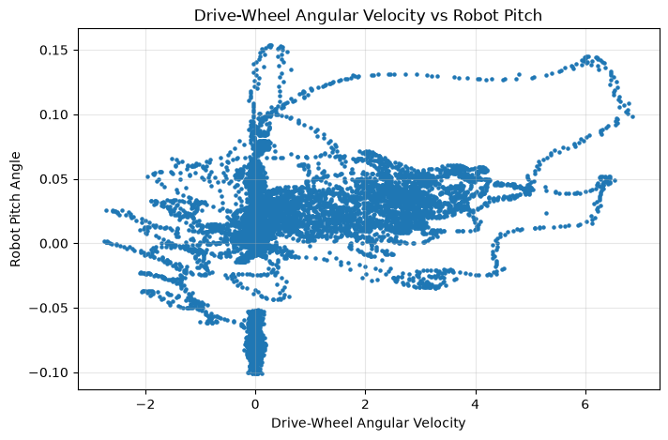
Figure placeholder — replace before final submission.
Figure 2 — Regression Line on the Test Data
Insert the test-set scatter plot with the fitted Simple Linear Regression line.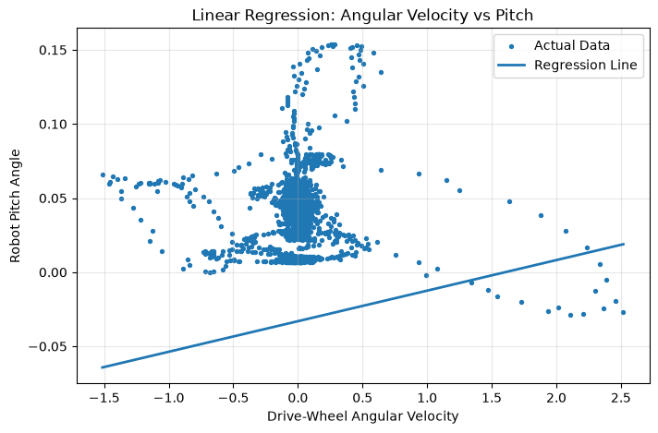
Figure placeholder — replace before final submission.
Figure 3 — Actual Pitch vs. Predicted Pitch
Insert the actual-vs-predicted plot. A 45-degree reference line should be included to show perfect prediction.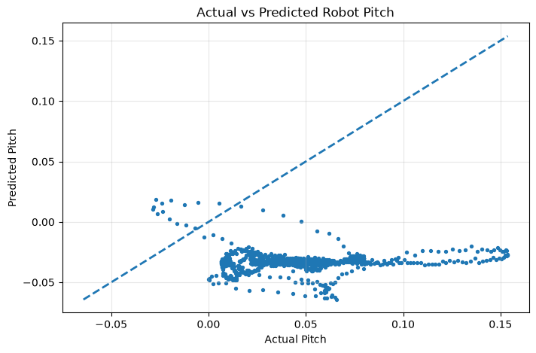
Figure placeholder — replace before final submission.
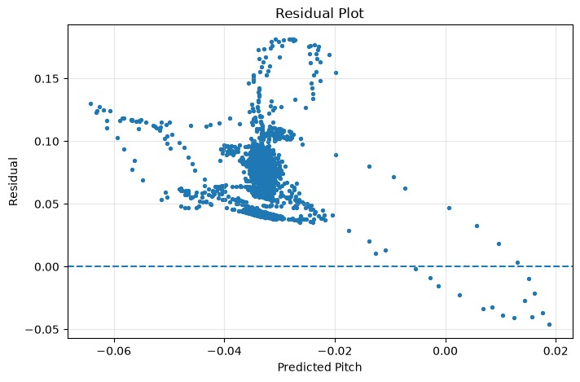
Figure 4 — Residual plot from the current analysis run. The horizontal dashed line represents zero residual.

Model Metrics Table
Metric | Final value | Interpretation
Pearson correlation (r) | INSERT | Linear association between drive-wheel angular velocity and pitch.
R² | INSERT | Variation in test-set pitch represented by the fitted linear model.
MAE | INSERT | Average absolute prediction error.
RMSE | INSERT | Prediction error measure that emphasizes larger errors.
Training samples | 11,851 | First 80% of the selected observations.
Testing samples | 2,963 | Final 20% of the selected observations.
Important: The metric values marked INSERT are intentionally left for the exact final run. Copy them directly from results/metrics.txt or the notebook output after the final execution.

Interpretation

What the Analysis Tells Us
The scatter plot shows the observed relationship between drive-wheel angular velocity and pitch angle. Pearson correlation summarizes the linear direction and strength of that relationship, while the regression line provides a simple predictive approximation.
The regression coefficient should be interpreted as an estimated change in pitch for a one-unit increase in drive-wheel angular velocity within the range represented by the data. The intercept is the model's predicted pitch at zero predictor value; this interpretation is most meaningful when zero lies within or near the observed predictor range.

Residual Analysis
The current residual plot shows residuals spread around the zero reference line, but also shows visible structure and non-uniform spread rather than a perfectly random cloud. This is important for the report: a simple linear model may not capture all of the Wheelbot's dynamics. A self-balancing robot is a dynamic, nonlinear system, and pitch can depend on additional variables such as wheel acceleration, reaction-wheel behavior, torque commands, angular velocity states, controller setpoints, and time-dependent effects.
Therefore, the residual plot is not just a presentation figure; it is a diagnostic tool. The visible patterns motivate future analysis using multiple predictors, time-series models, nonlinear models, or state-space/control-oriented approaches.

Correlation Is Not Causation
A statistical relationship between two recorded robot variables does not by itself prove that drive-wheel angular velocity causes the observed pitch changes. The robot controller and other coupled dynamics influence both variables. The result should therefore be described as an observed association and a predictive relationship within the selected experiment.

Limitations
- Only one experiment file (velocity_pitch/0.csv) is analyzed.
- Only one predictor is used in the first model.
- The model is linear, while the robot dynamics are nonlinear and coupled.
- Time dependence is not explicitly modelled by Simple Linear Regression.
- The test split follows time order, so the model is evaluated on later observations from the same experiment ratherthan on a completely different experiment.

How to Reproduce the Project
The project is organized so that another student can reproduce the analysis without manually copying calculations. wheelbot-project/
■
■■■ data/
■ ■■■ velocity_pitch/
■ ■■■ 0.csv ■
■■■ notebook/
■ ■■■ wheelbot.ipynb
■
■■■ results/
■ ■■■ actual_vs_prediction.png
■ ■■■ residual_plot.png
■ ■■■ velocity_vs_pitch.png
■ ■■■ metrics.txt
■ ■■■ model_results.csv
■
■■■ src/
■ ■■■ analysis.py
■
■■■ .gitignore
■■■ requirements.txt
■■■ README.md
Recommended execution order: (1) place the dataset in the data folder, (2) run python src/analysis.py, (3) open notebook/wheelbot.ipynb, (4) run all notebook cells, (5) export the four figures, and (6) insert the figures into the marked spaces in this report.

Core Analysis Code
The following is the core numerical logic for the project. In the final GitHub repository, the complete implementation should remain in src/analysis.py; the notebook should focus on plots, explanation, and presentation.
import os import numpy as np import pandas as pd from sklearn.linear_model import LinearRegression
from sklearn.metrics import r2_score, mean_absolute_error, mean_squared_error
PROJECT_ROOT = os.path.dirname(os.path.dirname(os.path.abspath(__file__)))
DATA_FILE = os.path.join(PROJECT_ROOT, "data", "velocity_pitch", "0.csv") RESULTS_DIR = os.path.join(PROJECT_ROOT, "results") os.makedirs(RESULTS_DIR, exist_ok=True)
velocity_column = "/dq_DR/drive_wheel" pitch_column = "/q_yrp/pitch"
df = pd.read_csv(DATA_FILE)
# Dataset checks print("Shape:", df.shape) print(df.columns.tolist()) print(df.dtypes) print(df.describe()) print("Missing values:") print(df.isnull().sum()) print("Duplicate rows:", df.duplicated().sum())
# Select and clean variables
analysis_df = df[[velocity_column, pitch_column]].dropna() X = analysis_df[[velocity_column]] y = analysis_df[pitch_column]
# Correlation correlation = analysis_df[velocity_column].corr( analysis_df[pitch_column] )
# Chronological 80/20 split
split_index = int(len(analysis_df) * 0.80)
X_train = X.iloc[:split_index] X_test = X.iloc[split_index:] y_train = y.iloc[:split_index] y_test = y.iloc[split_index:]
# Train regression model = LinearRegression() model.fit(X_train, y_train)
# Predict y_pred = model.predict(X_test) residuals = y_test - y_pred
# Metrics intercept = model.intercept_ coefficient = model.coef_[0]
r2 = r2_score(y_test, y_pred) mae = mean_absolute_error(y_test, y_pred) rmse = np.sqrt(mean_squared_error(y_test, y_pred))
print("Intercept:", intercept) print("Coefficient:", coefficient) print("Correlation:", correlation) print("R2:", r2) print("MAE:", mae) print("RMSE:", rmse)
# Save numerical results pd.DataFrame({ "intercept": [intercept],
"coefficient": [coefficient], "correlation": [correlation],
"r2": [r2],
"mae": [mae],
"rmse": [rmse] }).to_csv( os.path.join(RESULTS_DIR, "model_results.csv"), index=False )
pd.DataFrame({ "actual_pitch": y_test.to_numpy(),
"predicted_pitch": y_pred,
"residual": residuals.to_numpy() }).to_csv( os.path.join(RESULTS_DIR, "predictions.csv"), index=False
)

Notebook Visualization Code
# Main scatter plot plt.figure(figsize=(9, 6)) plt.scatter(analysis_df[velocity_column], analysis_df[pitch_column], alpha=0.6) plt.xlabel("Drive-Wheel Angular Velocity") plt.ylabel("Pitch Angle") plt.title("Drive-Wheel Angular Velocity vs Pitch") plt.grid(True, alpha=0.3) plt.savefig("../results/velocity_vs_pitch.png", dpi=300, bbox_inches="tight") plt.show()
# Residual plot plt.figure(figsize=(9, 6)) plt.scatter(y_pred, residuals, alpha=0.6) plt.axhline(0, linestyle="--") plt.xlabel("Predicted Pitch") plt.ylabel("Residual") plt.title("Residual Plot") plt.grid(True, alpha=0.3) plt.savefig("../results/residual_plot.png", dpi=300, bbox_inches="tight") plt.show()

Conclusion and Future Work
This project demonstrates how statistical methods can be applied to real robotics data. The Mini Wheelbot dataset provides high-frequency measurements from a self-balancing robot, and the selected velocity-pitch experiment makes it possible to study the relationship between wheel motion and body orientation.
The workflow combines Python, pandas, NumPy, Matplotlib, and scikit-learn. The analysis starts with dataset validation, selects physically meaningful variables, calculates correlation, fits a Simple Linear Regression model, evaluates test-set prediction error, and uses residual analysis to identify where the simple model does not fully describe the data.
For a robotics student, the main value of the project is not only the final regression equation. It is the complete engineering workflow: understanding sensor variables, working with time-series data, validating measurements, selecting a model, interpreting errors, and connecting statistical results to robot dynamics.

Future Improvements
- Use multiple predictors such as drive-wheel velocity, wheel acceleration, pitch velocity, torque command, andsetpoint.
- Compare Linear Regression with polynomial regression and tree-based models.
- Investigate time-lagged variables because robot dynamics depend on previous states.
- Use time-series models or state-space methods for dynamic prediction.
- Compare results across several velocity_pitch experiment files rather than a single CSV.
- Use cross-validation across independent experiments to test generalization.
- Connect the statistical model to a robotics control problem such as pitch prediction or disturbance analysis.

Submission Checklist
✓ | Dataset description included | Mini Wheelbot Dataset; velocity_pitch/0.csv
✓ | Data inspection included | Shape, columns, types, missing values, duplicates
✓ | Variable selection explained | Drive-wheel angular velocity → pitch angle
✓ | Statistical method explained | Pearson correlation + Simple Linear Regression
✓ | Train/test method explained | Chronological 80/20 split
✓ | Residual analysis included | Residual plot and interpretation
■ | Figure 1 inserted | Velocity vs pitch scatter plot
■ | Figure 2 inserted | Regression-line plot
■ | Figure 3 inserted | Actual vs predicted plot
✓ | Figure 4 included | Current residual plot
■ | Final coefficient inserted | Copy exact value from model_results.csv
■ | Final metrics inserted | Correlation, R², MAE, RMSE
✓ | Code documented | Core analysis.py + notebook workflow

References
- Hose, H., Brunzema, P., Subhasish, D., & Trimpe, S. (2026). The Mini Wheelbot Dataset: High-Fidelity Data for Robot Learning. arXiv:2601.11394.
- Hose, H., Weisgerber, J., & Trimpe, S. (2025). The Mini Wheelbot: A Testbed for Learning-based Balancing, Flips, and Articulated Driving. 2025 IEEE International Conference on Robotics and Automation (ICRA).
- Project dataset documentation / wheelbot-dataset package documentation. Used for understanding the datasetstructure, experiment groups, sampling rate, and data-field definitions.
- Scikit-learn documentation for LinearRegression and regression evaluation metrics.
- Python libraries used in the implementation: pandas, NumPy, Matplotlib, and scikit-learn.

Final Report Note
This document is designed as the final professional report layout. The figure spaces are deliberately reserved for the final plots generated from the user's notebook. Before submission, insert Figures 1–3 and replace the numerical INSERT fields with the exact values from the final execution of the project.

