**Homework Problem**

Consider a simple tomographic experiment in which we have a model with four blocks as shown in the figure below

1

1

m1=1

m2=2

m3=3

m4=4

The model vector containing slownesses of the four blocks is given by **m**=[1 2 3 4]T

We assume straight ray paths and for the four sets of ray-paths (source receiver configuration), the forward problem is given by the linear equation



1. write down the **G**, **d** and **m** for this problem
2. Matrix **G** is singular - compute SVD of **G** to demonstrate that.
3. Compute the model resolution matrix and comment on that.
4. Now solve for model estimate using a damped least squares; try a few weights and compare the solutions.

**Solution 1)**

d= G*m

$$\left[\begin{matrix}t1 \\ \begin{matrix}t2 \\ t3 \\ t4\end{matrix}\end{matrix}\right]= \left[\begin{aligned}\begin{matrix}1 & 1 \\ 0 & 0\end{matrix} \begin{matrix}0 & 0 \\ 1 & 1\end{matrix} \\ \begin{matrix}1 & 0 \\ 0 & 1\end{matrix} \begin{matrix}1 & 0 \\ 0 & 1\end{matrix}\end{aligned}\right]\left[\begin{matrix}s1 \\ s2 \\ \begin{matrix}s3 \\ s4\end{matrix}\end{matrix}\right]$$

As given, [s1 s2 s3 s4] T = [1 2 3 4 ]

We get, [t1 t2 t3 t4 ]T = [3 7 4 6]

**Solution 2)** From the SVD analysis we obtain the G=USVT

|  |
| --- |
| 2 0 0 0  0 1.41 0 0  0 0 1.41 0  0 0 0 6.16 e-33 |

And S=

As we can see the last eigenvalue of the matrix is too small, hence we can say our matrix inverse is not stable. It can be explained on the basis of following reasons.

* Determinant of a matrix is equal to multiplication of diagonal terms which in this case is near to zero.
* Our matrix is ill conditioned as the conditional No of the matrix is very large. Conditional no is the ratio of max to minimum of eigenvalue.

**Solution 3)**

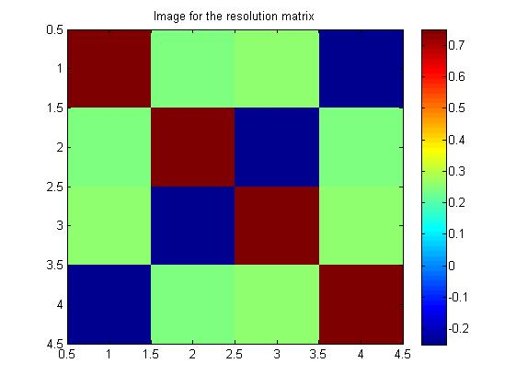

Resolution matrix is given by

|  |
| --- |
| 0.75 0.25 0.25 -0.25  0.25 0.75 -0.25 0.25  0.25 -0.25 0.75 0.25  -0.25 0.25 0.25 0.75 |

Vp VpT =

We can see the our values in matrix is not focused nearby diagonal. If it had been identity matrix then our model parameter would be exact and uniquely resolvd.

However in this case resolution matrix have values dispersed throughout the matrix so we can say that the model is not well resolved.

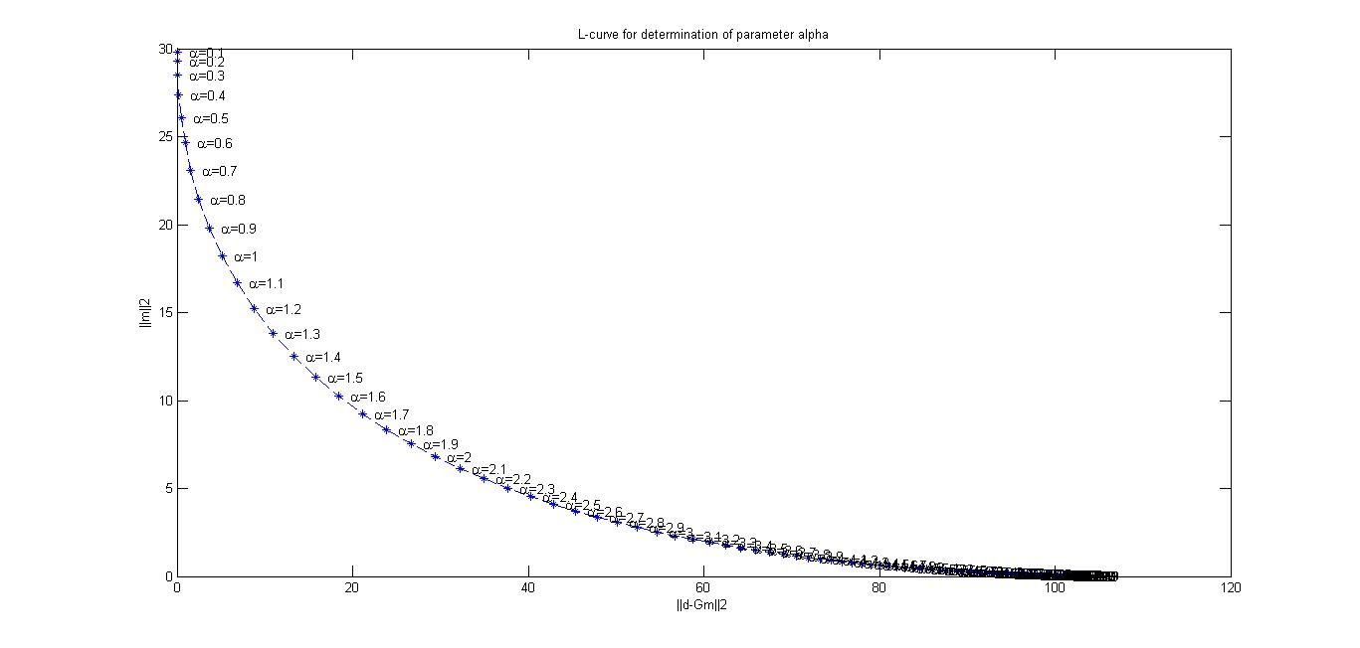**Solution 4)**

Optimum value of alpha from graph= 1.7 (roughly ).

If we compute the model parameter for it we get

note that original parameter were m=[ 1 2 3 4]

|  |  |  |  |  |
| --- | --- | --- | --- | --- |
| **Alpha** | **S1** | **S2** | **S3** | **S4** |
| **0.1** | 1.001 | 1.996 | 2.991 | 3.986 |
| **1** | 0.999 | 1.666 | 2.333 | 3.000 |
| **1.7 (optimum)** | 0.866 | 1.305 | 1.743 | 2.182 |
| **2** | 0.750 | 1.083 | 1.416 | 1.750 |