1

A. Write an SQL query to fetch “FIRST_NAME” from the Worker table using the alias name as <WORKER_NAME>.

Ans:-

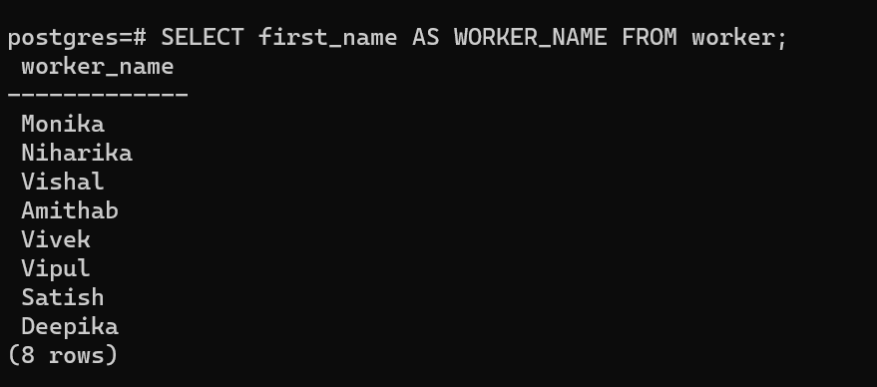

B. Write an SQL query to fetch “FIRST_NAME” from the Worker table in upper case.

Ans:-

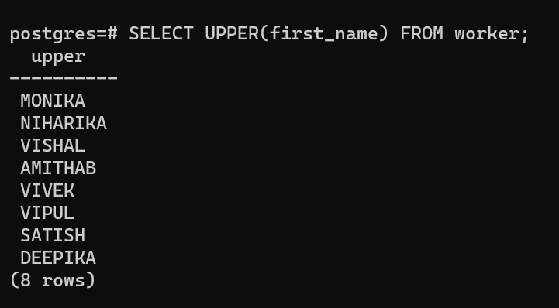

C. Write an SQL query to fetch unique values of DEPARTMENT from Worker table.

Ans:-

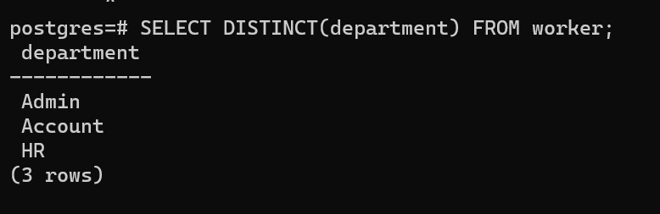

D. Write an SQL query to find the position of the alphabet (‘a’) in the first name column ‘Amitabh’ from the Worker table.

Notes:

* The INSTR method is case-sensitive by default.
* Using a Binary operator will make INSTR work as the case-sensitive function.

Ans:-

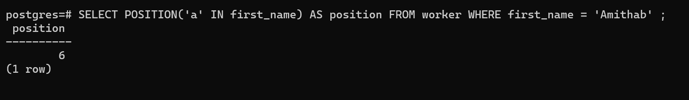

E. Write an SQL query to print the FIRST_NAME from the Worker table after removing white spaces from the right side.

Ans:-

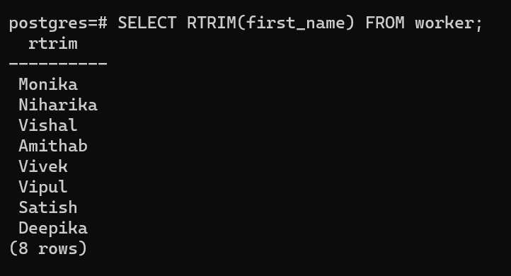

F. Write an SQL query to print the DEPARTMENT from the Worker table after removing white spaces from the left side.

Ans:-

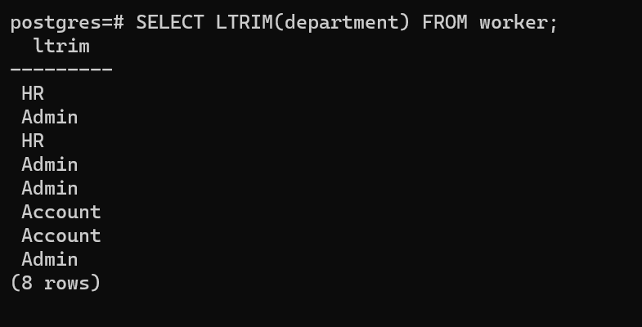

#### G. Write an SQL query to print the FIRST_NAME from the Worker table after replacing ‘a’ with ‘A’.

Ans:-

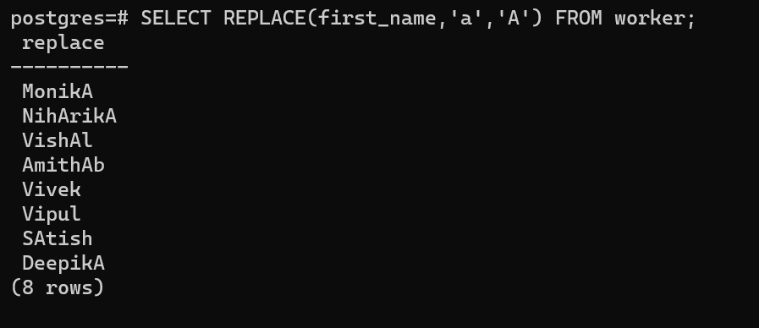

H. Write an SQL query to print the FIRST_NAME and LAST_NAME from the Worker table into a single column COMPLETE_NAME. A space char should separate them.

Ans:-

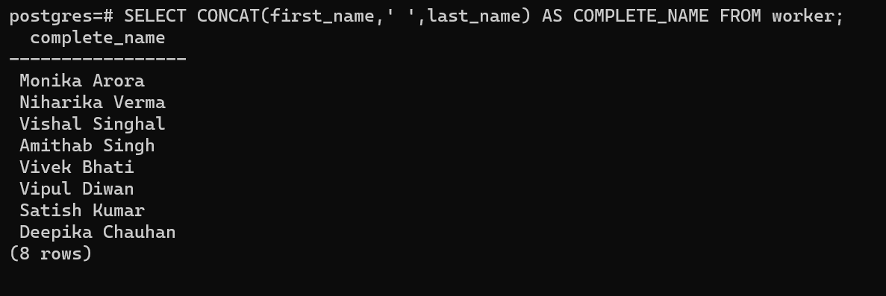

#### I. Write an SQL query to print all Worker details from the Worker table order by FIRST_NAME Ascending.

Ans:-

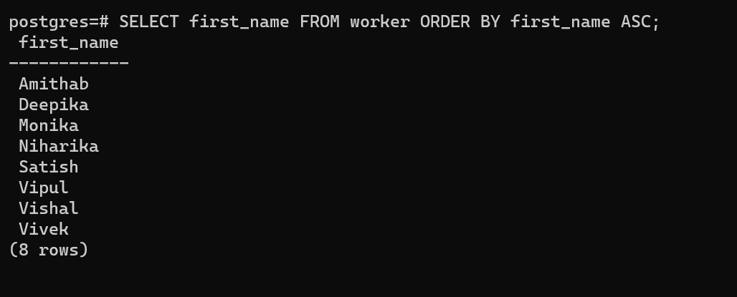

#### J. Write an SQL query to print all Worker details from the Worker table order by FIRST_NAME Ascending and DEPARTMENT Descending.

Ans:-

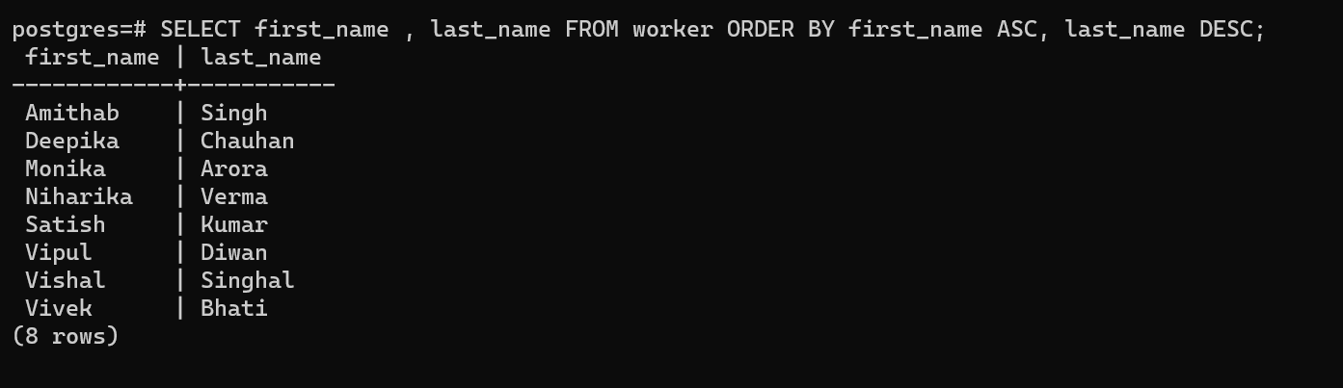

#### 

#### K. Write an SQL query to print details of the Workers whose FIRST_NAME contains ‘a’.

Ans:-

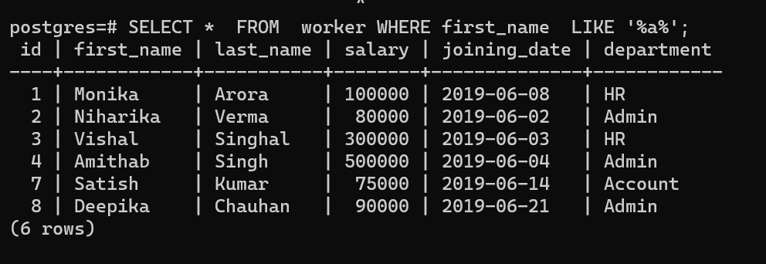

#### 

#### L. Write an SQL query to fetch worker names with salaries >= 50000 and <= 100000.

#### 

Ans:-

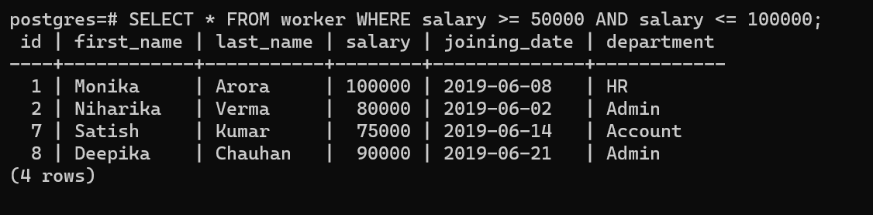

#### M. Write an SQL query to fetch the first 50% records from a table.

Ans:-

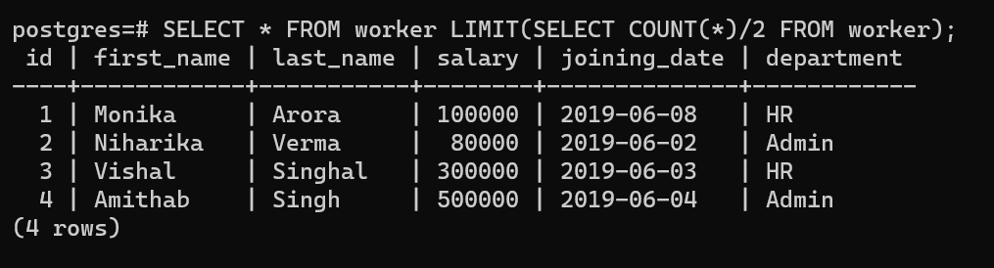

#### 

#### N. Write an SQL query to show the last record from a table.

Swapping the Values of first name and last name Columns in a worker table

