2

1. Write a query to find the third highest salary from the EmployeeInfo table ?

Ans:-

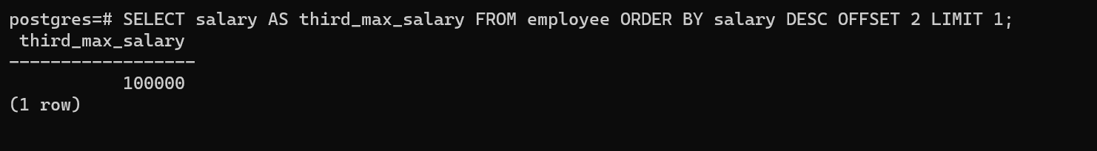

1. Write a query to find the third highest salary from the table without using TOP/LIMIT keyword ?

Ans:-

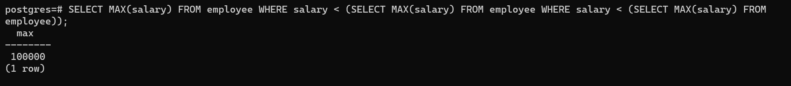

1. Write a query to find the duplicate row in a table ?

Ans:-

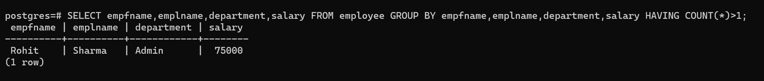

1. Write a query to calculate the even and odd records from a table ?

Ans:-

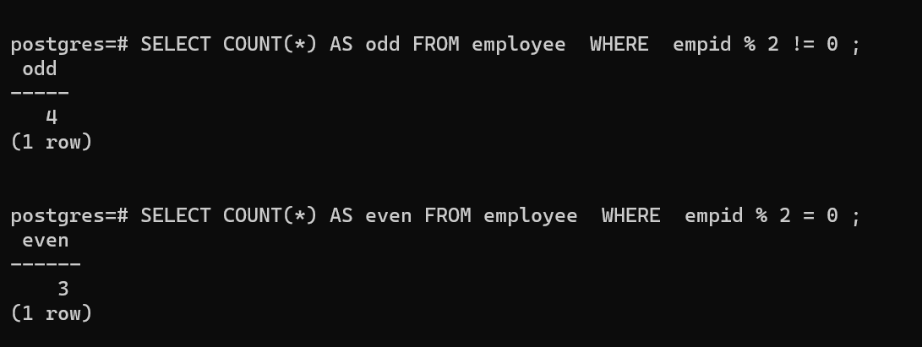

1. Write a query to display the first and last record from the EmployeeInfo table ?

Ans:-

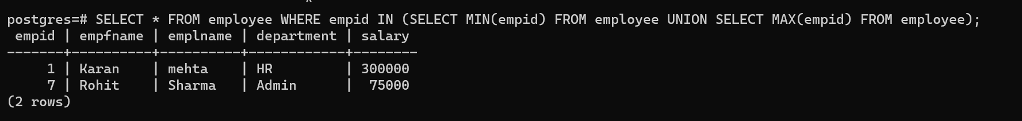

1. How do you copy all rows of a table using query ?

Ans:-

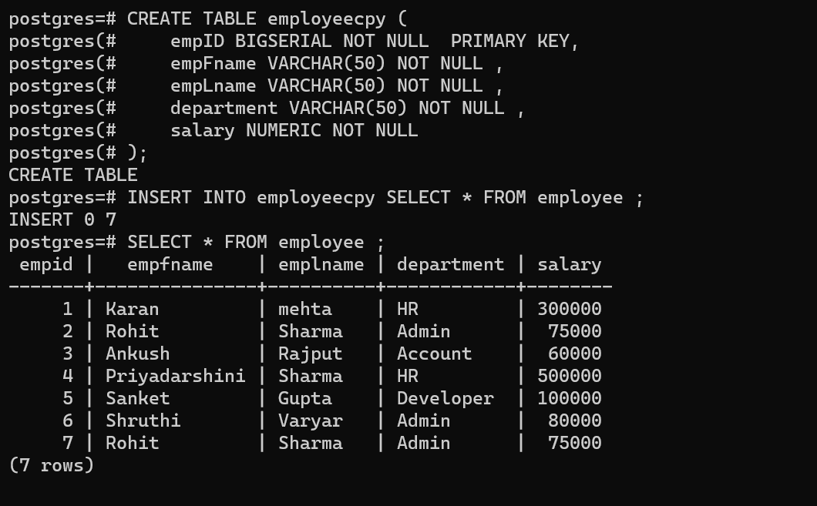

1. Write a query to retrieve the list of employees working in the same department ?

Ans:-

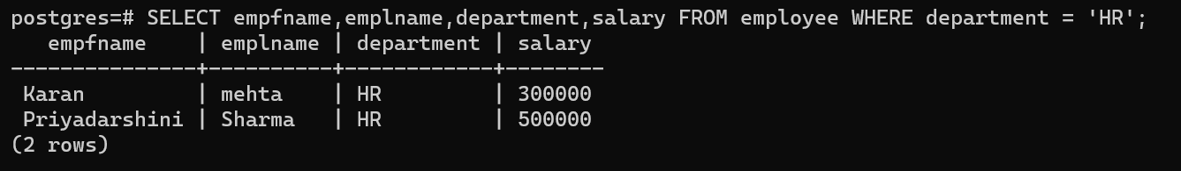

1. Write a query to retrieve the last 3 records from the EmployeeInfo table ?

Ans:-

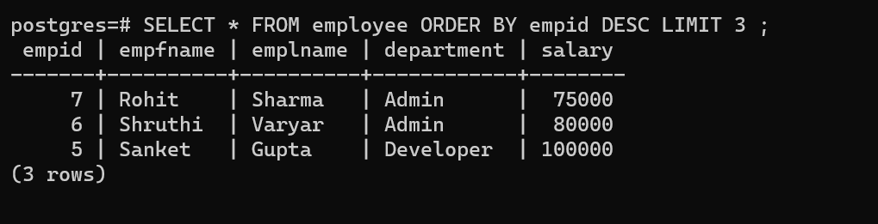

1. Write a query to fetch details of an employee whose EmpLname ends with an alphabet ‘A’ and contains five alphabets ?

Ans:-

