

**PORT KLANG FREE ZONE SDN BHD**

Free Zone, Port Klang Free Zone Sdn Bhd,

Jalan FZ2-P5/KS 12 Port Klang,

42920 Pulau Indah, Selangor

**BIDDER’S PROPOSAL FOR**

**SUPPLY, DELIVERY, INSTALLATION, CONFIGURATION,**

**TESTING, COMMISSIONING AND MAINTENANCE OF ENTERPRISE MANAGEMENT SYSTEM AT PORT KLANG FREE ZONE**

**TABLE OF CONTENTS**

**SECTION 1:** **Executive Summary** 3

**SECTION 2:** **Company Background** 3

**2.1** **Company Overview** 3

**2.2** **Core Business** 4

**2.3** **Technical Capability** 5

**2.4** **Company Experiences** 6

**2.5** **Overall Financial Overview** 6

**SECTION 3:** **Project Background** 7

**SECTION 4:** **Proposed Solution** 7

**SECTION 5:** **Project Scope of Work** 7

**5.1** **Scope of work** 7

**5.2** **Overall Work Program** 8

**5.3** **Project Deliverables** 8

**SECTION 6:** **Project Management Methodology** 11

**6.1** **Project Timeline – Detailed and High-Level Timeline** 11

**6.2** **Project Organizational Chart** 11

**6.3** **Proposed Steering Committee** 11

**6.4** **Proposed Working Committee** 12

**6.5** **Roles and Responsibilities of Project Team** 12

**6.6** **Project Implementation Milestone** 13

**SECTION 7:** **Project Implementation Schedule** 14

**SECTION 8:** **Helpdesk Management System** 14

**SECTION 9:** **Service Level Agreement (SLA)** 15

**SECTION 10:** **Support and Maintenance** 15

**SECTION 11:** **Schedule of Preventive and Corrective Maintenance** 15

# **Executive Summary**

Jsoft Solution Sdn Bhd (“JSOFT”) is honored by the opportunity to participate tender from Port Klang Free Zone Sdn Bhd (“PKFZ”) for the development and implementation of Enterprise Management System (EMS) and Portal & Smart Apps. JSOFT has been a trusted technology partner since 2013 wherein we have been serving through various technology solutions and support services.

Based on our understanding of your requirement specifications, we are confident about delivering the right system as expected by PKFZ within the timeline. The below mentioned person will be available for any queries and further discussion regarding this proposal.

**Mr. KUTTIKRISHNAN NAIR S /O MADHAVAN**

*OPERATION MANAGER*

Email: krish@jsoftsolution.com.my

Mobile (Malaysia): +60125509210

Office (Ara Damansara): +0383208198

# **Company Background**

## **2.1 Company Overview**

Jsoft Solution is a software house and consulting firm. We offer a creative professional and cost effective ONE STOP IT SOLUTIONS to fulfill business growth and varied IT needs of our clients. We build a solid and respected business by specializing in Developing Customized Solutions, and cloud-based products to enhance the end user experience.

Jsoft started its journey in ICT industry in 2013 and were registered by MOSTI and recognized by MDEC in 2014. We achieved our MSC status by 2016 and were appointed by MDEC as TSP for Smart Automation Grant & Digitalization Service Provider under Selangor Government, which started since last March 2020. We are supporting 300 over local SME companies on digitalization process in Malaysia.

We have digitized our business through MDEC’s transformation programs in various sectors and have been able to perform well by supporting local SME’s. Such business campaigns through various mediums, such as Webinars, Digital Marketing etc. has generated better revenue for the company and is continuously growing.

Jsoft is 100% local company, and we are mainly focused on supporting Malaysian candidates to support our operations, and we have been continuously working with the local universities to source the candidates from, such as MSU, APIIT, HELP, CITY. From our past recruitment drives, we support and train local students to build local talent pool.

We are committed to encourage local talents to work with us in our Digitalization & Web Development Projects and we are ready to provision training and support to local candidates through registered HRD Corp programs and increase their efficiency to next level.

Jsoft has diversified its business into educating ICT users on the job for their professional development & personal career growth. We have successfully launched our “Training & Development” department in 2021 and have been authorized by HRD Corp to conduct trainings.

Our service continuity roadmap encompasses complete IT Service Management based on ITIL framework to streamline our support processes to our clients. We perform Risk Assessment, Consultation, Service Delivery and Improve our services continuously in fast changing technology era.

Our SaaS products developed in-house customise application, digital signature, attendance system, POS and several business solution modules for our local SME’s which is efficient and cost-effective for Malaysian market. In addition to that we are e-Commerce platform developers, domain hosting and provision multiple web solutions.

Apart from that we are partnered with Microsoft, Google & Amazon Web Services to enhance our cloud-based SaaS platforms to provide better end user experience through our locally developed Application solutions. Our growing partnerships with tech giants shall prove fruitful to generate more employment opportunities for our Malaysian talent.

## **2.2 Core Business**

Here at Jsoft, we offer a creative, professional, and cost effective ONE STOP IT SOLUTIONS to fulfil business growth and varied IT needs of our clients. We build a solid and respected business by specializing in Developing Application, Providing IT Services, Data Centre Services, Networking and Maintenance and Support.

Our Expertise:

1. Software Development
2. Web Application Development
3. Third Party API Integration
4. Data mining / Data Warehousing
5. E-Commerce Solutions
6. Cloud Back Up
7. Logistics Solutions / Forwarders / Haulages

## **2.3 Technical Capability**

1. Staff Capabilities

|  |  |
| --- | --- |
| **Staff** | **Technical Capabilities** |
| Jerry | Experienced in Core PHP 7.4, CodeIgniter Frameworks, CakePHP Frameworks  Experienced in HMTL, CSS, JavaScript, JQuery, Bootstrap  Experienced in REST API, JSON  Experienced in Payment Gateways Instamojo, CCAvenue, PayuMoney payment  integration with web applications  Knowledge in version control system SVN, Github, Bitbucket, JIRA  Certification in Sun Certified Java Programmer |
| Shafeek Ajmal | Experienced in JAVA and .NET |
| Raja | Expertise in XAMARIN FORM, cross platform mobile app development, server side ASP.NET Core |

1. Other Unique Capabilities as Applicable

|  |  |
| --- | --- |
| **Year** | **Authorizing Body** |
| 2021 | Digitalization Service Provider |
| 2020 | Technology Service Provider |
| HRDF Corp |
| 2017 | Ministry of Finance (MOF) |
| 2016 | Multimedia Super Corridor (MSC) |
| 2015 | Malaysian Investment Development Authority |
| Malaysia Digital Economy Corporation (MDEC) |
| 2013 | The Minister of Science, Technology and Innovation |

## **2.4 Company Experiences**

1. Past Work Experiences

|  |  |  |  |  |
| --- | --- | --- | --- | --- |
| **No.** | **Client’s Name** | **Project Name** | **Brief Description of the Project Scope of Work** | **Year Completed** |
| 1 | e-estidotmys | Web Development /  ERP Solution | Web Development / IT  Consultant /  Mobile Apps | 2021 |
| 2 | Everest Integrated Logistics Sdn Bhd | ERP Solution / Accounting & Tax | ERP / Accounting & Tax | 2021 |
| 3 | Janacon Trading Sdn Bhd | Web Development / ERP Solution | Web Development / IT Consultant | 2020 |
| 4 | Pretty’s Food Corner | Electronic points-of-sale (ePOS) System – JPOS System | Electronic points-of-sale (ePOS) System – JPOS System | 2018 |

1. Client References

|  |  |
| --- | --- |
| **No.** | **Client’s Name** |
| 1 | Damco Logistics Malaysia Sdn Bhd |
| 2 | Eco Pest Asia Control |
| 3 | Everest Integrated Logistics Berhad |
| 4 | Janacon Trading Sdn Bhd |
| 5 | e-estidotmys |

## **2.5 Overall Financial Overview**

Please refer Appendix 12 & Appendix 13

# **Project Background**

Port Klang Free Zone Sdn Bhd (“PKFZ”) commercial and industrial zone established in 2004 in Malaysia. Back in 2019, PKFZ ranked as the 12th busiest port in the world. On top of that, PKFZ offers various investment incentives to investors such as tax exemptions on most products and services, subsidies, allowing wholly foreign owned enterprises, free repatriation of capital and profits and incentives for research and development, training and export.

In order to manage this big corporation more smoothly and more efficiently, PKFZ has open door for solution provider to fulfill their requirement to implement an Enterprise Management System at Port Klang Free Zone; which will help the corporation to run much more systematic than the method that are currently in use.

# **Proposed Solution**

According to the requirements provided by PKFZ, we are proposing a customized solution for the Enterprise Management System based on our current ready product, SmartOffice. This cloud-base, ready-to-use product that offers all the essentials functions and features needed for a business or organization to operate more smoothly and more efficient. SmartOffice is also customizable as per client’s request and needs.

# **Project Scope of Work**

## **Scope of work**

|  |  |
| --- | --- |
| **SCOPE** | **DESCRIPTION** |
| **EMS Project Manager** | To be responsible for general operations of the EMS and all related aspects including but not limited to the Operations, Integrations, Security and Support of the deployed systems. |
| **Integration Engineer** | To be responsible for the integration between different modules of EMS as well as the integration with outside systems connected with different EMS modules. |
| **Solution Developer** | To be responsible for prompt resolution of any defects, bugs and/or similar unwanted features that arises during the use of the system as well as act as Level 3 support provider for the solution. |
| **Database Administrator** | To be responsible for regular database maintenance and management and manage all security, roles, access and similar maintainable tasks required for upkeep of the EMS. |
| **Cyber Security In-charge** | To be responsible for the security and safety of deployed systems and assets in the cloud as well as related on-premise systems required to keep EMS running with optimal security and performance. |
| **EMS Project Administrator** | To be responsible for managing all the resources, liaising with the PKFZ IT department and assisting EMS Project Manager to generate monthly maintenance report and quarterly maintenance meetings with PKFZ users. |
| **Support Engineers** | Level 1 and Level 2 support engineers responsible for supporting PKFZ users and provides prompt resolution of any support related queries and liaise with Level 3 support provider whenever required. |

## **Overall Work Program**

|  |  |  |
| --- | --- | --- |
| **#** | **Description** | **Time** |
| 1 | Requirement Gathering | 1 Month |
| 2 | Design and Development | 3 Month |
| 3 | Code Review | 3 Month |
| 4 | System Integration Testing (UAT Env.) | 2 Month |
| 5 | User Acceptance Testing | 2 Month |
| 6 | System Integration Testing (Prod Env.) | 2 Month |
| 7 | Penetration Test | 2 Month |
| 8 | Pre-Go | 2 Month |
| 9 | Production | 1 Month |

## **Project Deliverables**

Based on the requirement provided by PKFZ, below are the deliverables for this project:

* **Enterprise Management System**
  + Customer, Management and Liaison (CML) Module
  + Procurement module
  + Administration Module
  + Engineering Module
  + Safety, Health and environment (SHE) Module
  + Inspection and surveying Application with EMS
  + Integrated Calendar management Module
  + Integrated Inventory Management System
  + Integrated Workflow Approval and rules management
  + Document management System
  + Integrated Digital Signatures with EMS
  + Authentication and authorization System
  + Financial System Integration (API)
  + Payroll System Integration (API)
* **Portals and Smart Apps**
  + Enterprise Portal and Smart Apps
  + Tenant’s Portal and Smart Apps
  + Supplier’s and Contractor’s Portal and Smart Apps
  + Public Portal and Smart Apps

**Diagram 1: High-level system diagram**

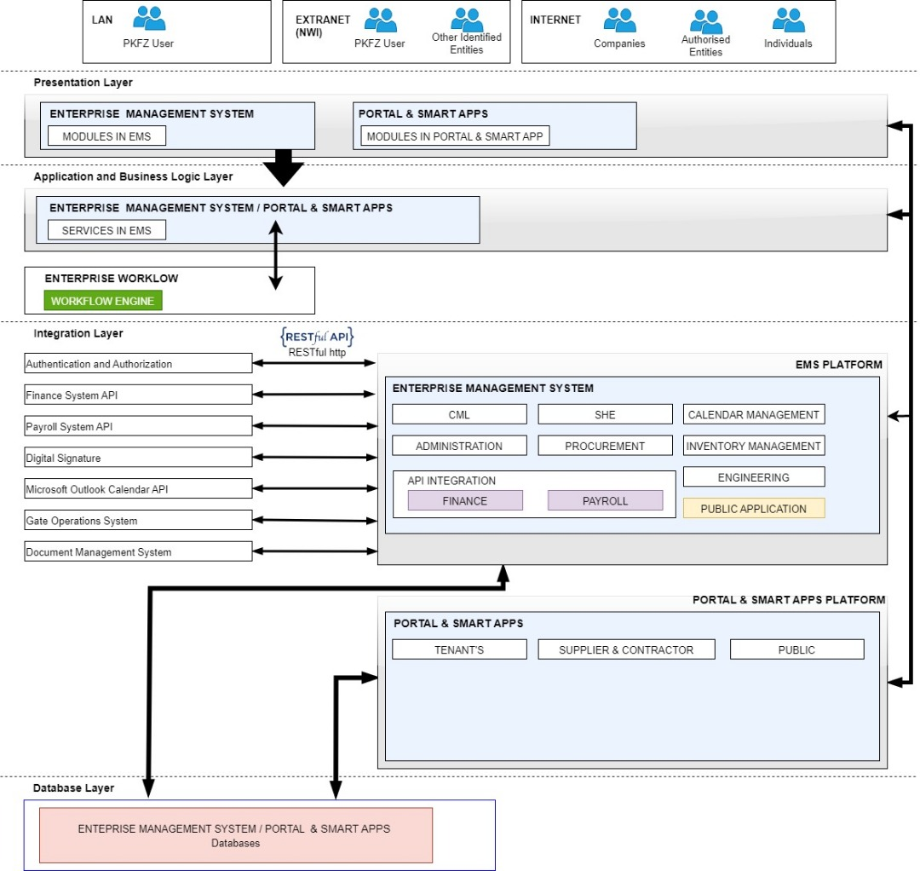

**Diagram 2: Infra Scalability Logical Design**

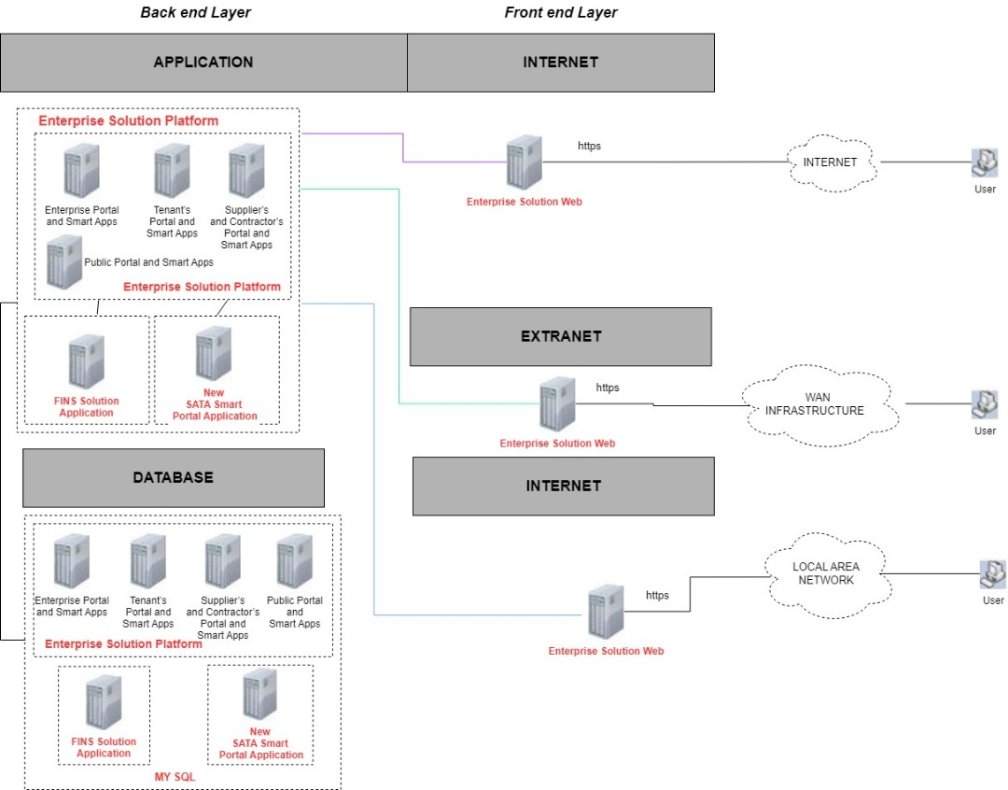

***Diagram 3: Enterprise Portal Authentication & Authorisation Process Detail***

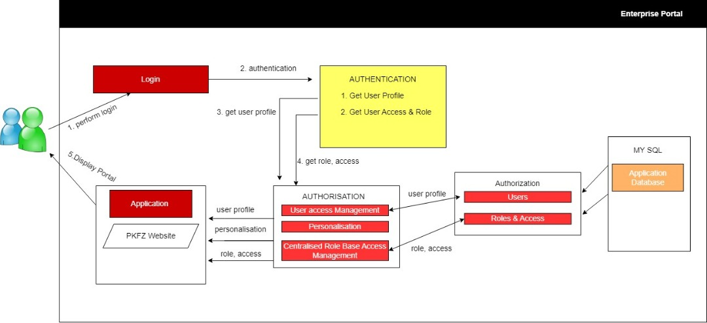

# **Project Management Methodology**

## **Project Timeline – Detailed and High-Level Timeline**

|  |  |  |  |  |  |  |  |  |  |  |  |  |  |  |  |  |  |  |  |  |  |  |  |  |  |  |  |  |
| --- | --- | --- | --- | --- | --- | --- | --- | --- | --- | --- | --- | --- | --- | --- | --- | --- | --- | --- | --- | --- | --- | --- | --- | --- | --- | --- | --- | --- |
| **Job**  **Description** | **1 Month** | | | | **2 Month** | | | | **3 Month** | | | | **4 Month** | | | | | **5 Month** | | | | **6 Month** | | | | | | |
| Weeks | 1 | 2 | 3 | 4 | 1 | 2 | 3 | 4 | 1 | 2 | 3 | 4 | | 1 | 2 | 3 | 4 | | 1 | 2 | 3 | | 4 | 1 | 2 | 3 | 4 |
| Requirement Gathering |  |  |  |  |  |  |  |  |  |  |  |  | |  |  |  |  | |  |  |  | |  |  |  |  |  |
| Design &  Development |  |  |  |  |  |  |  |  |  |  |  |  | |  |  |  |  | |  |  |  | |  |  |  |  |  |
| Implementation |  |  |  |  |  |  |  |  |  |  |  |  | |  |  |  |  | |  |  |  | |  |  |  |  |  |
| Testing & report submission & Training |  |  |  |  |  |  |  |  |  |  |  |  | |  |  |  |  | |  |  |  | |  |  |  |  |  |

## **Project Organizational Chart**

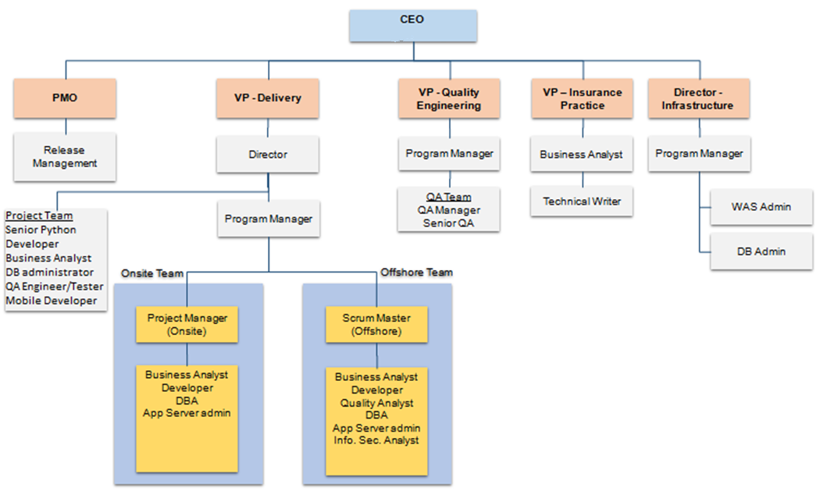

## **Proposed Steering Committee**

|  |  |
| --- | --- |
| **Name** | **Role** |
| Kuttikrisnan Nair A/L Madhavan | Project Director |
| Letchumy A/P Krishanan | Project Coordinator |
| Bilal Ahmad Wani | Project Manager |
| Devika | Senior Technical Lead |

## **Proposed Working Committee**

|  |  |
| --- | --- |
| **Name** | **Role** |
| Nor Amir Hakimi Bin Norzali | Senior System Analyst |
| Raviraja | Senior Programmer |
| Tan Kong Zhi | Website Development |
| Devika | Senior Technical Lead |
| Bilal Ahmad Wani | Project Manager |

## **Roles and Responsibilities of Project Team**

|  |  |
| --- | --- |
| **Role** | **Responsibilities** |
| **Project Manager** | * Single point of contact, manage escalations, estimation, Agile planning etc... * Monitor progress, conducts periodic reviews, consolidates and reports status and provide solution on issue. * Plan, govern and oversee the successful delivery. |
| **Lead/Scrum Master** | * Manage day to day activities of the offshore project team. * Ensure project delivery within the stipulated timeline and scope to SIT and UAT. * Works closely with Business and IT to highlight any project issues. * Design the Application Architecture, Integration, Security and Deployment. |
| **Business Analyst (BA)** | * Conduct system study and functional spec document (FSD) preparation * Capture User requirements into Software Requirements Specifications. * Ensure the software meets the User Requirements and get client sign-off |
| **UI Designer** | * Gathering and evaluating user requirements wrt GUI * Designing graphic user interface elements, like menus, tabs and widgets. * Make sure UI design are browser compatible |
| **Developer** | * Development and Unit Testing of application * Code review, Bug Fixing, Technical Support etc.. * Fix issues that occur during DEV, SIT, UAT (non-production environments) |
| **Quality Analyst** | * Test strategy, Test Plan, Test Case and Test Data preparation. * System testing, Integration Testing, Regression Testing. * Ensure the delivery meets the preset quality standards. |
| **Continuous Integration and**  **Deployment (CICD)** | * Implementation DevOps * Version Control Management * Jenkins Configuration for CI / CD * Client side environment setup / deployments. * Delivering the releases to clients. |
| **DBA** | * Responsible for database design, installation, configuration and DB related activities * Performance tuning, best practices etc.. |
| **App Server Admin** | * Application server and web server configuration * Application server profile setup * Application deployment to web and app server |
| **Info Security Analyst** | * Participation in the design to ensure security requirements are taken care * Security review of application and ensure the closure of all the findings * Ensure the deliver meets the preset security standards |

***Notes:*** *Resource plan given above is as per high level understanding and actual may vary subject to changes during detailed study.*

## **Project Implementation Milestone**

The Hybrid Agile Development Methodology will be used in efforts to help PKFZ with the deployment of its Enterprise Management System (EMS) at Port Klang Free Zone (PKFZ).

1. **Hybrid Agile Methodology Introduction**

Hybrid Agile methodology is an approach of a mix of both waterfall and agile module. A standalone Agile methodology follows a strict process and iteration cycle whereas the hybridization of agile and waterfall will offer a more flexible yet disciplined timeline for iteration cycles which more effective in changing situations.

In this proposed development, it involves multivendor (JSOFT Solution team and Resource team) as well as an independent agile team (PKFZ team) cannot run all the stages in Agile in order to achieve project targets in a dedicated timeline. Thus, requirements gathering and user acceptance testing are performed using a waterfall model whereas vendors follow the agile methodology for design, code, and testing.

1. **Implementation of Hybrid Agile Methodology**

A Hybrid agile model uses part of Waterfall Model and part of the Agile Model. The phases that will involve in Waterfall Model are requirement planning, analysis and design. Finally, deployment phase will take place for deployment and training. The complete phases of Hybrid agile model are shown below.

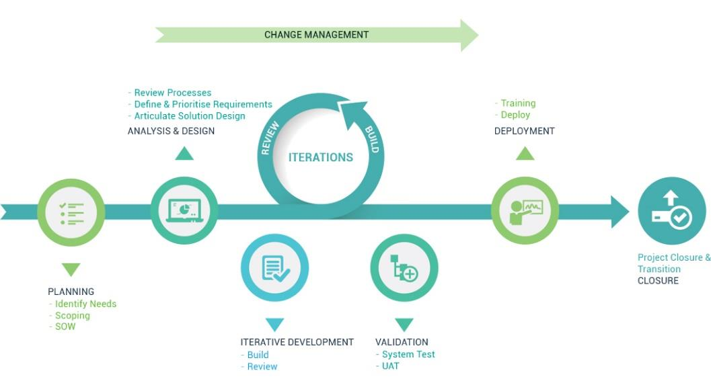

# **Project Implementation Schedule**

|  |  |  |  |  |  |  |  |
| --- | --- | --- | --- | --- | --- | --- | --- |
| **Delivery phase** | **Activities** | **M1** | **M2** | **M3** | **M4** | **M5** | **M6** |
| **Enterprise Management System (EMS)**  **&**  **Portal and Smart Apps** |
| **Requirement study & sign off** |  |  |  |  |  |  |
| **Design and development** |  |  |  |  |  |  |
| **Testing** |  |  |  |  |  |  |
| **Code Review** |  |  |  |  |  |  |
| **SIT(UAT)** |  |  |  |  |  |  |
| **UAT** |  |  |  |  |  |  |
| **SIT(Prod.)** |  |  |  |  |  |  |
| **Penetration Testing** |  |  |  |  |  |  |
| **Pre-Go** |  |  |  |  |  |  |
| **Go Live** |  |  |  |  |  |  |
| **Post ProductionSupport** |  |  |  |  |  |  |

# **Helpdesk Management System**

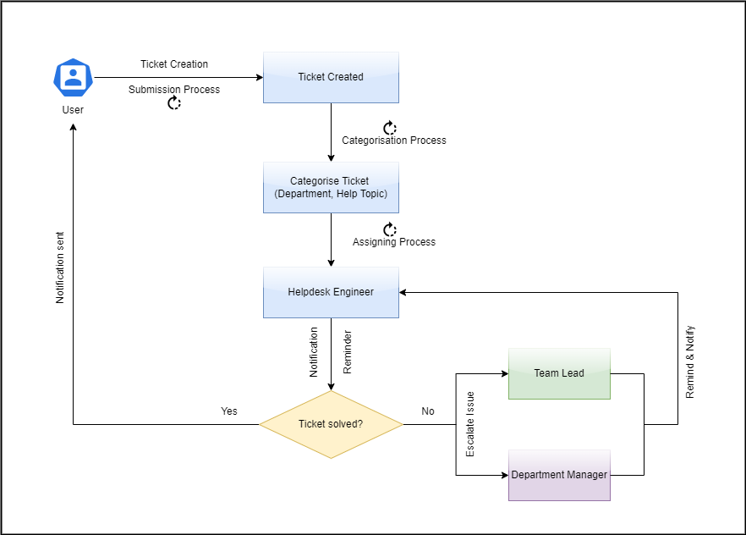

# **Service Level Agreement (SLA)**

*\*Please refer Appendix 16*

# **Support and Maintenance**

*\*Please refer Appendix 15*

# **Schedule of Preventive and Corrective Maintenance**

*\*Please refer Appendix 15*