**website Designing**

**<!-- Navigation bar -->**

**<nav class="navbar navbar-expand-lg navbar-dark bg-dark">**

**<div class="container">**

**<a class="navbar-brand" href="#">My Shop</a>**

**<button class="navbar-toggler" type="button" data-bs-toggle="collapse" data-bs-target="#navbarNav" aria-controls="navbarNav" aria-expanded="false" aria-label="Toggle navigation">**

**<span class="navbar-toggler-icon"></span>**

**</button>**

**<div class="collapse navbar-collapse" id="navbarNav">**

**<ul class="navbar-nav">**

**<li class="nav-item">**

**<a class="nav-link active" aria-current="page" href="#">Home</a>**

**</li>**

**<li class="nav-item">**

**<a class="nav-link" href="#">Products</a>**

**</li>**

**<li class="nav-item">**

**<a class="nav-link" href="#">Contact Us</a>**

**</li>**

**</ul>**

**</div>**

**</div>**

**</nav>**

**Complete source code**

<!DOCTYPE html>

<html lang="en">

<head>

    <meta charset="UTF-8">

    <meta name="viewport" content="width=device-width, initial-scale=1.0">

    <meta http-equiv="X-UA-Compatible" content="ie=edge">

    <title>Shopping Website</title>

    <!-- Bootstrap CSS -->

    <link rel="stylesheet" href="https://cdnjs.cloudflare.com/ajax/libs/bootstrap/5.0.0/css/bootstrap.min.css" integrity="sha512-DrlPX/W0tLquL/GBgj0nU5sb7NFUZKtcJzF0LI7XoZsNgv5fSL3ZxvHbt9xXZ8NVw77BG+Pvd7Ee6gWZ4y6Fvg==" crossorigin="anonymous" referrerpolicy="no-referrer" />

</head>

<body>

    <!-- Navigation bar -->

      <!-- Navigation bar -->

      <nav class="navbar navbar-expand-lg navbar-dark bg-dark">

        <div class="container">

            <a class="navbar-brand" href="#">My Shop</a>

            <button class="navbar-toggler" type="button" data-bs-toggle="collapse" data-bs-target="#navbarNav" aria-controls="navbarNav" aria-expanded="false" aria-label="Toggle navigation">

                <span class="navbar-toggler-icon"></span>

            </button>

            <div class="collapse navbar-collapse" id="navbarNav">

                <ul class="navbar-nav">

                    <li class="nav-item">

                        <a class="nav-link active" aria-current="page" href="#">Home</a>

                    </li>

                    <li class="nav-item">

                        <a class="nav-link" href="#">Products</a>

                    </li>

                    <li class="nav-item">

                        <a class="nav-link" href="#">Contact Us</a>

                    </li>

                </ul>

            </div>

        </div>

    </nav>

    <!-- Homepage section -->

    <section class="container py-5">

        <div class="row">

            <div class="col-lg-6">

                <h1>Welcome to our Shopping Website</h1>

                <p>Shop for a wide range of products from the comfort of your home.</p>

                <a href="#" class="btn btn-primary">Shop Now</a>

            </div>

            <div class="col-lg-6">

                <img src="https://picsum.photos/id/237/600/400" alt="Homepage Image" class="img-fluid">

            </div>

        </div>

    </section>

    <!-- Products section -->

    <section class="container py-5">

        <h2 class="text-center mb-4">Our Products</h2>

        <div class="row">

            <div class="col-lg-4 mb-4">

                <div class="card">

                    <img src="https://picsum.photos/id/1025/300/200" alt="Product Image" class="card-img-top">

                    <div class="card-body">

                        <h5 class="card-title">Product 1</h5>

                        <p class="card-text">Lorem ipsum dolor sit amet, consectetur adipiscing elit.</p>

                        <a href="#" class="btn btn-primary">Buy Now</a>

                    </div>

                </div>

            </div>

            <div class="col-lg-4 mb-4">

                <div class="card">

                    <img src="https://picsum.photos/id/1040/300/200" alt="Product Image" class="card-img-top">

                    <div class="card-body">

                        <h5 class="card-title">Product 2</h5>

                        <p class="card-text">Lorem ipsum dolor sit amet, consectetur adipiscing elit.</p>

                        <a href="#" class="btn btn-primary">Buy Now</a>

                    </div>

                </div>

            </div>

            <div class="col-lg-4 mb-4">

                <div class="card">

                    <img src="https://picsum.photos/id/1060/300/200" alt="Product Image" class="card-img-top">

                    <div class="card-body">

                        <h5 class="card-title">Product 3</h5>

                        <p class="card-text">Lorem ipsum dolor sit amet, consectetur adipiscing elit.</p>

                        <a href="#" class="btn btn-primary">Buy Now</a>

                    </div>

                </div>

            </div>

        </div>

    </section>

    <!-- Contact section -->

    <section class="container py-5">

        <h2 class="text-center mb-4">Contact Us</h2>

        <div class="row justify-content-center">

            <div class="col-lg-6">

                <form>

                    <div class="mb-3">

                        <label for="name" class="form-label">Name</label>

                        <input type="text" class="form-control" id="name">

                    </div>

                    <div class="mb-3">

                        <label for="email" class="form-label">Email address</label>

                        <input type="email" class="form-control" id="email" aria-describedby="emailHelp">

                        <div id="emailHelp" class="form-text">We'll never share your email with anyone else.</div>

                    </div>

                    <div class="mb-3">

                        <label for="message" class="form-label">Message</label>

                        <textarea class="form-control" id="message" rows="3"></textarea>

                    </div>

                    <button type="submit" class="btn btn-primary">Submit</button>

                </form>

            </div>

        </div>

    </section>

    <!-- Bootstrap JS -->

    <script src="https://cdnjs.cloudflare.com/ajax/libs/bootstrap/5.0.0/js/bootstrap.bundle.min.js" integrity="sha512-AasSs5m7l+RvNJ9/L90ztWETSLWizF9tf6ZU9OznNE+s7SvTjV6byBAsFqteGvIIQ55vlZt+4sm5+I69q8JyqQ==" crossorigin="anonymous" referrerpolicy="no-referrer"></script>

</body>

</html>

**Details:**

**In this code, we have added the nav element with the class navbar. Inside the nav element, we have added a div with the class container. Inside this div, we have added a a element with the class navbar-brand. This will display the logo or name of our website.**

**We have also added a button element with the class navbar-toggler. This button will be used to toggle the navigation menu on smaller screens. The data-bs-toggle and data-bs-target attributes are used to specify the target element that will be toggled. In this case, we have specified the navbarNav element.**

**Inside the navbar-collapse class, we have added a ul element with the class navbar-nav. This will contain our navigation links. We have added three li elements, each with the class nav-item. Inside each li element, we have added a a element with the class nav-link. These will be our actual navigation links.**

**With these changes, we have added a complete shopping website in HTML using Bootstrap, with a navigation bar and several sections for displaying products and a contact form.**

**Add css**

/* Global styles */

body {

font-family: Arial, sans-serif;

}

/* Navigation bar styles */

.navbar {

background-color: #343a40;

}

.navbar-brand {

font-size: 1.5rem;

font-weight: bold;

}

.navbar-nav .nav-link {

font-size: 1.2rem;

}

.navbar-toggler-icon {

color: #fff;

}

/* Hero section styles */

.hero {

background-color: #f8f9fa;

padding: 100px 0;

}

.hero h1 {

font-size: 3.5rem;

font-weight: bold;

text-align: center;

}

.hero p {

font-size: 1.5rem;

text-align: center;

margin-top: 30px;

}

/* Products section styles */

.products {

padding: 50px 0;

}

.products h2 {

font-size: 2.5rem;

font-weight: bold;

text-align: center;

}

.card {

box-shadow: 0 4px 8px 0 rgba(0,0,0,0.2);

transition: 0.3s;

border-radius: 5px;

margin-bottom: 30px;

}

.card:hover {

box-shadow: 0 8px 16px 0 rgba(0,0,0,0.2);

}

.card-img-top {

border-top-left-radius: 5px;

border-top-right-radius: 5px;

}

.card-body {

text-align: center;

}

.card-title {

font-size: 1.5rem;

font-weight: bold;

margin-bottom: 10px;

}

.card-text {

font-size: 1.2rem;

margin-bottom: 10px;

}

/* Contact section styles */

.container {

margin-top: 50px;

margin-bottom: 100px;

}

.contact-form {

background-color: #f8f9fa;

padding: 50px;

border-radius: 5px;

box-shadow: 0 4px 8px 0 rgba(0,0,0,0.2);

}

.form-label {

font-size: 1.2rem;

font-weight: bold;

}

.form-control {

font-size: 1.2rem;

padding: 10px;

margin-bottom: 20px;

}

.form-text {

font-size: 1rem;

}

**Details:**

In this code, we have added styles for various sections of the website, including the navigation bar, hero section, products section, and contact form. We have used classes to target specific elements and added styles to adjust the font sizes, colors, spacing, and box shadows.

You can add this CSS code to a separate file and link it in your HTML code using the link element, like this:

**Complete code with css and bootstrap**

<!DOCTYPE html>

<html lang="en">

<head>

    <meta charset="UTF-8">

    <meta name="viewport" content="width=device-width, initial-scale=1.0">

    <meta http-equiv="X-UA-Compatible" content="ie=edge">

    <title>Shopping Website</title>

    <style>

        /* Global styles */

body {

    font-family: Arial, sans-serif;

    /* background-color: yellowgreen; */

}

/* Navigation bar styles */

.navbar {

    background-color: #eaf0f5;

}

.navbar-brand {

    font-size: 1.5rem;

    font-weight: bold;

}

.navbar-nav .nav-link {

    font-size: 1.2rem;

}

.navbar-toggler-icon {

    color: #fff;

}

/* Hero section styles */

.hero {

    background-color: #f8f9fa;

    padding: 100px 0;

}

.hero h1 {

    font-size: 3.5rem;

    font-weight: bold;

    text-align: center;

}

.hero p {

    font-size: 1.5rem;

    text-align: center;

    margin-top: 30px;

}

/* Products section styles */

.products {

    padding: 50px 0;

}

.products h2 {

    font-size: 2.5rem;

    font-weight: bold;

    text-align: center;

}

.card {

    box-shadow: 0 4px 8px 0 rgba(0,0,0,0.2);

    transition: 0.3s;

    border-radius: 5px;

    margin-bottom: 30px;

}

.card:hover {

    box-shadow: 0 8px 16px 0 rgba(0,0,0,0.2);

}

.card-img-top {

    border-top-left-radius: 5px;

    border-top-right-radius: 5px;

}

.card-body {

    text-align: center;

}

.card-title {

    font-size: 1.5rem;

    font-weight: bold;

    margin-bottom: 10px;

}

.card-text {

    font-size: 1.2rem;

    margin-bottom: 10px;

}

/* Contact section styles */

.container {

    margin-top: 50px;

    margin-bottom: 100px;

}

.contact-form {

    background-color: #f8f9fa;

    padding: 50px;

    border-radius: 5px;

    box-shadow: 0 4px 8px 0 rgba(0,0,0,0.2);

}

.form-label {

    font-size: 1.2rem;

    font-weight: bold;

}

.form-control {

    font-size: 1.2rem;

    padding: 10px;

    margin-bottom: 20px;

}

.form-text {

    font-size: 1rem;

}

    </style>

    <!-- Bootstrap CSS -->

    <link rel="stylesheet" href="https://cdnjs.cloudflare.com/ajax/libs/bootstrap/5.0.0/css/bootstrap.min.css" integrity="sha512-DrlPX/W0tLquL/GBgj0nU5sb7NFUZKtcJzF0LI7XoZsNgv5fSL3ZxvHbt9xXZ8NVw77BG+Pvd7Ee6gWZ4y6Fvg==" crossorigin="anonymous" referrerpolicy="no-referrer" />

<!-- <link rel="stylesheet" href="/index.css"> -->

<!-- Bootstrap CSS -->

<link rel="stylesheet" href="https://cdnjs.cloudflare.com/ajax/libs/bootstrap/5.0.0/css/bootstrap.min.css" integrity="sha512-n/PkuM0rVjd2vdAVv3jiA7eI5CpO9kL1hQEvwfeD/vdPlYs+jXzM78UcJNt3YAvJ3TtBc+Xl1zI1kg+j/bWn5w==" crossorigin="anonymous" referrerpolicy="no-referrer" />

</head>

<body>

    <!-- Navigation bar -->

      <!-- Navigation bar -->

      <nav class="navbar navbar-expand-lg navbar-dark bg-dark">

        <div class="container">

            <a class="navbar-brand" href="#">My Shop</a>

            <button class="navbar-toggler" type="button" data-bs-toggle="collapse" data-bs-target="#navbarNav" aria-controls="navbarNav" aria-expanded="false" aria-label="Toggle navigation">

                <span class="navbar-toggler-icon"></span>

            </button>

            <div class="collapse navbar-collapse" id="navbarNav">

                <ul class="navbar-nav">

                    <li class="nav-item">

                        <a class="nav-link active" aria-current="page" href="#">Home</a>

                    </li>

                    <li class="nav-item">

                        <a class="nav-link" href="#">Products</a>

                    </li>

                    <li class="nav-item">

                        <a class="nav-link" href="#">Contact Us</a>

                    </li>

                </ul>

            </div>

        </div>

    </nav>

    <!-- Homepage section -->

    <section class="container py-5">

        <div class="row">

            <div class="col-lg-6">

                <h1>Welcome to our Shopping Website</h1>

                <p>Shop for a wide range of products from the comfort of your home.</p>

                <a href="#" class="btn btn-primary">Shop Now</a>

            </div>

            <div class="col-lg-6">

                <img src="https://picsum.photos/id/237/600/400" alt="Homepage Image" class="img-fluid">

            </div>

        </div>

    </section>

    <!-- Products section -->

    <section class="container py-5">

        <h2 class="text-center mb-4">Our Products</h2>

        <div class="row">

            <div class="col-lg-4 mb-4">

                <div class="card">

                    <img src="https://picsum.photos/id/1025/300/200" alt="Product Image" class="card-img-top">

                    <div class="card-body">

                        <h5 class="card-title">Product 1</h5>

                        <p class="card-text">Lorem ipsum dolor sit amet, consectetur adipiscing elit.</p>

                        <a href="#" class="btn btn-primary">Buy Now</a>

                    </div>

                </div>

            </div>

            <div class="col-lg-4 mb-4">

                <div class="card">

                    <img src="https://picsum.photos/id/1040/300/200" alt="Product Image" class="card-img-top">

                    <div class="card-body">

                        <h5 class="card-title">Product 2</h5>

                        <p class="card-text">Lorem ipsum dolor sit amet, consectetur adipiscing elit.</p>

                        <a href="#" class="btn btn-primary">Buy Now</a>

                    </div>

                </div>

            </div>

            <div class="col-lg-4 mb-4">

                <div class="card">

                    <img src="https://picsum.photos/id/1060/300/200" alt="Product Image" class="card-img-top">

                    <div class="card-body">

                        <h5 class="card-title">Product 3</h5>

                        <p class="card-text">Lorem ipsum dolor sit amet, consectetur adipiscing elit.</p>

                        <a href="#" class="btn btn-primary">Buy Now</a>

                    </div>

                </div>

            </div>

        </div>

    </section>

    <!-- Contact section -->

    <section class="container py-5">

        <h2 class="text-center mb-4">Contact Us</h2>

        <div class="row justify-content-center">

            <div class="col-lg-6">

                <form>

                    <div class="mb-3">

                        <label for="name" class="form-label">Name</label>

                        <input type="text" class="form-control" id="name">

                    </div>

                    <div class="mb-3">

                        <label for="email" class="form-label">Email address</label>

                        <input type="email" class="form-control" id="email" aria-describedby="emailHelp">

                        <div id="emailHelp" class="form-text">We'll never share your email with anyone else.</div>

                    </div>

                    <div class="mb-3">

                        <label for="message" class="form-label">Message</label>

                        <textarea class="form-control" id="message" rows="3"></textarea>

                    </div>

                    <button type="submit" class="btn btn-primary">Submit</button>

                </form>

            </div>

        </div>

    </section>

    <!-- Bootstrap JS -->

    <script src="https://cdnjs.cloudflare.com/ajax/libs/bootstrap/5.0.0/js/bootstrap.bundle.min.js" integrity="sha512-AasSs5m7l+RvNJ9/L90ztWETSLWizF9tf6ZU9OznNE+s7SvTjV6byBAsFqteGvIIQ55vlZt+4sm5+I69q8JyqQ==" crossorigin="anonymous" referrerpolicy="no-referrer"></script>

</body>

</html>

**how to create a navigation tab with Bootstrap:**

<ul class="nav nav-tabs" id="myTab" role="tablist">

<li class="nav-item">

<a class="nav-link active" id="home-tab" data-toggle="tab" href="#home" role="tab" aria-controls="home" aria-selected="true">Home</a>

</li>

<li class="nav-item">

<a class="nav-link" id="profile-tab" data-toggle="tab" href="#profile" role="tab" aria-controls="profile" aria-selected="false">Profile</a>

</li>

<li class="nav-item">

<a class="nav-link" id="contact-tab" data-toggle="tab" href="#contact" role="tab" aria-controls="contact" aria-selected="false">Contact</a>

</li>

</ul>

<div class="tab-content" id="myTabContent">

<div class="tab-pane fade show active" id="home" role="tabpanel" aria-labelledby="home-tab">

<h1>Home</h1>

<p>Welcome to the home page!</p>

</div>

<div class="tab-pane fade" id="profile" role="tabpanel" aria-labelledby="profile-tab">

<h1>Profile</h1>

<p>This is your profile page.</p>

</div>

<div class="tab-pane fade" id="contact" role="tabpanel" aria-labelledby="contact-tab">

<h1>Contact</h1>

<p>Get in touch with us.</p>

</div>

</div>

**Details:**

In this example, we have created a navigation tab with three links: Home, Profile, and Contact. We have used the nav and nav-tabs classes to create the tab layout, and added the data-toggle and href attributes to each link to indicate which tab pane it should activate. The active class is added to the first link to indicate that it is currently selected.

The tab panes are created using the tab-content class, and each pane is given a unique ID using the id attribute. We have also used the fade class to add a fade-in effect when switching between tabs.

**Index3.html website improve**

<!DOCTYPE html>

<html lang="en">

<head>

    <!-- Bootstrap CSS -->

    <link rel="stylesheet" href="https://cdnjs.cloudflare.com/ajax/libs/bootstrap/5.0.0/css/bootstrap.min.css" integrity="sha512-n/PkuM0rVjd2vdAVv3jiA7eI5CpO9kL1hQEvwfeD/vdPlYs+jXzM78UcJNt3YAvJ3TtBc+Xl1zI1kg+j/bWn5w==" crossorigin="anonymous" referrerpolicy="no-referrer" />

    <!-- Custom CSS -->

    <link rel="stylesheet" href="custom.css" />

    <!-- <style>

        /* Global styles */

body {

    font-family: Arial, sans-serif;

    /* background-color: yellowgreen; */

}

/* Navigation bar styles */

.navbar {

    background-color: #e9ecf0;

}

.navbar-brand {

    font-size: 1.5rem;

    font-weight: bold;

}

.navbar-nav .nav-link {

    font-size: 1.2rem;

}

.navbar-toggler-icon {

    color: #fff;

}

/* Hero section styles */

.hero {

    background-color: #f8f9fa;

    padding: 100px 0;

}

.hero h1 {

    font-size: 3.5rem;

    font-weight: bold;

    text-align: center;

}

.hero p {

    font-size: 1.5rem;

    text-align: center;

    margin-top: 30px;

}

/* Products section styles */

.products {

    padding: 50px 0;

}

.products h2 {

    font-size: 2.5rem;

    font-weight: bold;

    text-align: center;

}

.card {

    box-shadow: 0 4px 8px 0 rgba(0,0,0,0.2);

    transition: 0.3s;

    border-radius: 5px;

    margin-bottom: 30px;

}

.card:hover {

    box-shadow: 0 8px 16px 0 rgba(0,0,0,0.2);

}

.card-img-top {

    border-top-left-radius: 5px;

    border-top-right-radius: 5px;

}

.card-body {

    text-align: center;

}

.card-title {

    font-size: 1.5rem;

    font-weight: bold;

    margin-bottom: 10px;

}

.card-text {

    font-size: 1.2rem;

    margin-bottom: 10px;

}

/* Contact section styles */

.container {

    margin-top: 50px;

    margin-bottom: 100px;

}

.contact-form {

    background-color: #f8f9fa;

    padding: 50px;

    border-radius: 5px;

    box-shadow: 0 4px 8px 0 rgba(0,0,0,0.2);

}

.form-label {

    font-size: 1.2rem;

    font-weight: bold;

}

.form-control {

    font-size: 1.2rem;

    padding: 10px;

    margin-bottom: 20px;

}

.form-text {

    font-size: 1rem;

}

    </style> -->

    <title>My Shopping Website</title>

</head>

<body>

    <!-- Navigation bar -->

    <nav class="navbar navbar-expand-lg navbar-dark bg-dark">

        <div class="container-fluid">

            <a class="navbar-brand" href="#">My Shop</a>

            <button class="navbar-toggler" type="button" data-bs-toggle="collapse" data-bs-target="#navbarNav" aria-controls="navbarNav" aria-expanded="false" aria-label="Toggle navigation">

                <span class="navbar-toggler-icon"></span>

            </button>

            <div class="collapse navbar-collapse" id="navbarNav">

                <ul class="navbar-nav ms-auto">

                    <li class="nav-item">

                        <a class="nav-link" href="#">Home</a>

                    </li>

                    <li class="nav-item">

                        <a class="nav-link" href="#">Products</a>

                    </li>

                    <li class="nav-item">

                        <a class="nav-link" href="#">Contact</a>

                    </li>

                </ul>

            </div>

        </div>

    </nav>

    <!-- Hero section -->

    <section class="hero">

        <div class="container">

            <h1>Welcome to My Shop</h1>

            <p>We offer a wide range of products to suit your needs.</p>

        </div>

    </section>

    <!-- Products section -->

    <section class="products">

        <div class="container">

            <h2>Our Products</h2>

            <div class="row">

                <div class="col-md-4">

                    <div class="card">

                        <img class="card-img-top" src="https://via.placeholder.com/300x200.png?text=Product+1" alt="Product 1">

                        <div class="card-body">

                            <h5 class="card-title">Product 1</h5>

                            <p class="card-text">This is a description of Product 1.</p>

                            <a href="#" class="btn btn-primary">Buy Now</a>

                        </div>

                    </div>

                </div>

                <div class="col-md-4">

                    <div class="card">

                        <img class="card-img-top" src="https://via.placeholder.com/300x200.png?text=Product+2" alt="Product 2">

                        <div class="card-body">

                            <h5 class="card-title">Product 2</h5>

                            <p class="card-text">This is a description of Product 2.</p>

                            <a href="#" class="btn btn-primary">Buy Now</a>

                        </div>

                    </div>

                </div>

                <div class="col-md-4">

                    <div class="card">

                        <img class="card-img-top" src="https://via.placeholder.com/300x200.png?text=Product+3" alt="Product 3">

                        <div class="card-body">

                            <h5 class="card-title">Product 3</h5>

                            <p class="card-text">This is a description of Product 3.</p>

                            <a href="#" class="btn btn-primary">Buy Now</a>

                        </div>

                    </div>

                </div>

            </div>

        </div>

    </section>

    <!-- Contact section -->

    <section class="contact">

        <div class="container">

            <h2>Contact Us</h2>

            <form>

                <div class="form-group">

                    <label for="name">Name</label>

                    <input type="text" class="form-control" id="name" placeholder="Enter your name">

                </div>

                <div class="form-group">

                    <label for="email">Email address</label>

                    <input type="email" class="form-control" id="email" placeholder="Enter your email">

                </div>

                <div class="form-group">

                    <label for="message">Message</label>

                    <textarea class="form-control" id="message" rows="5" placeholder="Enter your message"></textarea>

                </div>

                <button type="submit" class="btn btn-primary">Send Message</button>

            </form>

        </div>

    </section>

    <!-- Bootstrap JS -->

    <script src="https://cdnjs.cloudflare.com/ajax/libs/bootstrap/5.0.0/js/bootstrap.min.js" integrity="sha512-qhlZrxE4t1K/GW4zfuXKm1+JQjrz1fZKtGx/zgb4f6yBHuERG0sY/GTaJUE5Vq/QLqF0lGGbb3T5AKPZx9s+WQ==" crossorigin="anonymous" referrerpolicy="no-referrer"></script>

</body>

</html>

**Custom.css**

/* Global styles */

body {

    font-family: Arial, sans-serif;

    background-color: yellowgreen;

}

/* Navigation bar styles */

.navbar {

    background-color: #ecf1f5;

}

.navbar-brand {

    font-size: 1.5rem;

    font-weight: bold;

}

.navbar-nav .nav-link {

    font-size: 1.2rem;

}

.navbar-toggler-icon {

    color: #fff;

}

/* Hero section styles */

.hero {

    background-color: #f8f9fa;

    padding: 100px 0;

}

.hero h1 {

    font-size: 3.5rem;

    font-weight: bold;

    text-align: center;

}

.hero p {

    font-size: 1.5rem;

    text-align: center;

    margin-top: 30px;

}

/* Products section styles */

.products {

    padding: 50px 0;

}

.products h2 {

    font-size: 2.5rem;

    font-weight: bold;

    text-align: center;

}

.card {

    box-shadow: 0 4px 8px 0 rgba(0,0,0,0.2);

    transition: 0.3s;

    border-radius: 5px;

    margin-bottom: 30px;

}

.card:hover {

    box-shadow: 0 8px 16px 0 rgba(0,0,0,0.2);

}

.card-img-top {

    border-top-left-radius: 5px;

    border-top-right-radius: 5px;

}

.card-body {

    text-align: center;

}

.card-title {

    font-size: 1.5rem;

    font-weight: bold;

    margin-bottom: 10px;

}

.card-text {

    font-size: 1.2rem;

    margin-bottom: 10px;

}

/* Contact section styles */

.container {

    margin-top: 50px;

    margin-bottom: 100px;

}

.contact-form {

    background-color: #f8f9fa;

    padding: 50px;

    border-radius: 5px;

    box-shadow: 0 4px 8px 0 rgba(0,0,0,0.2);

}

.form-label {

    font-size: 1.2rem;

    font-weight: bold;

}

.form-control {

    font-size: 1.2rem;

    padding: 10px;

    margin-bottom: 20px;

}

.form-text {

    font-size: 1rem;

}

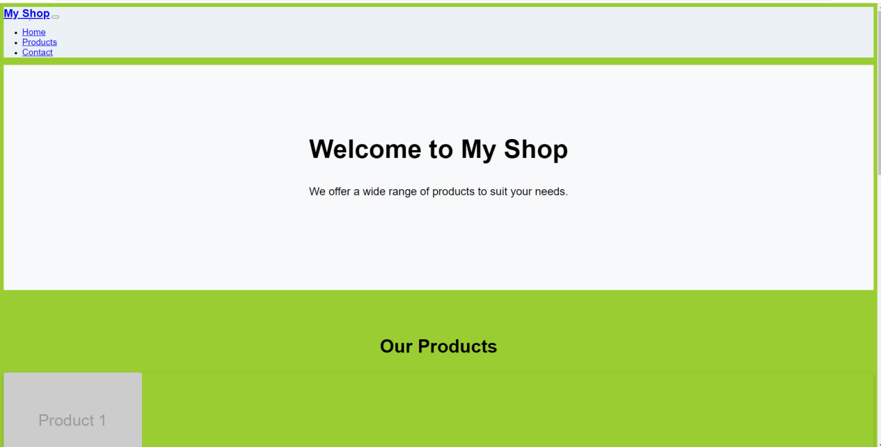

**Portfolio.html**

<!DOCTYPE html>

<html lang="en">

<head>

    <meta charset="UTF-8">

    <meta name="viewport" content="width=device-width, initial-scale=1.0">

    <meta http-equiv="X-UA-Compatible" content="ie=edge">

    <title>Ajman Ullah Khan | Portfolio</title>

    <!-- Bootstrap CSS -->

    <link rel="stylesheet" href="https://cdnjs.cloudflare.com/ajax/libs/bootstrap/5.0.0/css/bootstrap.min.css" integrity="sha512-y6gA8fNzifMAwPaVHJ2tzy1sMD7FYV79dPxjEg8ZcfeF5TvLkLsLlkytjK5TvGQax+uQUX8AKjVqKQwBr10FdA==" crossorigin="anonymous" referrerpolicy="no-referrer" />

    <!-- Custom CSS -->

    <link rel="stylesheet" href="portfolio.css">

</head>

<body>

    <!-- Nav bar -->

    <nav class="navbar navbar-expand-lg navbar-light bg-light">

        <div class="container-fluid">

            <a class="navbar-brand" href="#">Ajman Ullah Khan</a>

            <button class="navbar-toggler" type="button" data-bs-toggle="collapse" data-bs-target="#navbarNav" aria-controls="navbarNav" aria-expanded="false" aria-label="Toggle navigation">

                <span class="navbar-toggler-icon"></span>

            </button>

            <div class="collapse navbar-collapse" id="navbarNav">

                <ul class="navbar-nav">

                    <li class="nav-item">

                        <a class="nav-link active" aria-current="page" href="#about">About Me</a>

                    </li>

                    <li class="nav-item">

                        <a class="nav-link" href="#experience">Experience</a>

                    </li>

                    <li class="nav-item">

                        <a class="nav-link" href="#education">Education</a>

                    </li>

                    <li class="nav-item">

                        <a class="nav-link" href="#projects">Projects</a>

                    </li>

                    <li class="nav-item">

                        <a class="nav-link" href="#contact">Contact Me</a>

                    </li>

                </ul>

            </div>

        </div>

    </nav>

    <!-- About section -->

    <section id="about">

        <div class="container">

            <h2>About Me</h2>

            <p>Hi, I'm Ajman Ullah Khan, a Software Engineer at NUST CIPS. I have experience in web development, software engineering, and project management. I'm passionate about creating high-quality, user-friendly applications that solve real-world problems.</p>

            <p>In my free time, I enjoy hiking, playing soccer, and spending time with my family.</p>

        </div>

    </section>

    <!-- Experience section -->

    <section id="experience">

        <div class="container">

            <h2>Experience</h2>

            <div class="card">

                <div class="card-body">

                    <h5 class="card-title">Software Engineer, NUST CIPS</h5>

                    <h6 class="card-subtitle mb-2 text-muted">January 2020 - Present</h6>

                    <p class="card-text">At NUST CIPS, I develop web applications for clients in various industries, including healthcare and finance. I collaborate with a

                        team of developers, designers, and project managers to deliver high-quality products that meet client requirements.</p>

                    </div>

                    </div>

                    <div class="card mt-4">

                    <div class="card-body">

                    <h5 class="card-title">Software Engineer Intern, XYZ Company</h5>

                    <h6 class="card-subtitle mb-2 text-muted">June 2019 - December 2019</h6>

                    <p class="card-text">During my internship at XYZ Company, I gained experience in software development and worked on several projects using Java and React. I also collaborated with a team of developers to design and develop a mobile app for the company.</p>

                    </div>

                    </div>

                    </div>

                    </section>

                    <!-- Education section -->

<section id="education">

    <div class="container">

        <h2>Education</h2>

        <div class="card">

            <div class="card-body">

                <h5 class="card-title">Bachelor of Science in Computer Science, National University of Sciences and Technology (NUST)</h5>

                <h6 class="card-subtitle mb-2 text-muted">August 2016 - June 2020</h6>

                <p class="card-text">During my time at NUST, I learned about programming languages such as Java, Python, and C++. I also gained experience in database design, web development, and software engineering.</p>

            </div>

        </div>

    </div>

</section>

<!-- Projects section -->

<section id="projects">

    <div class="container">

        <h2>Projects</h2>

        <div class="card">

            <div class="card-body">

                <h5 class="card-title">Web Application for ABC Hospital</h5>

                <p class="card-text">As part of my role at NUST CIPS, I led the development of a web application for ABC Hospital that allows patients to book appointments online. The application was developed using React and Node.js, and was integrated with the hospital's existing patient management system.</p>

            </div>

        </div>

        <div class="card mt-4">

            <div class="card-body">

                <h5 class="card-title">Mobile App for XYZ Company</h5>

                <p class="card-text">During my internship at XYZ Company, I collaborated with a team of developers to design and develop a mobile app for the company. The app was developed using React Native and was integrated with the company's existing backend system.</p>

            </div>

        </div>

    </div>

</section>

<!-- Contact section -->

<section id="contact">

    <div class="container">

        <h2>Contact Me</h2>

        <form>

            <div class="form-group">

                <label for="name">Name</label>

                <input type="text" class="form-control" id="name" placeholder="Enter your name">

            </div>

            <div class="form-group">

                <label for="email">Email</label>

                <input type="email" class="form-control" id="email" placeholder="Enter your email">

            </div>

            <div class="form-group">

                <label for="message">Message</label>

                <textarea class="form-control" id="message" rows="3"></textarea>

            </div>

            <button type="submit" class="btn btn-primary">Send Message</button>

        </form>

    </div>

</section>

<!-- Bootstrap JavaScript -->

<!-- footer section  -->

<footer>

    <div class="container">

        <p>Copyright © 2023

            Ajman Ullah Khan</p>

    </div>

</footer>

<!-- Bootstrap JavaScript -->

<script src="https://cdnjs.cloudflare.com/ajax/libs/jquery/3.6.0/jquery.min.js"></script>

<script src="https://cdnjs.cloudflare.com/ajax/libs/popper.js/2.9.3/umd/popper.min.js"></script>

<script src="https://cdnjs.cloudflare.com/ajax/libs/twitter-bootstrap/5.0.1/js/bootstrap.min.js"></script>

<!-- Custom JavaScript -->

<script src="script.js"></script>

</body>

</html>

**Portfolio.css**

/* Global styles */

body {

    font-family: 'Poppins', sans-serif;

    font-size: 16px;

    color: #333;

    line-height: 1.5;

}

a {

    color: #333;

}

h1, h2, h3, h4, h5, h6 {

    font-family: 'Montserrat', sans-serif;

    font-weight: 700;

    margin-top: 0;

    margin-bottom: 1rem;

}

p {

    margin-top: 0;

    margin-bottom: 1rem;

}

/* Navigation styles */

.navbar {

    background-color: #fff;

    box-shadow: 0px 1px 4px rgba(0, 0, 0, 0.1);

}

.nav-link {

    color: #333 !important;

}

.nav-link.active {

    color: #008080 !important;

    font-weight: 600;

}

/* Hero section styles */

#hero {

    height: 100vh;

    background-image: url('hero-bg.jpg');

    background-size: cover;

    background-position: center;

    display: flex;

    justify-content: center;

    align-items: center;

    text-align: center;

    position: relative;

}

#hero:before {

    content: '';

    background-color: rgba(0, 0, 0, 0.5);

    position: absolute;

    top: 0;

    left: 0;

    bottom: 0;

    right: 0;

}

#hero h1 {

    color: #fff;

    font-size: 3rem;

    font-weight: 700;

    margin-top: 0;

    margin-bottom: 1rem;

}

#hero p {

    color: #fff;

    font-size: 1.5rem;

    font-weight: 400;

    margin-top: 0;

    margin-bottom: 1rem;

}

/* About section styles */

#about {

    background-color: #f7f7f7;

    padding: 6rem 0;

}

#about h2 {

    color: #333;

    font-size: 2.5rem;

    font-weight: 700;

    margin-top: 0;

    margin-bottom: 1rem;

}

#about p {

    color: #333;

    font-size: 1.25rem;

    font-weight: 400;

    margin-top: 0;

    margin-bottom: 1rem;

}

/* Experience section styles */

#experience {

    background-color: #fff;

    padding: 6rem 0;

}

#experience h2 {

    color: #333;

    font-size: 2.5rem;

    font-weight: 700;

    margin-top: 0;

    margin-bottom: 1rem;

}

#experience .card-title {

    color: #333;

    font-size: 1.5rem;

    font-weight: 700;

    margin-top: 0;

    margin-bottom: 0.5rem;

    }

    #experience .card-subtitle {

    color: #008080;

    font-size: 1.25rem;

    font-weight: 400;

    margin-top: 0;

    margin-bottom: 1rem;

    }

    #experience .card-text {

    color: #333;

    font-size: 1rem;

    font-weight: 400;

    margin-top: 0;

    margin-bottom: 1rem;

    }

    /* Skills section styles */

    #skills {

    background-color: #f7f7f7;

    padding: 6rem 0;

    }

    #skills h2 {

    color: #333;

    font-size: 2.5rem;

    font-weight: 700;

    margin-top: 0;

    margin-bottom: 1rem;

    }

    #skills .skill {

    margin-bottom: 1.5rem;

    }

    #skills .skill-title {

    color: #333;

    font-size: 1.5rem;

    font-weight: 700;

    margin-top: 0;

    margin-bottom: 0.5rem;

    }

    #skills .skill-bar {

    background-color: #008080;

    height: 10px;

    border-radius: 10px;

    }

    #skills .skill-progress {

    background-color: #fff;

    height: 10px;

    border-radius: 10px;

    }

    /* Projects section styles */

    #projects {

    background-color: #fff;

    padding: 6rem 0;

    }

    #projects h2 {

    color: #333;

    font-size: 2.5rem;

    font-weight: 700;

    margin-top: 0;

    margin-bottom: 1rem;

    }

    #projects .project {

    margin-bottom: 1.5rem;

    }

    #projects .project-title {

    color: #333;

    font-size: 1.5rem;

    font-weight: 700;

    margin-top: 0;

    margin-bottom: 0.5rem;

    }

    #projects .project-description {

    color: #333;

    font-size: 1rem;

    font-weight: 400;

    margin-top: 0;

    margin-bottom: 1rem;

    }

    #projects .project-link {

    color: #008080;

    font-size: 1rem;

    font-weight: 400;

    margin-top: 0;

    margin-bottom: 1rem;

    }

    /* Contact section styles */

    #contact {

    background-color: #f7f7f7;

    padding: 6rem 0;

    }

    #contact h2 {

    color: #333;

    font-size: 2.5rem;

    font-weight: 700;

    margin-top: 0;

    margin-bottom: 1rem;

    }

    #contact form {

    margin-top: 2rem;

    }

    #contact input,

    #contact textarea {

    width: 100%;

    padding: 1rem;

    border: none;

    border-radius: 4px;

    margin-bottom: 1rem;

    font-size: 1rem;

    font-weight: 400;

    }

    #contact textarea {

    height: 10rem;

    }

    #contact button {

    background-color: #008080;

    color: #fff;

    padding: 1rem 2rem;

    border: none;

    border-radius: 4px;

    font-size: 1rem;

    font-weight: 700;

    cursor: pointer;

    }

    #contact button:hover {

    background-color: #006666;

    }

    /* Footer section styles  */

    #footer {

        background-color: #333;

        color: #fff;

        padding: 2rem 0;

        }

        #footer p {

        font-size: 1rem;

        font-weight: 400;

        margin-top: 0;

        margin-bottom: 1rem;

        }

        #footer a {

        color: #fff;

        }

        #footer a:hover {

        color: #008080;

        }

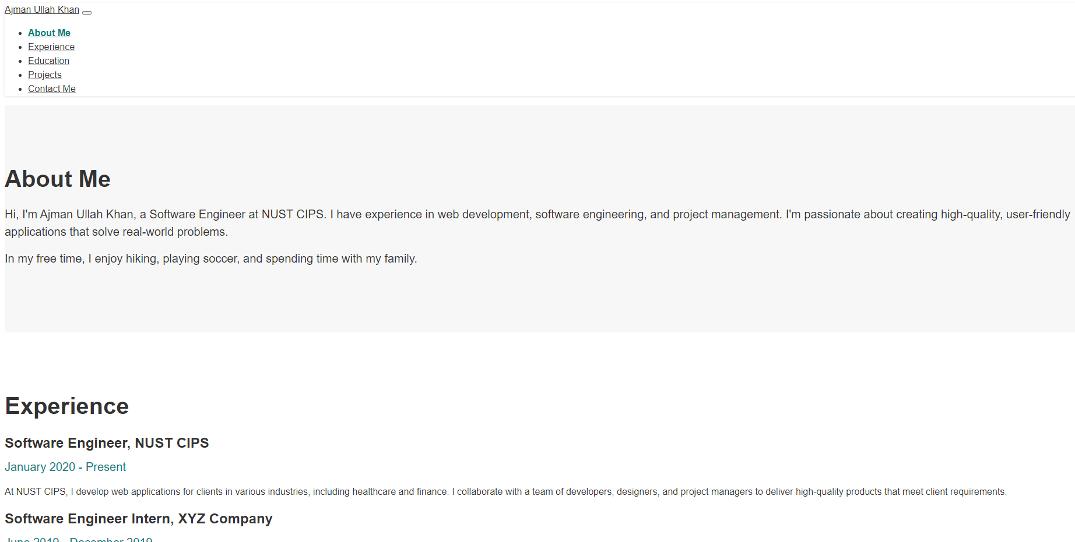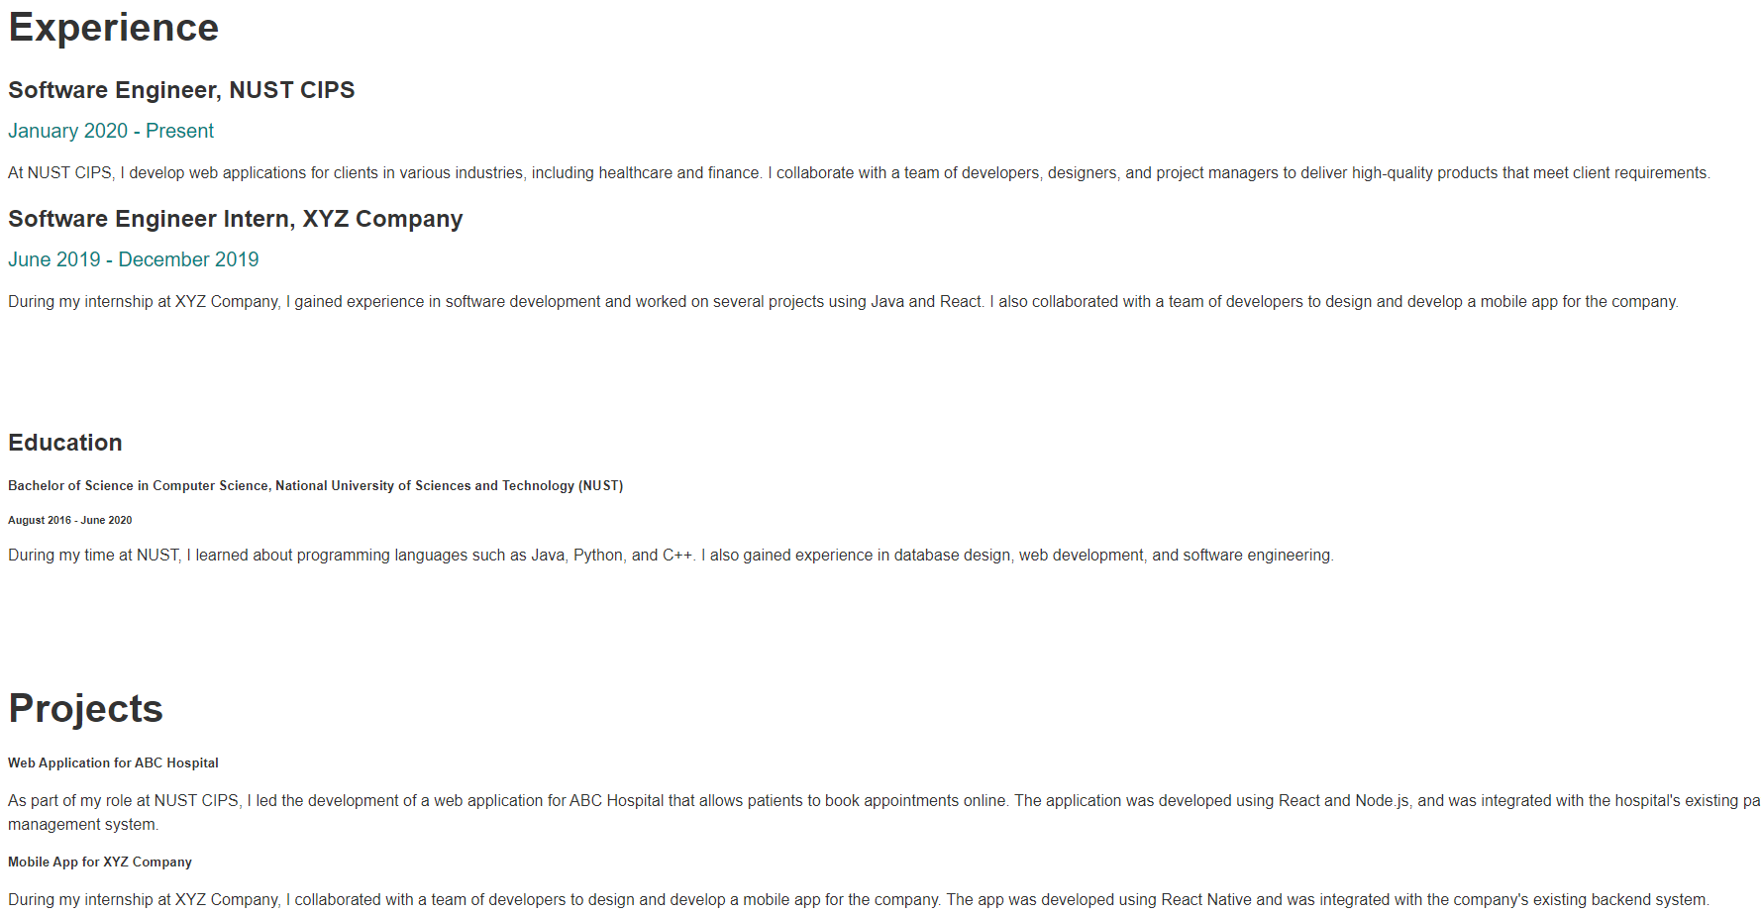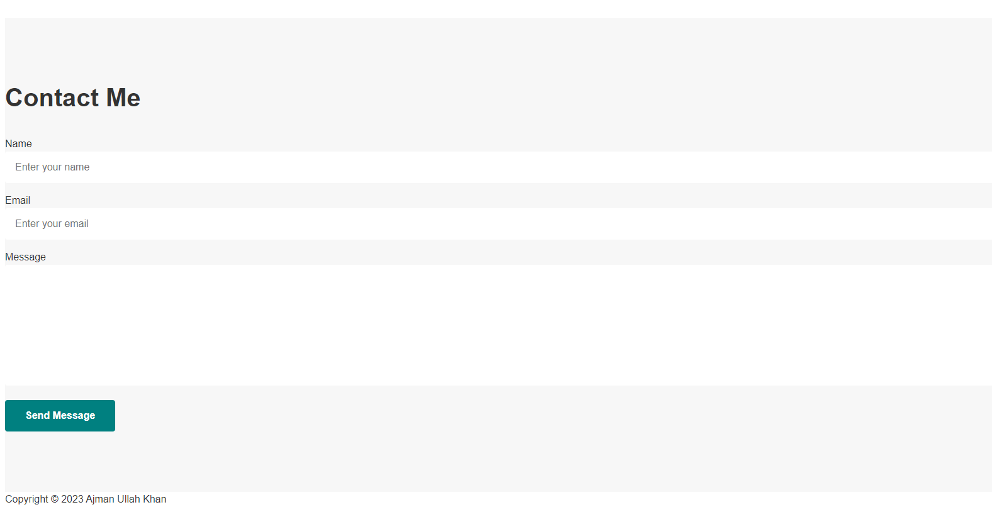

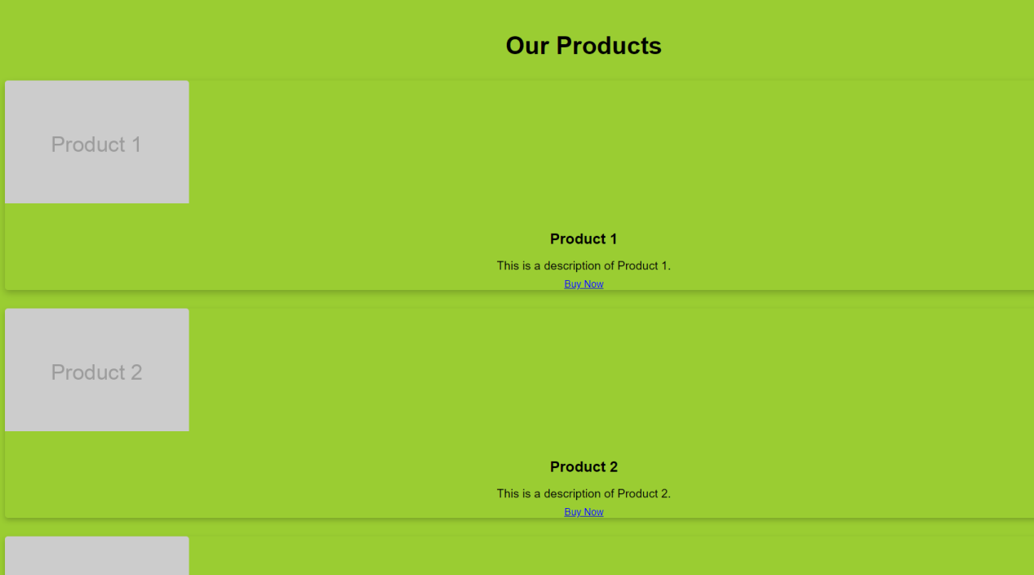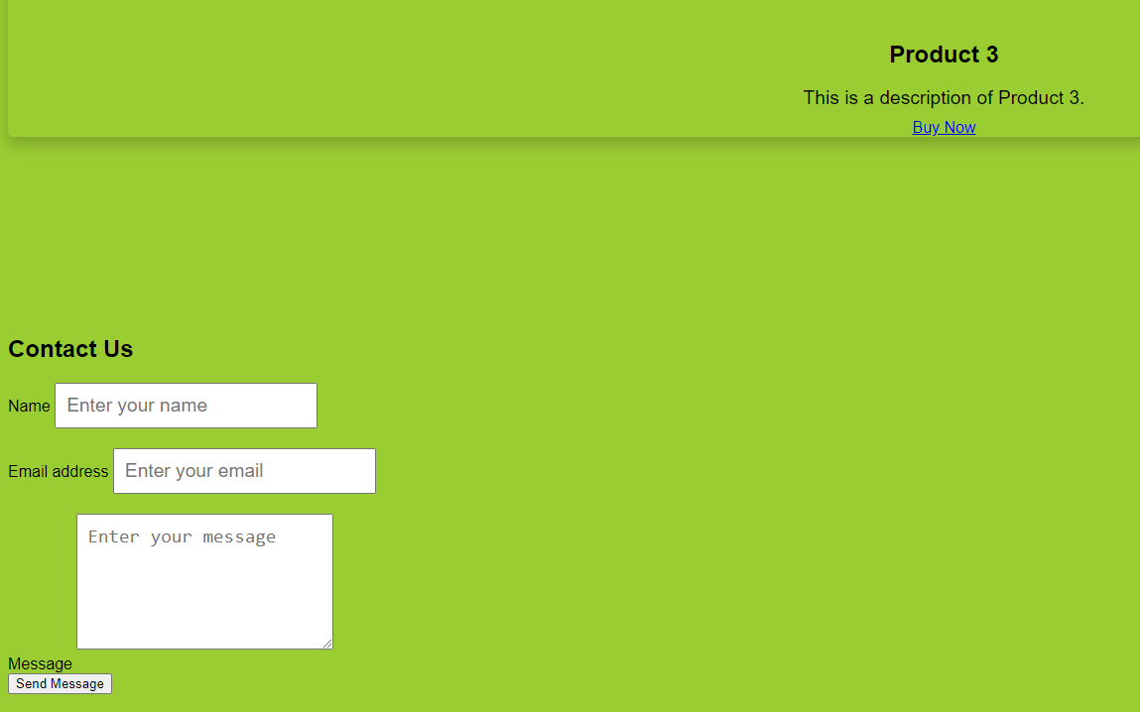

**Portfolio 2 complete website**

<!DOCTYPE html>

<html lang="en">

<head>

    <meta charset="UTF-8">

    <meta name="viewport" content="width=device-width, initial-scale=1.0">

    <meta http-equiv="X-UA-Compatible" content="ie=edge">

    <title>Ajman Ullah Khan - Software Engineer</title>

    <link rel="stylesheet" href="https://stackpath.bootstrapcdn.com/bootstrap/4.3.1/css/bootstrap.min.css" integrity="sha384-ggOyR0iXCbMQv3Xipma34MD+dH/1fQ784/j6cY/iJTQUOhcWr7x9JvoRxT2MZw1T" crossorigin="anonymous">

    <link rel="stylesheet" href="styles.css">

</head>

<body>

    <nav class="navbar navbar-expand-lg navbar-dark bg-dark">

        <a class="navbar-brand" href="#">Ajman Ullah Khan</a>

        <button class="navbar-toggler" type="button" data-toggle="collapse" data-target="#navbarNav" aria-controls="navbarNav" aria-expanded="false" aria-label="Toggle navigation">

            <span class="navbar-toggler-icon"></span>

        </button>

        <div class="collapse navbar-collapse" id="navbarNav">

            <ul class="navbar-nav ml-auto">

                <li class="nav-item">

                    <a class="nav-link" href="#about">About</a>

                </li>

                <li class="nav-item">

                    <a class="nav-link" href="#experience">Experience</a>

                </li>

                <li class="nav-item">

                    <a class="nav-link" href="#skills">Skills</a>

                </li>

                <li class="nav-item">

                    <a class="nav-link" href="#projects">Projects</a>

                </li>

                <li class="nav-item">

                    <a class="nav-link" href="#contact">Contact</a>

                </li>

            </ul>

        </div>

    </nav>

    <!-- header section   -->

    <header id="about">

        <div class="container">

            <div class="row">

                <div class="col-md-6">

                    <h1>Ajman Ullah Khan</h1>

                    <h2>Software Engineer </h2>

                </div>

                <div class="col-md-6">

                    <img src="logo/logo2.jpg" alt="Ajman Ullah Khan" class="img-fluid rounded-circle">

                </div>

            </div>

        </div>

    </header>

    <section id="experience">

        <div class="container">

            <h2>Experience</h2>

            <div class="card">

                <div class="card-body">

                    <h5 class="card-title">Software Engineer</h5>

                    <h6 class="card-subtitle mb-2 text-muted"> CIPS PVT LTD</h6>

                    <p class="card-text">Lorem ipsum dolor sit amet, consectetur adipiscing elit. Sed malesuada quam ut tellus pulvinar, vel tincidunt ex molestie. Fusce sed erat quis elit pharetra pulvinar. </p>

                </div>

            </div>

            <br><br>

            <div class="card">

                <div class="card-body">

                    <h5 class="card-title">FullStack Developer </h5>

                    <h6 class="card-subtitle mb-2 text-muted">Bilal Group of company</h6>

                    <p class="card-text">Lorem ipsum dolor sit amet, consectetur adipiscing elit. Sed malesuada quam ut tellus pulvinar, vel tincidunt ex molestie. Fusce sed erat quis elit pharetra pulvinar. </p>

                </div>

            </div>

            <br><br>

            <div class="card">

                <div class="card-body">

                    <h5 class="card-title">Data analyst </h5>

                    <h6 class="card-subtitle mb-2 text-muted">Bilal Group of company baraku branch </h6>

                    <p class="card-text">Lorem ipsum dolor sit amet, consectetur adipiscing elit. Sed malesuada quam ut tellus pulvinar, vel tincidunt ex molestie. Fusce sed erat quis elit pharetra pulvinar. </p>

                </div>

            </div>

        </div>

    </section>

    <section id="skills">

        <div class="container">

            <h2>Skills</h2>

            <div class="skill">

                <h3 class="skill-title">Web Development</h3>

                <div class="skill-bar">

                    <div class="progress" style="height: 20px;">

                        <div class="progress-bar" role="progressbar" style="width: 90%;" aria-valuenow="90" aria-valuemin="0" aria-valuemax="100">90%</div>

                        </div>

                        </div>

                        <!-- wordpress backend and Frontend -->

                        <div class="skill">

                            <h3 class="skill-title">Wordpress Frontend and Backend Developer</h3>

                            <div class="skill-bar">

                                <div class="progress" style="height: 20px;">

                                    <div class="progress-bar" role="progressbar" style="width: 80%;" aria-valuenow="80" aria-valuemin="0" aria-valuemax="100">80%</div>

                                    </div>

                                    </div>

                        <!-- java programming  -->

                        <div class="skill">

                        <h3 class="skill-title">Java Programming</h3>

                        <div class="skill-bar">

                        <div class="progress" style="height: 20px;">

                        <div class="progress-bar" role="progressbar" style="width: 80%;" aria-valuenow="80" aria-valuemin="0" aria-valuemax="100">80%</div>

                        </div>

                        </div>

                        </div>

                        <div class="skill">

                        <h3 class="skill-title">Database Design</h3>

                        <div class="skill-bar">

                        <div class="progress" style="height: 20px;">

                        <div class="progress-bar" role="progressbar" style="width: 75%;" aria-valuenow="75" aria-valuemin="0" aria-valuemax="100">75%</div>

                        </div>

                        </div>

                        </div>

                        </div>

                        </div>

                        </section>

                        <!-- project section  -->

                        <section id="projects">

                            <div class="container">

                                <h2>Projects</h2>

                                <div class="row">

                                    <div class="col-md-4">

                                        <div class="card">

                                            <img class="card-img-top" src="logo/logo2.jpg" alt="Project 1">

                                            <div class="card-body">

                                                <h5 class="card-title">Project 1</h5>

                                                <p class="card-text">Lorem ipsum dolor sit amet, consectetur adipiscing elit. Sed malesuada quam ut tellus pulvinar, vel tincidunt ex molestie. Fusce sed erat quis elit pharetra pulvinar.</p>

                                                <a href="#" class="btn btn-primary">View Details</a>

                                            </div>

                                        </div>

                                    </div>

                                    <div class="col-md-4">

                                        <div class="card">

                                            <img class="card-img-top" src="logo/logo2.jpg" alt="Project 2">

                                            <div class="card-body">

                                                <h5 class="card-title">Project 2</h5>

                                                <p class="card-text">Lorem ipsum dolor sit amet, consectetur adipiscing elit. Sed malesuada quam ut tellus pulvinar, vel tincidunt ex molestie. Fusce sed erat quis elit pharetra pulvinar.</p>

                                                <a href="#" class="btn btn-primary">View Details</a>

                                            </div>

                                        </div>

                                    </div>

                                    <div class="col-md-4">

                                        <div class="card">

                                            <img class="card-img-top" src="logo/logo2.jpg" alt="Project 3">

                                            <div class="card-body">

                                                <h5 class="card-title">Project 3</h5>

                                                <p class="card-text">Lorem ipsum dolor sit amet, consectetur adipiscing elit. Sed malesuada quam ut tellus pulvinar, vel tincidunt ex molestie. Fusce sed erat quis elit pharetra pulvinar.</p>

                                                <a href="#" class="btn btn-primary">View Details</a>

                                            </div>

                                        </div>

                                    </div>

                                </div>

                            </div>

                        </section>

                        <section id="contact">

                            <div class="container">

                                <h2>Contact</h2>

                                <div class="row">

                                    <div class="col-md-6">

                                        <form action="#" method="post">

                                            <div class="form-group">

                                                <label for="name">Name</label>

                                                <input type="text" class="form-control" id="name" name="name" placeholder="Enter your name" required>

                                            </div>

                                            <div class="form-group">

                                                <label for="email">Email address</label>

                                                <input type="email" class="form-control" id="email" name="email" placeholder="Enter your email" required>

                                            </div>

                                            <div class="form-group">

                                                <label for="message">Message</label>

                                                <textarea class="form-control" id="message" name="message" rows="5" placeholder="Enter your message" required></textarea>

                                            </div>

                                            <button type="submit" class="btn btn-primary">Send Message</button>

                                        </form>

                                    </div>

                                    <div class="col-md-6">

                                        <div class="contact-info">

                                            <div class="info">

                                                <i class="fas fa-map-marker-alt"></i>

                                                <p>H# 294c St 87 G-6/1-4 , Islamabad, Pakistan</p>

                                            </div>

                                            <div class="info">

                                                <i class="fas fa-phone"></i>

                                                <p>+92 3324118288</p>

                                            </div>

                                            <div class="info">

                                                <i class="fas fa-envelope"></i>

                                                <p>ajman41288@gmail.com</p>

                                            </div>

                                        </div>

                                    </div>

                                </div>

                            </div>

                        </section>

                        <!-- Footer -->

                        <footer>

                            <div class="container">

                                <p>&copy; 2023 Ajman Ullah Khan</p>

                            </div>

                        </footer>

                        <!-- Optional JavaScript -->

                        <!-- jQuery first, then Popper.js, then Bootstrap JS -->

                        <script src="https://code.jquery.com/jquery-3.5.1.slim.min.js" integrity="sha384-DfXdz2htPH0lsSSs5nCTpuj/zy4C+OGpamoFVy38MVBnE+IbbVYUew+OrCXaRkfj" crossorigin="anonymous"></script>

                        <script src="https://cdn.jsdelivr.net/npm/@popperjs/core@2.9.3/dist/umd/popper.min.js"></script>

                        <script src="https://cdn.jsdelivr.net/npm/bootstrap@5.0.0/dist/js/bootstrap.min.js"></script>

</body>

</html>

