Maybe something like this would be useful as an abstraction of the algorithm
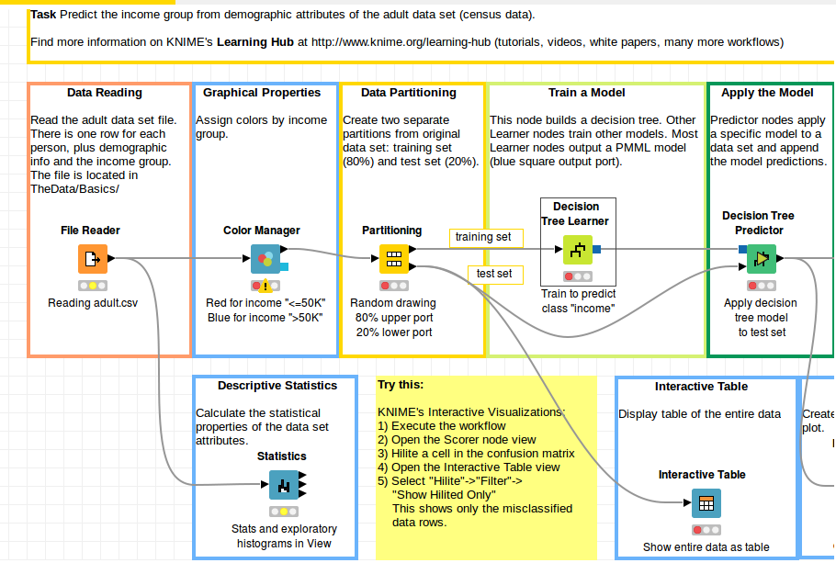

- use PMML as common “model” format
  - allow PKL (pickle) uploads and use jpmml-sklearn to convert for sklearn
  - also allow direct PMML uploads
  - evaluate it using jpmml-evaluator
- use ONNX as a modern, alternative “model” format
- users can download whatever is available (PMML or ONNX)
  - look into converting between either so we can supply both downloads
- look into allowing direct CSV upload – choose an algorithm (future)

