Debugging :

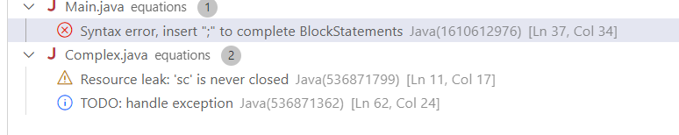

Error and updated:

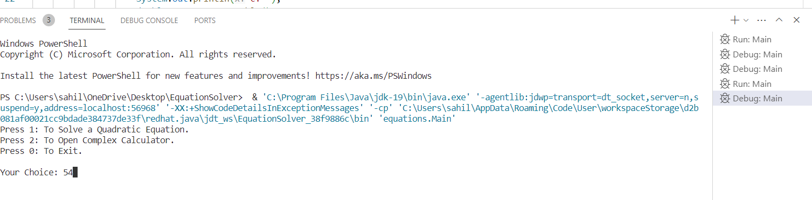

Latex documentation:

\documentclass{article}

\usepackage{listings} % For displaying code

\usepackage{graphicx} % For including images

\usepackage{color} % For defining colors

\usepackage{hyperref} % For adding hyperlinks

\usepackage{amsmath} % For mathematical symbols and equations

% Define custom colors for code highlighting

\definecolor{codegreen}{rgb}{0,0.6,0}

\definecolor{codegray}{rgb}{0.5,0.5,0.5}

\definecolor{codepurple}{rgb}{0.58,0,0.82}

\definecolor{backcolour}{rgb}{0.95,0.95,0.92}

% Define code listing settings

\lstdefinestyle{mystyle}{

backgroundcolor=\color{backcolour},

commentstyle=\color{codegreen},

keywordstyle=\color{magenta},

numberstyle=\tiny\color{codegray},

stringstyle=\color{codepurple},

basicstyle=\ttfamily\footnotesize,

breakatwhitespace=false,

breaklines=true,

captionpos=b,

keepspaces=true,

numbers=left,

numbersep=5pt,

showspaces=false,

showstringspaces=false,

showtabs=false,

tabsize=2

}

\lstset{style=mystyle}

\begin{document}

\title{Equation Solver Documentation}

\author{Your Name}

\date{\today}

\maketitle

\tableofcontents

\newpage

\section{Introduction}

This document provides a detailed explanation of the Java code for solving quadratic equations and performing complex number calculations. The code allows users to solve quadratic equations and perform operations such as addition, subtraction, multiplication, and finding modulus of complex numbers.

\section{Quadratic Equation Solver}

The quadratic equation solver consists of the following components:

\subsection{Main Class (\texttt{Main.java})}

The \texttt{Main} class provides a menu-driven interface for users to choose between solving a quadratic equation and performing complex number calculations.

\subsection{Quadratic Class (\texttt{Quadratic.java})}

The \texttt{Quadratic} class contains methods for finding the roots and nature of roots for a given quadratic equation.

\section{Complex Number Calculator}

The complex number calculator includes the following classes:

\subsection{Complex Class (\texttt{Complex.java})}

The \texttt{Complex} class presents a menu for users to choose operations on complex numbers.

\subsection{ComplexAddition Class (\texttt{ComplexAddition.java})}

The \texttt{ComplexAddition} class performs addition of two complex numbers.

\subsection{ComplexSubtraction Class (\texttt{ComplexSubtraction.java})}

The \texttt{ComplexSubtraction} class performs subtraction of two complex numbers.

\subsection{ComplexMultiplication Class (\texttt{ComplexMultiplication.java})}

The \texttt{ComplexMultiplication} class performs multiplication of two complex numbers.

\subsection{ModComplex Class (\texttt{ModComplex.java})}

The \texttt{ModComplex} class calculates the modulus of a complex number.

\section{Conclusion}

In conclusion, the provided Java code offers a user-friendly interface for solving quadratic equations and performing various operations on complex numbers. Users can choose options from the menu to solve equations and perform calculations with ease.

\end{document}

Output :

1). Quadratic Equation Solver

The first part of the code presents a menu to the user, allowing them to choose between solving a quadratic equation, opening a complex number calculator, or exiting the program. If the user selects option 1, they are prompted to enter the coefficients of a quadratic equation (aX^2 + bX + c = 0). The program then creates a `Quadratic` object with the provided coefficients and calculates the nature of roots using the discriminant.

2) Complex Number Calculator

In the second part of the code, if the user selects option 2 from the main menu, they enter the complex number calculator section. Here, the program provides options to add, subtract, multiply two complex numbers, or calculate the modulus of a complex number. The user is prompted to enter complex numbers in the format (a+bi ).

3).Complex Number Operations

The third part of the code consists of classes for performing complex number operations. The `ComplexAddition`, `ComplexSubtraction`, and `ComplexMultiplication` classes handle addition, subtraction, and multiplication of complex numbers, respectively. These classes parse the input complex numbers, perform the operations, and display the results. Additionally, the `ModComplex` class calculates and displays the modulus of a complex number entered by the user