System Architecture Document

1. Introduction

1.1 Purpose
The purpose of this document is to provide a comprehensive overview of the system architecture for the Military Supply Chain Management System. It details the system components, technologies used, and their interactions.

1.2 Scope
This document covers the architectural design of the Military Supply Chain Management System, including user interactions, backend services, data storage, and cloud infrastructure.

2. System Overview
The Military Supply Chain Management System facilitates efficient management of supply inventory, logistics, and route optimization for military operations. It aims to enhance the decision-making process for supply officers and warehouse staff through a user-friendly interface and robust backend services.

3. Architectural Design

3.1 System Architecture Diagram
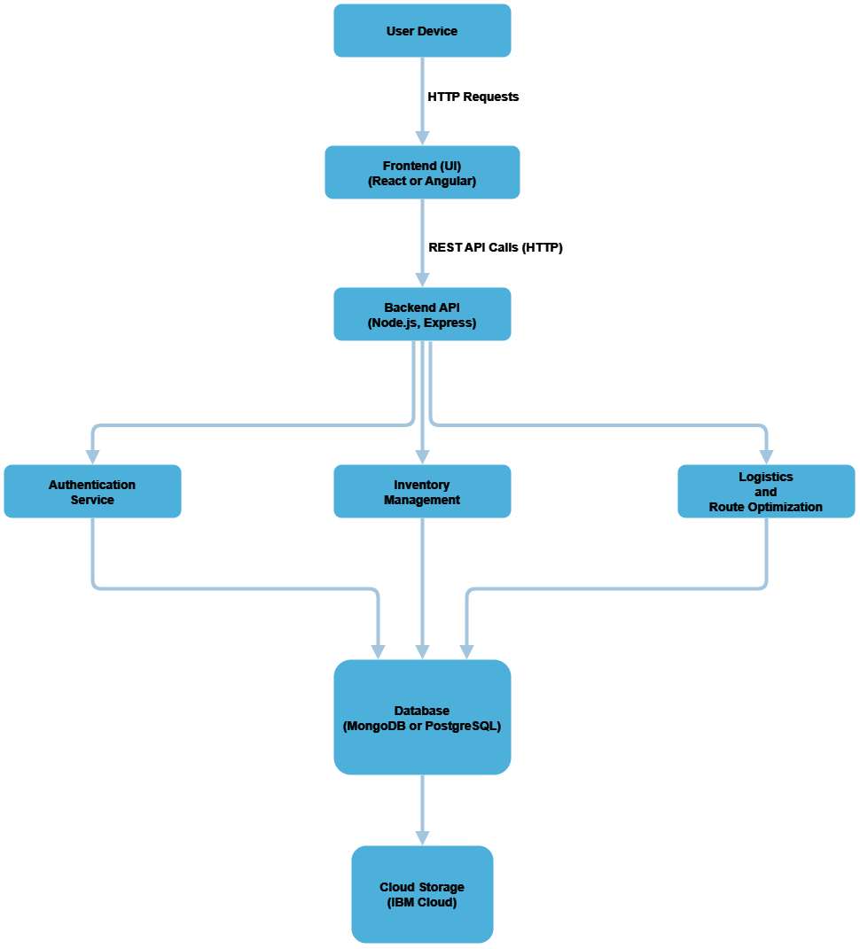

3.2 Components and Technologies

3.2.1 User Devices
- Description: Devices used by supply officers, managers, and warehouse staff to interact with the system.
- Technology: Web and Mobile devices.

3.2.2 Frontend (UI)
- Description: User interface that allows users to interact with the system.
- Technology: React

3.2.3 Backend API
- Description: Manages business logic and serves data to the frontend via RESTful APIs.
- Technology: Spring Boot

3.2.4 Authentication Service
- Description: Handles user authentication and authorization.
- Technology: Spring Security (integrated with Spring Boot)

3.2.5 Inventory Management
- Description: Manages supply inventory, including tracking items and managing stock levels.
- Technology: Spring Boot service

3.2.6 Logistics & Route Optimization
- Description: Optimizes delivery routes for supplies.
- Technology: Spring Boot service

3.2.7 Database Layer
- Description: Stores all data related to users, roles, supply inventory, requests, locations, delivery routes, and item logs.
- Technology: PostgreSQL

3.2.8 Cloud Storage
- Description: Provides storage for documents and large datasets.
- Technology: IBM Cloud

4. Component Interaction
- User Devices initiate HTTP requests to the Frontend (React).
- The Frontend makes REST API calls to the Backend API (Spring Boot).
- The Backend API interacts with various services (Authentication, Inventory Management, Logistics) to process requests.
- Data is stored and retrieved from the Database (PostgreSQL).
- The Cloud Storage (IBM Cloud) is used for additional data storage requirements.

5. Non-Functional Requirements
- Performance: The system should handle up to 500 concurrent users.
- Scalability: Must support scaling as user demand increases.
- Security: Implement role-based access control for sensitive data.
- Availability: The system should have a 99.9% uptime.

6. Conclusion
This document outlines the architecture for the Military Supply Chain Management System, detailing the components and technologies involved. The design aims to deliver a robust, secure, and efficient solution for managing military supplies and logistics.

7. References
- React Documentation
- Spring Boot Documentation
- PostgreSQL Documentation
- IBM Cloud Documentation

