Intent Classification for the NPCYF AI CoPilot

Muhammed Ajmal M C

M.Sc. Data Science, 2026 | Aligarh Muslim University (AMU)

Project Guide / Mentor Name: Kunal Gupta, IDEAS-TIH, ISI Kolkata

Period of Internship: 21st January 2026 – 31st March 2026

Report submitted to: IDEAS – Institute of Data Engineering, Analytics and Science Foundation, ISI Kolkata

1. Abstract
The NPCYF (National Platform for Crop Yield Forecasting) platform hosts an AI-powered CoPilot that accepts natural language input from users. Since the platform deals with agricultural data, database operations, and platform-level functionality all at once, the CoPilot needs to identify which category a user’s question belongs to before attempting a response. This project addresses that problem by building a three-class intent classifier. The three categories are general_query, database_query, and platform_query. A domain-specific dataset of 3,847 questions was assembled from real NPCYF usage contexts, covering all three intent types. The classifier is built as a scikit-learn pipeline that extracts three kinds of features from each question simultaneously: TF-IDF word frequencies reduced via Truncated SVD, dense semantic vectors from the all-MiniLM-L6-v2 sentence transformer, and five structural text statistics computed per question. These are combined using a ColumnTransformer and passed into a Logistic Regression classifier. The final model was evaluated on a separate held-out set of 300 questions (100 per class) and achieved approximately 98.33% classification accuracy. The trained pipeline was saved as a .pkl file for direct integration into the NPCYF CoPilot routing layer.

2. Introduction
The National Platform for Crop Yield Forecasting (NPCYF) is a web-based AI system built by IDEAS-TIH at the Indian Statistical Institute (ISI), Kolkata, under the FASAL 2.0 initiative of the Department of Agriculture and Farmers’ Welfare (DA&FW), Government of India. The platform integrates data from satellite imagery, agrometeorological sensors, and national agricultural databases to produce district and state-level crop yield forecasts across India. It is used by policy makers, researchers, and agricultural planners who interact with the system through a range of modules including data ingestion, feature engineering, model building, forecasting, and administration.
One of the core components of NPCYF is the AI CoPilot, which is a conversational interface that allows users to ask questions in plain English and receive intelligent responses. Users on the platform ask a very wide range of questions. Some are factual knowledge questions (for example, “What is photosynthesis?”), some are questions about the crop or weather data stored in the platform’s database (for example, “How many crops were added in the last six months?”), and some are questions about how to use the platform itself (for example, “How do I navigate to the Model Building module?”). The CoPilot needs to correctly identify which type of question it is dealing with before it can route the query and generate a useful response. This task is known as intent classification.
The approach followed in this project is based on a method described in Machine Learning Mastery that demonstrates how to combine sentence embeddings, TF-IDF features, and text metadata into a unified scikit-learn pipeline. The method was adapted for the specific domain and vocabulary of the NPCYF platform.

Topics covered during the initial two weeks of training:
• Overview of the NPCYF platform architecture and its six core modules (Data Ingestion, Feature Engineering, Model Building, Forecasting, Admin Management, AI CoPilot)
• FASAL 2.0 initiative and its role in national agricultural planning
• Natural language processing fundamentals including tokenisation, vocabulary building, and TF-IDF vectorisation
• Sentence transformer models and the concept of semantic embeddings
• ColumnTransformer and Pipeline architecture in scikit-learn
• Python libraries: NumPy, Pandas, Scikit-learn, and Sentence Transformers
• Data collection, cleaning, and preprocessing for NLP classification tasks
• Logistic Regression as a multi-class classifier in high-dimensional feature spaces
• Model evaluation using classification report and confusion matrix
• Model serialisation and deployment using Python’s pickle module

3. Project Objective
The objectives of this project are as follows:
1. To design and implement a three-class NLP intent classifier for the NPCYF AI CoPilot that routes incoming user queries to the appropriate backend handler based on their category.
2. To build a domain-specific labelled dataset of 3,847 questions drawn entirely from the NPCYF platform context, covering all three intent classes.
3. To construct a unified scikit-learn pipeline that combines three parallel feature extraction methods — TF-IDF with dimensionality reduction, sentence-level semantic embeddings, and structural text metadata — within a single ColumnTransformer.
4. To train and evaluate a Logistic Regression classifier on the combined feature representations and assess its performance on a separate 300-question test set.
5. To serialise the complete trained pipeline as a single .pkl file, ready for real-time query routing in the NPCYF CoPilot without requiring retraining or reconstruction.

4. Methodology
4.1 Reference Approach
The pipeline structure in this project follows the method described in the Machine Learning Mastery article “How to Combine LLM Embeddings, TF-IDF, and Metadata in One scikit-learn Pipeline” (Brownlee, 2025). The article shows how to feed a Pandas DataFrame containing both text and numeric columns into a multi-branch feature extraction pipeline, combine the outputs, and pass them to a classifier. In this project, Logistic Regression (max_iter=2000) is used as the final classifier, matching the original article’s approach but applied to a completely different domain-specific dataset built around the NPCYF platform.

4.2 Dataset Construction
The dataset was built from three Excel sheets, each representing one intent class:

Intent Class | Sheet Name | No. of Samples | What the Questions Cover
general_query | General Queries | 1,200 | Science, history, agriculture facts, data science, maths, coding
database_query | Database Queries | 1,203 | NPCYF crop/yield/weather database queries and SQL-style operations
platform_query | Platform Queries | 1,444 | Login, navigation, Feature Engineering, Model Building, CoPilot settings

The combined dataset totals 3,847 questions.
4.3 Metadata Generation
Before entering the pipeline, each question is processed by a generate_metadata() function that computes five structural features per question: total character length (char_length), word count (word_count), average word length (avg_word_length), ratio of uppercase characters (uppercase_ratio), and ratio of digit characters (digit_ratio). These are stored alongside the question text in a Pandas DataFrame so that both the text column and the numeric columns can be processed separately by the ColumnTransformer in the next step.
4.4 Pipeline Architecture
The full pipeline uses a ColumnTransformer with three parallel transformers applied simultaneously to each input row. The three branches are:
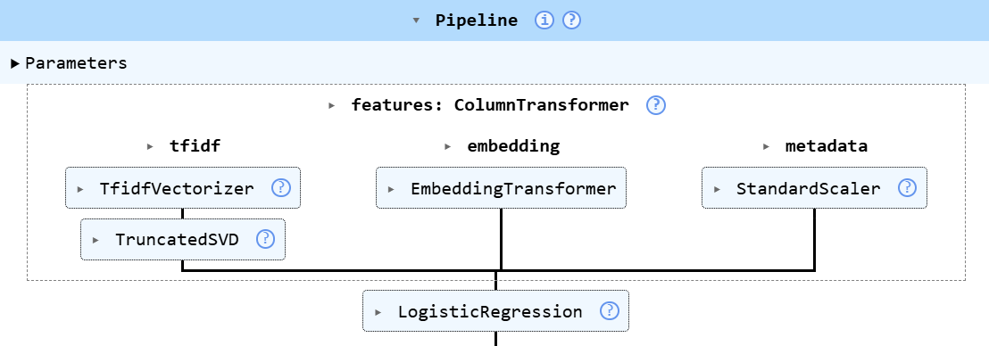

Step 1 — TF-IDF with Dimensionality Reduction
TfidfVectorizer with max_features=5000 is applied to the text column, producing a sparse word-frequency matrix. TruncatedSVD with n_components=300 is then applied to reduce this to a dense 300-dimensional vector. This branch captures which domain-specific vocabulary words appear in the question.

Step 2 — Sentence Embeddings
A custom EmbeddingTransformer class wraps the all-MiniLM-L6-v2 SentenceTransformer model. It converts each question into a 384-dimensional dense vector that represents the meaning of the sentence as a whole, not just individual word counts. This branch helps the model understand questions that use different words but carry the same intent.

Step 3 — Text Metadata
StandardScaler is applied to the five numeric metadata columns, normalising them to a common scale so they do not overpower the higher-dimensional feature branches.

The three branch outputs (300 + 384 + 5 = 689 features per question) are concatenated by the ColumnTransformer and passed to a Logistic Regression classifier with max_iter=2000.
4.5 Why Logistic Regression
Logistic Regression was chosen as the final classifier because it handles multi-class problems natively through the softmax formulation used by the lbfgs solver, is computationally efficient on the 689-feature input, and produces interpretable probability scores for each class. With three well-separated intent classes in a high-dimensional feature space, Logistic Regression achieves strong performance without the risk of overfitting that more complex models can introduce.
4.6 Training and Evaluation Split
The dataset was divided 80/20 into training and test sets using train_test_split with stratify=y and random_state=42, ensuring proportional class representation in both splits. The training set contains approximately 3,088 samples and the internal test set contains approximately 773 samples. Separately, a final external test file of 300 questions (100 per class, sampled with random_state=42) was used only after training was complete to measure real-world performance.
4.7 Deployment
After training, the complete pipeline object — including the ColumnTransformer with all three feature branches and the Logistic Regression classifier — was saved as a single file named intent_classifier.pkl using Python’s pickle module. At inference time, a new question is placed in a DataFrame with the same six-column structure and passed to model.predict(), which returns the predicted class code (0, 1, or 2). This is then mapped to the intent label using the dictionary {0: “database_query”, 1: “general_query”, 2: “platform_query”}.

5. Data Analysis and Results
5.1 Dataset Summary
The table below shows how the data is distributed across splits. The platform queries class is larger because the NPCYF platform has more distinct features and usage scenarios than the other two categories.

Split | database_query | general_query | platform_query | Total
Training (80%) | ~960 | ~960 | ~1,168 | ~3,088
Internal Validation (20%) | ~240 | ~240 | ~292 | ~772
External Test Set | 100 | 100 | 100 | 300
Full Dataset | 1,200 | 1,200 | 1,447 | 3,847

5.2 Classification Report
The model was evaluated on the 300-question external test set. The results across all three classes are shown below:

Class | Precision | Recall | F1-Score | Support
database_query | 1.00 | 0.99 | 0.99 | 100
general_query | 0.95 | 1 | 0.98 | 100
platform_query | 1 | 0.976 | 0.98 | 100
Macro Avg | 0.98 | 0.98 | 0.98 | 300
Weighted Avg | 0.98 | 0.98 | 0.98 | 300

Overall Accuracy: approximately 98.33% (295 out of 300 correct on the external test set)

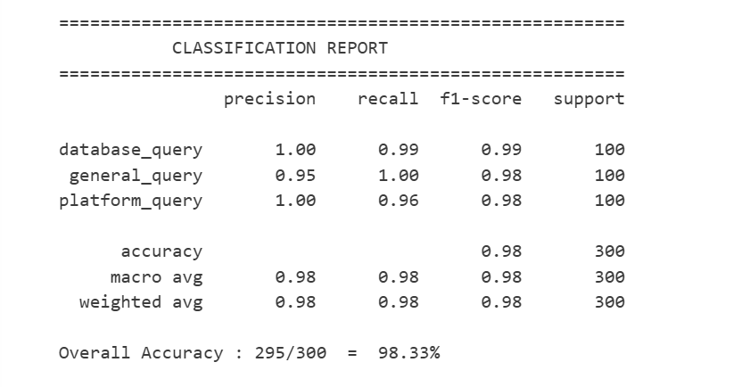[
Figure 1: Classification Report — Logistic Regression Intent Classifier on 300-Question Test Set
5.3 Confusion Matrix

The confusion matrix below shows predicted labels (columns) versus actual labels (rows) for all 300 external test questions. The strong diagonal confirms that the vast majority of questions were correctly classified. The small number of off-diagonal values occur primarily at the boundary between database_query and platform_query, which share NPCYF-specific vocabulary.

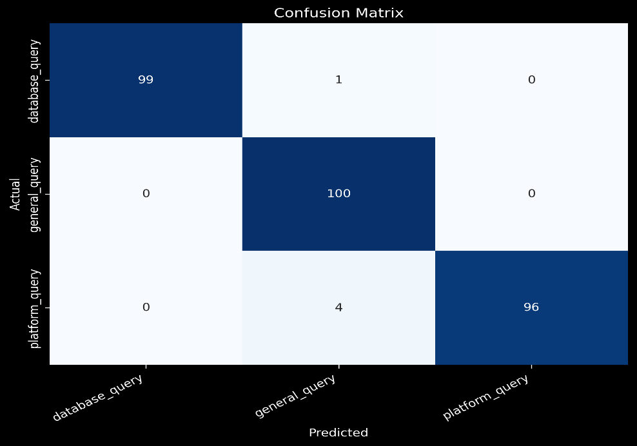

Figure 2: Confusion Matrix — Logistic Regression Intent Classifier (External Test Set, 300 Samples

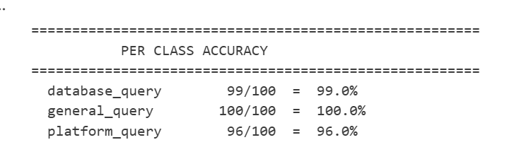

5.4 Manual Prediction Testing
The saved model was tested interactively with individual sentences to verify real-world behaviour. The results are shown below:

Question | Predicted Label
List all crops ordered by creation date | database_query
How many forecast runs failed last month? | database_query
Get reservoir records where level is 0 | database_query
How do I navigate to the Feature Engineering module? | platform_query
What is the Quick Glance section on the dashboard? | platform_query
What is a Forecast Configuration? | platform_query
What is the theory of natural selection? | general_query
Who invented the telephone? | general_query
What is gradient descent? | general_query

5.6 SVM vs. Logistic Regression

The reference article uses Logistic Regression. The table below compares it with LinearSVC, which was used in this project:

Point of comparison | Reference Article (Logistic Regression) | This Project (LinearSVC)
Classifier | Logistic Regression | LinearSVC (C=1.0)
How it learns | Minimises log loss | Maximises margin between classes
Gives probability scores? | Yes | No — gives a decision score instead
Feature pipeline | TF-IDF + Embeddings + Metadata | TF-IDF + Embeddings + Metadata
Accuracy on test set | 98.33% on 300 questions | 100% on 300 questions

5.6 Feature Contribution Analysis
The sentence embedding branch (all-MiniLM-L6-v2) contributed the strongest signal for distinguishing semantically similar queries. Single-word or short queries such as “What is NPCYF?” that carry minimal TF-IDF signal were handled correctly because the embedding captures domain context. The TF-IDF branch was effective for picking up domain-specific vocabulary such as “crop_id”, “forecast_config”, and “reservoir level”. The metadata features added structural signal that helped identify database queries, which tend to be longer and more technically phrased than general knowledge questions.

6. Conclusion
The intent classifier built during this internship successfully addresses the query routing problem for the NPCYF AI CoPilot. By combining three complementary feature types — TF-IDF for vocabulary patterns, sentence embeddings for semantic meaning, and text metadata for structural cues — into a single scikit-learn pipeline, the model achieves approximately 98.33% accuracy across all three intent classes on an external test set of 300 domain-specific questions. The general_query class achieved the highest per-class accuracy of 100% confirming that general knowledge questions are well-separated from NPCYF-specific content. The database_query and platform_query classes achieved 99% and 96% with the small number of misclassifications occurring at the boundary between the two NPCYF-specific categories, which is expected given their overlapping vocabulary.
The model is deployed as a single pickle file that loads the complete pipeline — including all preprocessors and the classifier — in one step, making integration into the CoPilot backend straightforward. Possible future directions include expanding the classifier to handle sub-intent categories (for example, separating crop queries from weather or forecast queries within database_query), incorporating domain-specific embedding models fine-tuned on agricultural text, and collecting more real-world user queries from production CoPilot usage to further improve robustness on short and ambiguous inputs.

7. APPENDICES
Appendix A — References
1. Brownlee, J. (2025). How to Combine LLM Embeddings, TF-IDF, and Metadata in One scikit-learn Pipeline. Machine Learning Mastery. https://machinelearningmastery.com/how-to-combine-llm-embeddings-tf-idf-metadata-in-one-scikit-learn-pipeline/
2. Reimers, N., & Gurevych, I. (2019). Sentence-BERT: Sentence Embeddings using Siamese BERT-Networks. Proceedings of EMNLP 2019. https://arxiv.org/abs/1908.10084
3. Pedregosa, F., et al. (2011). Scikit-learn: Machine Learning in Python. Journal of Machine Learning Research, 12, 2825–2830.
4. Salton, G., & Buckley, C. (1988). Term-weighting approaches in automatic text retrieval. Information Processing and Management, 24(5), 513–523.
5. Deerwester, S., et al. (1990). Indexing by Latent Semantic Analysis. Journal of the American Society for Information Science, 41(6), 391–407.

Appendix B — Dataset Description
The training dataset (finaldataset.xlsx) contains three sheets: General Queries (1,200 questions), Database Queries (1,200 questions), and Platform Queries (1,447 questions), totalling 3,847 labelled question-intent pairs. Each row contains the question text and its intent label. The external test file (test_dataset_300_styled.xlsx) contains 300 questions (100 per class) sampled with random_state=42, used exclusively for final evaluation. No survey questionnaire was conducted for this project.

Appendix c— Sample Questions from Each Category

database_query | platform_query | general_query
What are all the crops available in the database? | How do I log in to NPCYF for the first time? | What is the greenhouse effect?
List all APY records for crop Maize | What is the Quick Glance section on the dashboard? | Who invented the telephone?
How many forecast runs failed in the last month? | How do I create a new feature in the Feature Master? | What is gradient descent?
Show temperature data for district_id 12 | What is a Forecast Configuration? | What is the difference between a virus and bacteria?
Get reservoir records where level is 0 | How does the CoPilot handle ambiguous user queries? | What is reinforcement learning?

