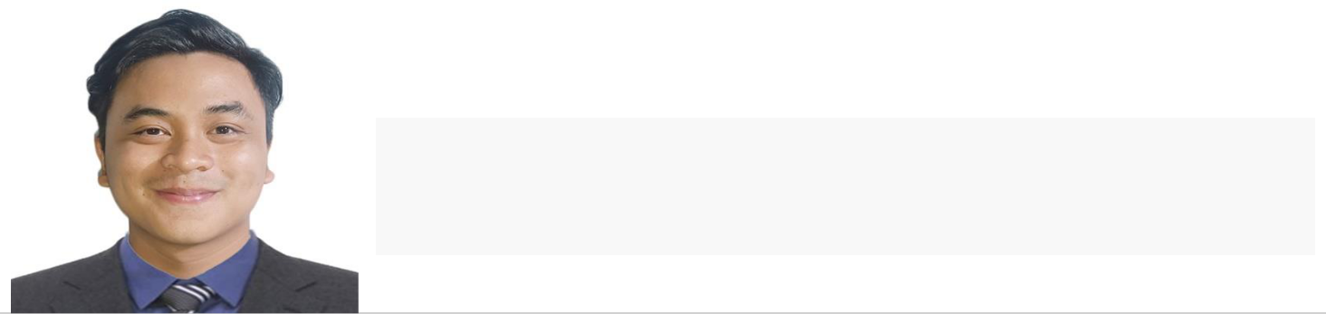
Rilan,Michael Angelo S.

Address: Orchids St, Greenvalley Molino II, Bacoor City Cavite
Contact number: 0912-028-2536
Email: micorilan1999@gmail.com
Website: https://michaelrilan-portfolio.netlify.app/

Objectives

- To impart my knowledge and skills and to enhance my capabilities for personal growth and development.


Skills

Personal Information

Date of Birth: October 02, 1999 | Age: 23
Place of Birth: Lemery, Batangas
Gender: Male
Civil Status: Single
Religion: Catholic
Mother: Catalina S. Rilan | Occupation: House Wife
Father: Roberto A. Rilan | Occupation: Factory Worker

Educational Attainment

TERTIARY

TECHNOLOGICAL UNIVERSITY OF THE PHILIPPINES-CAVITE CAMPUS
BACHELOR OF ENGINEERING TECHNOLOGY-COMPUTER ENGINEERING TECHNOLOGY |  |  | 2018-PRESENT
SECONDARY
ASIAN INSTITUTE OF COMPUTER STUDIES-BACOOR BRANCH
INFORMATION COMMUNICATION AND TECHNOLOGY(ICT) |  |  | 2016-2018
SENIOR HIGH SCHOOL
Bacoor National High School - Molino Main |  |  | 2012 – 2016
Junior High School
ELEMENTARY
 |  |  | 2010-2012
San Nicolas Central School (San Nicolas Batangas) |  |  | 2010-2012
Our Lady of Guadalupe Montessori School |  |  | 2004-2009

Work

Experience

● | PhlPost- Imus | November 2017 – February 2018
Data Encoder (OJT)
Imus Cavite
● | Mang Inasal- SM Molino | April 2018 – July 2018
Service Crew
SM Molino
● | Jollibee North Molino | April 2019 – July 2019

Service Crew
Beside Bacoor Government Center (BGC),

Molino blvd, Bacoor Cavite

Seminars | ● | Computer Literacy Program | February 2015
Attended | DATACOM INSTITUTE OF COMPUTER TECHNOLOGY
Attended | (COMPUTER HARDWARE SOFTWARE AND GRAPHICS DESIGN)
 | ● | BUSINESS MODEL CANVAS WEBINAR | October 3 2020
TECHNOLOGICAL UNIVERSITY OF THE PHILIPPINES-CAVITE CAMPUS

Character References

- John Christopher Ala Customer Service Representative Teleperformance EDSA 0967-817-0412

- Norelyn Sto. Domingo
Food Steward

Sodexo On-site Philippines Inc.
0966-988-0898

This is to certify that the above-mentioned information is true and correct.

Signature over Printed Name

