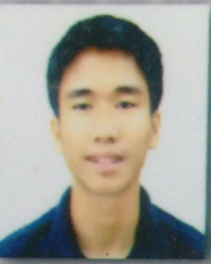**AVOR JOHN A. NARAG**

I'm hardworking, persevere, and fast learner person. Knowledgeable Web Developer brings front- and back-end design to promote organization-specific website presence. Using HTML, CSS and JavaScript to generate custom web page designs and with the use of PHP and Python programming languages to provide a back-end function.

**Education**

**Contact**

**Address**

Bacoor, Cavite, 4102

**Phone**

09089637505

**E-mail**

[ajnarag25@gmail.com](mailto:ajnarag25@gmail.com)

**Website**

https://ajnarag25.github.io/my-portfolio

2018 – **Bachelor of Engineering Technology:**

2023 **Computer Engineering Technology**

**College**

Technological University of the Philippines – Cavite

BET – Computer Engineering Technology studied the

fundamentals about programming such as Procedural,

Object Oriented Programming, Algorithms, and Data

Structures.

2015-06 – **APEC School** - **Accounting Business and Management:**

2017-03 **Senior High School**

**Skills**

**Experience**

2020 – Current **Freelancing (Web Development & App Development)**

* Provided front-end website development using Css, Bootstrap, and other editing software.
* Pulled from PHP, MYSQL, JavaScript, and other back-end Library knowledge to provide server-side functions.
* Knowledgeable in Python in developing desktop application using PyQt5 framework

2021- **Web Developer (Intern) – Chrislmm Sentimo Kumon**

* Provided a quality website for the company.
* Certification of employment from the company.

**Certifications**

2021-08 TESDA Scholarship Program – Web Development

Mindtech Training and Development Institute Inc.

2021-09 TESDA Scholarship Program – Web Design

Mindtech Training and Development Institute Inc.