COMP 776 Triangulation Assignment
Rohan Prinja / rohan@cs.unc.edu / 730110583

Triangulation function

def triangulate_points(keypoints1, keypoints2, P):
points3D = np.empty((len(keypoints1), 3))

for i, (x1, x2) in enumerate(zip(keypoints1, keypoints2)):
Pident = np.array([[1,0,0,0],
[0,1,0,0],
[0,0,1,0]])
x1c = np.array([[0, -1, x1[1]],
[1, 0, -x1[0]],
[-x1[1], x1[0], 0]])
x2c = np.array([[0, -1, x2[1]],
[1, 0, -x2[0]],
[-x2[1], x2[0], 0]])
A = np.row_stack((np.dot(x1c, Pident), np.dot(x2c, P)))
U, S, VT = svd(A)
X = VT[-1]
points3D[i] = X[:-1] / (X[-1])

return points3D

Link to code

https://drive.google.com/open?id=1TmQNhiSvTncuLjnb5Dpix0wNh3n4AZ_n

Views of point clouds

I have imported all PLY files into a single scene and taken front, left, right, bottom-up and top-down views of the scene.

Front view

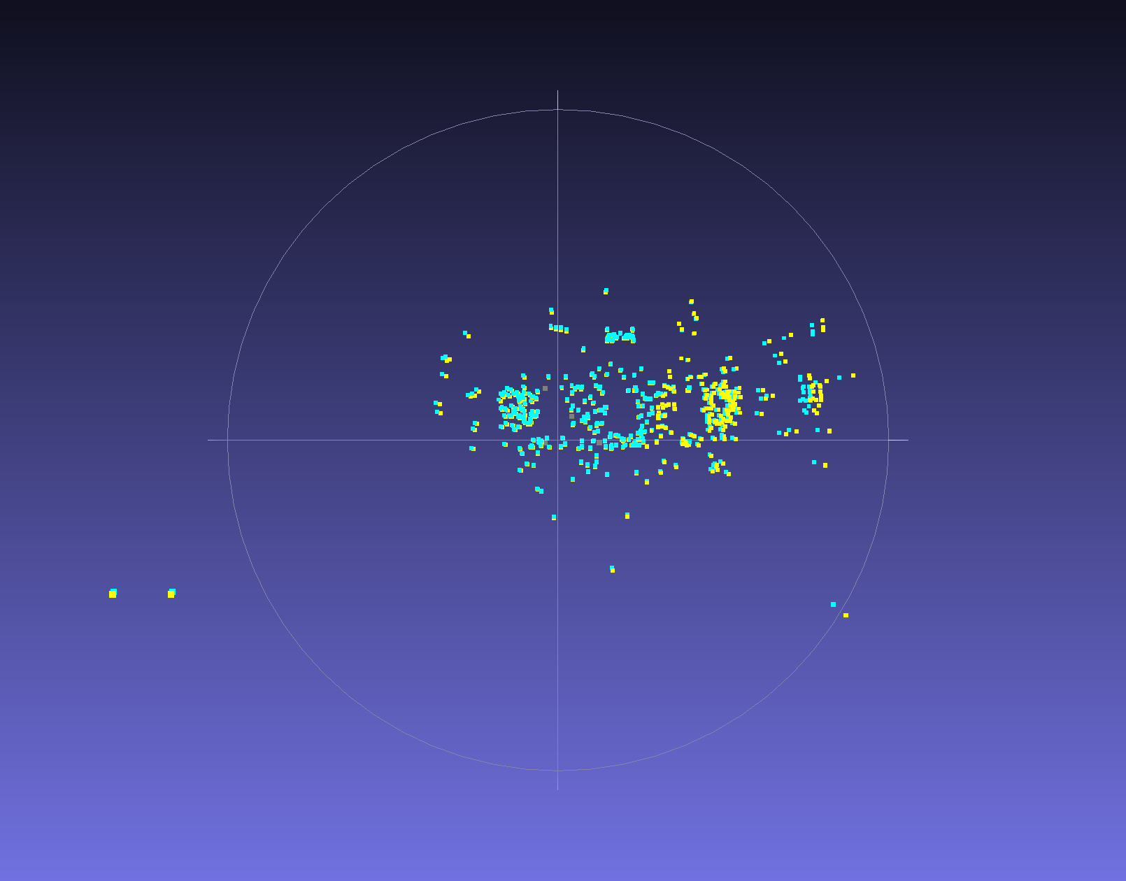

Left view

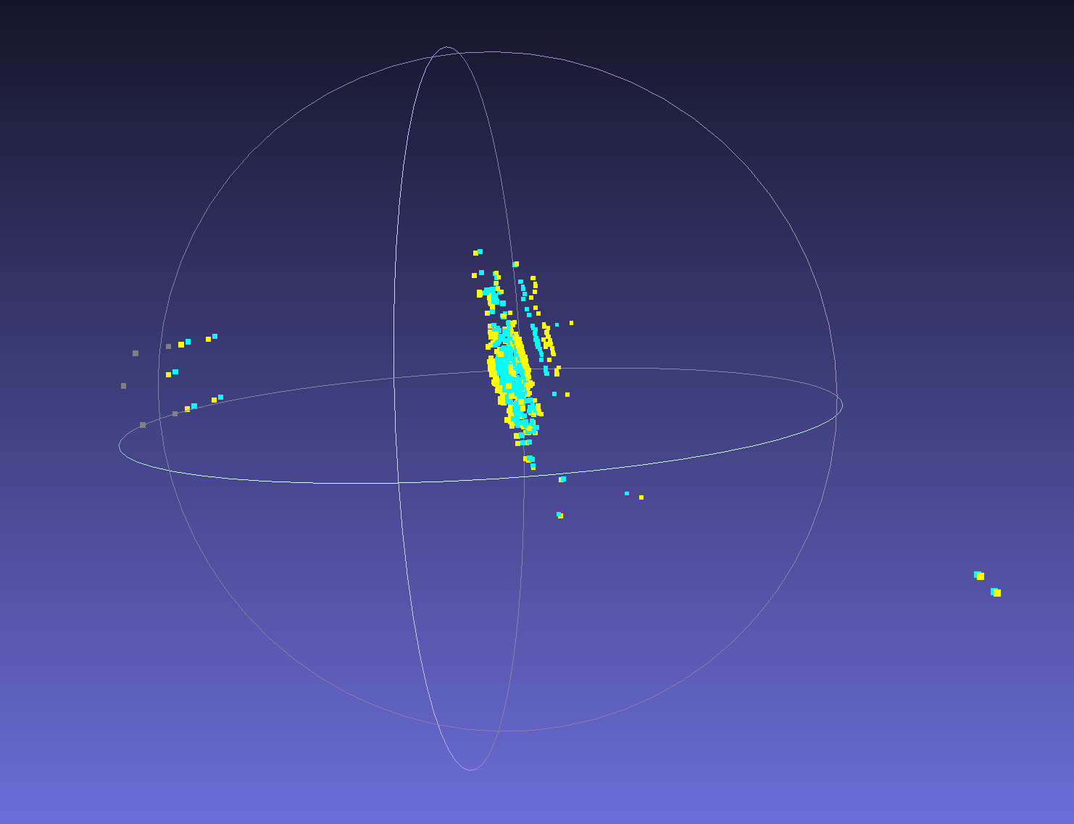

Right view

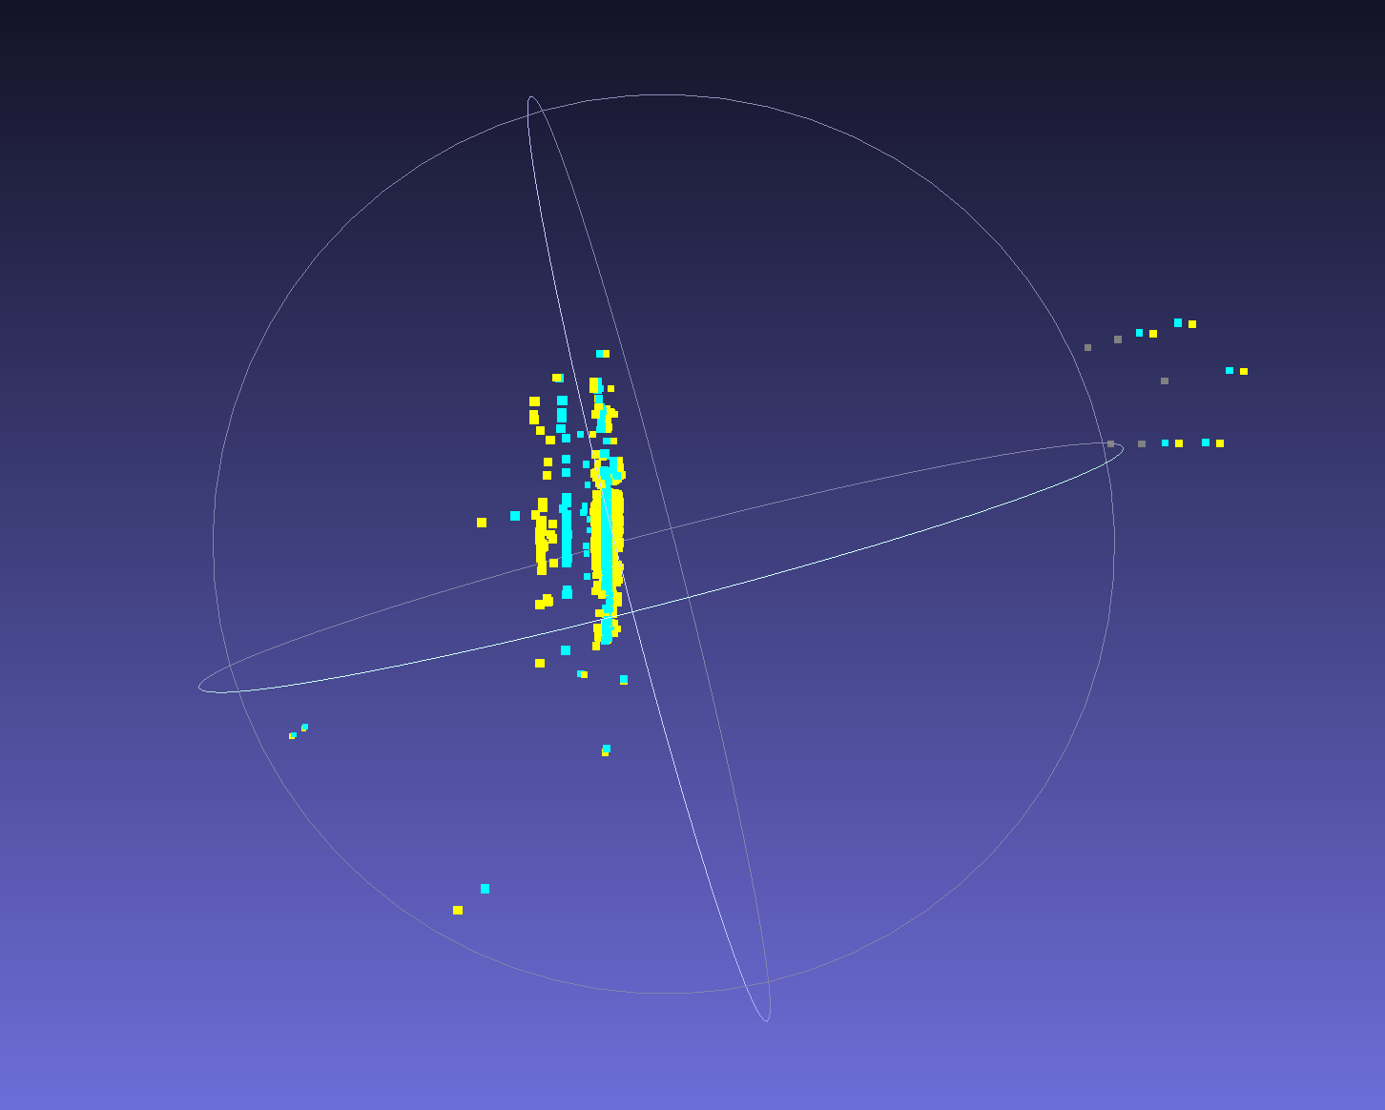

Bottom view

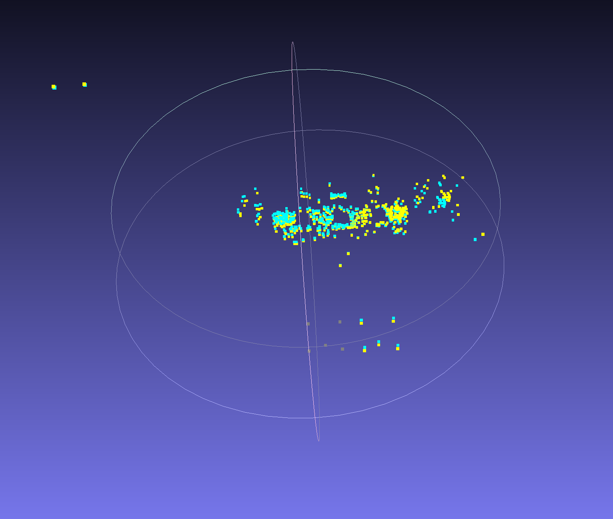

Top view

