Steps for Containerization

1)instance creation

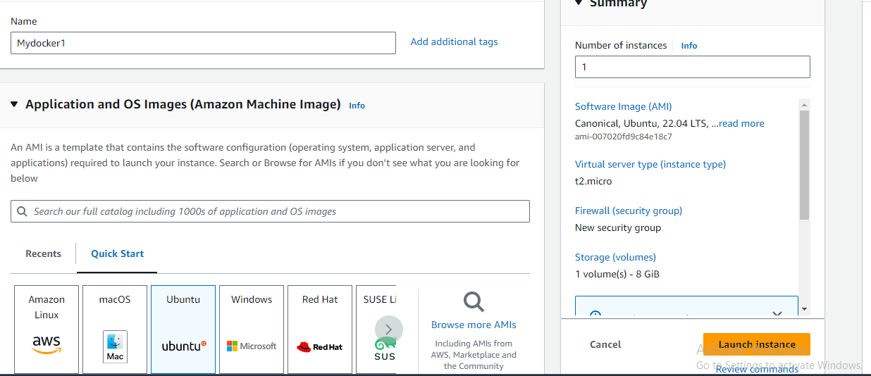

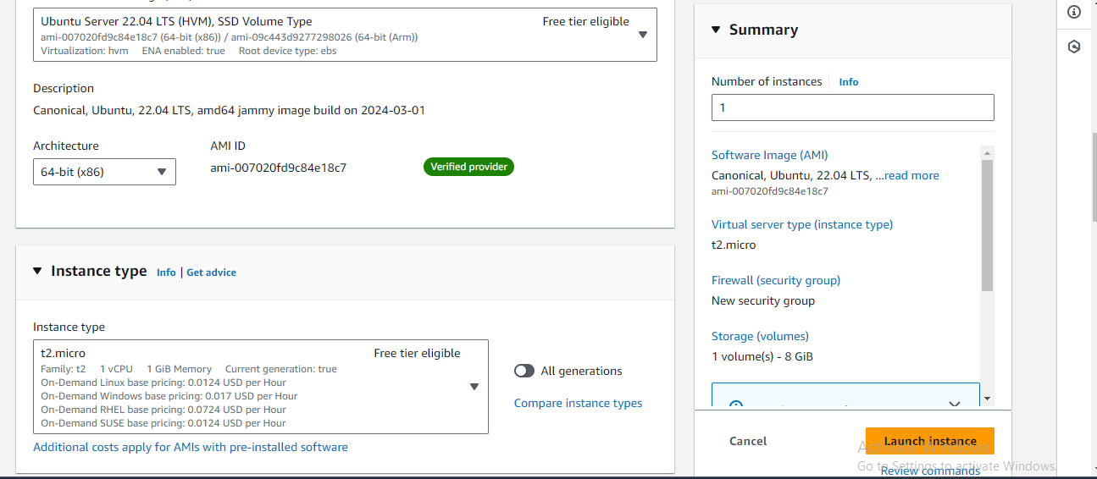

Create key pair using .ppk

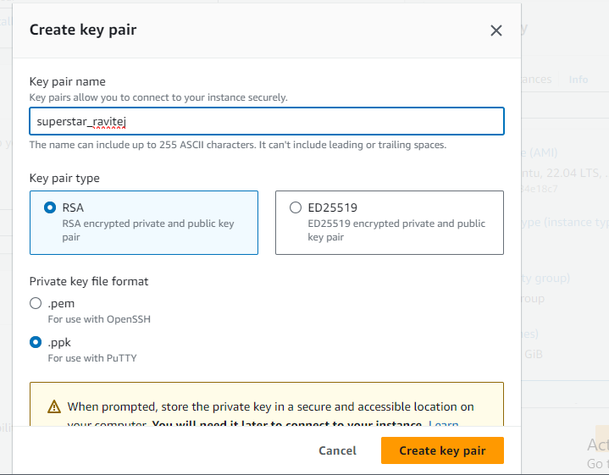





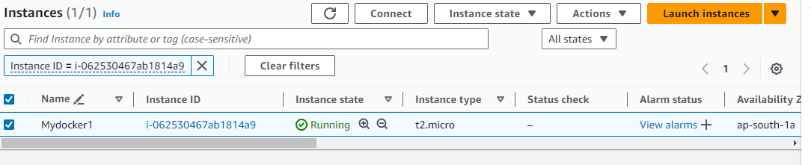

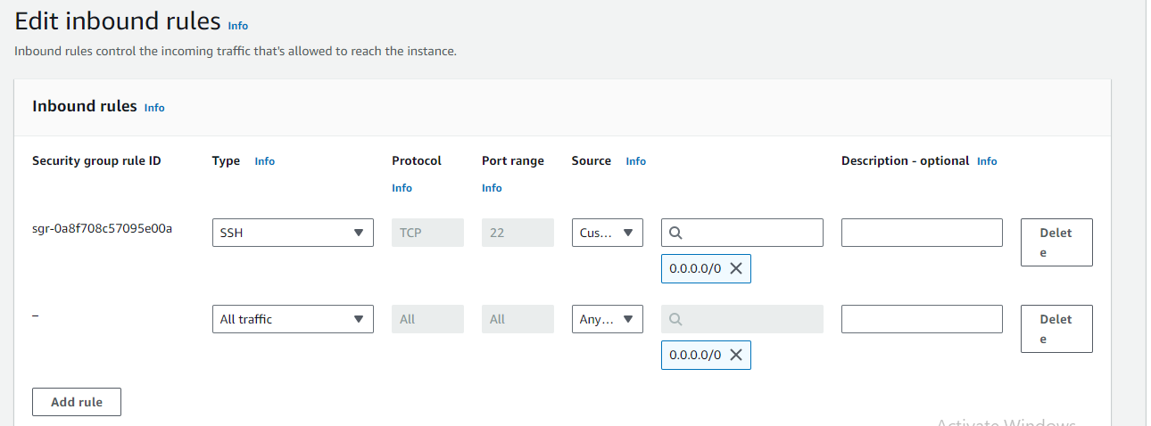

Give instance ip in host name and set port 22

Putty configuration

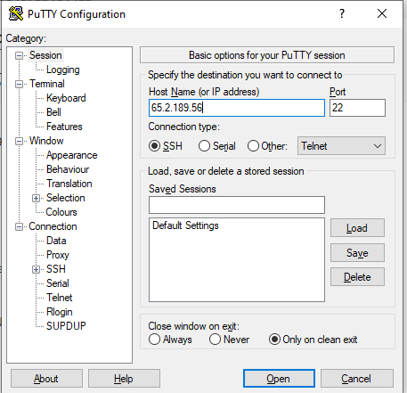

Connection->Data

Set auto login username as ubuntu

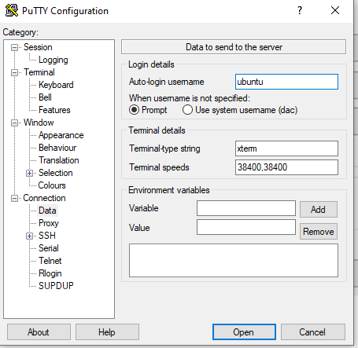

Connection->SSH->Auth->Credentials

Set path of private key file

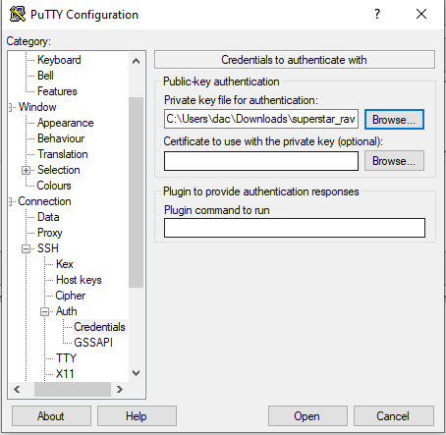

Accept

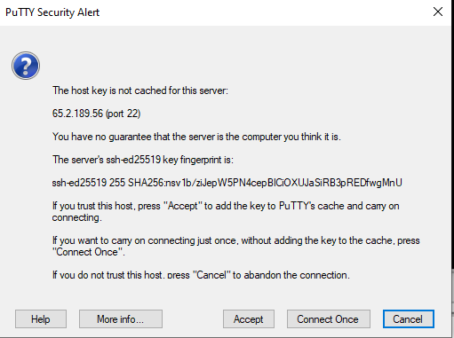

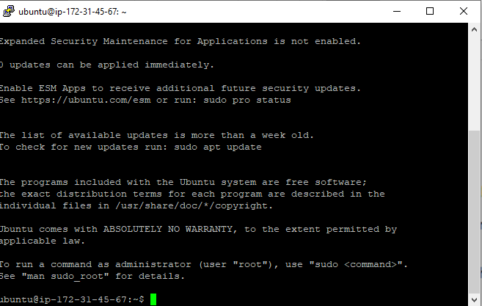

Commands for containerization

Sudo apt update

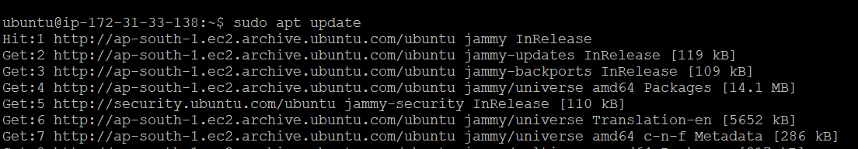

docker -v

sudo apt install docker.io

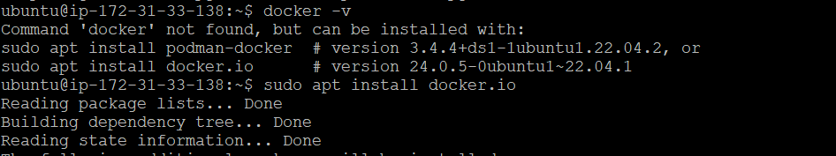

sudo systemctl status docker

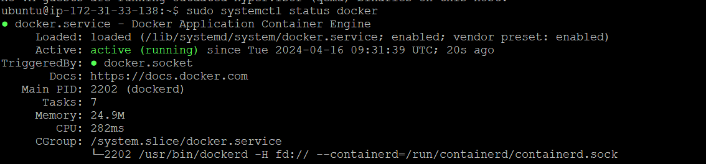

sudo docker ps

sudo docker images



sudo docker images

sudo docker run hello-world

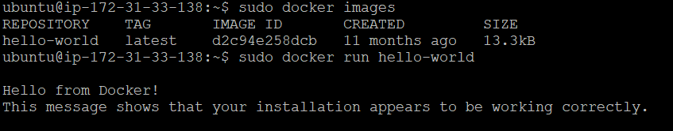

sudo docker pull nginx

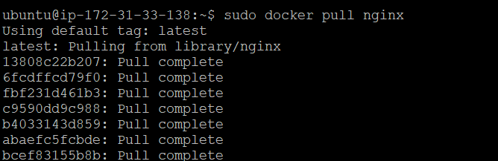

sudo docker images

sudo docker run --name Mydocker -d -p 8080:80 nginx

sudo docker ps

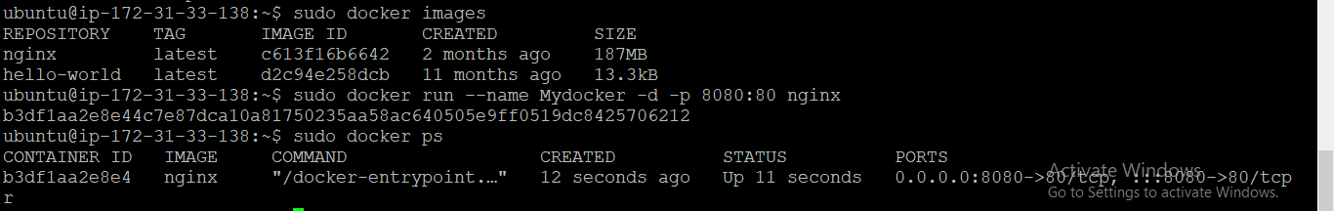

<Instance ip address>:8080

65.0.80.225:8080

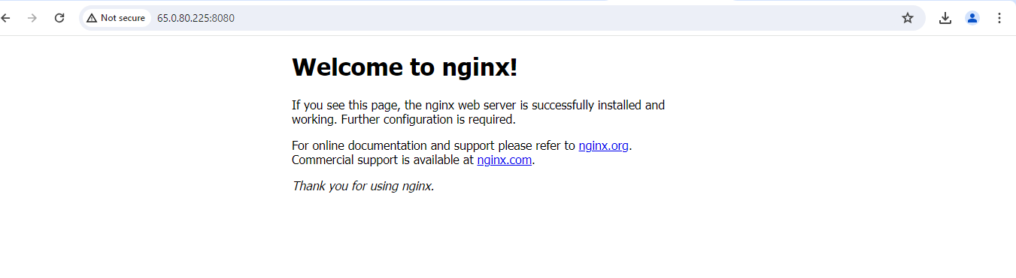

2)

mkdir tfl

cd tfl

tfl git clone <url of repository>

cd tflstore

ls

sudo docker images

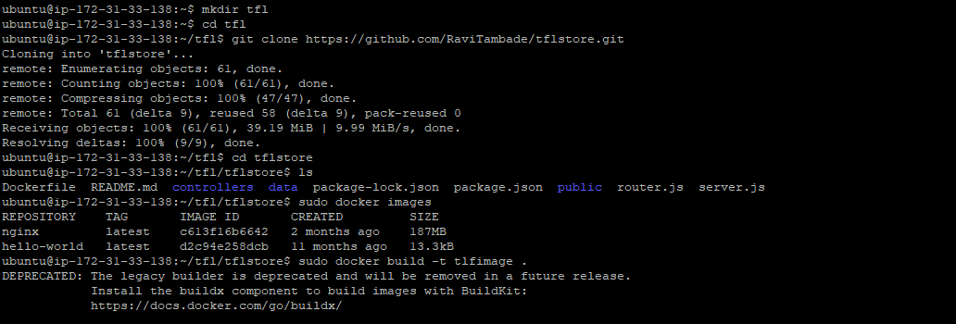

sudo docker build –t tflimage .

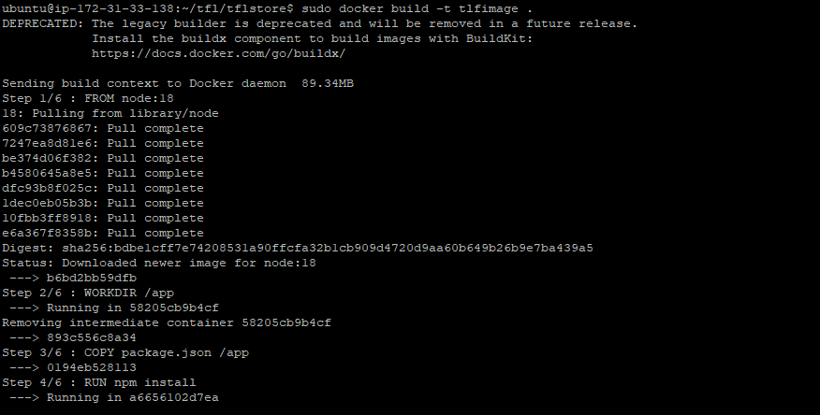

sudo docker images

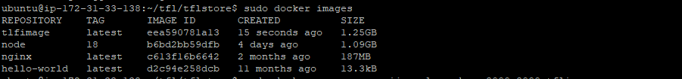

Sudo docker run –name vijaysales –d –p 8000:8000 tflimage



<ip address of instance>:8000

65.0.80.225:8000

