**SDM Asssignemt 1**

**BRANCH**

1) To check branch

🡺 > git branch

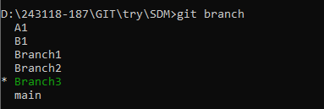

2) To create and switch branch

🡺 > git checkout -b SDM1

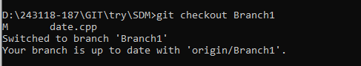

3) To check status of branch

🡺> git status

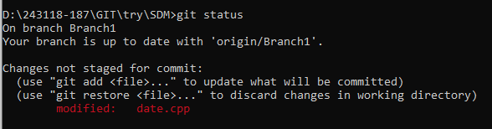

4) To add file to staging as snapshot

🡺> git add .



5) To check status after adding to stage

🡺> git status

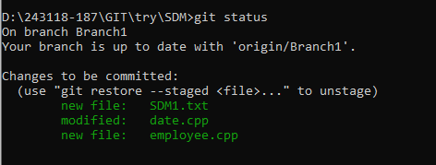

6) To commit file in local repository with message

🡺> git commit –m “pushing branch”

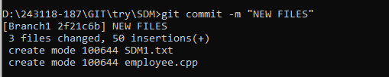

7) To pushing branch to remote repository using git

🡺> git push –u origin SDM1

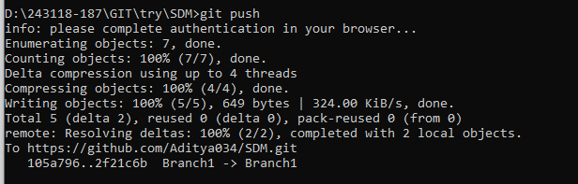

8) To merge we have to switch to main first and then merge

🡺> git checkout main

🡺>git merge SDM1

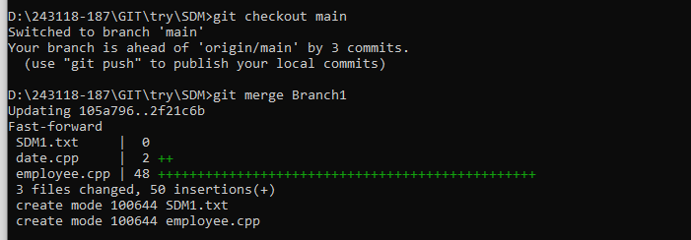

9) To push merge file into the remote repository we have to use this command

🡺>git push origin main

