# GitHub Actions

# Config server

Git-url: <https://github.com/ajoelflores124/pe-config-server>

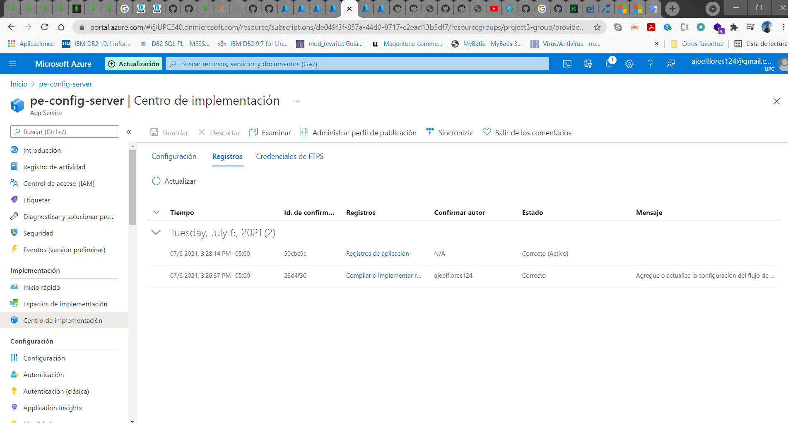

Aplicación desplegada

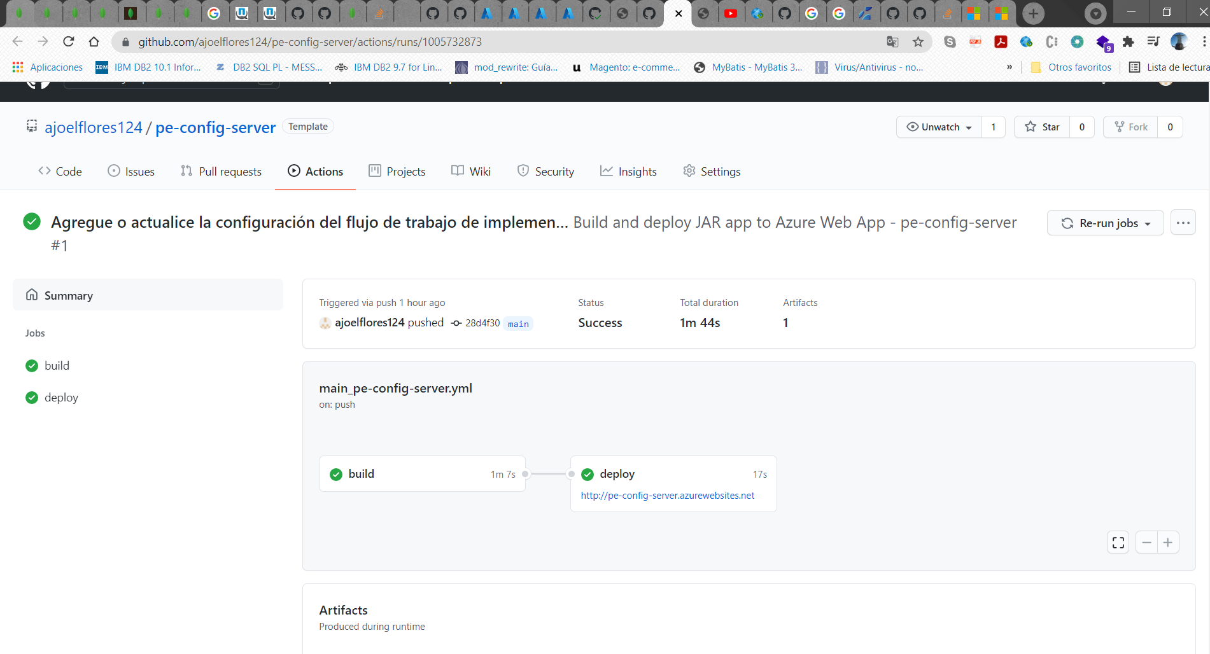

Evidencia:

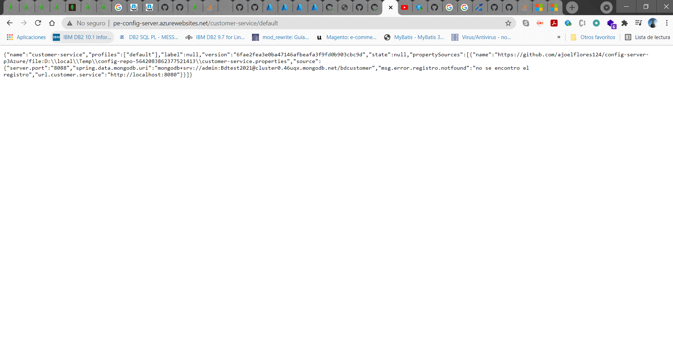

# Customer-service

url git: <https://github.com/ajoelflores124/pe-customer-service>

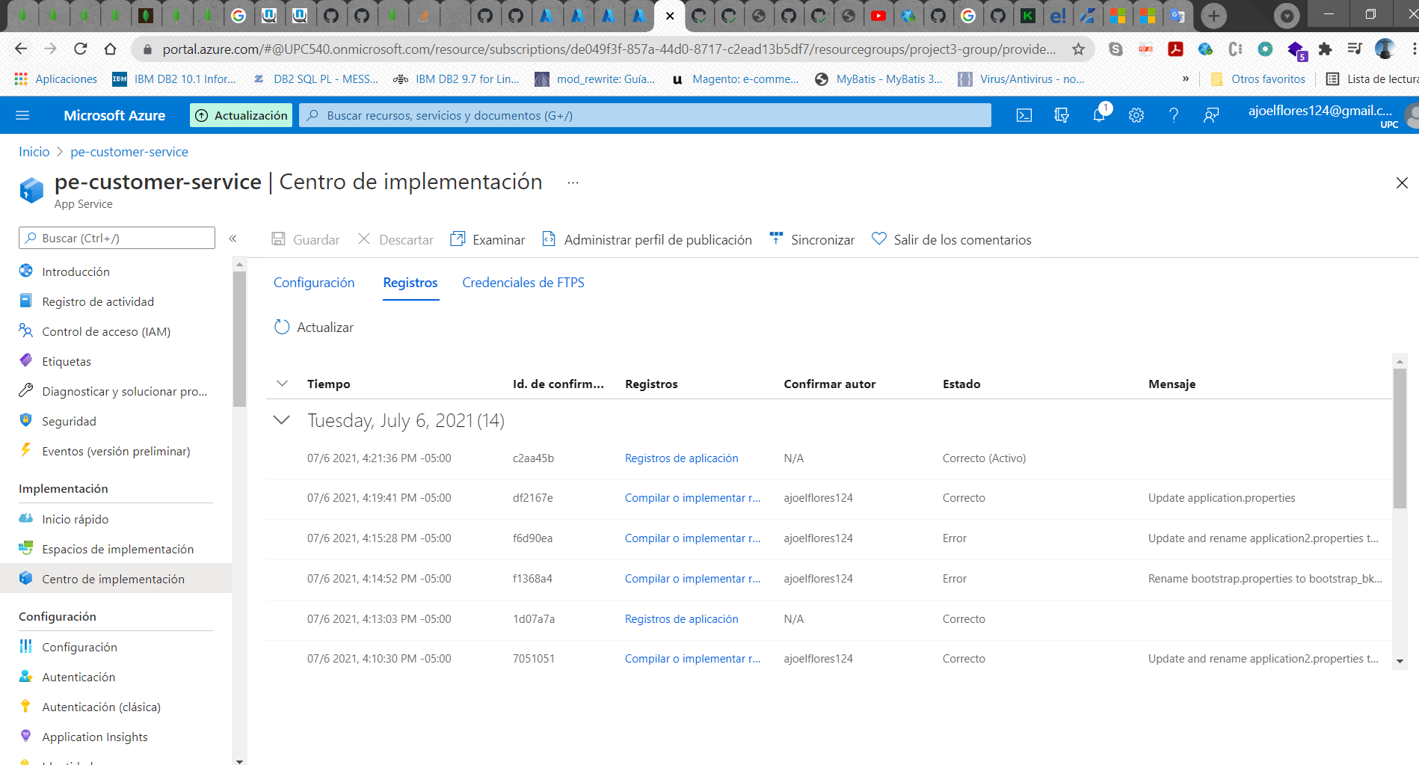

Aplicación desplegada

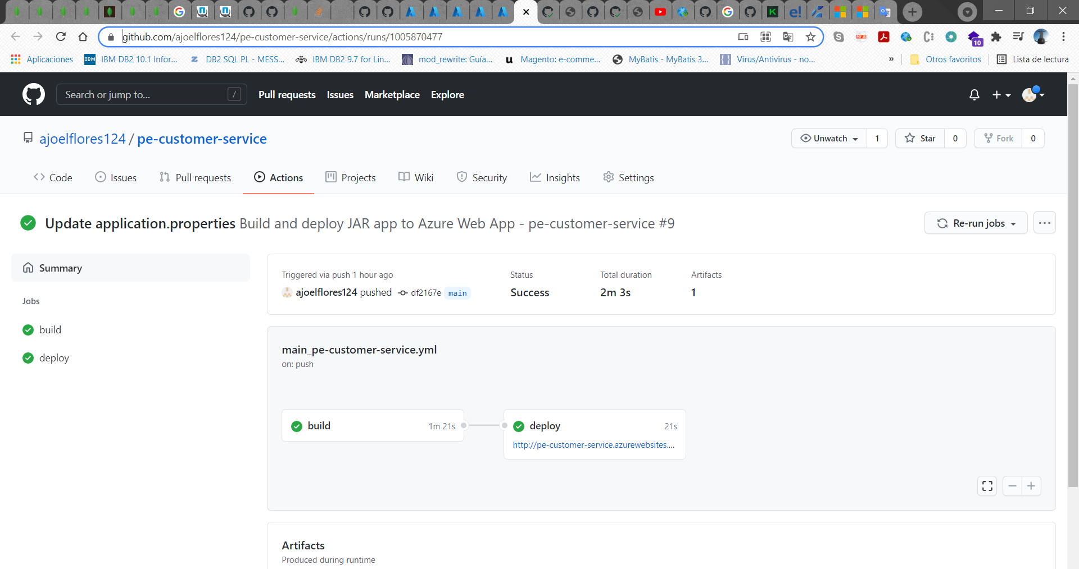

# Product Service

url git: <https://github.com/ajoelflores124/pe-product-service>

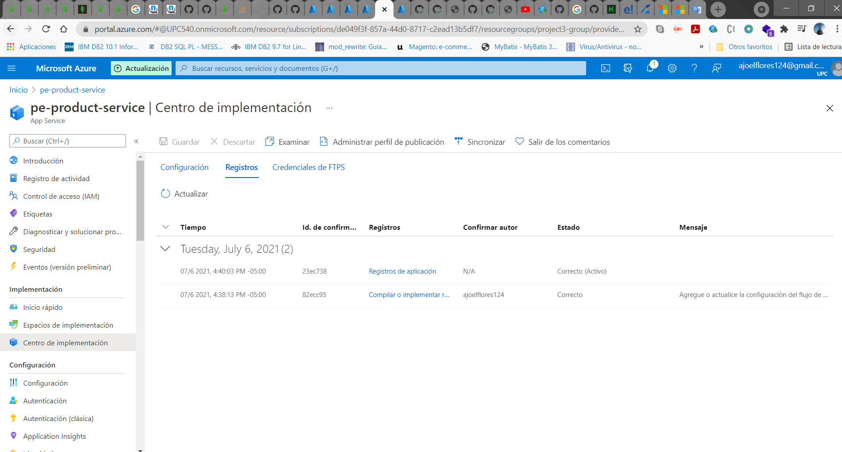

Aplicación desplegada

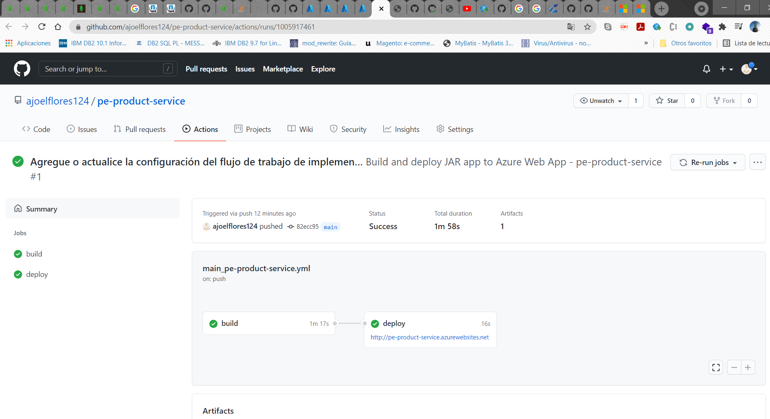

# Transaction – Service

url-git: <https://github.com/ajoelflores124/pe-transaction-service>

