**Lab Assessment**

**Program:1**

**import** java.util.Scanner;

**public** **class** PrintSeries {

**public** **static** **void** main(String args[]) {

**int** i,x=0,b=3;

Scanner sc =**new** Scanner(System.***in***);

System.***out***.print("Enter the Input : ");

**int** n=sc.nextInt();

**for**(i=0;i<n;i++)

{

System.***out***.print(" "+x);

x=x+b;

b=b+2;

}

}

}

**Output:**

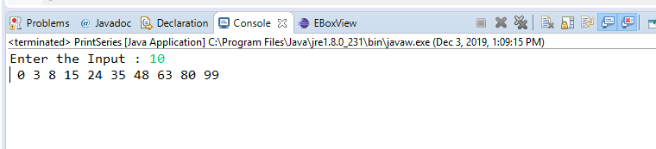

**Program:2**

**import** java.util.Scanner;

**public** **class** IntegerSort {

**void** sort(**int** arr[])

{

**int** n = arr.length;

// One by one move boundary of unsorted sub array

**for** (**int** i = 0; i < n-1; i++)

{

// Find the minimum element in unsorted array

**int** min_idx = i;

**for** (**int** j = i+1; j < n; j++)

**if** (arr[j] < arr[min_idx])

min_idx = j;

// Swap the found minimum element with the first

// element

**int** temp = arr[min_idx];

arr[min_idx] = arr[i];

arr[i] = temp;

}

}

// Prints the array

**void** printArray(**int** arr[])

{

**int** n = arr.length;

**for** (**int** i=0; i<n; ++i)

System.***out***.print(arr[i]+" ");

System.***out***.println();

}

// Driver code to test above

**public** **static** **void** main(String args[])

{

Scanner sc = **new** Scanner(System.***in***);

IntegerSort ob = **new** IntegerSort();

**int** k = 10;

**int** arr[] = **new** **int**[k];

System.***out***.println("Input the array elements:");

**for**(**int** i = 0; i < k; i++)

{

arr[i] = sc.nextInt();

//{4 8 1 3 45 12 36 99 81 9};

}

ob.sort(arr);

System.***out***.println("Array elements after sorting:");

ob.printArray(arr);

}

}

**Output:**

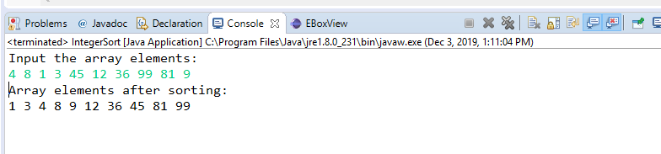

**Program:3**

**class** ProgOverLoadDemo {

**void** volume(**double** radius)

{

**double** c=(4.0/3.0) * 3.14 * (radius * radius * radius);

System.***out***.println("volume of sphere : "+c);

}

}

**public** **class** ProgOverLoad

{

**public** **static** **void** main(String args[])

{

ProgOverLoadDemo obj = **new** ProgOverLoadDemo();

obj.volume(48);

obj.volume(35);

}

}

**Output:**

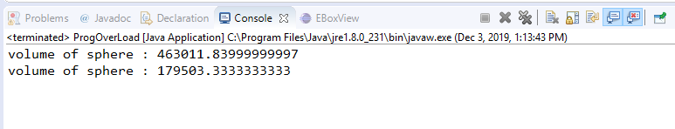

**Program:4**

**import** java.util.Scanner;

**public** **class** BillElectricity {

**private** **static** Scanner *sc*;

**public** **static** **void** main(String[] args)

{

String name;

**int** Units;

**double** Final_Amt;

*sc* = **new** Scanner(System.***in***);

//System.out.print("Customer name: ");

// name=sc.next();

System.***out***.print("Please Enter the Units that you Consumed : ");

Units = *sc*.nextInt();

Final_Amt = *Electricity*(Units);

System.***out***.println("Final amount: = " + Final_Amt);

}

**public** **static** **double** Electricity(**int** Units)

{

**double** Amount = 0, Suv_Tax=0.1475,Fixed_meter=250,Final_Amt, BillAmount;

**if** (Units <=100)

{

Amount = Units * 3.25;

}

**else** **if** (Units>100 && Units <= 300)

{

Amount =Units*4.75;

}

**else**

{

Amount = Units * 6.35;

}

BillAmount = Amount +Fixed_meter;

Final_Amt=BillAmount+(BillAmount*Suv_Tax);

**return** Final_Amt;

}

}

**Output:**

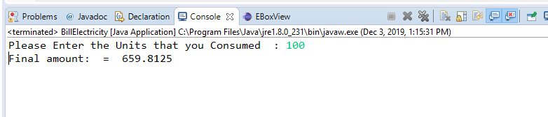

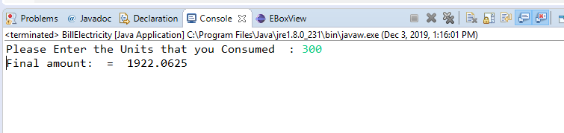

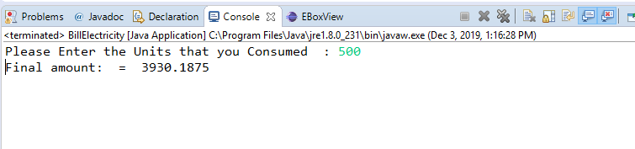

**Program:5**

**import** Classroom.Training;

**import** Student.Student;

**public** **class** Mainn {

**public** **static** **void** main(String[] args) {

Student s=**new** Student();

Training t=**new** Training();

System.***out***.println();

s.passed();

t.ends();

}

}

**package** Classroom;

**public** **class** Training {

**public** **boolean** started;

//constructor

**public** Training(){

started=**true**;

}

//method

**public** **void** ends()

{

System.***out***.println("Training ends");

}

}

**package** Student;

**public** **class** Student {

**public** **boolean** Present;

//constructor

**public** Student(){

Present=**true**;

}

//method

**public** **void** passed()

{

System.***out***.println("Student passed");

}

}

**Output:**

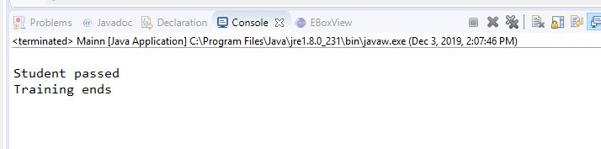

**Program:6**

**import** java.util.Scanner;

**public** **class** CommandLineArgs {

**public** **static** **void** main(String args[]) {

Scanner sc=**new** Scanner(System.***in***);

String full_name,address,email;

System.***out***.print("Full Name : ");

full_name=sc.nextLine();

System.***out***.print("Address : ");

address=sc.nextLine();

System.***out***.print("Email : ");

email=sc.nextLine();

**if**(full_name.isEmpty()) {

System.***out***.println("Insufficient data");

}

**else** **if**(address.isEmpty()) {

System.***out***.println("Insufficient data");

}

**else** **if**(email.isEmpty()) {

System.***out***.println("Insufficient data");

}

**else** {

System.***out***.println("Full Name : "+full_name + " ,Address : "+address+" ,Email : "+email);

}

}

}

**Output:**

