Alex Johnson

Steganography Final Project Compilation Guide

(For Mac OSX)

1. Download and install OpenCV
   1. <http://opencv.org/downloads.html>
   2. get latest version available for mac
2. Download and install CMake
   1. <https://cmake.org/download/>
   2. get latest version available for mac
3. Follow instructions on the following webpage to link OpenCV and CMake
   1. <http://blogs.wcode.org/2014/10/howto-install-build-and-use-opencv-macosx-10-10/>
   2. follow up until the *Make and Application* section
4. Download and unzip my project file
5. In Terminal, navigate to the project’s root directory
6. Enter the following commands

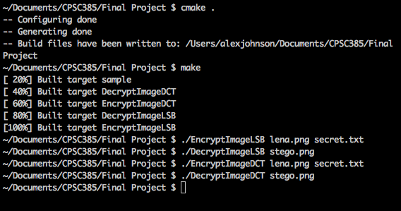

1. The original image is the lena.png image, which I found to be the most commonly used steganographic image. The output image from embedding is stored in stego.png in both the LSB and DCT methods. The output file from the decoding is output.txt for the LSB method and outputDCT.txt for the DCT method. Feel free to change the data in the secret.txt file, or even use a different image to hide the data in. However, the image must be a .png image for the DCT method to work properly, and the pixel dimensions of the image must be divisible by 8 or a segmentation fault will occur in the DCT method. Also note that some images will hide the data better than others. For example if you were to use a plain white image, it would be easier to see that part of the image is not as white as the rest.