**Pantry User Manual**

**Contents:**

* **Purpose**
* **Main Window Application**
* **Get Recipes Page**
* **All Recipes Page**

**GitHub Repository Address:**

**https://github.com/ajohnston49/SDEV140FinalProject_AlexJohnston**

**Purpose**

**During 2021, in the peak of the pandemic, everybody was stuck at home. People were going stir crazy and started taking on new hobbies and various activities to pass the time. Our family got into cooking! However, one other draw backs to the pandemic were the lack of certain ingredients required to cook most of the recipes I could find online. I would sometimes spend hours trying to search through hundreds of recipes before I found one that we could cook with the ingredients we had. So, we came up with Pantry. An application that allows you to choose what recipes you have and create a search to find tons of recipes you’re able to cook right now! This is also great for people who are low on money and have limited ingredients to work with, or maybe you’re a babysitter and never can figure out what to make the children you watch.**

**Whatever your cooking needs may be,**

**Pantry is your go to source for Recipes using what’s in *your p*antry.**

**Main Window Application**

**The main window of the Pantry application**

* **The Checklist on the side is to choose your ingredients; simply click as many ingredients that you would like to cook with.**
* **Once you have selected all your ingredients, click the Get Recipes button to see what recipes you can make.**
* **Or you can click the All Recipes button and see all the recipes Pantry has to offer! Many more will be available soon!**

**Get Recipes Page (1 of 3)**

**This is the Get Recipes Page**

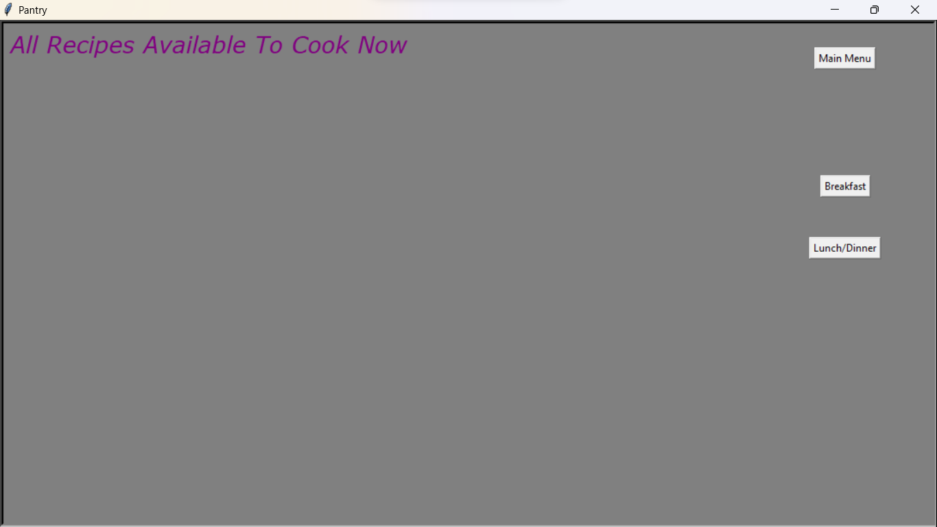

**After choosing your ingredients from the main window and chose to get recipes, you must choose another option, to cook breakfast, or lunch/dinner. Or, you can go back and choose different ingredients by clicking Main Menu**

**Get Recipes Page (2 of 3)**

**After choosing Breakfast or Lunch/Dinner, You will come to a menu like this**

**This is where you will find what recipes you have available**

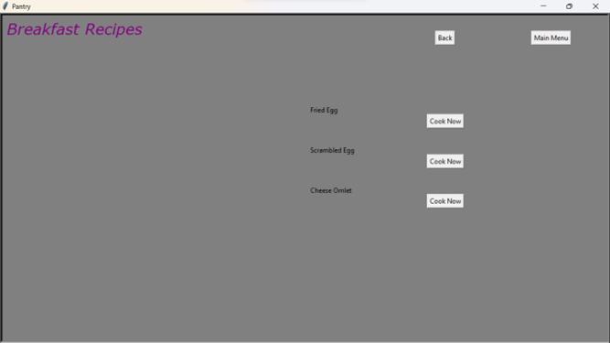

**You have several options here:**

* **you can choose to go back to the previous page and choose from the type of food you want to cook by clicking Back**
* **You can choose to go to the main menu and search with new ingredients by clicking Main Menu**
* **Or, you can choose to see the steps to the Recipe by clicking the Cook Now button next to the Recipe you’d like to cook!**

**Get Recipes Page (3 of 3)**

**Once You have chosen Cook Now on your selected Recipe, it will bring you to a page like this**

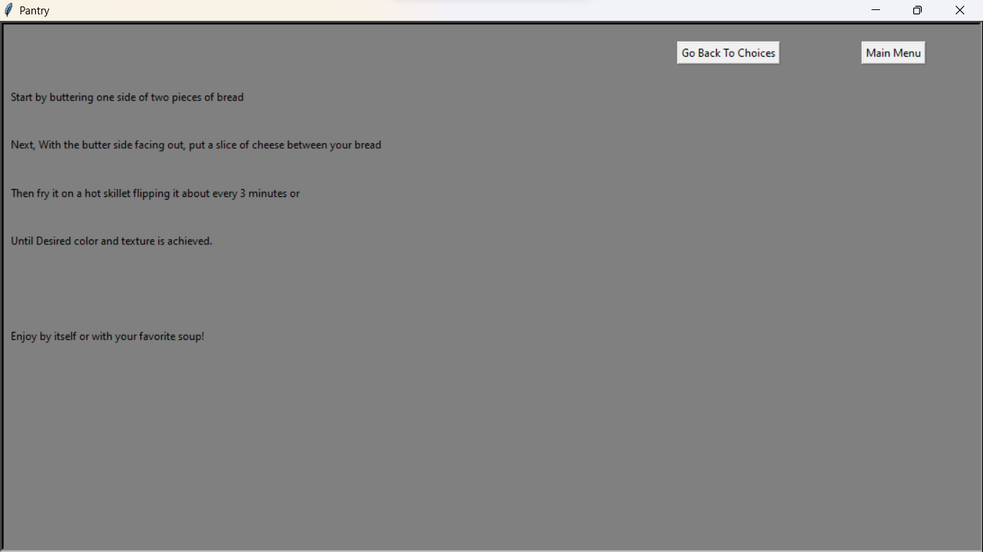

**On this page, it has steps to follow to cook your Recipe!**

**However, you can choose a different recipe based off your chosen ingredients**

**by clicking the Go Back To Choices button.**

**Or, you can start over and select new ingredients by clicking the Main Menu button**

**All Recipes Page**

**You may choose to click on the All Recipes button from the main window and see**

**all the available recipes pantry has to offer.**

**The menu looks like this:**

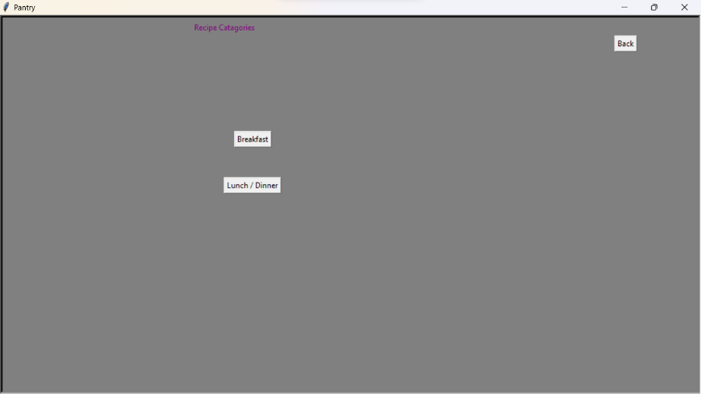

**From here you select a category, or click Back to go to the Main Menu**

**When you select a category, you will get a page with all the recipes available in that category.**

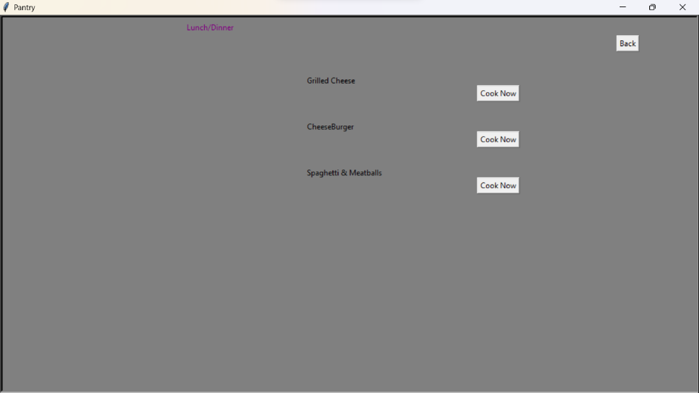

**Simply hit Cook Now to view the Recipe steps, or click back to select another category!**