SDEV 248 - Group Project #1
Team : Threek
Collaborators:

Alex Johnston
--------------
-------------

Ivy Tech Community College
Working Title: Knight Up

Assets Being used:

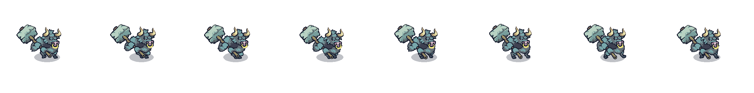
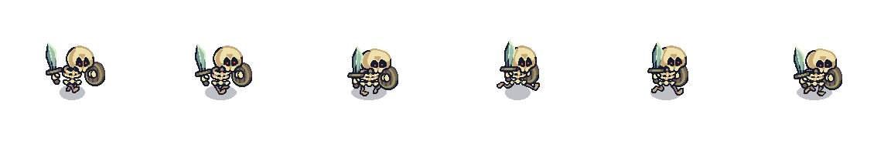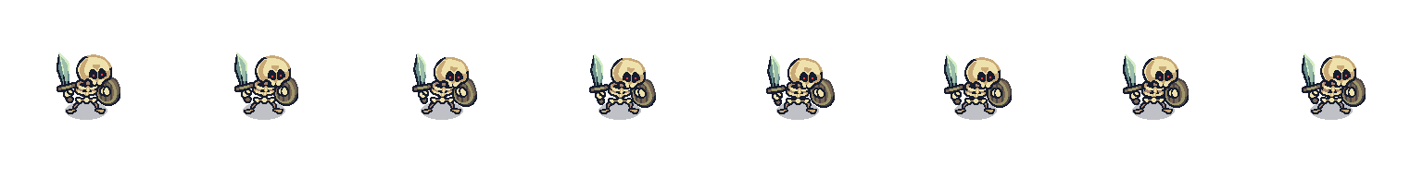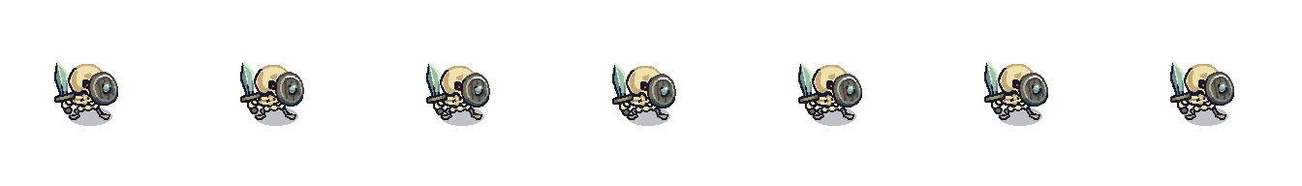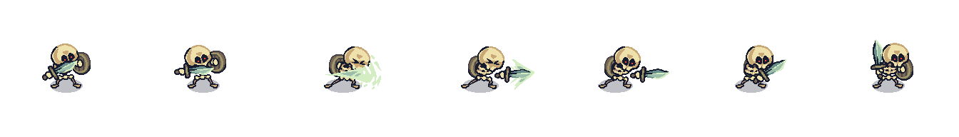
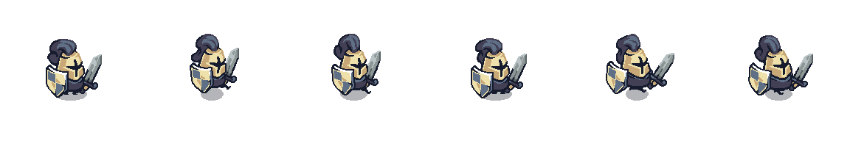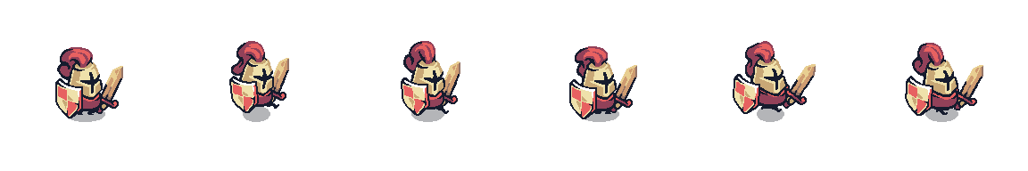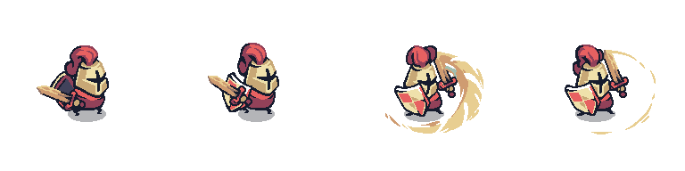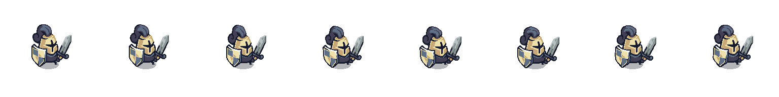
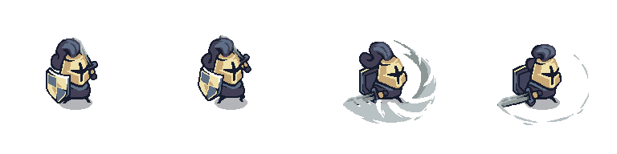

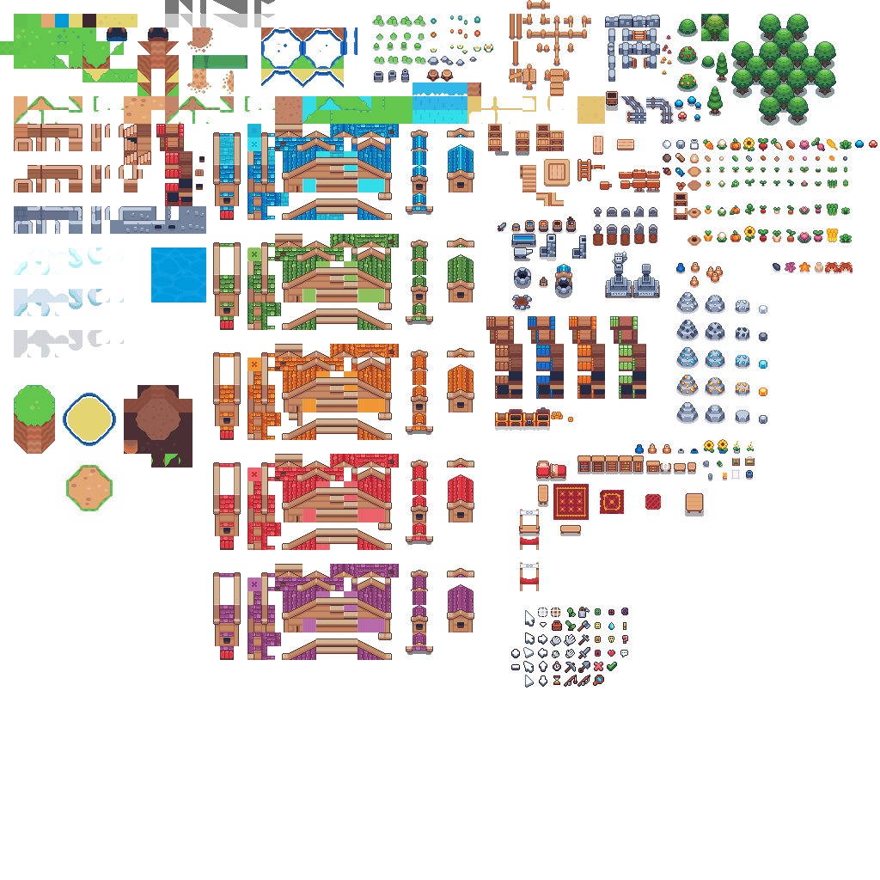

Steps To Final Product:

Step 1: Choose Your Screens
- Pick three sequential screens from the original Legend of Zelda (forest, dungeon, graveyard, etc.).
- Avoid trap or repeating maze screens.
- Decide as a group which ones fit best with the story you want to tell.
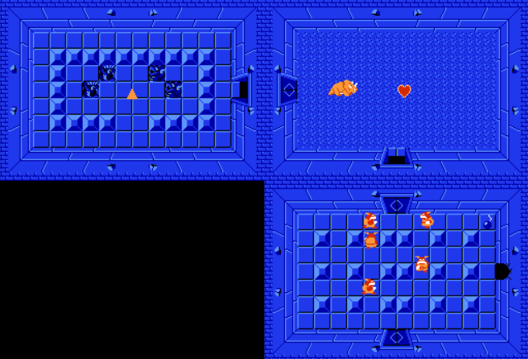

Step 2: Define Your Story
- Write a short original story that ties the three screens together.
- Plan a cut-scene intro (text-based) to set the stage.
- Plan two endings: one for success, one for failure (also text-based).

Cut-Scene 1: Entering the Dungeon
- The knight descends into the cursed halls.

- Legends speak of a relic hidden deep within — guarded by the dead and the damned.

- He draws his blade. The trial begins.

Cut-Scene 2: After Beating the Skeletons

- The restless dead lie shattered.

- But deeper in the dungeon, a greater beast stirs.

- The knight presses on, heart steady, toward the horned guardian.

Cut-Scene 3: After Beating the Minotaur

- The beast falls with a final roar.

- Beyond the chamber lies the relic — untouched, gleaming, waiting.

- But the knight is not alone...

NPC Dialogue (Final Room Betrayal)
- A second knight steps from the shadows.

- "You did well. But this relic belongs to the Order."

- Before the knight can react, steel flashes.

- Darkness falls. The relic is taken.

- To be continued...

Step 3: Build the Tilemap
- Use Godot’s TileMap node to recreate the layout of obstacles and walls.
- Match the Zelda screen layouts, but adapt them to your own art style if you want.
Level 1 Design: First edit:
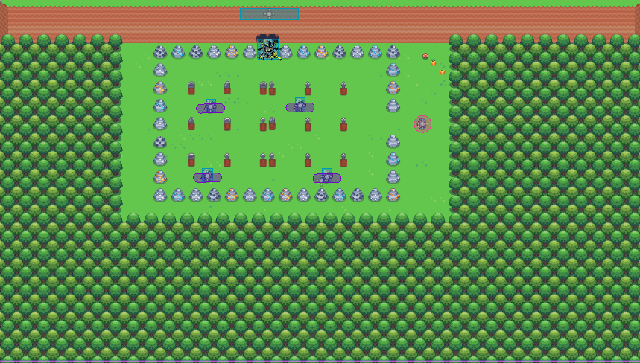
Final edit:
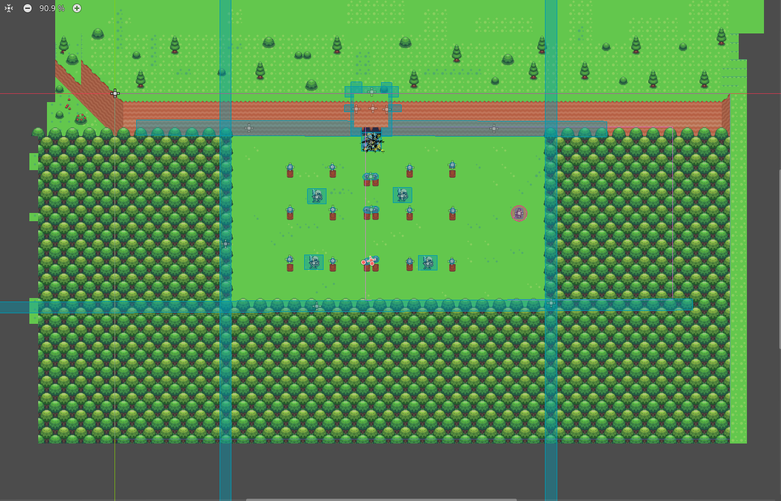
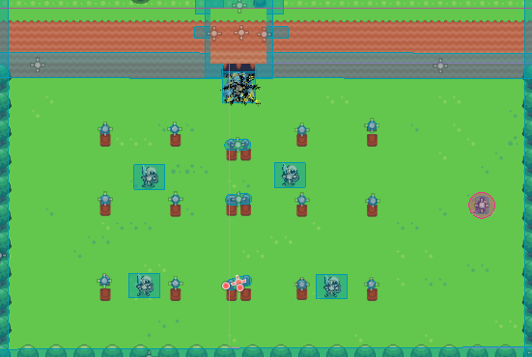
From :
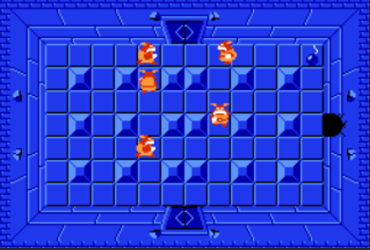

Level 2 Design :
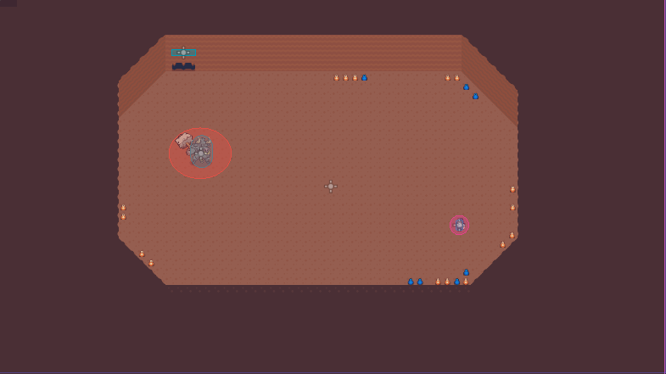
Level 2 oem :
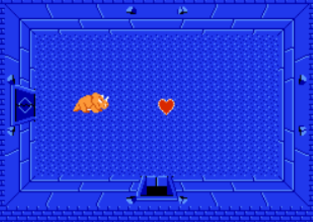

Level 3 design :
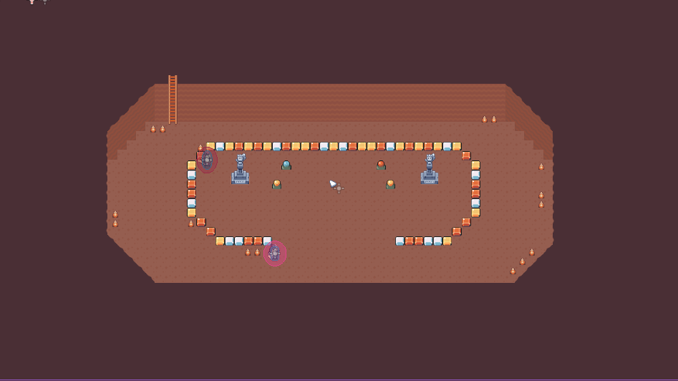
Level 3 oem:
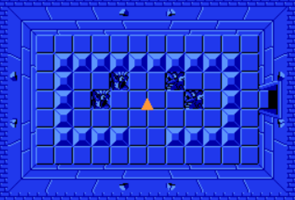

Step 4: Add MOBs (Enemies)
- Place enemies in each room.
- Program them to move in non-random patterns (patrol routes, chasing, circling).
- Make sure they can interact meaningfully with the player (damage, blocking paths, etc.).

Skeleton:
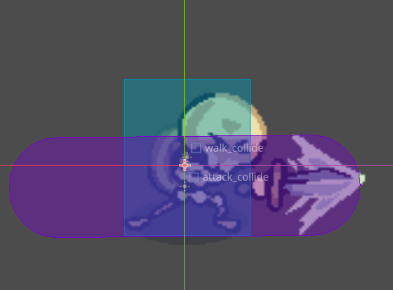
Seen: First Level
Count: 4
Animations:
- Run
- Idle
- Attack
- Block
Easier oppent for first level

Minitour:
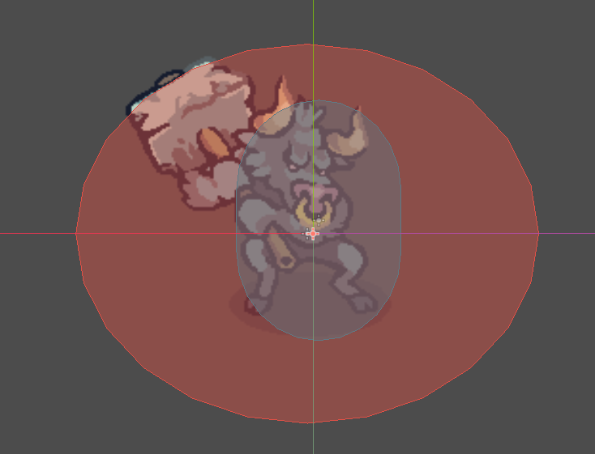
Seen: Second Level
Count: 1
Seen as a boss, will have a decorative health container to show if you beat him or not, he is what deifnes win or lose.

Step 5: Add an NPC
Red:
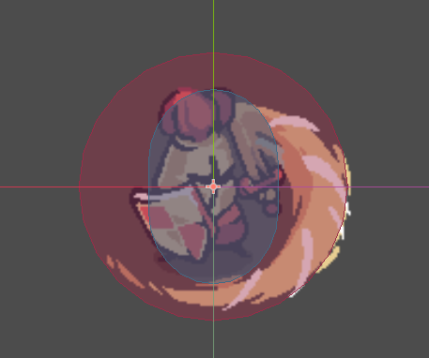
This is the other Knight found in the dungeon after the boss. If you chose to interact with him, he will befriend you and give you the artifact, however if you interact with the artifact first, then he will attack you (one hit he kills you, hidden boss, he is beatable)

Step 6: Player Controls
- Implement top-down movement (arrow keys/WASD).
- Add collision with walls and obstacles.
- Ensure smooth input control, just like the first project.
Complete
Step 7: Cut-Scenes
- Intro cut-scene: text explaining the story.
- Success cut-scene: text for winning.
- Failure cut-scene: text for losing.
- Keep them simple but clear.
Step 8: Test & Polish
- Play through all three screens.
- Check MOB movement patterns.
- Verify cut-scenes trigger correctly.
- Make sure the game feels complete and playable.

