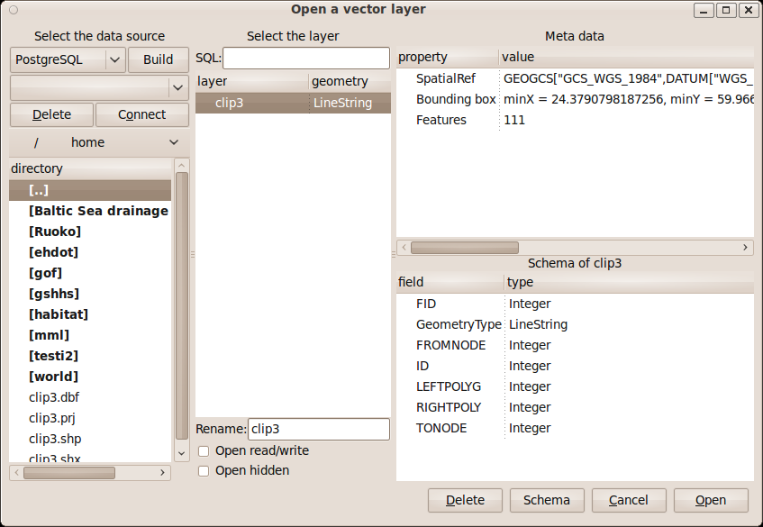
open_vector_dialog

open_vector_driver_combobox
open_vector_datasource_build_connection_button
open_vector_datasource_combobox
open_vector_delete_datasource_button
open_vector_connect_datasource_button
open_vector_directory_toolbar
open_vector_directory_treeview
open_vector_SQL_entry
open_vector_layer_treeview
open_vector_layer_name_entry
open_vector_update_checkbutton
open_vector_open_hidden_checkbutton
open_vector_property_treeview
open_vector_schema_label
open_vector_schema_treeview
open_vector_remove_button
open_vector_schema_button
open_vector_cancel_button
open_vector_ok_button

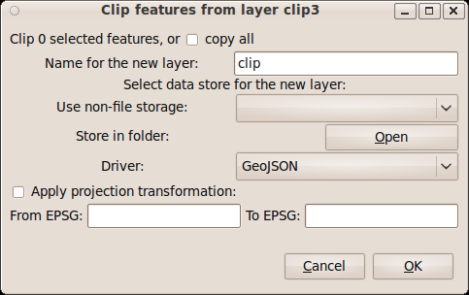

clip_vector_dialog

clip_count_label
clip_all_checkbutton
clip_name_entry
clip_non_file_source_label
clip_file_source_label
clip_datasource_combobox
clip_datasource_label
clip_datasource_button
clip_driver_combobox
clip_projection_checkbutton
from_EPSG_entry
from_srs_label
to_EPSG_entry
to_srs_label
clip_cancel_button
clip_ok_button

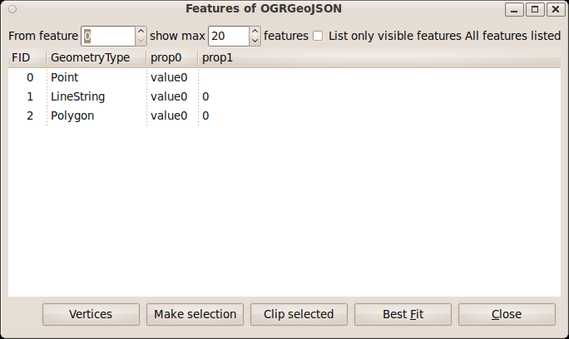
features_dialog

from_feature_spinbutton
max_features_spinbutton
features_limit_checkbutton
all_features_label
feature_treeview
features_vertices_button
make_selection_button
clip_selected_button
zoom_to_button
close_features_button

