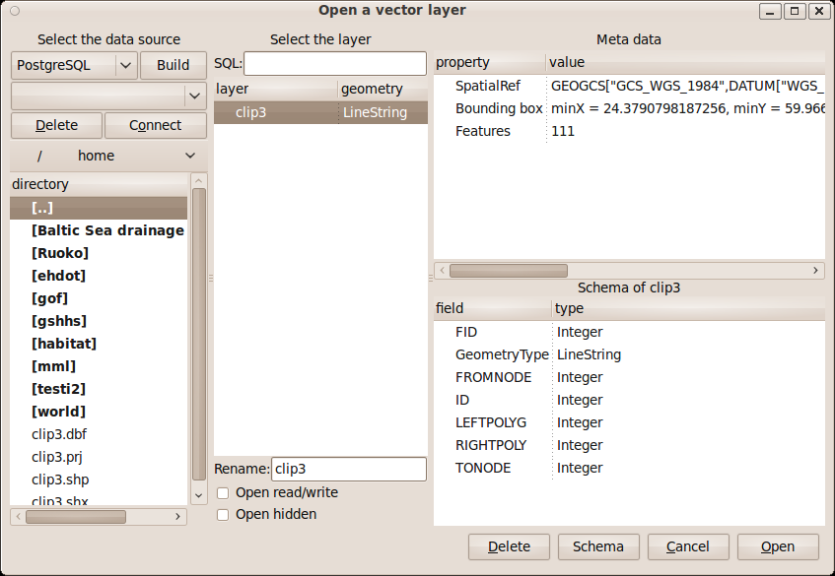
open_vector_dialog

open_vector_driver_combobox
open_vector_datasource_build_connection_button
open_vector_datasource_combobox
open_vector_delete_datasource_button
open_vector_connect_datasource_button
open_vector_directory_toolbar
open_vector_directory_treeview
open_vector_SQL_entry
open_vector_layer_treeview
open_vector_layer_name_entry
open_vector_update_checkbutton
open_vector_open_hidden_checkbutton
open_vector_property_treeview
open_vector_schema_label
open_vector_schema_treeview
open_vector_remove_button
open_vector_schema_button
open_vector_cancel_button
open_vector_ok_button

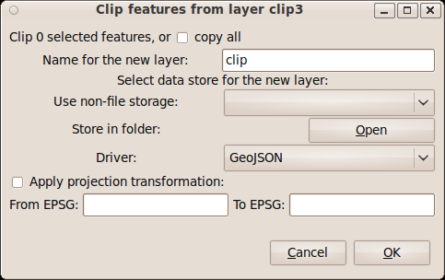

copy_vector_dialog

copy_count_label
copy_all_checkbutton
copy_name_entry
copy_non_file_source_label
copy_file_source_label
copy_datasource_combobox
copy_datasource_label
copy_datasource_button
copy_driver_combobox
copy_projection_checkbutton
from_EPSG_entry
from_srs_label
to_EPSG_entry
to_srs_label
copy_cancel_button
copy_ok_button

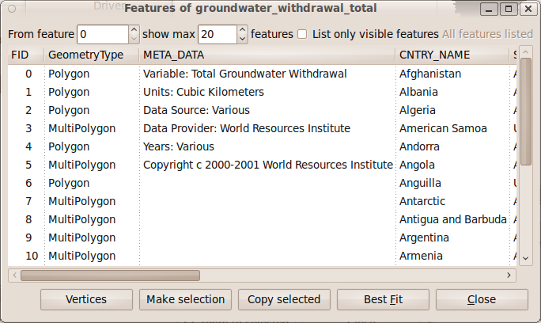
features_dialog

from_feature_spinbutton
max_features_spinbutton
features_limit_checkbutton
all_features_label
feature_treeview
features_vertices_button
make_selection_button
copy_selected_button
zoom_to_button
close_features_button

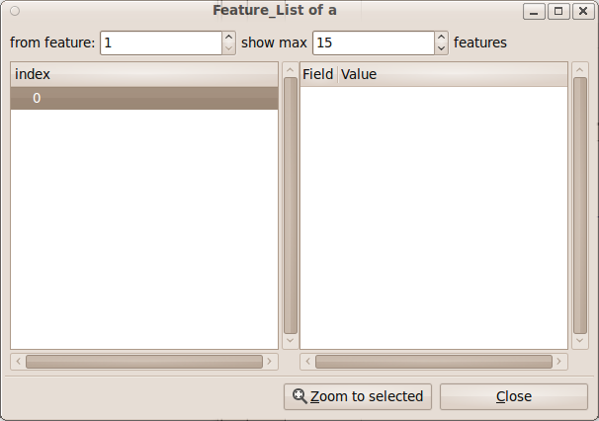

feature_list_dialog

feature_list_from_spinbutton
feature_list_max_spinbutton
feature_list_treeview
feature_list_attributes_treeview
feature_list_zoom_to_button
feature_list_close_button

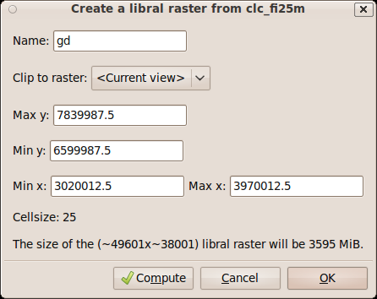

copy_dialog

copy_driver_combobox
copy_name_entry
copy_folder_button
copy_folder_entry
copy_region_combobox
copy_maxy_entry
copy_miny_entry
copy_minx_entry
copy_maxx_entry
copy_cellsize_entry
copy_size_label
copy_memory_size_label
copy_projection_checkbutton
from_EPSG_entry
from_srs_label
to_EPSG_entry
to_srs_label
copy_compute_button
copy_cancel_button
copy_ok_button

