Reproducible research project

## Activity monitoring data

This is an R Markdown document created to provide the reader with the code and guide to processing the activity data set. This data set was provided in a **csv** format that was loaded into R and saved as **activity_file** using the following commands

setwd("c:/misc/data science")  
active_file<-read.csv("activity.csv")

## Loading required packages

To start, we load the required package, dplyr, for the data analysis

library(dplyr)

## Warning: package 'dplyr' was built under R version 3.3.3

##   
## Attaching package: 'dplyr'

## The following objects are masked from 'package:stats':  
##   
## filter, lag

## The following objects are masked from 'package:base':  
##   
## intersect, setdiff, setequal, union

## Preparing data

With the data loaded, we can begin the processing steps. First, convert the 'date' variable to date format. We can the apply the efficient **group_by** and **summarize** functions.

active_file$date<-as.Date(active_file$date)  
active_date<-group_by(active_file,date)  
ggg<-summarize(active_date,total=sum(steps),avrg=mean(steps,na.rm=TRUE),maxi=max(steps),mini=min(steps))  
  
head(active_file)

## steps date interval  
## 1 NA 2012-10-01 0  
## 2 NA 2012-10-01 5  
## 3 NA 2012-10-01 10  
## 4 NA 2012-10-01 15  
## 5 NA 2012-10-01 20  
## 6 NA 2012-10-01 25

head(ggg)

## # A tibble: 6 × 5  
## date total avrg maxi mini  
## <date> <int> <dbl> <int> <int>  
## 1 2012-10-01 NA NaN NA NA  
## 2 2012-10-02 126 0.43750 117 0  
## 3 2012-10-03 11352 39.41667 613 0  
## 4 2012-10-04 12116 42.06944 547 0  
## 5 2012-10-05 13294 46.15972 555 0  
## 6 2012-10-06 15420 53.54167 526 0

Note that the total steps on 2012-10-01 shows as NA. As shown below, if na.rm=TRUE is used, the total is zero.

ggg2<-summarize(active_date,total=sum(steps,na.rm=TRUE),avrg=mean(steps,na.rm=TRUE),maxi=max(steps,na.rm=TRUE),mini=min(steps,na.rm=TRUE))  
  
head(ggg2)

## # A tibble: 6 × 5  
## date total avrg maxi mini  
## <date> <int> <dbl> <int> <int>  
## 1 2012-10-01 0 NaN NA NA  
## 2 2012-10-02 126 0.43750 117 0  
## 3 2012-10-03 11352 39.41667 613 0  
## 4 2012-10-04 12116 42.06944 547 0  
## 5 2012-10-05 13294 46.15972 555 0  
## 6 2012-10-06 15420 53.54167 526 0

## Mean total number of steps

Below is a histogram showing the total number of steps per day (on the x-axis), and how many days (on y-axis) that occured. The mean, median, and maximun total number of steps taken a day are also shown below.

hist(ggg2$total,col="red")

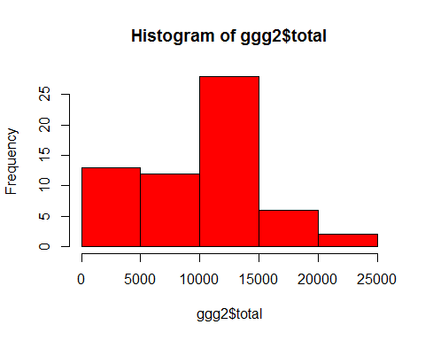

mean(ggg2$total,na.rm=TRUE)

## [1] 9354.23

median(ggg2$total,na.rm=TRUE)

## [1] 10395

max(ggg2$total,na.rm=TRUE)

## [1] 21194

## Average daily activity pattern

Rather than grouping by date, we can group the data by the 5 minute intervals using the following code.Here, we have plotted a graph of the average number of steps at a given interval (on y-axis), against the corresponding interval (on the x-axis). Also shown below is the interval with the maximum mean total number of steps. This was determined by first ordering the data in descending order of the average number of steps

t_series<-group_by(active_file,interval)  
t_seriesdata<-summarize(t_series,avg_at_interval=mean(steps,na.rm=TRUE))  
with(t_seriesdata,plot(interval,avg_at_interval,type="l"))

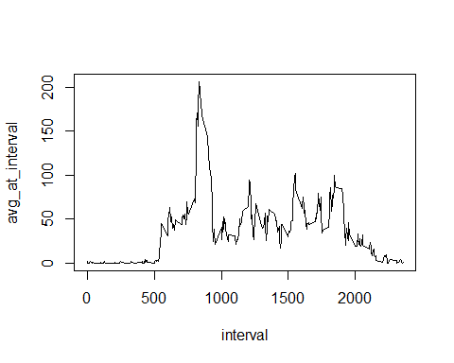

ordered_data<-arrange(t_seriesdata,desc(avg_at_interval))  
head(ordered_data)

## # A tibble: 6 × 2  
## interval avg_at_interval  
## <int> <dbl>  
## 1 835 206.1698  
## 2 840 195.9245  
## 3 850 183.3962  
## 4 845 179.5660  
## 5 830 177.3019  
## 6 820 171.1509

max_interval<-as.numeric(ordered_data[1,1])  
max_interval

## [1] 835

## IMPUTING MISSING VALs

In this section, we are interested in filling the missing values with appropriate values. To start with, we want to know how many missing values are in the **steps** column:

sum(is.na(active_file[,1]))

## [1] 2304

Rather than ignoring the NAs as we did previously, we will replace the NAs with the daily average (averaged over the 7 days of a week) at the given interval. This is done using a 'for loop'. Displayed below are the first few rows and last few rows of the modified data.

for(i in 1:length(active_file$interval)){  
 inte<-active_file[i,3]  
 if(is.na(active_file[i,1])){active_file[i,1]<-t_seriesdata[t_seriesdata$interval==inte,2]  
 }  
}  
head(active_file)

## steps date interval  
## 1 1.7169811 2012-10-01 0  
## 2 0.3396226 2012-10-01 5  
## 3 0.1320755 2012-10-01 10  
## 4 0.1509434 2012-10-01 15  
## 5 0.0754717 2012-10-01 20  
## 6 2.0943396 2012-10-01 25

tail(active_file)

## steps date interval  
## 17563 2.6037736 2012-11-30 2330  
## 17564 4.6981132 2012-11-30 2335  
## 17565 3.3018868 2012-11-30 2340  
## 17566 0.6415094 2012-11-30 2345  
## 17567 0.2264151 2012-11-30 2350  
## 17568 1.0754717 2012-11-30 2355

Now, we determine the statistics as we did previously:

active_date2<-group_by(active_file,date)  
ggg3<-summarize(active_date2,total=sum(steps),avrg=mean(steps,na.rm=TRUE),maxi=max(steps),mini=min(steps))  
  
hist(ggg3$total,col="red")

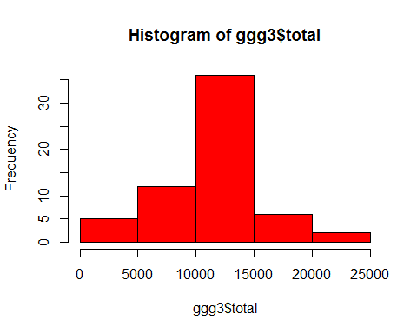

mean(ggg3$total,na.rm=TRUE)

## [1] 10766.19

median(ggg3$total,na.rm=TRUE)

## [1] 10766.19

max(ggg3$total,na.rm=TRUE)

## [1] 21194

Clearly, this process has a desirable effect of creating a histogram that is more bell-shaped. The mean now coincides with the median. Whereas, without the NAs replaced, the mean was lower than the median.

## Weekday and Weekend activity

In this section, we are interested in determining the statistics of the steps taken during the weekdays, and compare them with weekends. To start, we create a new variable **wkday**, which shows the day of the week (i.e. Monday, Tuesday, e.t.c). We then create a factor variable with two levels, **wkday** and **wkend**, corresponding to days that fall on a weekday or a weekend, respectively.

act_fileday<-mutate(active_file,wkday=weekdays(date))  
  
data_part3<-mutate(act_fileday,facto=factor(wkday=="Saturday"|wkday=="sunday",labels=c("wkday","wkend")))  
head(data_part3)

## steps date interval wkday facto  
## 1 1.7169811 2012-10-01 0 Monday wkday  
## 2 0.3396226 2012-10-01 5 Monday wkday  
## 3 0.1320755 2012-10-01 10 Monday wkday  
## 4 0.1509434 2012-10-01 15 Monday wkday  
## 5 0.0754717 2012-10-01 20 Monday wkday  
## 6 2.0943396 2012-10-01 25 Monday wkday

We can determine the statistics for weekdays separate from weekends as follows:

desireddata<-group_by(data_part3,interval,facto)  
desireddata2<-summarize(desireddata,avgint=mean(steps))  
head(desireddata2)

## Source: local data frame [6 x 3]  
## Groups: interval [3]  
##   
## interval facto avgint  
## <int> <fctr> <dbl>  
## 1 0 wkday 1.94375222  
## 2 0 wkend 0.21462264  
## 3 5 wkday 0.38447846  
## 4 5 wkend 0.04245283  
## 5 10 wkday 0.14951940  
## 6 10 wkend 0.01650943

To create the final plot to show this separate statistics, first load the **lattice** package and apply the **xyplot** function as follows:

library(lattice)  
xyplot(avgint~interval|facto,data=desireddata2,layout=c(1,2),type="l")

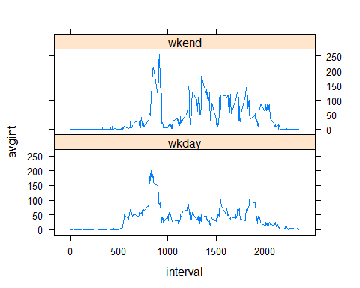

t_series<-group_by(active_file,interval)  
t_seriesdata<-summarize(t_series,avg_at_interval=mean(steps,na.rm=TRUE))  
with(t_seriesdata,plot(interval,avg_at_interval,type="l"))



max_interval<-t_seriesdata[max(t_seriesdata$avg_at_interval),1]  
max_interval

## # A tibble: 1 × 1  
## interval  
## <int>  
## 1 1705

ordered_data<-arrange(t_seriesdata,desc(avg_at_interval))  
head(ordered_data)

## # A tibble: 6 × 2  
## interval avg_at_interval  
## <int> <dbl>  
## 1 835 206.1698  
## 2 840 195.9245  
## 3 850 183.3962  
## 4 845 179.5660  
## 5 830 177.3019  
## 6 820 171.1509

as.numeric(ordered_data[1,1])

## [1] 835