# Reproducible Research: Peer Assessment 2

Pooja Sharma May 19, 2016

## Analysis of Impacts on Public Health and Economy of USA due to harsh weather

### ABSTRACT:

Severe weather causes impacts on both economy of country and health of people living there. The U.S. National Oceanic and Atmospheric Administration (NOAA) Storm Database has tracked economic losses, fatalities, and injuries associated with major storm events from 1950 onwards to 2011.

In this report, we will use the NOAA database to analyze the total fatality, total injury, and total economic loss over this time frame due to different storms.

The raw data can be easily accessed from [National Weather Service Data][1]. [1]: <https://d396qusza40orc.cloudfront.net/repdata%2Fdata%2FStormData.csv.bz2> "National Weather Service Data"

### FUNDAMENTAL SETTINGS BEFORE DATA PROCESSING:

library(R.utils)

## Warning: package 'R.utils' was built under R version 3.2.5

## Loading required package: R.oo

## Loading required package: R.methodsS3

## R.methodsS3 v1.7.1 (2016-02-15) successfully loaded. See ?R.methodsS3 for help.

## R.oo v1.20.0 (2016-02-17) successfully loaded. See ?R.oo for help.

##   
## Attaching package: 'R.oo'

## The following objects are masked from 'package:methods':  
##   
## getClasses, getMethods

## The following objects are masked from 'package:base':  
##   
## attach, detach, gc, load, save

## R.utils v2.3.0 (2016-04-13) successfully loaded. See ?R.utils for help.

##   
## Attaching package: 'R.utils'

## The following object is masked from 'package:utils':  
##   
## timestamp

## The following objects are masked from 'package:base':  
##   
## cat, commandArgs, getOption, inherits, isOpen, parse, warnings

library(ggplot2)

## Warning: package 'ggplot2' was built under R version 3.2.5

library(plyr)

## Warning: package 'plyr' was built under R version 3.2.5

require(gridExtra)

## Loading required package: gridExtra

## Warning: package 'gridExtra' was built under R version 3.2.5

### DATA PROCESSING:

Initial step is to download the data file and unzip it then subset for variables of interest.

if (!"stormData.csv.bz2" %in% dir("./repdata-data-StormData.csv/")) {  
 print("hhhh")  
 download.file("http://d396qusza40orc.cloudfront.net/repdata%2Fdata%2FStormData.csv.bz2", destfile = "repdata-data-StormData.csv/stormData.csv.bz2")  
 bunzip2("repdata-data-StormData.csv/stormData.csv.bz2", overwrite=T, remove=F)  
}

After this, we check the generated csv file. We do not need to load data if there is already an existence of datasets in the working environment.

if (!"stormData" %in% ls()) {  
 stormData <- read.csv("repdata-data-StormData.csv/stormData.csv", sep = ",")  
}  
dim(stormData)

## [1] 902297 37

head(stormData, n = 2)

## STATE__ BGN_DATE BGN_TIME TIME_ZONE COUNTY COUNTYNAME STATE  
## 1 1 4/18/1950 0:00:00 0130 CST 97 MOBILE AL  
## 2 1 4/18/1950 0:00:00 0145 CST 3 BALDWIN AL  
## EVTYPE BGN_RANGE BGN_AZI BGN_LOCATI END_DATE END_TIME COUNTY_END  
## 1 TORNADO 0 0  
## 2 TORNADO 0 0  
## COUNTYENDN END_RANGE END_AZI END_LOCATI LENGTH WIDTH F MAG FATALITIES  
## 1 NA 0 14 100 3 0 0  
## 2 NA 0 2 150 2 0 0  
## INJURIES PROPDMG PROPDMGEXP CROPDMG CROPDMGEXP WFO STATEOFFIC ZONENAMES  
## 1 15 25.0 K 0   
## 2 0 2.5 K 0   
## LATITUDE LONGITUDE LATITUDE_E LONGITUDE_ REMARKS REFNUM  
## 1 3040 8812 3051 8806 1  
## 2 3042 8755 0 0 2

The database consists of storm events from the year 1950 to November 2011. There are 902297 rows and 37 columns in total in the given database.

if (dim(stormData)[2] == 37) {  
 stormData$year <- as.numeric(format(as.Date(stormData$BGN_DATE, format = "%m/%d/%Y %H:%M:%S"), "%Y"))  
}  
hist(stormData$year, breaks = 60)

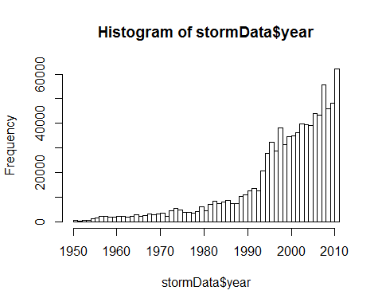

Produced histogram shows that the number of events tracked starts to significantly increase starting from 1995. Now we will use the subset of the data from 1990 to 2011 to try to get near to the precise records.

storm <- stormData[stormData$year >= 1995, ]  
dim(storm)

## [1] 681500 38

This gives us 681500 rows and 38 columns in total.

#### LETS ANALYSE HOW IT IMPACTS ON PUBLIC HEALTH:

In this part, we will analyse the number of **fatalities** and **injuries** that are caused by the severe weather events. We would try to get the first 15 most severe types of weather events.

sortHelper <- function(fieldName, top = 15, dataset = stormData) {  
 index <- which(colnames(dataset) == fieldName)  
 field <- aggregate(dataset[, index], by = list(dataset$EVTYPE), FUN = "sum")  
 names(field) <- c("EVTYPE", fieldName)  
 field <- arrange(field, field[, 2], decreasing = T)  
 field <- head(field, n = top)  
 field <- within(field, EVTYPE <- factor(x = EVTYPE, levels = field$EVTYPE))  
 return(field)  
}  
  
fatalities <- sortHelper("FATALITIES", dataset = storm)  
injuries <- sortHelper("INJURIES", dataset = storm)

#### LETS ANALYSE HOW IT IMPACTS ON ECONOMY OF THE COUNTRY:

In this part, we will convert the **property damage** and **crop damage** data into comparable numerical forms according to the meaning of units described in the code book ([Storm Events](http://ire.org/nicar/database-library/databases/storm-events/)). Both PROPDMGEXP and CROPDMGEXP columns record a multiplier for each observation where we have Hundred (H), Thousand (K), Million (M) and Billion (B).

convertHelper <- function(dataset = storm, fieldName, newFieldName) {  
 totalLen <- dim(dataset)[2]  
 index <- which(colnames(dataset) == fieldName)  
 dataset[, index] <- as.character(dataset[, index])  
 logic <- !is.na(toupper(dataset[, index]))  
 dataset[logic & toupper(dataset[, index]) == "B", index] <- "9"  
 dataset[logic & toupper(dataset[, index]) == "M", index] <- "6"  
 dataset[logic & toupper(dataset[, index]) == "K", index] <- "3"  
 dataset[logic & toupper(dataset[, index]) == "H", index] <- "2"  
 dataset[logic & toupper(dataset[, index]) == "", index] <- "0"  
 dataset[, index] <- as.numeric(dataset[, index])  
 dataset[is.na(dataset[, index]), index] <- 0  
 dataset <- cbind(dataset, dataset[, index - 1] * 10^dataset[, index])  
 names(dataset)[totalLen + 1] <- newFieldName  
 return(dataset)  
}  
  
storm <- convertHelper(storm, "PROPDMGEXP", "propertyDamage")

## Warning in convertHelper(storm, "PROPDMGEXP", "propertyDamage"): NAs  
## introduced by coercion

storm <- convertHelper(storm, "CROPDMGEXP", "cropDamage")

## Warning in convertHelper(storm, "CROPDMGEXP", "cropDamage"): NAs introduced  
## by coercion

names(storm)

## [1] "STATE__" "BGN_DATE" "BGN_TIME" "TIME_ZONE"   
## [5] "COUNTY" "COUNTYNAME" "STATE" "EVTYPE"   
## [9] "BGN_RANGE" "BGN_AZI" "BGN_LOCATI" "END_DATE"   
## [13] "END_TIME" "COUNTY_END" "COUNTYENDN" "END_RANGE"   
## [17] "END_AZI" "END_LOCATI" "LENGTH" "WIDTH"   
## [21] "F" "MAG" "FATALITIES" "INJURIES"   
## [25] "PROPDMG" "PROPDMGEXP" "CROPDMG" "CROPDMGEXP"   
## [29] "WFO" "STATEOFFIC" "ZONENAMES" "LATITUDE"   
## [33] "LONGITUDE" "LATITUDE_E" "LONGITUDE_" "REMARKS"   
## [37] "REFNUM" "year" "propertyDamage" "cropDamage"

options(scipen=999)  
property <- sortHelper("propertyDamage", dataset = storm)  
crop <- sortHelper("cropDamage", dataset = storm)

### RESULTS:

As for the impact on public health, we have got two sorted lists of severe weather events below by the number of people badly affected.

fatalities

## EVTYPE FATALITIES  
## 1 EXCESSIVE HEAT 1903  
## 2 TORNADO 1545  
## 3 FLASH FLOOD 934  
## 4 HEAT 924  
## 5 LIGHTNING 729  
## 6 FLOOD 423  
## 7 RIP CURRENT 360  
## 8 HIGH WIND 241  
## 9 TSTM WIND 241  
## 10 AVALANCHE 223  
## 11 RIP CURRENTS 204  
## 12 WINTER STORM 195  
## 13 HEAT WAVE 161  
## 14 THUNDERSTORM WIND 131  
## 15 EXTREME COLD 126

injuries

## EVTYPE INJURIES  
## 1 TORNADO 21765  
## 2 FLOOD 6769  
## 3 EXCESSIVE HEAT 6525  
## 4 LIGHTNING 4631  
## 5 TSTM WIND 3630  
## 6 HEAT 2030  
## 7 FLASH FLOOD 1734  
## 8 THUNDERSTORM WIND 1426  
## 9 WINTER STORM 1298  
## 10 HURRICANE/TYPHOON 1275  
## 11 HIGH WIND 1093  
## 12 HAIL 916  
## 13 WILDFIRE 911  
## 14 HEAVY SNOW 751  
## 15 FOG 718

And the following shows a pair of graphs of total fatalities and total injuries affected by these severe weather events.

fatalitiesPlot <- qplot(EVTYPE, data = fatalities, weight = FATALITIES, stat = "count", width = 1) +   
 scale_y_continuous("Number of Fatalities") +   
 theme(axis.text.x = element_text(angle = 45,   
 hjust = 1)) + xlab("Severe Weather Type") +   
 ggtitle("Total Fatalities by Severe Weather\n Events in the U.S.\n from 1995 - 2011")

## Warning: `stat` is deprecated

injuriesPlot <- qplot(EVTYPE, data = injuries, weight = INJURIES, stat = "count", width = 1) +   
 scale_y_continuous("Number of Injuries") +   
 theme(axis.text.x = element_text(angle = 45,   
 hjust = 1)) + xlab("Severe Weather Type") +   
 ggtitle("Total Injuries by Severe Weather\n Events in the U.S.\n from 1995 - 2011")

## Warning: `stat` is deprecated

grid.arrange(fatalitiesPlot, injuriesPlot, ncol = 2)

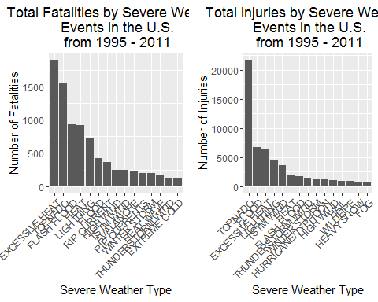

Based on the above statistics achieved, we can summaries that **excessive heat** and **tornado** caused most fatalities where as **tornado** caused most injuries in the United States from 1995 to 2011.

Now for the impact on economy, we have got two sorted lists below by the amount of money cost by damages.

property

## EVTYPE propertyDamage  
## 1 FLOOD 144022037057  
## 2 HURRICANE/TYPHOON 69305840000  
## 3 STORM SURGE 43193536000  
## 4 TORNADO 24935939545  
## 5 FLASH FLOOD 16047794571  
## 6 HAIL 15048722103  
## 7 HURRICANE 11812819010  
## 8 TROPICAL STORM 7653335550  
## 9 HIGH WIND 5259785375  
## 10 WILDFIRE 4759064000  
## 11 STORM SURGE/TIDE 4641188000  
## 12 TSTM WIND 4482361440  
## 13 ICE STORM 3643555810  
## 14 THUNDERSTORM WIND 3399282992  
## 15 HURRICANE OPAL 3172846000

crop

## EVTYPE cropDamage  
## 1 DROUGHT 13922066000  
## 2 FLOOD 5422810400  
## 3 HURRICANE 2741410000  
## 4 HAIL 2614127070  
## 5 HURRICANE/TYPHOON 2607872800  
## 6 FLASH FLOOD 1343915000  
## 7 EXTREME COLD 1292473000  
## 8 FROST/FREEZE 1094086000  
## 9 HEAVY RAIN 728399800  
## 10 TROPICAL STORM 677836000  
## 11 HIGH WIND 633561300  
## 12 TSTM WIND 553947350  
## 13 EXCESSIVE HEAT 492402000  
## 14 THUNDERSTORM WIND 414354000  
## 15 HEAT 401411500

Now follows a pair of graphs of total property damage and total crop damage affected by these severe weather events.

propertyPlot <- qplot(EVTYPE, data = property, weight = propertyDamage, stat = "count", width = 1) +   
 theme(axis.text.x = element_text(angle = 45, hjust = 1)) + scale_y_continuous("Property Damage in US dollars")+   
 xlab("Severe Weather Type") + ggtitle("Property Damage by\n Weather Events in\n U.S. from 1995 - 2011")

## Warning: `stat` is deprecated

cropPlot<- qplot(EVTYPE, data = crop, weight = cropDamage, stat = "count", width = 1) +   
 theme(axis.text.x = element_text(angle = 45, hjust = 1)) + scale_y_continuous("Crop Damage in US dollars") +   
 xlab("Severe Weather Type") + ggtitle("Crop Damage by \n Weather Events in\n U.S. from 1995 - 2011")

## Warning: `stat` is deprecated

grid.arrange(propertyPlot, cropPlot, ncol = 2)

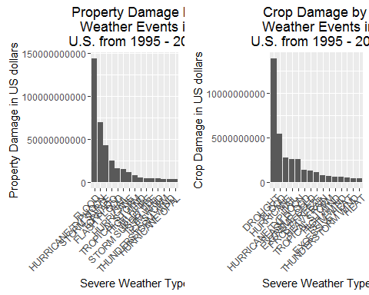

Again,based on the above statistics, we can analyse that **flood** and **hurricane/typhoon** caused most property damage where as **drought** and **flood** caused most crop damage in the United States from 1995 to 2011.

### ANALYSIS SUMMARY:

From this analysis, we came to know that **excessive heat** and **tornado** have the most impacts on population health, while **flood**, **drought**, and **hurricane/typhoon** have the greatest impact on the field of economy.