CS 415 Program #1 Notes

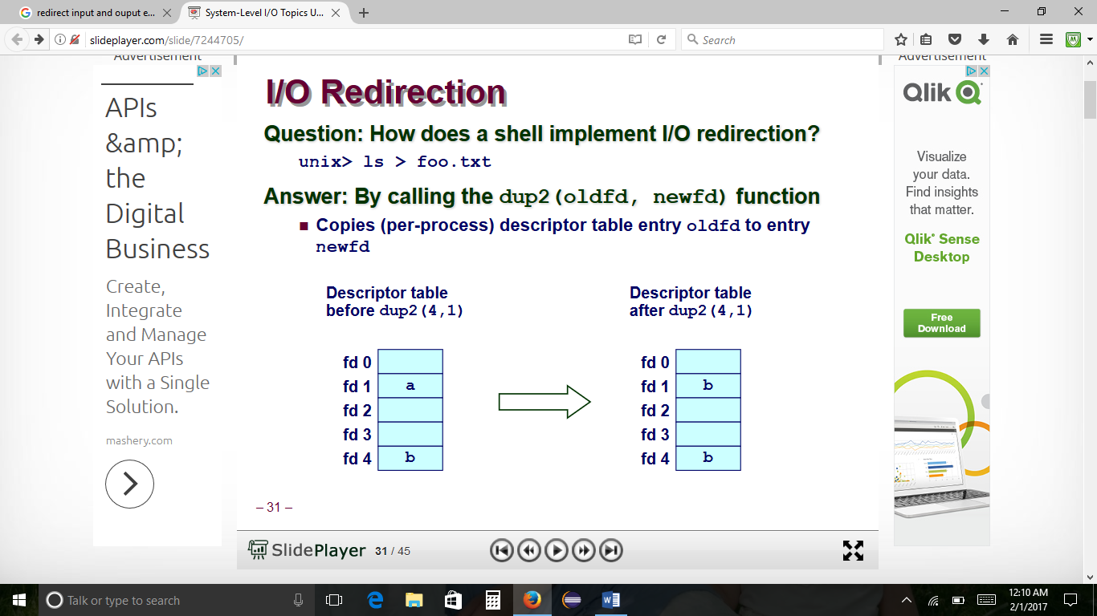

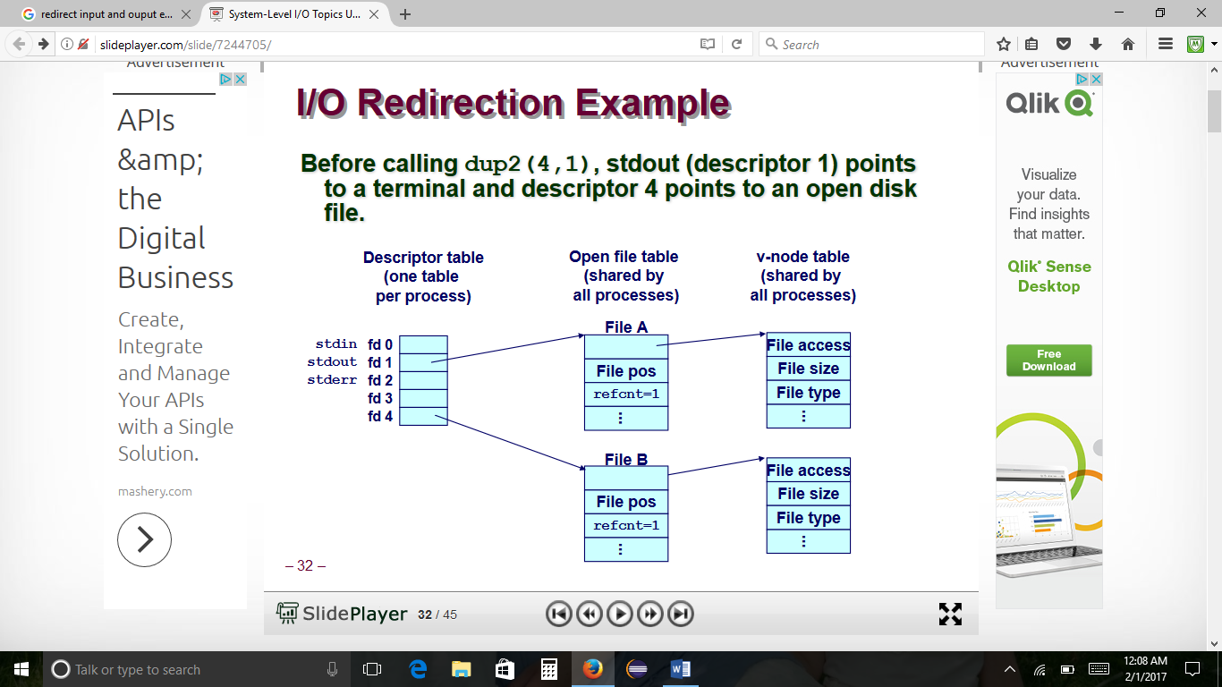

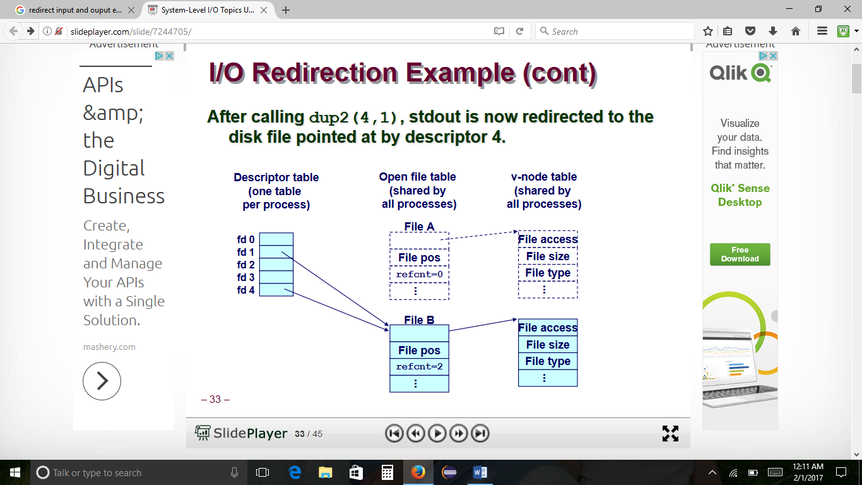

Code Example Redirecting in a new process

The command to run in a separate process while sending its output to the file that we created, we can simply fork a new process. Note that we perform our dup2 call in the child so that we do not overwrite the standard output of the parent. We also close the standard input since we do not want the forked process trying to read from there (the ls command in this example will not but other programs might). Finally, the parent waits for the child process to terminate before continuing



