Diagrams:

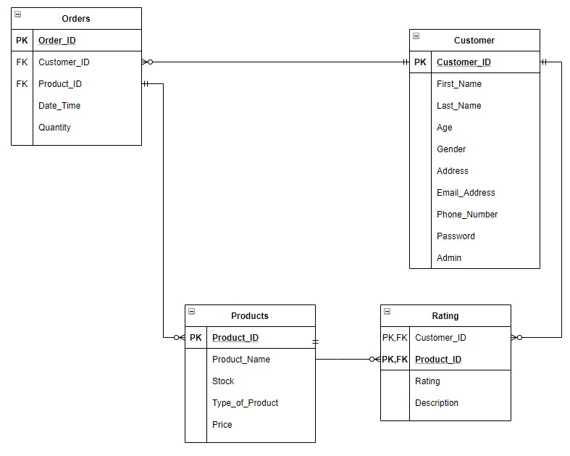**Entity Relationship Diagram**:

**Use Case Diagrams:**

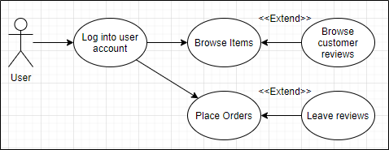

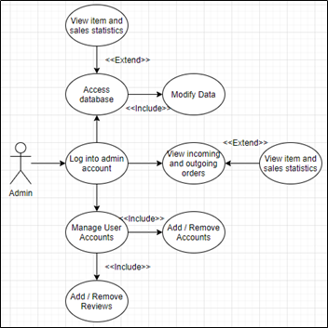

**Activity Diagrams:**

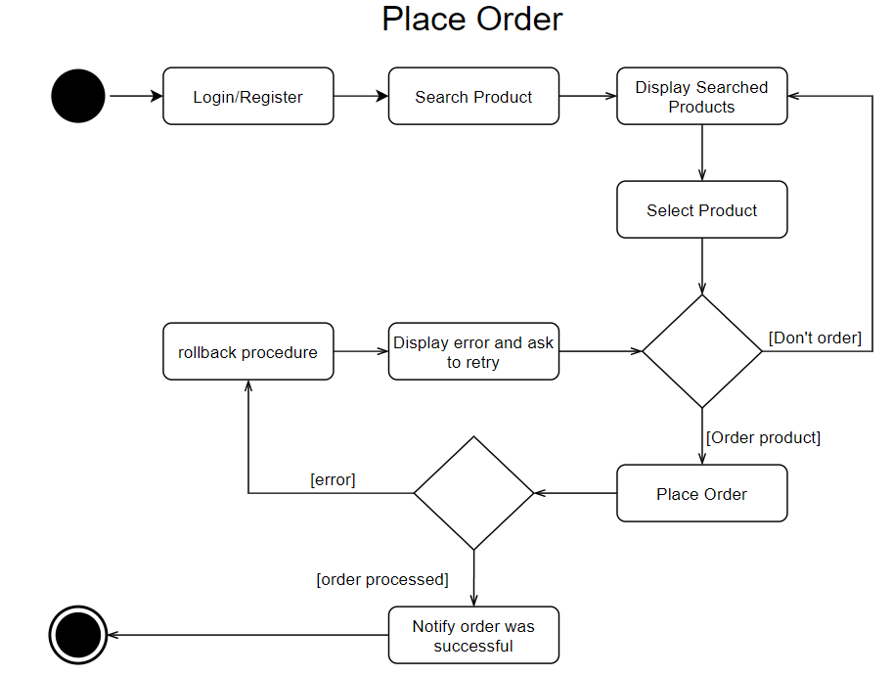

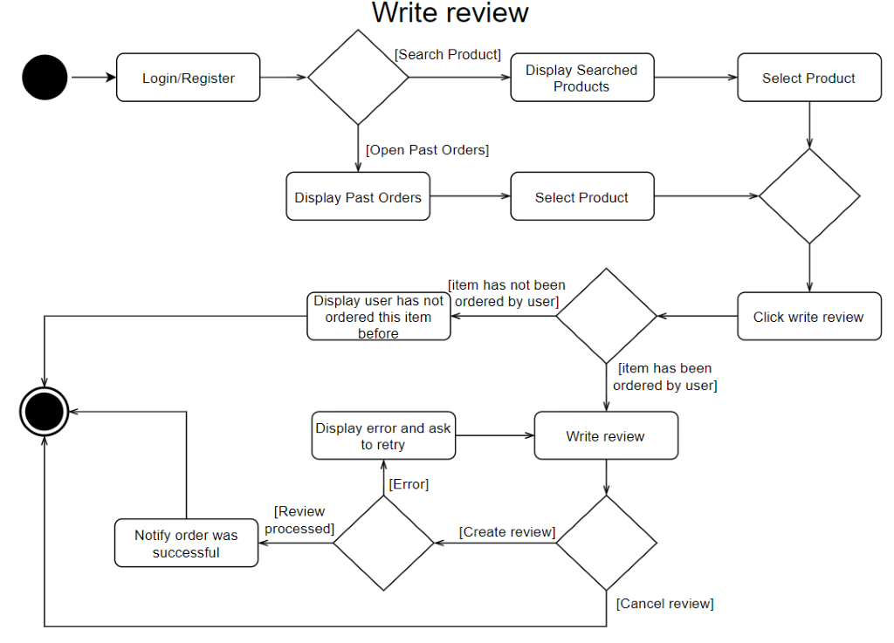

**Initial Class Diagram**:

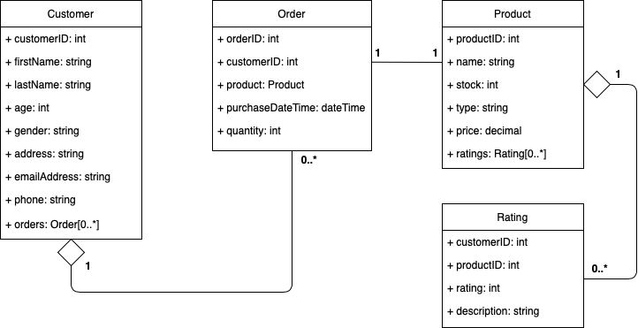

**State Diagram:**

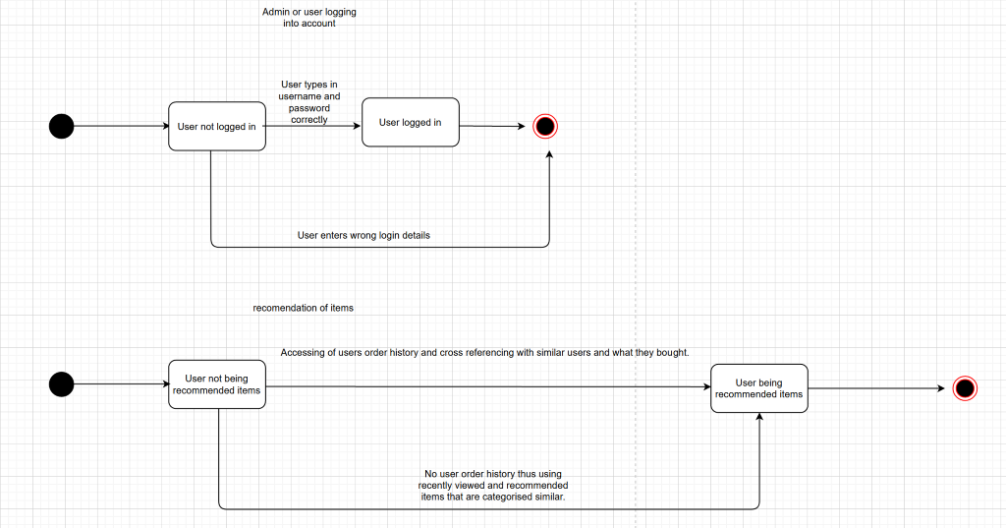

**Sequence diagram:**

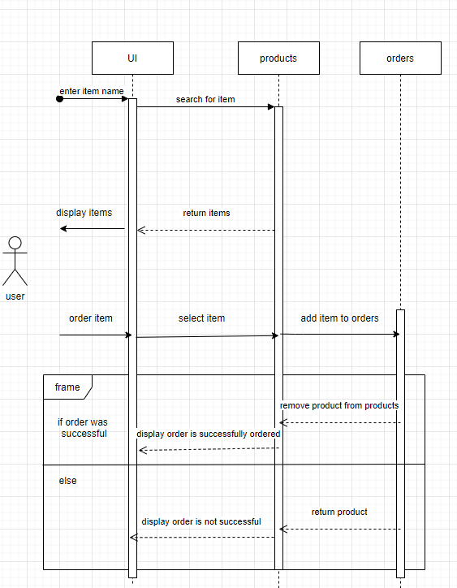

**Admin Class Diagrams:** (Please Zoom into read)

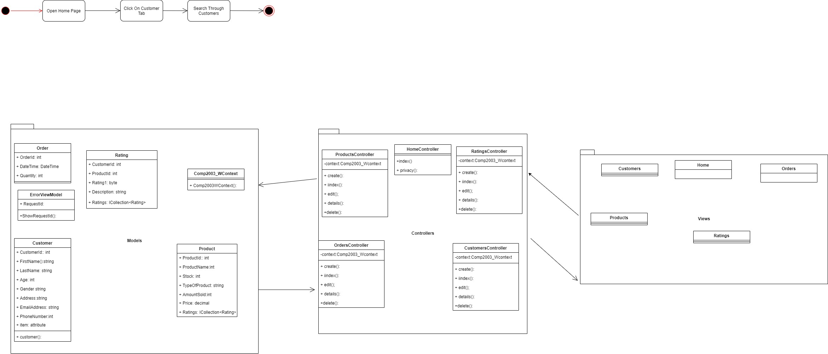

**Mobile Class Diagrams:**

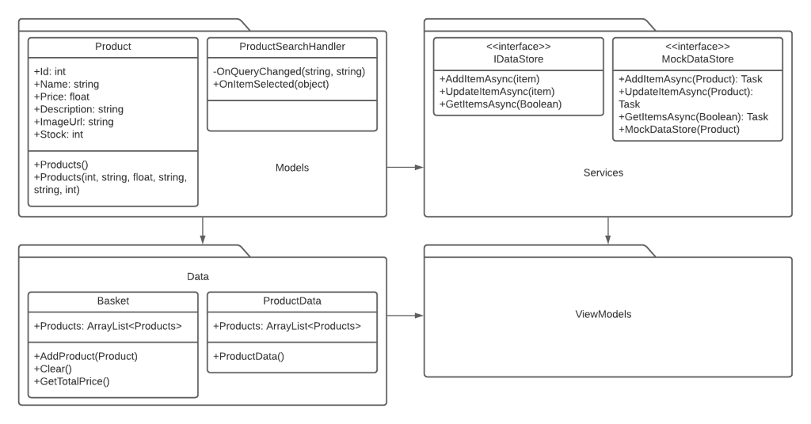

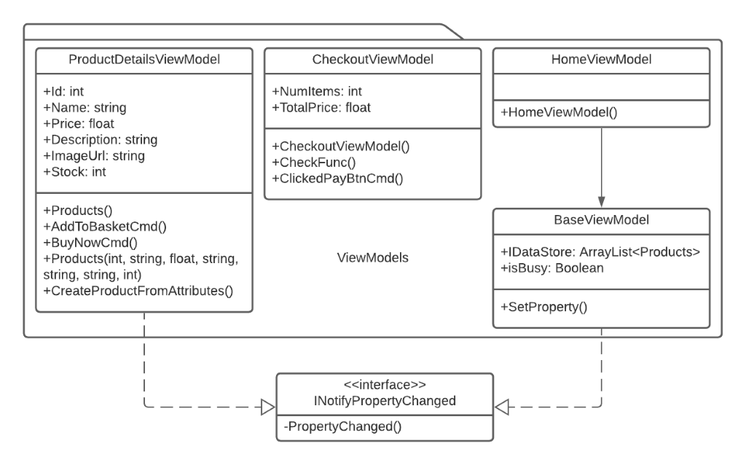

**Activity Diagram for Admin application to view list of customers:**

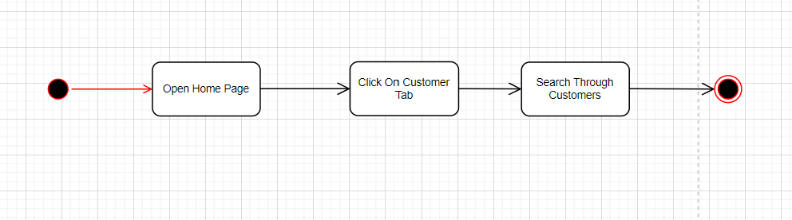

**Activity diagram for making a purchase on mobile application:**

