Admin Interface Wireframe

**Login page**

This the page the admin will be met with when not signed in on the interface website.

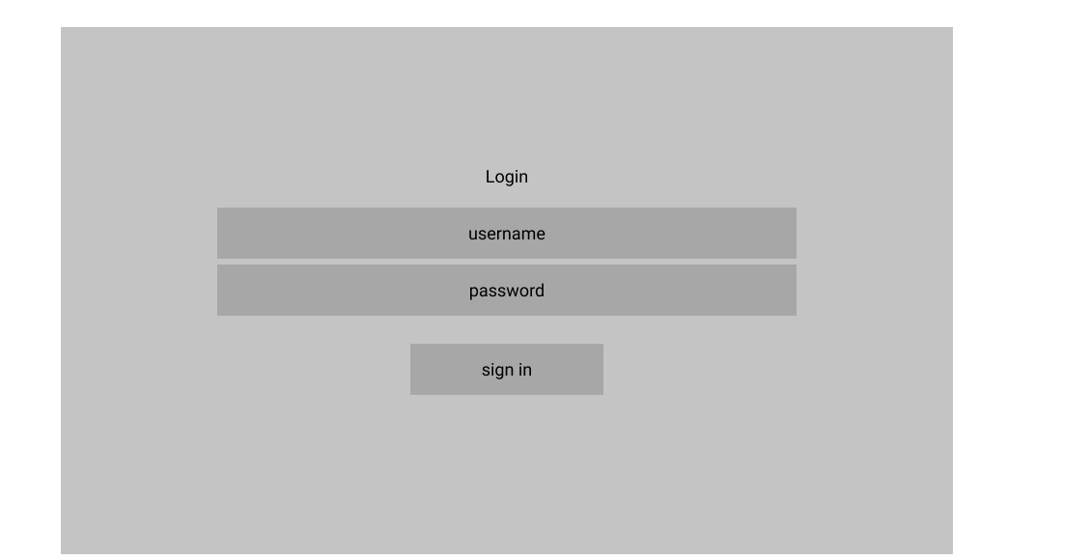

**Dashboard – Desktop view**

Once signing in, the admin will be brought to the web interfaces dashboard page. This page will contain all headings and sections the admin needs to monitor and moderate. As well as presenting the headings of all sections, under each section name there will be a small preview of the most relevant information for each given section. For example, the products dashboard view displays the best selling items and items that are in low stock – then allowing further action to be taken once entering each sections actual page.

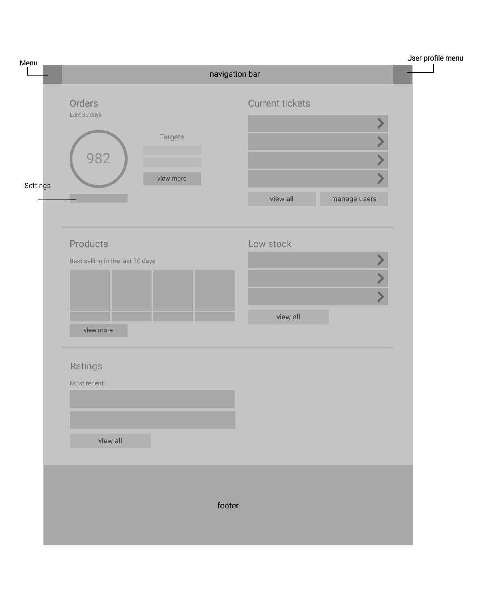

*Dashboard – (Mobile View)*

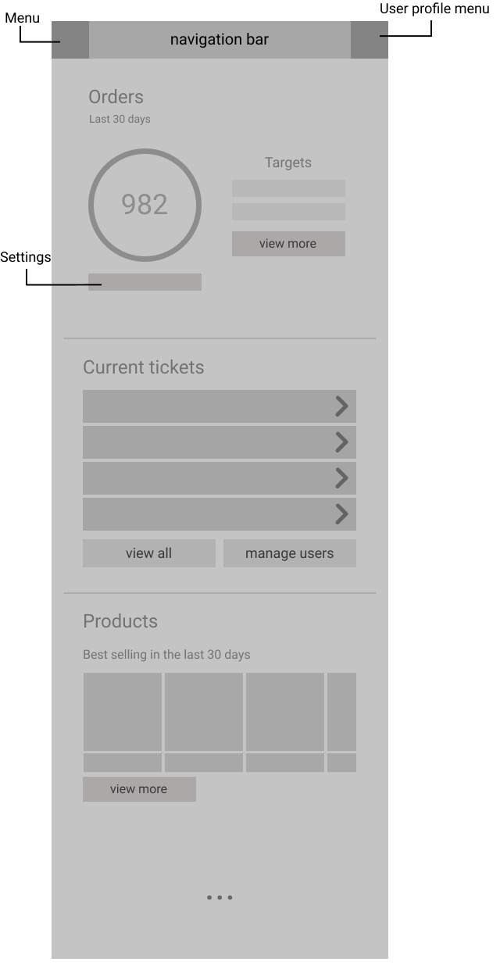

**Orders**

This is the orders page. It still displays the dashboard information (target order sales) – but with the addition of being able to edit and access it too. This page will then display the full order history of the site, sorted by most recent orders. There is a search bar to pick out specific orders and filters to help navigate the table. Each order in the table is clickable in order to open up a much more detailed order details page.

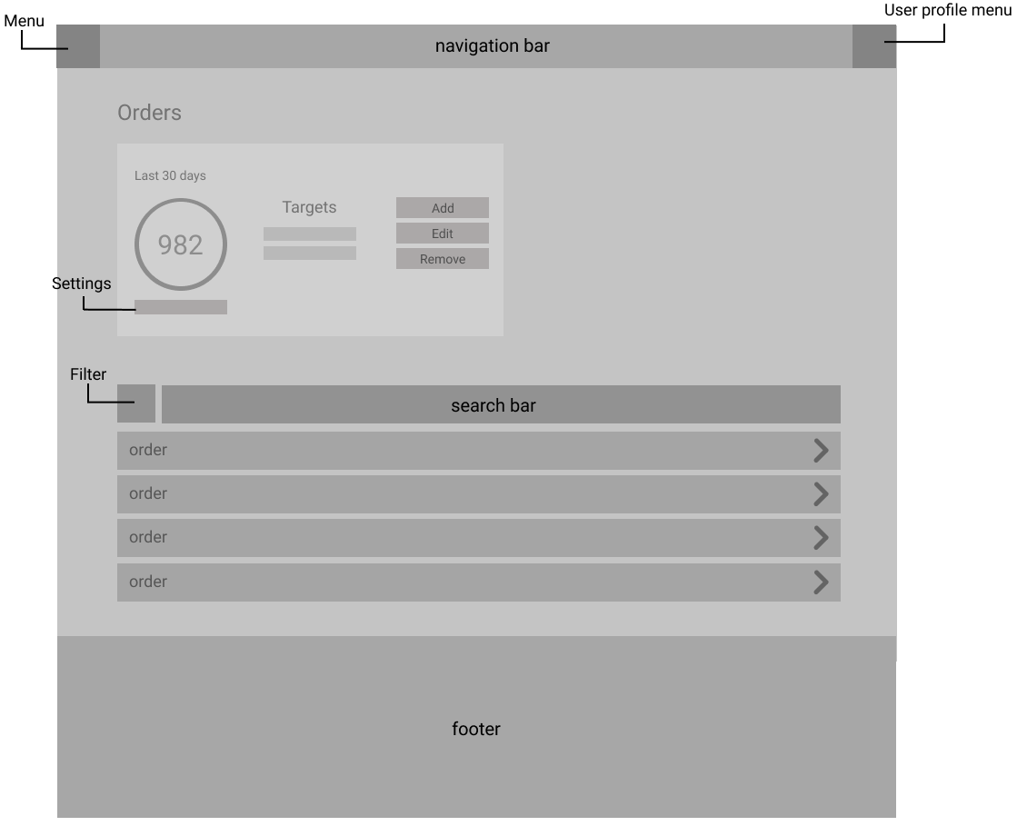

*Order details*

This page will then display much more information about that given order and provide options to cancel the order or to contact the customer in the event of any problems surrounding the order.

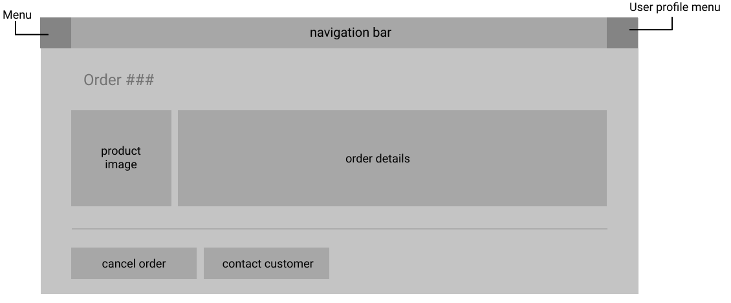

**Customers**

This this the customers page. It will display a complete record of all registered customers on the site. The options to filter and search through the table will be present in order to pick out individuals and groups of people. Each customer record is clickable and will open a customer details page.

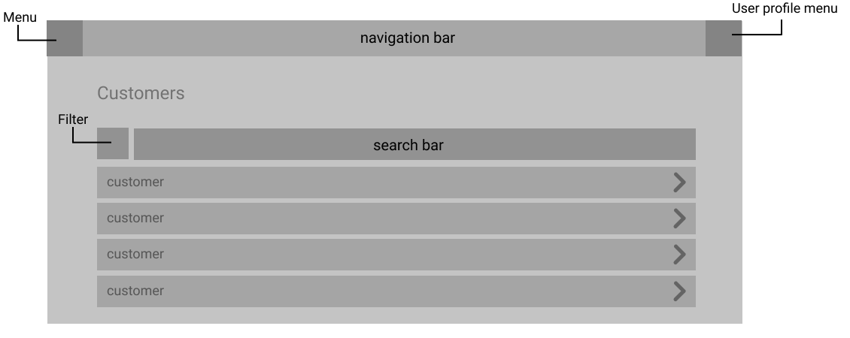

*Customer details*

On this page, a full set of customer details will be present – complete with their recent order history and the option to view it in full. Options to reset their password and delete their account will be present in case the select customer needs assistance doing so.

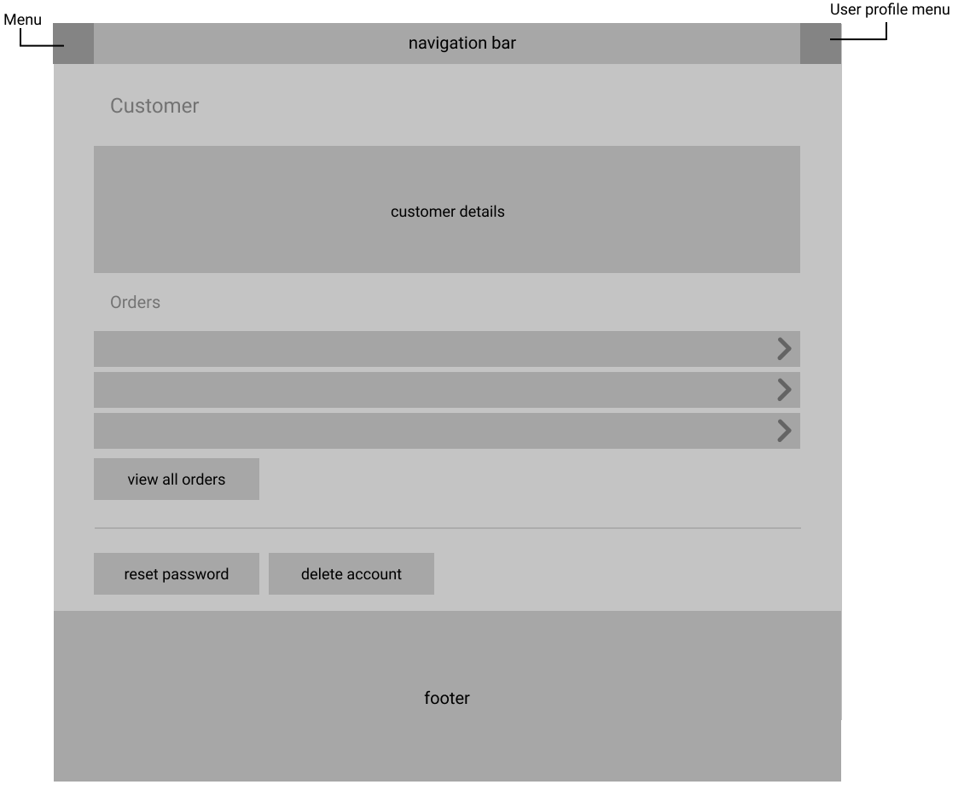

**Products**

This is the products page. This page will start by displaying a clickable alert that indicates a list of items that are currently low stock as well as a carousel display of best-selling items in the last thirty days (that can both also be found on the dashboard). Next is a table containing a list of all products that can be searched through and have filters applied to it in order to pick out specific products and groups of products of the same type. Similar to previous sections, each entry is clickable in order to open up a further page, in this case, product details.

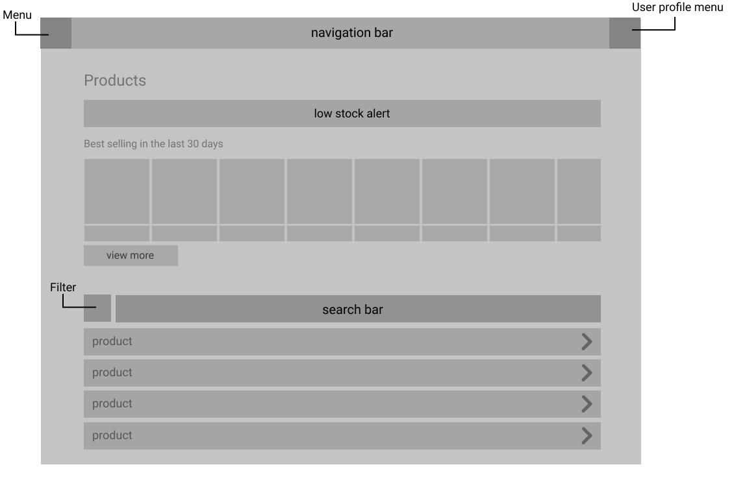

*Product details*

This page will display all information of a select product in full. Each section will need to be editable as this is where the admins manage the information that will be displayed to the users of the site – including not only the item description, but technicalities such as whether the product is low in stock or even available to purchase.

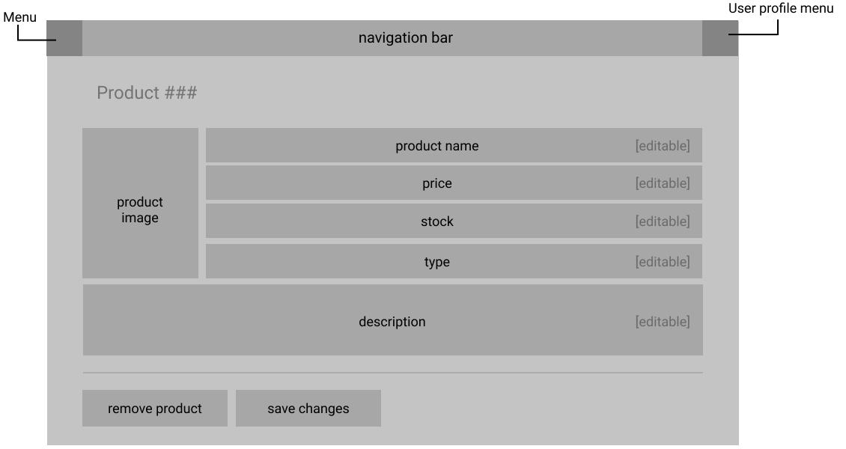

**Ratings**

This is the ratings page. This page will display a full list of all ratings left by all customers for all products. The table will be filterable through displaying a list of all ratings left by an individual customer or all ratings for a select item. Once again, each table entry will be clickable to open up further information.

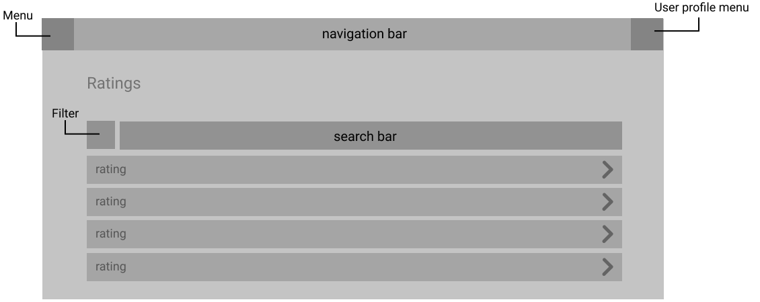

*Product rating*

Once a rating as been selected and clicked, the admin will be met with this product rating page. It will indicate what product the rating is for and who has left it. As well as simply a number rating, a review / description is also displayed. This will be so that admins and other customers can be informed of what the customer in question has to say about this product.

