These are all the wireframes for different pages on the mobile app. The app makes the customer sign in and automatically sync with their account. It will display the latest information from the customer’s account. There will not be a mobile version for the admin as we have decided there is no purpose for the admin to use a mobile interface.

**Home Page**

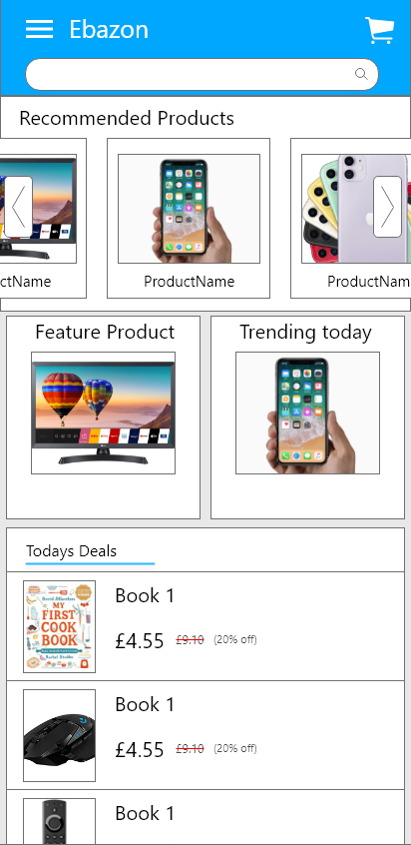

This is the home page wireframe for the customer once they first initiate the app. It is simply a generic online store with multiple features. There is a search bar by default so the user will be able to search for products that they wish to buy. Also, a list of recommended products will be presented to the user depending on factors such as previous search history. The user will be able to swipe left or right to view more recommended products. Certain categories of products are shown to the user such as trending and featured products. Deals for the day will be advertised as well just to promote products and offers. The three lines at the top left of the page is the method of navigation for the user and transition to different pages. The trolley symbol on the top right of the page is represented as the basket which is used as a shortcut for the user to reach the page.

**Results page after searching for a particular product**

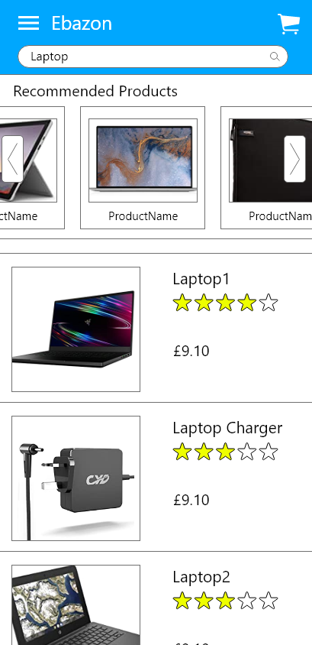

This page will possess the same header as all other pages on the app so it will be convenient for the user to navigate through the app. After searching, the results page will display recommended products that are similar to the searched product. In addition, the rest of the page displays products to the user containing brief information on them. For example, the name of the product, the product rating and the price. Also, images of the product will be available to the user, so the user is able to visualize what they are purchasing. The user can be able to scroll down the page to view more products.

**Specific product page**

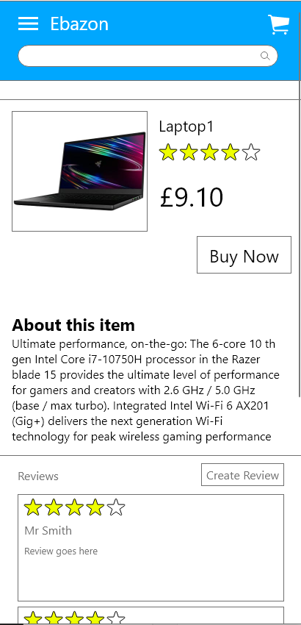

This page will show up when the user selects a product that they intend to purchase or find further details about. The picture, name, rating and price will be clearly be presented at the top. Below this information, there is a “Buy Now” button which will move the product to the basket. Below that, there are specifications about the product so the user will acknowledge features are in this product. If you scroll down, there will be reviews of the product from other buyers and their own ratings for the user’s reassurance before purchasing. If the user has bought the product, they may wish to leave their own review and rating by selecting the “Create Review” button.

**Write a review page**

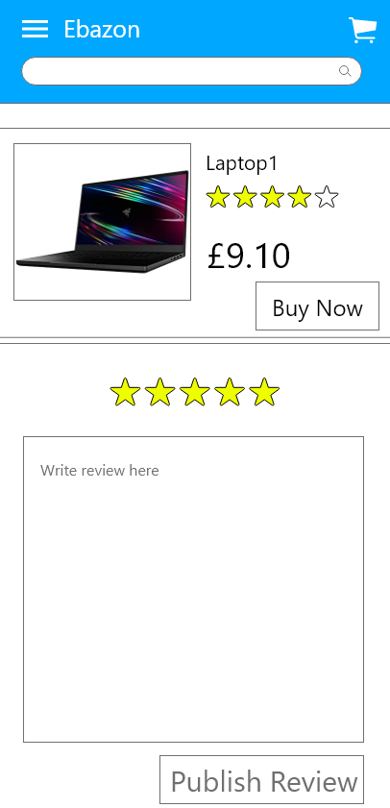

This page will show up when the user selects the “Create Review” button from the previous page. The top of the page will display which product they have selected to review. Then, there are 5 stars where the user can change it to choose their personal rating for the product. The text box below that is used to write the review for the product. The box will default have the text “Write review here” and when the user selects the box and starts to type, that text will automatically be erased. Finally, there is a “Publish Review” button where the user selects after writing their review so it will be updated to the specific product page under the reviews section.

**Checkout page**

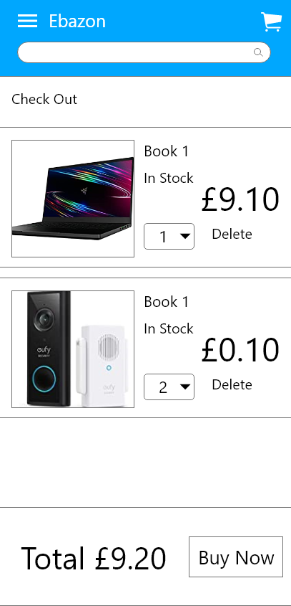

The user will be redirected to the checkout page when they select the basket or if they select the buy now from a specific product page. This page starts of by stating what page the user is on by having a sub-heading called “Check out”. Below this, products the user has selected to purchase will be displayed. The user will be able to know the status of the product such as if it is in stock and the price of the product. Also, users will be able to adjust the quantity of the product. They can also delete the product from the basket. At the very bottom of the app, the total price will be stated clearly, and the button “Buy Now” will confirm the purchase of all the items in the basket.