Creation of “Facebook users” table Script:

CREATE TABLE `isad157_ajose`.`facebook_users` (

`user_id` INT(4) NOT NULL,

`first_name` VARCHAR(50) NOT NULL,

`last_name` VARCHAR(50) NOT NULL,

`gender` VARCHAR(6) NOT NULL,

`hometown` VARCHAR(50) NOT NULL,

`city` VARCHAR(50) NOT NULL,

PRIMARY KEY (`user_id`));

--------------------------------------------------------------------------------------------------------------------------------------

Creation of “Facebook friendships” table Script:

CREATE TABLE `isad157_ajose`.`facebook_friendships` (

`userID_1` INT(4) NOT NULL,

`userID_2` INT(4) NOT NULL);

CONSTRAINT `userID_1`

FOREIGN KEY (`userID_1`)

REFERENCES `isad157_ajose`.`facebook_users` (`user_id`)

ON DELETE CASCADE

ON UPDATE CASCADE;

CONSTRAINT `userID_2`

FOREIGN KEY (`userID_2`)

REFERENCES `isad157_ajose`.`facebook_users` (`user_id`)

ON DELETE CASCADE

ON UPDATE CASCADE;

--------------------------------------------------------------------------------------------------------------------------------------

Creation of “messages” table Script:

CREATE TABLE `isad157_ajose`.`messages` (

`sender_id` INT(4) NOT NULL,

`receiver_id` INT(4) NOT NULL,

`date_time` DATETIME NOT NULL,

`message` VARCHAR(1000) NOT NULL,

CONSTRAINT sender_id

FOREIGN KEY(sender_id)

REFERENCES `isad157_ajose`.`facebook_friendships` (`userID_1`)

ON DELETE CASCADE

ON UPDATE CASCADE,

CONSTRAINT `receiver_id`

FOREIGN KEY (`receiver_id`)

REFERENCES `isad157_ajose`.`facebook_friendships` (`userID_2`)

ON DELETE CASCADE

ON UPDATE CASCADE;

--------------------------------------------------------------------------------------------------------------------------------------

Creation of “universities” table Script:

CREATE TABLE `isad157_ajose`.`universities` (

`user_id` INT(4) NOT NULL,

`university` VARCHAR(100) ;

CONSTRAINT `user_id`

FOREIGN KEY (`user_id`)

REFERENCES `isad157_ajose`.`facebook_users` (`user_id`)

ON DELETE CASCADE

ON UPDATE CASCADE;

--------------------------------------------------------------------------------------------------------------------------------------

Creation of “workplace” table Script:

CREATE TABLE `isad157_ajose`.`workplace` (

`user_id` INT(4) NOT NULL,

`workplace` VARCHAR(100) ;

CONSTRAINT `USERID`

FOREIGN KEY (`user_id`)

REFERENCES `isad157_ajose`.`facebook_users` (`user_id`)

ON DELETE CASCADE

ON UPDATE CASCADE;

Activity Diagram:

Receive messages, receive notifications, reply to any if needed, prepare newsfeed

No

Yes

Set up profile

New user?

Yes

Lock account and send email to user

Yes

No

Increment invalid login count

No

Invalid user?

Valid user?

Existing

Account?

Provide information to create new account

Register

Not existing

Use Case Diagram:

<<Include>>

Email verification

Registration

<<Extend>>

<<Include>>

Account exists

<<actor>> User database

Login

Password verification

User

View newsfeed

<<Extend>>

Manage messages

Chat

<<Extend>>

Edit bio

Edit profile

<<Include>>

Add new friend

Inform friends

<<Include>>

Accept friend requests

<<Include>>

Reject friend requests

Sequence Diagram:

User Database

User

Form

Select user

Create user instance

Search for user

Found user

Inform user has friends

Return user details

No user found

Nothing returned

Inform user has no friends

|  |
| --- |
| **Friend** |
| friend_name: string  accept_or_reject: Boolean |
| sendFriendRequest()  unfriend() |

Class Diagram:

0..1

|  |
| --- |
| **Account** |
| first_name: string  last_name: string  password: string  gender: string  relationship status: string  hometown: string  city: string  school or university: string  workplace: string |
| createAccount() |

|  |
| --- |
| **User** |
| Friendships  Messages |
| Login()  createAccount() |

0..1

0..1

0..1

|  |
| --- |
| **Messages** |
| sender: string  receiver: string  date_and_time: DATETIME  message: string |
| sendMessage()  readMessage() |

Entity Relationship Diagram:

facebook_users

messages

facebook_friendships

workplace

universities

|  |
| --- |
| **facebook_friendships** |
| USERID_1 |
| USERID_2 |

|  |
| --- |
| **messages** |
| sender_id |
| receiver_id |
| date_time |
| message |

|  |
| --- |
| **facebook_users** |
| user_id |
| first_name |
| last_name |
| hometown |
| gender |
| city |

|  |
| --- |
| **workplace** |
| user_id |
| workplace |

|  |
| --- |
| **universities** |
| user_id |
| university |

EER Diagram:

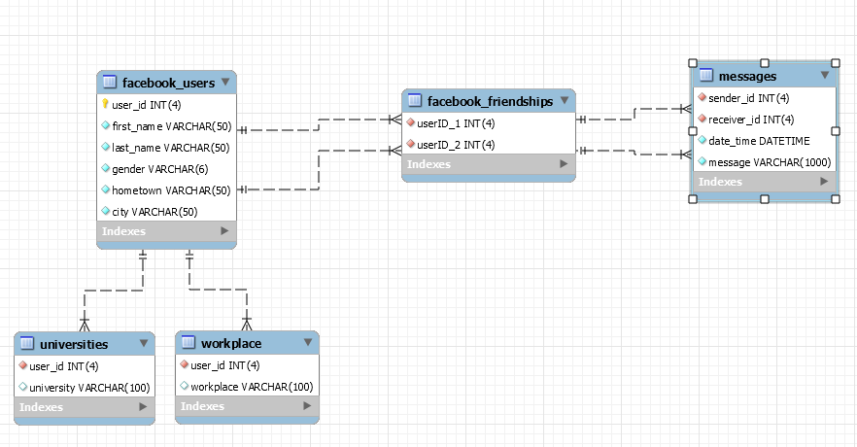

Normalisation:

**UNF** **1NF** **2NF 3NF**

User ID User ID User ID User ID

First Name First Name First Name First Name

Last Name Last Name Last Name Last Name

Hometown Hometown Hometown Hometown

Gender Gender Gender Gender

Relationship Status Relationship Status Relationship Status Relationship Status

Current Town or City Current Town or City Current Town or City Current Town or City

Workplace Workplace Workplace

School or University School or University School or University User ID

Workplace

(Friend ID User ID User ID

First Name Friend ID Friend ID User ID

Last Name) First Name School or University

Last Name User ID

(Sender ID Sender ID User ID

Receiver ID User ID Receiver ID Friend ID

Date and Time Sender ID Date and Time

Message) Receiver ID Message User ID

Date and Time Sender ID

Message Receiver ID

Date and Time

Message