Agent Identity

WHAT IS IT?  A security pattern where each task gets a temporary identity — a short-lived token scoped only to what that task needs. After the task, the agent is destroyed with zero trace left behind.  Think of it like a one-time visitor badge: unlocks only specific rooms, expires automatically, cannot be reused.  HOW IT WORKS  1 Manager — Submits task + allowed scope. Receives result only — zero access to credentials or agent internals.  2 Orchestrator — Mints a scoped short-lived token. Spawns the agent. Destroys agent after task — always, even on error.  3 Ephemeral Agent — Runs with temp token. No raw credentials. Internal memory wiped on destroy.  4 Scoped Resource — Validates token on every access — checks scope, expiry, and revocation before allowing any action.  ARCHITECTURE DIAGRAM  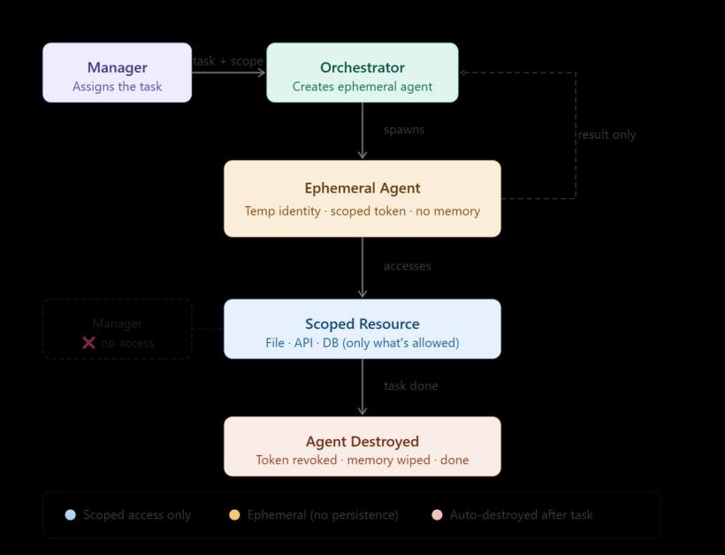 | SECURITY PROPERTIES  Scope isolation Token minted with explicit allowed actions only  No leakage Manager receives result string only — never a token  Zero persistence New uuid4 identity + token per task; wiped after  No reuse Revocation is permanent; destroyed token always denied  Auto-expiry TTL enforced on every access check (15 s default)  DEMO SCENARIOS (prototype output)  read_file in scope — Task executes, result returned, agent destroyed.  query_db in scope — Same lifecycle, different resource permitted.  send_email not in scope — PermissionError raised. Agent still destroyed in finally.  Revoked token reused — Access denied — token not found in identity store.  REAL-WORLD ANALOGUES  AWS IAM STS — AssumeRole → short-lived scoped credentials  GitHub Actions OIDC — Per-job token, expires with the job  HashiCorp Vault — Dynamic secrets, revoked after lease  OAuth 2.0 — Short-lived bearer tokens with explicit scope  PROTOTYPE · agent_identity_prototype.py  Language: Python 3 · no external dependencies  Key classes: EphemeralAgent, Orchestrator, Manager, SecureResource  Token store: In-memory dict · uuid4 IDs · TTL-enforced · permanent revocation  Safety: Agent always destroyed in finally block — even on error

