* LINEAR SVC WITH PREPROCESS INSIDE TIFD

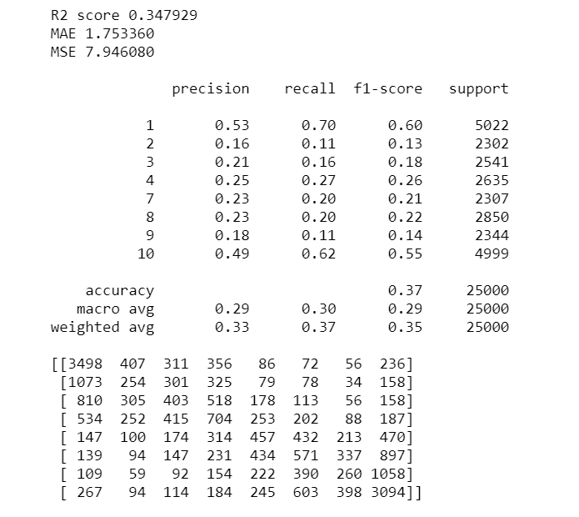

* LINEAR SVC SIN PRE PREPROCESS

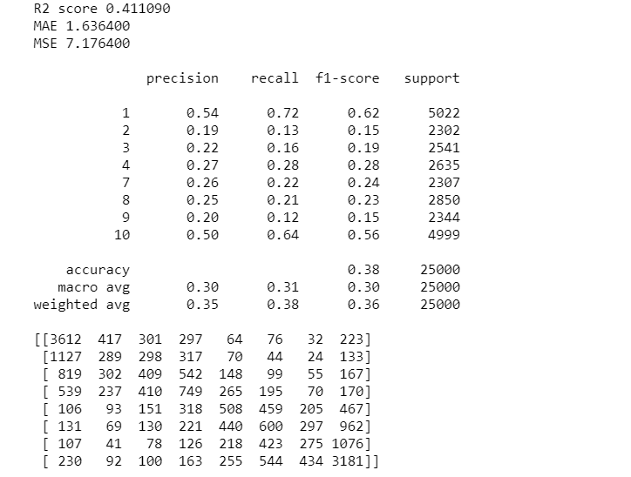

* LOGISTIC REGRESSION SIN PREPRO

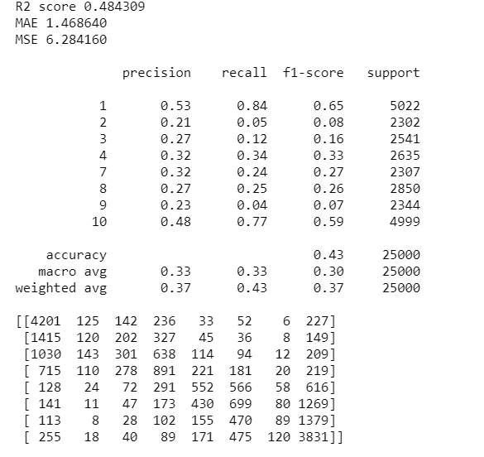

* LOGISTIC REGRESSION CON PREPO

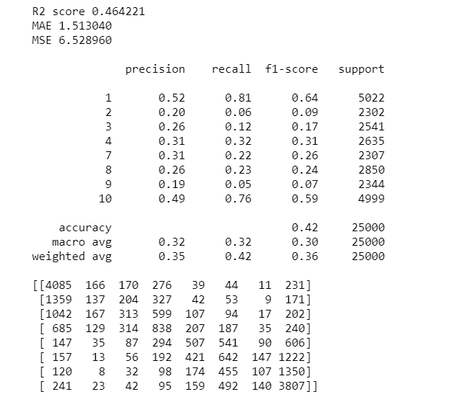

* LOGISTIC REGRESSION

ADDING NGRAM_RANGE(2,2) GAVE ME WORST ACCURACY F1 AND ALSO MACRO

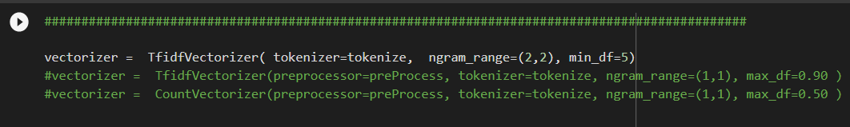

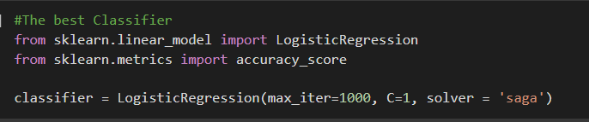

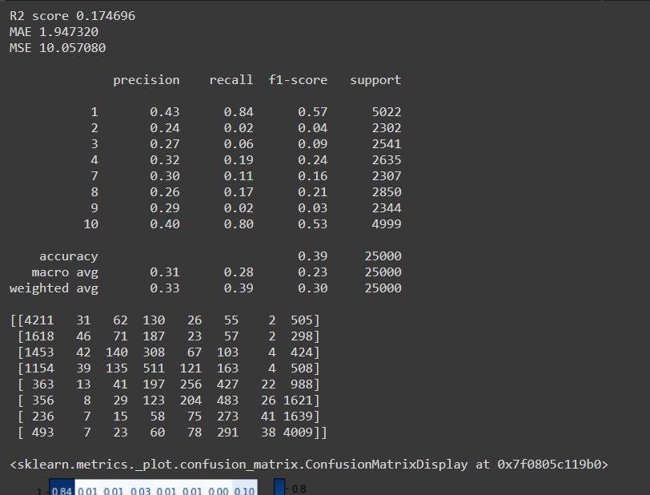

* LOG: NORMALIZING DE X_TRAIN

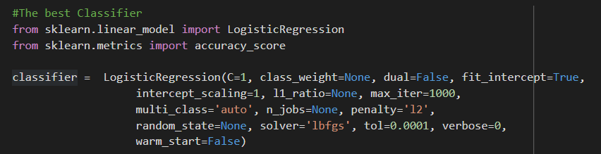

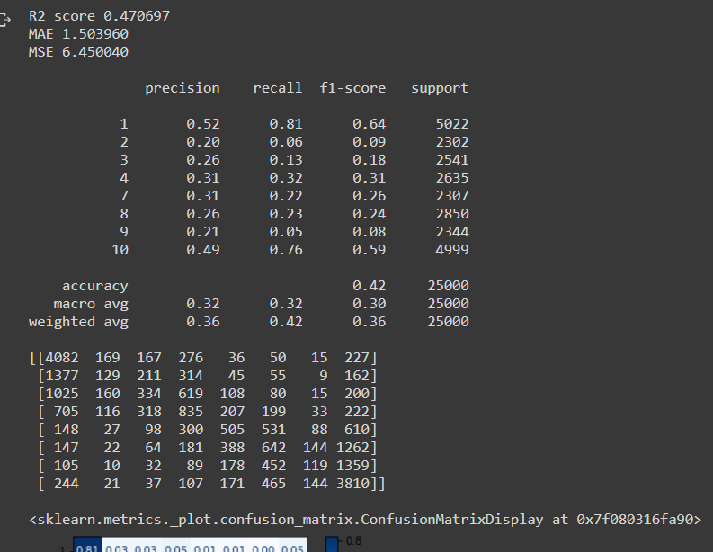

* LG CON NORMALIZING X_TRAIN

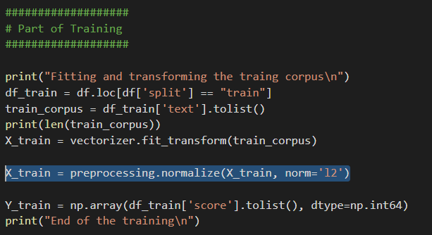

* DOWNSAMPLING TO 2250

NORMALIZING XTRAIN

* svc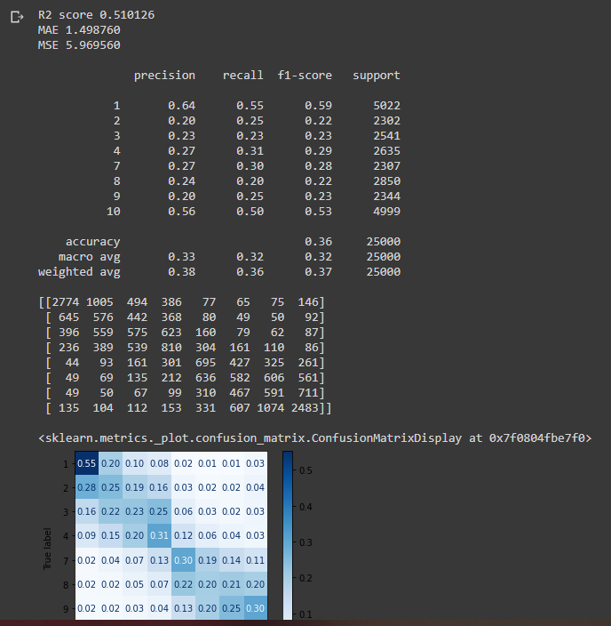
* LINEAR SVC

AL QUITA STOP WORD SUBE EN 0.01 ACCURACY AND MACRO

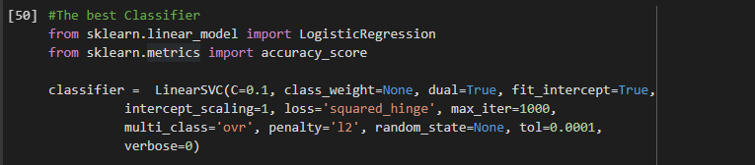

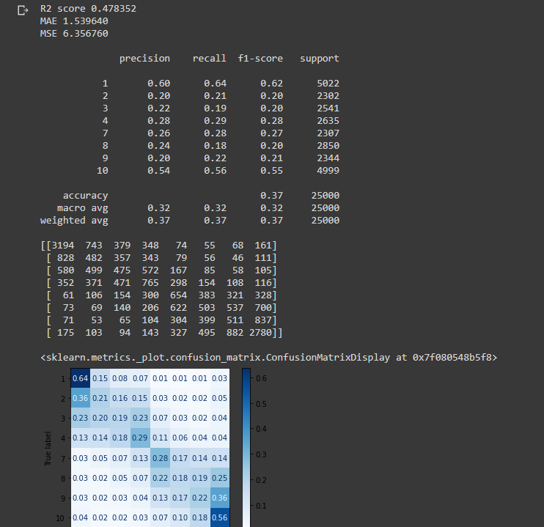

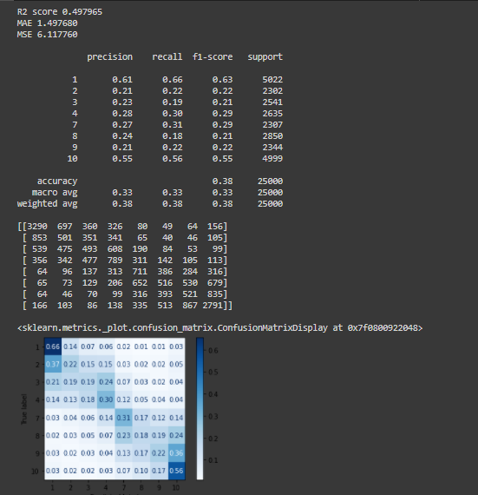

* SIN STOP WORDS, WIN REGEX, SOLO LEMMATIZER

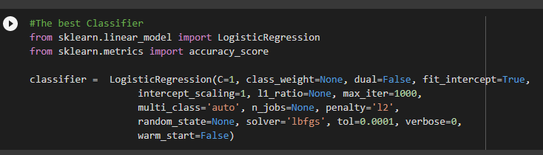

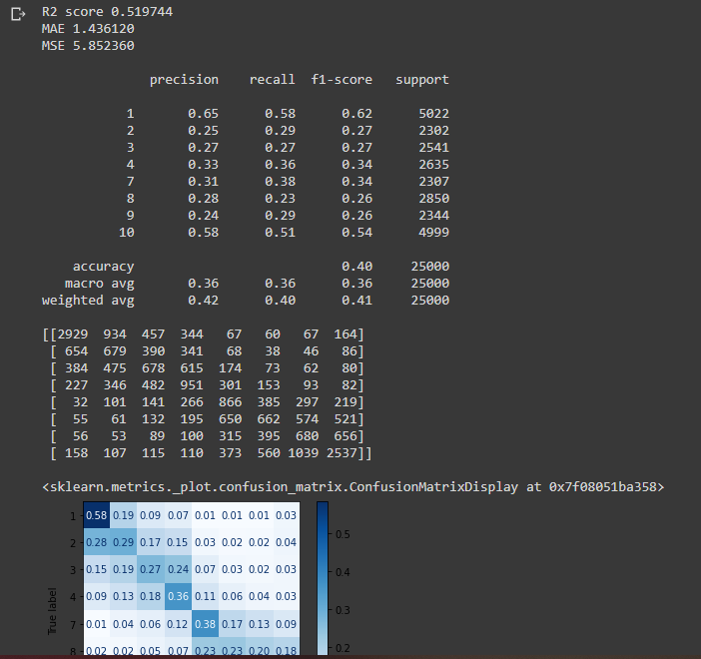

* LINEAR SVC SIN REGEX SIN STOP WORDS

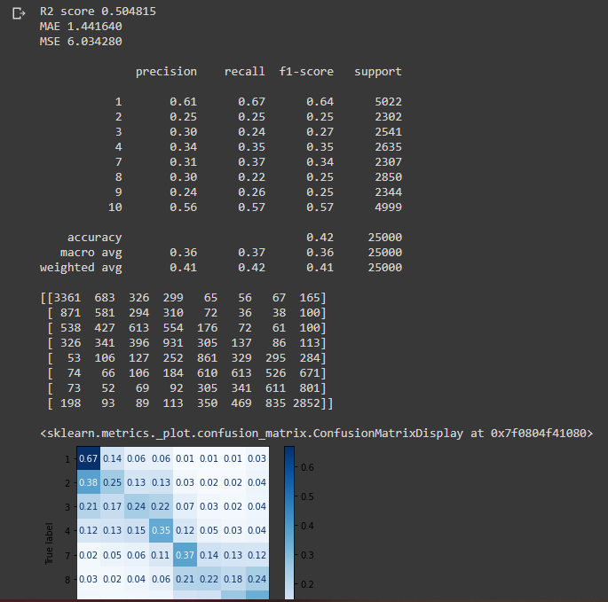

* LINEAR SVC, SIN STOP WORDS SIN REGEX

2250 words for class

AGREGO TRUE = sublinear_tf

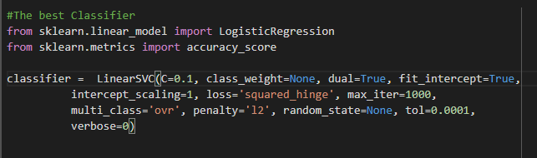

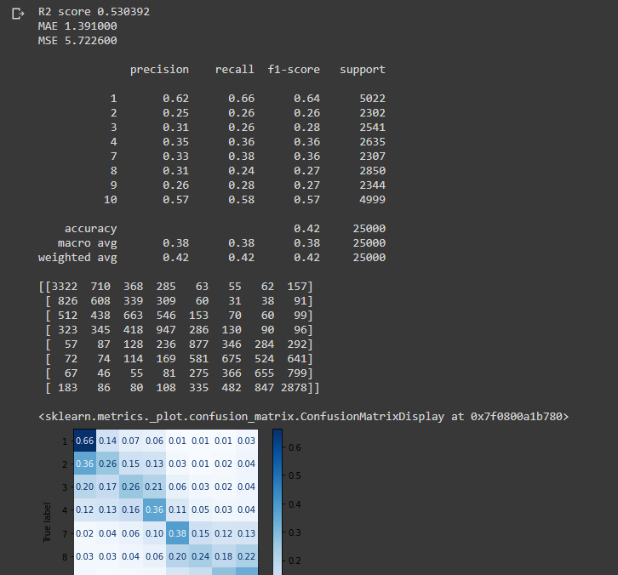

* LINEAR SVC

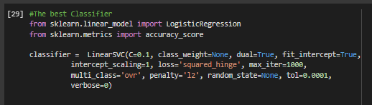

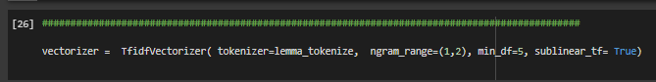

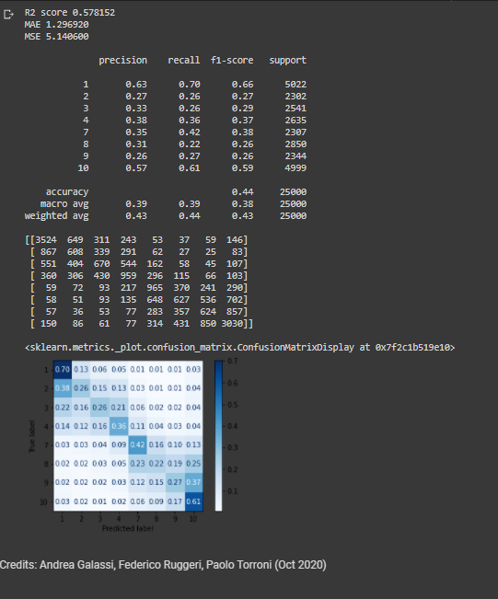

* LINEAR SVC

