# Phenology of flora of mediterranean high-mountains meadows (Sierra Nevada)

**Pérez-Luque, A.J.** (1); **Sánchez-Rojas, CP**(2); **Zamora, R.**(1,2); **Bonet, F.J.**(1,2)

1 Laboratorio de Ecología (iEcolab), Instituto Interuniversitario de Investigación del Sistema Tierra en Andalucía (CEAMA), Universidad de Granada, Avenida del Mediterráneo s/n, 18006, Granada, Spain.

2 Grupo de Ecología Terrestre, Departamento de Ecología, Universidad de Granada, Facultad de Ciencias, Campus de Fuentenueva s/n, 18071, Granada, Spain

3 Agencia de Medio Ambiente y Agua de Andalucía. Consejería de Medio Ambiente y Ordenación del Territorio. Junta de Andalucía, C/ Joaquina Egüaras, 10, 18003, Granada, Spain

#### Corresponding author(s):

Antonio Jesús Pérez-Luque ([ajperez@ugr.es](mailto:ajperez@ugr.es)), Cristina Patricia Sánchez-Rojas ([cpsanchez@agenciamedioambienteyagua.es](mailto:cpsanchez@agenciamedioambienteyagua.es))

Received {date}; Revised {date}; Accepted {date}; Published {date}

#### Citation:

Combination of authors, year of data paper publication (in parentheses), Title, Journal Name, Volume, Issue number (in parentheses), and doi of the data paper.

#### Resource Citation

iEcolab, University of Granada-Andalusian Environmental Center (Andalusian Institute for Earth System Research) (2014) Phenology of flora of mediterranean high-mountains meadows (Sierra Nevada). 10560 data records. Contributed by University of Granada, OBSNEV, Agencia de Medio Ambiente y Agua de Andalucía, Zamora R, Sánchez-Rojas CP, @TODO(aquí los nombres de los técnicos y de apoyo que ha contribuido a tomar datos). Online at http://www.gbif.es:8080/ipt/resource.do?r=sinfonevada and http://obsnev.es/noticia.html?id=5307, version 1.0 (last updated on 2013-08-01). Resource ID: GBIF Key: http://www.gbif.org/dataset/db6cd9d7-7be5-4cd0-8b3c-fb6dd7446472

## Abstract

TODO

## Keywords

*Wet high-mountian meadows*, *abundance*, *phenology*, *Sierra Nevada (Spain)*, *long-term research*, *global change monitoring*, *occurrence*, *observation*.

## Project details

#### Project title:

Sierra Nevada Global Change Observatory (OBSNEV)

#### Personnel:

Regino Jesús Zamora Rodríguez (Scientific Coordinator, Principal Investigator, University of Granada); Francisco Javier Sánchez Gutiérrez (Director of the Sierra Nevada National Park and Natural Park); Ignacio Luis Henares Civantos (Conservator of Sierra Nevada National Park and Natural Park); Blanca Ramos Losada (Project Manager of Sierra Nevada Global-Change Monitoring Programme); Ignacio Maldonado Lozano (Head of the Monitoring Programme in the Environment and Water Agency of Andalusia).

#### Funding:

Sierra Nevada Global Change Observatory is funded by Andalusian Regional Government (via Environmental Protection Agency) and by the Spanish Government (via “Fundación Biodiversidad”, which is a Public Foundation).

#### Study area descriptions/descriptor:

Sierra Nevada (Andalusia, SE Spain), is a mountainous region with an altitudinal range between 860 m and 3482 m a.s.l. which covers more than 2000 km2 (Figure 1 a, b). The climate is Mediterranean, characterized by cold winters and hot summers, with pronounced summer drought (July-August). The annual average temperature decreases in altitude from 12-16ºC below 1500 m to 0ºC above 3000 m a.s.l., and the annual average precipitation is about 600 mm. Additionally, the complex orography of the mountains causes strong climatic contrasts between the sunny, dry south-facing slopes and the shaded, wetter north-facing slopes. Annual precipitation ranges from less than 250 mm in the lowest parts of the mountain range to more than 700 mm in the summit areas. Winter precipitation is mainly in the form of snow above 2000 m of altitude. The Sierra Nevada mountain range hosts a high number of endemic plant species (c. 80; Lorite et al. 2007) for a total of 2,100 species of vascular plants (25% and 20% of Spanish and European flora, respectively), being considered one of the most important biodiversity hotspots in the Mediterranean region (Blanca et al. 1998; Cañadas et al. 2014).

This mountain range has several legal protections: Biosphere Reserve MAB Committee UNESCO; Special Protection Area and Site of Community Importance (Natura 2000 network); and National Park. The area includes 61 municipalities with more than 90,000 inhabitants. The main economic activities are agriculture, tourism, cattle raising, beekeeping, mining, and skiing (Bonet el al. 2010).

#### Design description:

Sierra Nevada Global Change Observatory (OBSNEV) (Bonet et al. 2011) is a long-term research project which is being undertaken at Sierra Nevada Biosphere Reserve (SE Spain). It is intended to compile the information necessary for identifying as early as possible the impacts of global change, in order to design management mechanisms to minimize these impacts and adapt the system to new scenarios (Aspizua et al. 2010, Bonet el al. 2010). The general objectives are to:

* Evaluate the functioning of ecosystems in the Sierra Nevada Nature Reserve, their natural processes and dynamics over a medium-term timescale.
* Identify population dynamics, phenological changes, and conservation issues regarding key species that could be considered indicators of ecological processes.
* Identify the impact of global change on monitored species, ecosystems, and natural resources, providing an overview of trends of change that could help foster ecosystem resilience.
* Design mechanisms to assess the effectiveness and efficiency of management activities performed in the Sierra Nevada in order to implement an adaptive management framework.
* Help to disseminate information of general interest concerning the values and importance of Sierra Nevada.

The Sierra Nevada Global Change Observatory has four cornerstones:

1. A monitoring program with 40 methodologies that collect information on ecosystem functioning (Aspizua et al. 2012; 2014)
2. An information system to store and manage all the information gathered (<http://obsnev.es/linaria.html> - Pérez-Pérez et al. 2012; Free access upon registration)
3. A plan to promote adaptive management of natural resources using the knowledge amassed through the monitoring programme
4. An outreach program to disseminate all the available information to potential users (see News Portal of the project at <http://obsnev.es> and the wiki of the project at <http://wiki.obsnev.es>, Pérez-Luque et al. 2012)

The Sierra Nevada Global Change Observatory is linked to other national (Zamora and Bonet 2011) and international monitoring networks: GLOCHAMORE (Global Change in Mountain Regions) (Björnsen 2005), GLOCHAMOST (Global Change in Mountain Sites) (Schaaf 2009), LTER-Spain (Long-Term Ecological Research).

In addition to monitoring the ecosystems of this mountain range (i.e., collection of recent data from biotic and abiotic variables) the Sierra Nevada Global Change Observatory is incorporating historical information of biodiversity into its information system and some historical experiments and studies are being revisited to detect potential changes due to global change. The dataset described here is a good example of this idea: a singular ecosystem was revisited and resampled 30 years after to check if the phenology of its flora community has suffered changes.

#### Data published through GBIF:

http://www.gbif.es:8080/ipt/resource.do?r=obsnev @TODO(cambiar link; Hablar con Katia)

### Taxonomic coverage

This dataset include records of phylum Magnoliophyta (10940 records, 99.41%) and marginally Pteridophyta (63 records, below 1 % of total records) and Pinophyta (2 records, 0.02 %). Most of the records included in this dataset belong to both class Magnoliopsida (6057 records; 55.04 %) and Liliopsida (4883 records; 44.37 %). The class Psilotopsida and Pinopsida are represented by 63 and 2 records respectively (Figure 2). There are 20 orders represented in the dataset, being Poales (44.25 %) and Lamiales (12.52 %) the mosts important order from classes Liliopsida and Magnoliopsida respectively. Psilotopsida and Pinopsida classes are represented only by one order each, Ophioglossales and Cupressales respectively. In this collection, 29 families are represented, with Cyperaceae, Poaceae and Fabaceae being the families with major number of records (Figure 3). The dataset contains 73 taxa belonging to 52 genera. Carex, Nardus and Scorzoneroides are the most represented genera in the database. There are 24 threatened taxa (Table 1).

### Taxonomic ranks

***Kingdom:***Plantae

***Phylum:*** Pteridophyta, Magnoliophyta

***Class:***Liliopsida (Monocotyledones), Magnoliopsida (Dicotyledones), Psilotopsida

***Order:*** Boraginales, Poales, Ranunculales, Caryophyllales, Malpighiales, Brassicales, Rosales, Fabales, Myrtales, Apiales, Gentianales, Lamiales, Asterales, Asparagales, Liliales, Saxifragales, Ericales, Celastrales, Ophioglossales

***Family:*** Boraginaceae, Poaceae, Ranunculaceae, Portulacaceae, Caryophyllaceae, Polygonaceae, Violaceae, Brassicaceae, Rosaceae, Fabaceae, Onagraceae, Linaceae, Apiaceae, Gentianaceae, Plantaginaceae, Scrophulariaceae, Lentibulariaceae, Campanulaceae, Rubiaceae, Asteraceae, Juncaceae, Cyperaceae, Asparagaceae, Liliaceae, Crassulaceae, Ericaceae, Celastraceae, Ophioglossaceae

***Genus:*** Ranunculus, Montia, Paronychia, Spergularia, Arenaria, Stellaria, Cerastium, Sagina, Silene, Rumex, Viola, Draba, Erophila, Potentilla, Lotus, Trifolium, Epilobium, Radiola, Eryngium, Gentiana, Myosotis, Plantago, Linaria, Veronica, Pinguicula, Campanula, Galium, Scorzoneroides, Cirsium, Juncus, Luzula, Eleocharis, Carex, Poa, Festuca, Agrostis, Bromus, Anthericum, Gagea, Sedum, Meum, Vaccinium, Herniaria, Nardus, Parnassia, Botrychium, Euphrasia, Gentianella, Phleum, Pilosella

### Spatial coverage

##### **General spatial coverage:**

Sierra Nevada is an isolated high mountain range (reaching 3.482 m.a.s.l.) located in Southern Spain (37ºN, 3ºW) covering 2.100 km2. It hosts a high number of vegetal endemic species (c. 80) (Lorite et al. 2007) in a total of 2.100 species of vascular plants (25 % and 20 % of Spain and Europe flora respectively), being considered one of the most important biodiversity hotspot in the Mediterranean region (Blanca et al. 1998). It has several legal protections: Biosphere Reserve MAB Committee UNESCO; Special Protection Area and Site of Community Importance (Natura 2000 network); and National Park. This mountain area comprises 27 habitats types from the habitat directive. It contains 31 fauna species (20 birds, 5 mammals, 4 invertebrates, 2 amphibians and reptiles) and 20 plants species listed in the Annex I and II of habitats and birds directives. There are 61 municipalities with more than 90.000 inhabitants. The main economic activities are agriculture, tourism, beekeeping, mining and skiing (Bonet et al. 2010).

#### Coordinates:

36°52’12’‘N and 37°21’36’‘N Latitude; 3°41’24’‘W and 2°33’36’’E Longitude

#### 

#### Temporal coverage

June 1988 - Sep 2012

#### 

#### Parent collection identifier: Not defined

##### **Collection name:**

##### Phenology of flora of mediterranean high-mountains meadows (Sierra Nevada)

##### **Collection identifier:**

db6cd9d7-7be5-4cd0-8b3c-fb6dd7446472 @TODO(ME LO TIENE QUE DAR KATIA EL NÚMERO)

#### 

#### Methods

##### **Study extent description:**

The mediterranean high-mountain meadows (know locally as “*borreguiles*”) are ecosystems conditioned by the snow dynamics and potentially sensitive to changes in water availability and temperature (CITA).

This ecosystem occupies an altitudinal range between 2200 and 3000 m a.s.l. (Martínez-Parras et al. 1987; Fernández-Casas 1974)

In Sierra Nevada mountain range this ecosystem occupies 1125 ha and its distribution is determined by accumulation of the meltwater (Fernández-Casas 1974). Aunque solo representa un XX % de toda la superficie de Sierra Nevada, this ecosystem has a high rate of plant endemicity (Table 1) (Bonet et al. 2010).

This ecosystem contains several plant communities arranged as parallel bands in relation to water courses (Lorite 2002) (Figure 4). The floristic composition of these communities depends on moisture content of the substrate. First, on some moist soil, as a transition from dry grasslands to borreguiles themselves, there is a medium coverage grassland called ***dry borreguil***. It hosts species such as *Armeria splendens*, *Agrostis nevadensis*, *Potentilla nevadensis*, *Plantago nivalis*, *Arenaria tetraquetra* subsp. *amabilis* or *Euphrasia willkommii* (among others) (Lorite 2002). Then ***dense grassland*** appears, located in areas with constant moisture throughout the summer. As typical species of this community include *Nardus stricta*, *Pinguicula nevadensis*, *Leontodon microcephalus*, *Luzula hispanica*, *Ranunculus demissus* and *Campanula herminii*. Moreover, in the rocky promontories areas forming the borreguil are enriched with the presence of *Vaccinium uliginosum* subsp. *nanum* and *Ranunculus acetosellifolius*. In places where there is constant flooding and still waters until fall, the optimum conditions of oxygen deprivation exist for ***incipient peat formations*** are installed. These communities are characterized by the presence of species such as *Carex intricata* jonquils , *C. echinata*, *Eleocharis quinqueflora*, *C. lepidocarpa* subsp. *nevadensis*, *Juncus articulatus*, *Ranunculus angustifolius* or *Festuca frigida*.

We selected one of the most representative borreguiles of Sierra Nevada, located at San Juan Basin river (Guejar-Sierra; Granada, Spain) (Figure 1 c). This meadow occupies an area of XX ha, and the catchment area is about XX ha. This basin formed by glacial erosion of the bedrock (mica schists) and presents a valley with U-shaped (Martín Martín et al. 2010).

##### **Sampling description:**

We sampled at three localities along an altitudinal gradient (Figure 5): one at Prado de la Mojonera (Low Altitude; around 2200 m a.s.l.) and two at Hoya del Moro (Middle and High altitude; 2430-2550 m a.s.l. and around 2775 m a.s.l respectively). For each locality, the sampling was performed every 15 days during the free-snow period once a year from 1988-1990 and from 2009 to 2012. For the middle altitude locality we have data from two periods: 1988-1990 and 2009-2013. For low and high altitude locations we have data from 2009-2013 period.

In each locality permanent plots of 1 x 1 m were randomly distributed. In each plot a floristic inventory was carried out. The presence/absence and an estimation of abundance-coverage using the Braun-Blaquet cover-abundance scale (Braun-Blanquet 1964) were recorded for each taxa. We also counted the number of individuals belong to three main phenological phase (phenophase) established: vegetative phenophase, reproductive phenophase (flowering) and seed phenophase. Plots were divided into quadrats of 25 x 25 cm to facilitate counting (Figure 5).

##### **Method step description:**

All data were sotred in a normalized database (meter esquema??) and incorporated into the Information System of Sierra Nevada Global Change Observatory (figure ??). Taxonomic and spatial validations were made on this database (see *Quality control description*). A custom-made SQL view of the database was performed to gather occurrence data and others variables associated to some occurence data, specifically:

* Flower number of a taxon by square meter.
* Fruit number of a taxon by square meter.
* Cover: the percentage of cover by taxon. The value represents a transformation of Braun-Blanquet cover-abundance scale (van der Maarel 1979, 2007)

The occurrence and measurement data were accommodated to fulfill the Darwin Core Standard (Wieczorek et al. 2009; 2012). We used Darwin Core Archive Validator tool (http://tools.gbif.org/dwca-validator/) to check whether the dataset meets Darwin Core specifications. The Integrated Publishing Toolkit (IPT v2.0.5)(Robertson et al. 2014) of the Spanish node of the Global Biodiversity Information Facility (GBIF) (http://www.gbif.es:8080/ipt) was used both to upload the Darwin Core Archive and to fill out the metadata.

The Darwin Core elements for the occurrence data included in the dataset are: occurrenceId, modified, basisOfRecord, institutionCode, collectionCode, catalogNumber, occurrenceRemarks, scientificName, kingdom, phylum, class, order, family, genus, specificEpithet, infraspecificEpithet, scientificNameAuthorship, continent, country, stateProvince, county, locality, minimumElevationInMeters, maximumElevationInMeters, recordedBy, identifiedBy, dateIdentified, decimalLongitude, decimalLatitude, coordinateUncertaintyinMeters.

For the measurement data, the Darwin Core elements included are: id, measurementID, measurementType, measurementValue, measurementAccuracy, measurementUnit, measurementDeterminedDate, measurementDeterminedBy, measurementMethod.

##### **Quality control description:**

Meter un texto similar a esto: *We performed several procedures Validation and cleaning of geographic, taxonomic and additional data associated with the dragonfly specimens was incorporated at se-veral steps of the process (Fig. 2) as an essential component of the digitisation project (see Chapman 2005a, b)*

The specimens were taxonmically identify using … Flora Iberica (Castroviejo et al. 1986-2005) and severel reference floras: Flora Europaea (); –> PREGUNTAR A CRISTINA. The scientific names were checked with databases of International Plant Names Index (IPNI 2013) and Catalogue of Life/Species 2000 (Roskov et al. 2013). We also used the R package taxize (Chamberlian and Szocs 2013; Chamberlain et al. 2014) to verify the taxonomical classification.

The sampling plots were georeferenced using a Garmin eTrex Legend GPS (WGS84 Datum) with an accuracy of ±10 m. We also used colour digital ortophotographs provided by the Andalusian Cartography Institute (ICA) and GIS (ArcGIS 9.2; ESRI, Redlands, California, USA) to verify that the geographical coordinates of each sampling plots were correct (Chapman and Wieczorek 2006).

We also performed validation procedures (geopraohic coordinate format, coordinates within country/provincial boundaries, absence of ASCII anomalous characters in the dataset) with DARWIN_TEST (v3.2) software (Ortega-Maqueda and Pando, 2008).

#### Dataset description

##### **Object name:**

Darwin Core Archive Phenology of flora of mediterranean high-mountains meadows (Sierra Nevada)

##### **Character encoding:** UTF-8

##### **Format name:** Darwin Core Archive format

##### **Format version:** 1.0

##### **Distribution:** http://www.gbif.es:8080/ipt/archive.do?r=obsnev

##### **Publication date of data:** 2014-04-29

##### **Language:** English

##### **Licenses of use:** This [DATA(BASE)-Colección de registros de seguimiento de cambios en la abundancia e incidencia de taxones en comunidades de borreguiles en Sierra Nevada] is made available under the Open Data Commons Attribution License: http://www.opendatacommons.org/licenses/by/1.0

##### **Metadata language:** English

**Date of metadata creation:** 2013-03-05

**Hierarchy level:** Dataset

#### Acknowledgements

We thank to Katia Cezón, Cristina Valverde and Franciso Pando (Spanish GBIF node–CSIC) for technical support. We thank David Nesbitt for linguistic advice.

This research work was conducted in the collaborative framework of the “Sierra Nevada Global Change Observatory” Project from the Environment Department of Andalusian Regional Government and the Sierra Nevada National Park. (INCLUIR ALGO DE LAS SUBVENCIONES DE LA JUNTA????) A. J. Pérez-Luque would like to thank the MICINN of the Government of Spain for the financial support (PTA 2011-6322-I)

#### References

Aspizua-Cantón R, Bonet FJ, Zamora R, Sánchez FJ, Cano-Manuel FJ, Henares I (2010) El observatorio de cambio global de Sierra Nevada: hacia la gestión adaptativa de los espacios naturales. Ecosistemas 19 (2): 56–68. http://www.revistaecosistemas.net/index.php/ecosistemas/article/view/46

Aspizua-Cantón R, Barea-Azcón JM, Bonet FJ, Pérez-Luque AJ, Zamora R (Eds) (2012) Observatorio de Cambio Global Sierra Nevada: metodologías de seguimiento. Consejería de Medio Ambiente, Junta de Andalucía, 1–112.

Aspizua R, Barea-Azcón JM, Bonet FJ, Pérez-Luque AJ, Zamora RJ (2014) Sierra Nevada Global-Change Observatory. Monitoring methodologies. Consejería de Medio Ambiente, Junta de Andalucía, 112 pp

Blanca G (1996) Protección de la flora de Sierra Nevada (Granada y Almería). Conservación Vegetal 1: 6

Blanca G, Cueto M, Martínez-Lirola MJ, Molero-Mesa J (1998) Threatened vascular flora of Sierra Nevada (Southern Spain). Biological Conservation 85 (3): 269-285. doi: 10.1016/S0006-3207(97)00169-9

Bonet FJ, Pérez-Luque AJ, Moreno R, Zamora R (2010) Sierra Nevada Global Change Observatory. Structure and Basic Data. Environment Department (Andalusian Regional Government)–University of Granada, 1–48.

Bonet FJ, Aspizua-Cantón R, Zamora R, Sánchez FJ, Cano-Manuel FJ, Henares I (2011) Sierra Nevada Observatory for monitoring global change: Towards the adaptive management of natural resources. In: Austrian MaB Comitee (Ed). Biosphere Reserves in the mountains of the world. Excellence in the clouds?. Austrian Academy of Sciences Press, Vienna: 48-52.

Braun-Blanquet J (1964) Pflanzensoziologie. Springer Verlag, Wien, New York, 1 – 865.

Björnsen A (Ed) (2005) The GLOCHAMORE (Global Change and Mountain Regions) Research Strategy. Berne (Switzerland) and Vienna (Austria). Mountain Research Initiative Office and University of Vienna, 1– 48. <http://unesdoc.unesco.org/images/0014/001471/147170E.pdf>

Cabezudo B, Talavera S, Blanca G, Salazar C, Cueto M, Valdés B, Hernández-Bermejo JE, Herrera CM, Rodríguez-Hiraldo C, Navas D (2005) Lista roja de la flora vascular de Andalucía. Junta de Andalucía, Consejería de Medio Ambiente; Sevilla, Spain

Cañadas EM, Fenu G, Peñas J, Lorite J, Mattana E, Bacchetta G (2014) Hotspots within hotspots: Endemic plant richness, environmental drivers, and implications for conservation. Biological Conservation 170: 282–291

Chamberlain SA, Szöcs E (2013) taxize: taxonomic search and retrieval in R. F1000Research 2: 191. doi: 10.12688/f1000research.2-191.v2. http://f1000research.com/articles/2-191/v2.

Chamberlain S, Szocs E, Boettiger C, Ram K, Bartomeus I, Baumgartner J (2014) taxize: Taxonomic information from around the web. R package version 0.3.0. https://github.com/ropensci/taxize

Chapman AD (2005a) Principles and Methods of Data Cleaning – Primary Species and Species-Occurrence Data, version 1.0. Global Biodiversity Information Facility, Copenhagen, 75 pp. http://www.gbif.org/orc/?doc_id=1262

Chapman AD (2005b) Principles of Data Quality, version 1.0. Global Biodiversity Information Facility, Copenhagen, 61 pp. http://www.gbif.org/orc/?doc_id=1229

Chapman AD, Wieczorek J (2006) Guide to Best Practices for Georeferencing. Copenhagen: Global Biodiversity Information Facility. Available online at <http://www.gbif.org/orc/?doc_id=1288>

Fernández-Casas, J. (1974). Vegetacion y flora de Sierra Nevada. Los borreguiles. Boletín de la Estación Central de Ecología, 3: 29–42.

IPNI (2013) The International Plant Names Index. http://www.ipni.org [accessed 05.08.2014]

IUCN (2001) IUCN Red List Categories. Prepared by the IUCN Species Survival Commission. As approved by the 51st Meeting of the IUCN Council Gland, Switzerland. UICN, Gland, Switzerland.

Lorite, J. (2002). Vegetación de Sierra Nevada. Pp.: 23-45. In: BLANCA, G. & col. (Eds.). Flora amenazada y endémica de Sierra Nevada. Editorial Universidad de Granada. Granada. 410 pp

Lorite J, Valle F, Salazar C (2003) Síntesis de la vegetación edafohigrófila del Parque Natural y Nacional de Sierra Nevada. Monografías Flora y Vegetación Béticas 13: 47–110

Lorite J, Navarro FB, Valle F (2007) Estimation of threatened orophytic flora and priority of its conservation in the Baetic range (S. Spain). Plant Biosystems 141 (1): 1-14. doi: 10.1080/11263500601153560

Losa Quintana JM, Molero-Mesa J, Casares Porcel M, Pérez-Raya F (1986) El paisaje vegetal de Sierra Nevada: la cuenca alta del Río Genil. Servicio de Publicaciones de la Universidad de Granada, Granada. 285 pp.

Martín-Martín JM, Braga JC, Gómez-Pugnaire MT (2010) Itinerarios geológicos por Sierra Nevada. Consejería de Medio Ambiente. Junta de Andalucia

Moreno JC (coord.) (2010) Lista Roja 2008 de la flora vascular española. Actualización con los datos del Adenda 2010 al Atlas y Libro Rojo de la Flora Vascular Amenazada. Dirección General de Medio Natural y Política Forestal (Ministerio de Medio Ambiente, y Medio Rural y Marino, y Sociedad Española de Biología de la Conservación de Plantas). Madrid. 46 pp.

Ortega-Maqueda I, Pando F (2008) DARWIN_TEST v3.2: Una aplicación para la validación y el chequeo de los datos en formato Darwin Core 1.2 or Darwin Core 1.4. Unidad de Coordinación de GBIF.ES, CSIC. Ministerio de Educación y Ciencia. Madrid, Spain, http://www.gbif.es/Darwin_test/Darwin_test.php

Pérez-Luque AJ, Bonet FJ, Zamora R (2012) The Wiki of Sierra Nevada Global Change Observatory. Bulletin of the Ecological Society of America 93(3): 239–240.

Pérez-Pérez R, Bonet FJ, Pérez-Luque AJ, Zamora R (2012) Linaria: a set of information management tools to aid environmental decision making in Sierra Nevada (Spain) LTER site. In: Long Term Ecological Research (LTER) (Ed) Proceedings of the 2013 LTER All Scientist Meeting: The Unique Role of the LTER Network in the Antropocene: Collaborative Science Across Scales. LTER, Estes Park - Colorado (EE.UU)

Robertson T, Döring M, Guralnick R, Bloom D, Wieczorek J, Braak K, Otegui J, Russell L, Desmet P (2014) The GBIF Integrated Publishing Toolkit: Facilitating the Efficient Publishing of Biodiversity Data on the Internet. PLoS ONE 9(8): e102623EP

Roskov Y, Kunze T, Paglinawan L, Abucay L, Orrell T, Nicolson D, Culham A, Bailly N, Kirk P, Bourgoin T, Baillargeon G, Hernandez F, De Wever A, Didžiulis V (Eds) (2013) Species 2000 & ITIS Catalogue of Life. Species 2000: Reading, UK. http://www.catalogueoflife.org/col [accessed 05.05.2013]

Sánchez-Rojas CP (2012) Pastos húmedos de alta montaña: borreguiles. In: Aspizua R, Barea-Azcón JM, Bonet FJ, Pérez-Luque AJ, Zamora R (Eds) Observatorio de Cambio Global Sierra Nevada: metodologías de seguimiento. Consejería de Medio Ambiente, Junta de Andalucía, 72–73.

Schaaf T (2009) Mountain Biosphere Reserves–A People Centred Approach that also Links Global Knowledge. Sustainable Mountain Development 55: 13–15. http://lib.icimod.org/record/26505/files/c_attachment_601_5624.pdf

van der Maabel E (1979) Transformation of cover-abundance values in phytosociology and its effects on community similarity. Vegetatio 39(2): 97–114. doi: 10.1007%2FBF00052021

van der Maarel E (2007) Transformation of cover-abundance values for appropriate numerical treatment – Alternatives to the proposals by Podani. Journal of Vegetation Science 18(5): 767–770. doi: 10.1111/j.1654-1103.2007.tb02592.x

Wieczorek J, Döring M, De Giovanni R, Robertson T, Vieglais D (2009) Darwin Core Terms: A quick reference guide. http://rs.tdwg.org/dwc/terms/ [accessed 17 October 2014].

Wieczorek J, Bloom D, Guralnick R, Blum S, Döring M, Giovanni R, Robertson T, Vieglais D (2012) Darwin Core: An Evolving Community-Developed Biodiversity Data Standard. PLoS ONE 7(1): e29715EP

Zamora R, Bonet FJ (2011) Programa de Seguimiento del Cambio Global en Sierra Nevada: ciencia y tecnología para la gestión adaptativa. Boletín de la RED de seguimiento del cambio global en Parques Nacionales, 1: 18–24. <http://reddeparquesnacionales.mma.es/parques/rcg/html/rcg_boletin_01.htm>

biblio a meter

EC (1992) Council Directive 92/43/EEC of 21 May 1992 on the conservation of natural habitats and of wild fauna and flora. Official Journal L 206: 7–50. <http://eur-lex.europa.eu/LexUriServ/LexUriServ.do?uri=CELEX:31992L0043:EN:HTML>

Lorite J, Gómez F, Mota JF and Valle F (2007). Orophilous plant communities of Baetic range in Andalusia (south-eastern Spain): priority altitudinal-islands for conservation. Phytocoenologia, 37 (3-4): 625-644

Libro azul sierra Nevada

Figure 1.

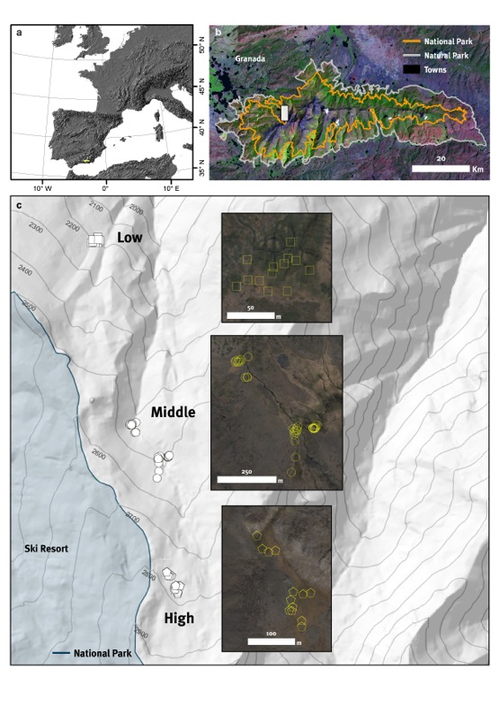

Figure 2.

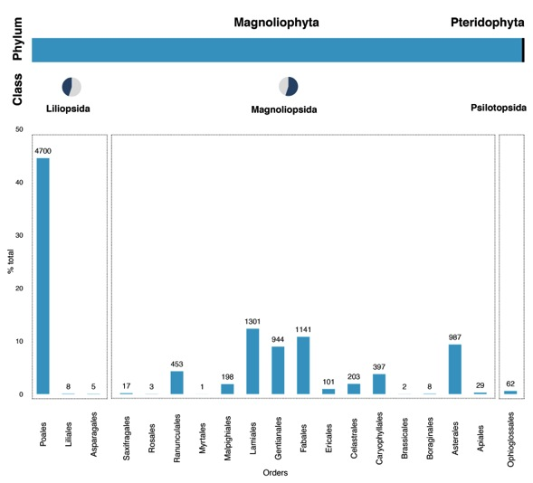

Figure 3.

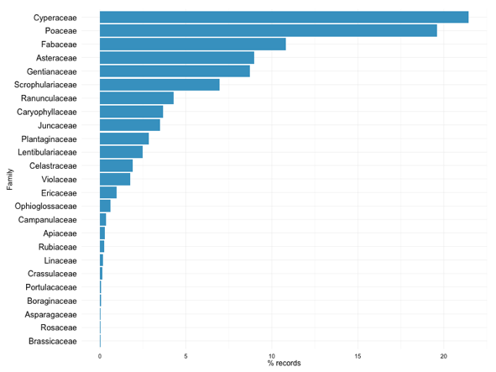

Figure 4.

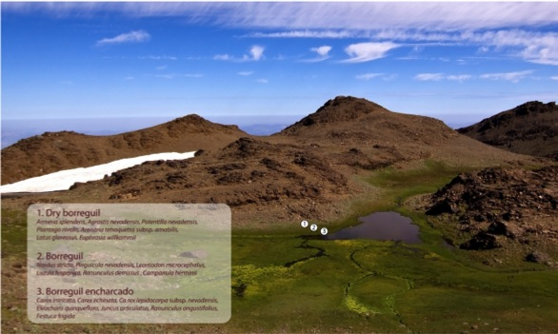

Figure 5.

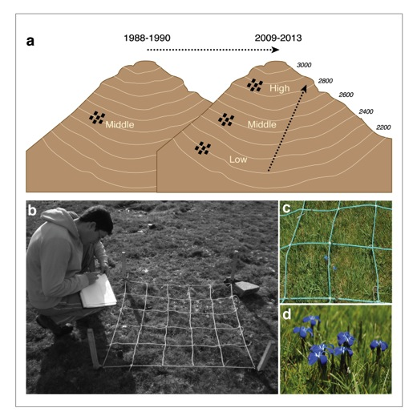

***notas QC***

* Other postvalidation procedures (including geographic coordinate format, congruence between collection and identification dates absence of ASCII anomalous characters) were checked by use of the Darwin test software (http://www.gbif.es/darwin_test/Darwin_Test_in.php).
* Other validation procedures, including geographic coordinates format, coordinates within country/provincial boundaries, congruence between collection and identification dates and were checked with DARWIN_TEST (v1.3) software (http://www.gbif.es/darwin_test/Darwin_test.php).
* The information of the first period (1988-1990) was taken in notebooks (INCLUIR FIGURA).
* Biodiversity data were exported to a dataset in Darwin Core (v1.2) format. DARWIN_TEST software was used to validate and clean the geographic, taxonomic and additional data associated with the specimens. Erroneous data were corrected and data cleaning was repeated to enhance the data quality (see details in the section on quality control).
* The dataset was transformed to a Darwin Core Archive format with metadata and was uploaded to the Integrated Publishing Toolkit (IPT v2.0.4) of the Spanish node of the Global Biodiversity Information Facility (GBIF) (http://www.gbif.es:8080/ipt). On the BOS Arthropod Collection website (http://www.unioviedo.es/BOS/Zoologia/artropodos), links to data pertaining to the BOS odonate specimens included in the GBIF data portal were also provided. The offline version of the dataset includes the identification history of each specimen (17846 items), the habitats in which the specimens were collected, and notes on materials derived from specimens (e.g., microscopic preparations, morphometric data, publications, etc.). This information is available on request.
* In adition the geo-coordinates of each sampling plot was verified using digital cartography and GIS (ArcGIS 9.2; ESRI, Redlands, California, USA)
* Following Wieczorek (2001) and Chapman and Wieczorek (2006), validation of geographic, taxonomic and additional data was incorporated in the digitalization process at several steps (Figure 1), as well as the geo-referencing of all specimens. All sampling plots were georeferenced using a hand-hel global positioning system (Garmin CS x 60; accurate to ±10 m)(Chapman and Wieczorek 2006)