Dataset of Passerine bird communities in a mediterranean high mountain (Sierra Nevada, Spain)
Pérez-Luque A.J. ^{1,2}; Barea-Azcón J.M. ³; Álvarez-Ruiz D. ¹; Bonet-García F.J. ^{1,2} and Zamora R. ^{1,2}
¹ Laboratorio de Ecología (iEcolab), Instituto Interuniversitario de Investigación del Sistema Tierra en Andalucía (CEAMA), Universidad de Granada, Avenida del Mediterráneo s/n, 18006, Granada, Spain.
² Grupo de Ecología Terrestre, Departamento de Ecología, Universidad de Granada, Facultad de Ciencias, Campus de Fuentenueva s/n, 18071, Granada, Spain.
³ Agencia de Medio Ambiente y Agua, Consejería de Medio Ambiente y Ordenación del Territorio (Junta de Andalucía), C/ Joaquina Egüaras 10, E-18013, Granada, Spain.

Corresponding author(s):
Antonio Jesús Pérez-Luque (ajperez@ugr.es)
Citation:
Combination of authors, year of data paper publication (in parentheses), Title, Journal Name, Volume, Issue number (in parentheses), and doi of the data paper.
Received {date}; Revised {date}; Accepted {date}; Published {date}

Resource citation:
iEcolab, University of Granada-Andalusian Environmental Center (Andalusian Institute for Earth System Research) (2015) Passerine bird communities in a high mountain (Sierra Nevada, Spain). 28146 data records. Contributed by University of Granada, OBSNEV, Agencia de Medio Ambiente y Agua de Andalucía, Archila Gallegos F, Arias Navarro A, Barea-Azcón JM, Bueno de la Rosa V; Cobos L; Contreras Parody F, Debén Duarte C, Foronda J, Galdo Fuentes P, Hernández Soto I, Lopera E, López Martínez A, López-Sanjuán R, Lozano Rubio AJ; Marín Escribano JM; Martín Jaramillo J; Martos García C, Morillas Fernández D, Rodríguez G. Online at http://www.gbif. es/ipt/resource.do?r=XXXX and http://obsnev.es/noticia.html?id=XXXX, version 1.0 (last updated on 2014-10-10). Resource ID: GBIF Key: http://www.gbif.org/dataset/ff7d3d4a-6c31-4876-8339-a1794f7d0316

Abstract
FALTA

Keywords
Passerine birds, Sierra Nevada (Spain), global change monitoring, mediterranean high-mountain, occurrences, abundance

Introduction
Birds are one of the most suitable organism to assess species vulnerability to climate change (Pacifi et al. 2015). There are scientific evidences of the effects of climate change on bird communities (Crick 2004, Pearce-Higgins and Green 2014, Pearce-Higgins et al. 2015). Most of studies supporting those impacts are based on long-term datasets (e.g. Gregory et al. 2009). Long-term datasets have been recognized as a key component for monitoring biodiversity (Magurran et al 2010), and are considered one of the major requirements to identify changes in phenology (Sanz 2002). However, it is often difficult to maintain long-term monitoring programs. In this sense re-sampling old studies can help to integrate short-term researches into long-term datasets and would provide a potential source of data to assess changes in ecological communities (Sanz 2002, Müller et al. 2010). This is relevant for Mediterranean region where more bird studies as well as available long-term datasets (Sanz 2002) are needed, especially considering that predicted variations in species richness showed large decreased in the southern regions of Europe (Barbet-Massin et al. 2012).
In this paper we describe a dataset of passerine bird communities from Sierra Nevada, a Mediterranean high mountain region. The dataset comes from Sierra Nevada Global Change Observatory (OBSNEV), a monitoring scheme designed to evaluate the potential impacts of global change in this mountain area. Monitoring methodologies of the OBSNEV include re-visiting old plots to assess long-term populations trends, changes in phenology, and shifts in community composition, among others.
Studies of bird communities in Sierra Nevada mountain region go back to the 1850s, with the first published records of field observations recorded by ornithologists (Pleguezuelos 1991, Garzón 2012). A recent review of ornithology in the Sierra Nevada was accomplished by Garzón and Henares (2012). All those works include passerine birds, but specific studies focusing specifically on Passerine birds communities on this mountain region were carried out during the early 1980s (Zamora and Camacho 1984, Zamora 1987a, 1987b, 1988a, 1988b, 1990). The dataset presented here contributes to increase the knowledge of Passerine birds in this mountain area and allows to carry out assessment of populations trends (e.g. Zamora and Barea 2015). Ya que se han revisitado algunos de los muestreos llevados a cabo en la época de los 80, además de otros muestreos en otras zonas de Sierra Nevada.

Project details

Project title
Sierra Nevada Global-Change Observatory (OBSNEV)

Personnel
Regino Jesús Zamora Rodríguez (Scientific Coordinator, Principal Investigator, University of Granada); Francisco Javier Sánchez Gutiérrez (Director of the Sierra Nevada National Park and Natural Park).

Funding
Sierra Nevada Global Change Observatory is funded by the Consejería de Medio Ambiente y Ordenación del Territorio (Junta de Andalucía) through the European Union (FEDER project) and by the Spanish Government (via “Fundación Biodiversidad”, which is a Public Foundation). Some activities carried out by the OBSNEV (data analysis, quantification of ecosystem services, harmonization of monitoring methods, integration in major cyberinfrastructures, etc.) are funded by the European Commission thanks to different projects (FP7: EU BON; H2020: eLTER, ECOPOTENTIAL; Life: ADAPTAMED).

Study area description
Sierra Nevada (Andalusia, SE Spain), is a mountainous region with an altitudinal range between 860 m and 3482 m a.s.l. covering more than 2000 km² (Figure 1). The climate is Mediterranean, characterized by cold winters and hot summers, with pronounced summer drought (July-August). The annual average temperature decreases in altitude from 12–16°C below 1500 m to 0°C above 3000 m a.s.l., and the annual average precipitation is about 600 mm. Additionally, the complex orography of the mountains causes strong climatic contrasts between the sunny, dry south-facing slopes and the shaded, wetter north-facing slopes. Annual precipitation ranges from less than 250 mm in the lowest parts of the mountain range to more than 700 mm in the summit areas. Winter precipitation is mainly in the form of snow above 2000 m of altitude.
This mountain area comprises 27 habitat types from the Habitat Directive. Sierra Nevada protected area contains 72 animal species (44 breeding birds, 17 mammals, 5 invertebrates, 2 amphibians and 4 reptiles) and 20 plant species listed in the Annex II and/or in the Annex IV of Habitat or Bird directives. It is thus considered one of the most important biodiversity hotspots in the Mediterranean region (Blanca 1996, Blanca et al. 1998, Cañadas et al. 2014).
Sierra Nevada has several legal protections: Biosphere Reserve MAB Committee UNESCO; Special Area of conservation (Natura 2000 network); Natural Park and National Park. The area includes 61 municipalities with more than 90, 000 inhabitants. The main economic activities are agriculture, tourism, cattle raising, beekeeping, mining, and skiing (Bonet el al. 2010).

Design description
Sierra Nevada Global Change Observatory (OBSNEV) (Bonet et al. 2011) is a long-term research project that is being undertaken at Sierra Nevada Biosphere Reserve (SE Spain). It is intended to compile the information necessary for identifying as early as possible the impacts of global change, in order to design management mechanisms to minimize these impacts and adapt the system to new scenarios (Aspizua et al. 2010, Bonet el al. 2010). The general objectives are to:
- Evaluate the functioning of ecosystems in the Sierra Nevada Nature Reserve, their natural processes and dynamics over a medium-term timescale.
- Identify population dynamics, phenological changes, and conservation issues regarding key species that could be considered indicators of ecological processes.
- Identify the impact of global change on monitored species, ecosystems, and natural resources, providing an overview of trends of change that could help foster ecosystem resilience.
- Design mechanisms to assess the effectiveness and efficiency of management activities performed in the Sierra Nevada in order to implement an adaptive management framework.
- Help to disseminate information of general interest concerning the values and importance of Sierra Nevada.
The Sierra Nevada Global Change Observatory has four cornerstones:
- A monitoring program with 40 methodologies that collect information on ecosystem functioning (Aspizua et al. 2012; 2014).
- An information system to store and manage all the information gathered (http://obsnev.es/linaria.html - Pérez-Pérez et al. 2012; Free access upon registration).
- A plan to promote adaptive management of natural resources using the data amassed through the monitoring programme.
- An outreach programme to disseminate all the available information to potential users (see News Portal of the project at http://obsnev.es and the wiki of the project at http://wiki.obsnev.es, Pérez-Luque et al. 2012)
The Sierra Nevada Global Change Observatory is linked to other national (Zamora and Bonet 2011) and international monitoring networks: GLOCHAMORE (Global Change in Mountain Regions) (Björnsen 2005), GLOCHAMOST (Global Change in Mountain Sites) (Schaaf 2009), LTER-Spain (Long-Term Ecological Research), LifeWatch (Basset and Los 2012), etc. This project is also involved in several European projects like MS-MONINA (FP7 project. www.ms-monina.eu), EU BON (Hoffmann et al. 2014), eLTER (H2020 project. www.lter-europe.net/projects/eLTER), ECOPOTENTIAL (H2020 project. www.ecopotential-project.eu/) and ADAPTAMED (Life project).
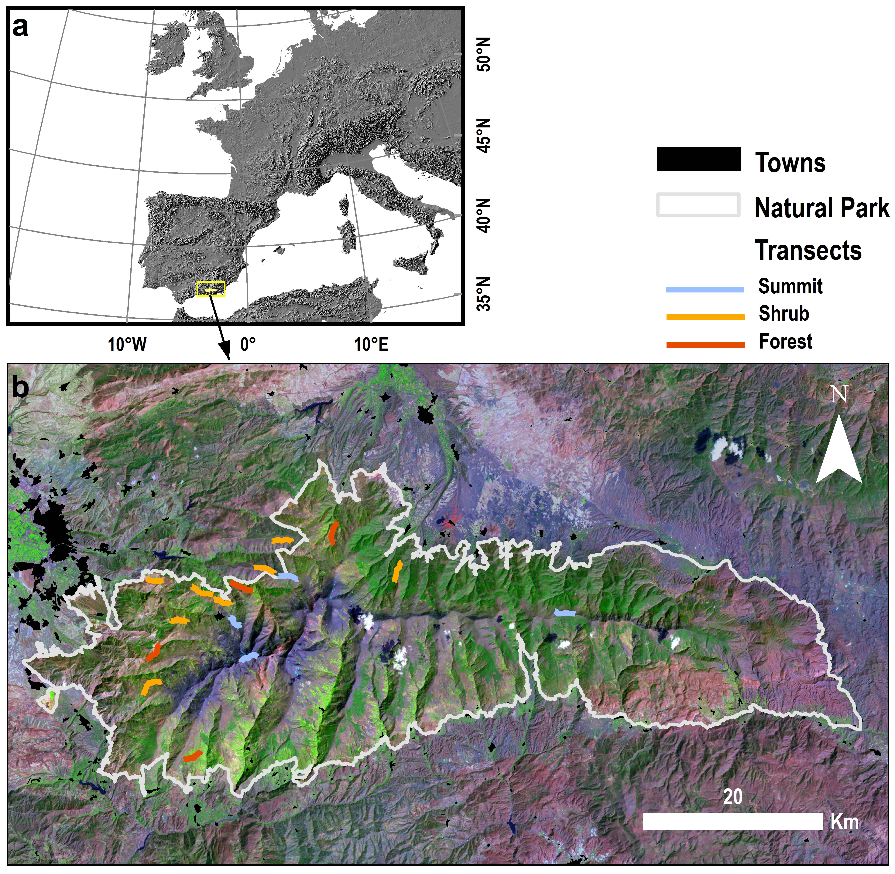
Figure 1. Location of Sierra Nevada (southern Spain) (a) and boundaries of the National and Natural Parks. Blue, Red and Yellow lines indicate location of sampled transects in each of the habitat type (see Methods section).

Taxonomic coverage
This dataset includes a total of 28437 records of the order Passeriformes. There are 16 families represented in this dataset (Figure 2). Nearly one third of the specimens belong to the family Fringillidae. A total of 44 genera are represented in this collection, with Emberiza, Cyanistes, Turdus, Fringilla and Parus having the highest number of records (Figure 3). There are 70 (Incluir % 70/74) taxa of this dataset included in the European Red List (BirdLife International 2015): 67 categorized as Least Concern; 2 Not evaluated, and 1 taxa considered as Vulnerable (Table 1). According to Spanish Red List (Madroño et al. 2004), 3 taxa of this dataset are considered under Near Threatened category, 1 taxa as Vulnerable and 1 as Least Concern categories respectively (Table 1).

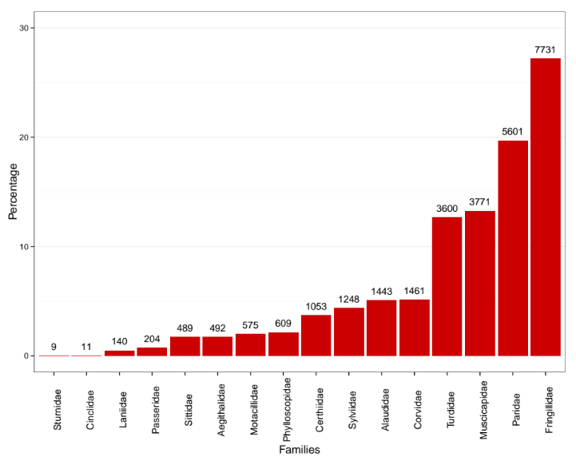
Figure 2: Taxonomic families included in the dataset. The bars show the percentage of records belonging to each family.
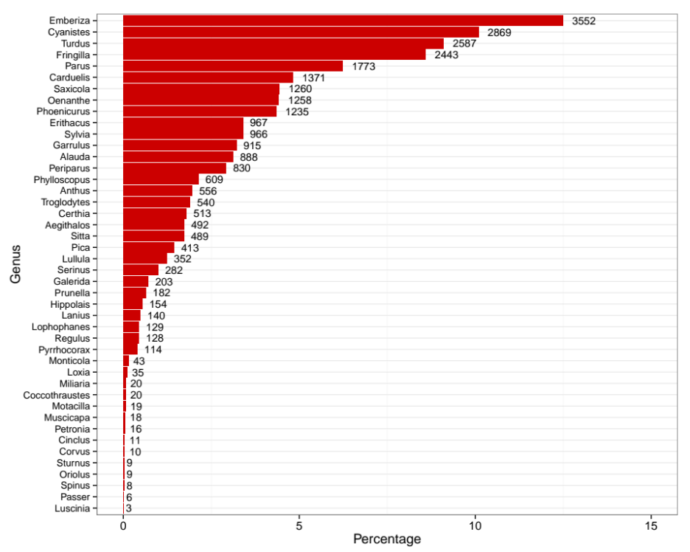
Figure 3: Distribution of records in the collection according to genus.

Taxonomic ranks
Kingdom: Metazoa
Phylum: Chordata
Subphylum: Craniata
Class: Aves
Order: Passeriformes
Family: Aegithalidae, Alaudidae, Certhiidae, Cinclidae, Corvidae, Fringillidae, Laniidae, Motacillidae, Muscicapidae, Paridae, Passeridae, Phylloscopidae, Sittidae, Sturnidae, Sylviidae, Turdidae
Genus: Aegithalos, Alauda, Anthus, Carduelis, Certhia, Cinclus, Coccothraustes, Corvus, Cyanistes, Emberiza, Erithacus, Fringilla, Galerida, Garrulus, Hippolais, Lanius, Lophophanes, Loxia, Lullula, Luscinia, Miliaria, Monticola, Motacilla, Muscicapa, Oenanthe, Oriolus, Parus, Passer, Periparus, Petronia, Phoenicurus, Phylloscopus, Pica, Prunella, Pyrrhocorax, Regulus, Saxicola, Serinus, Sitta, Spinus, Sturnus, Sylvia, Troglodytes, Turdus
Table 1. Conservation status of the species included in this dataset.
Scientific name | European Red List ª | Spanish Red List ^{b} | Birds Directive ^{c} | Bern ^{d} | Spanish Name ^{e} | English Name ^{f}
Aegithalos caudatus (Linnaeus, 1758) | LC | NE |  | III | Mito | Long-tailed Tit
Alauda arvensis Linnaeus, 1758 | LC | NE |  | III | Alondra común | Eurasian Skylark
Anthus campestris (Linnaeus, 1758) | LC | NE |  | III | Bisbita campestre | Tawny Pipit
Anthus spinoletta (Linnaeus, 1758) | LC | NE |  |  | Bisbita alpino | Water Pipit
Carduelis cannabina (Linnaeus, 1758) | LC | NE | II |  | Pardillo común | Common Linnet
Carduelis carduelis (Linnaeus, 1758) | LC | NE | I | III | Jilguero | European Goldfinch
Carduelis chloris (Linnaeus, 1758) | LC | NE |  | III | Verderón común | European Greenfinch
Carduelis spinus (Linnaeus, 1758) | LC | NE | I | III | Verderón serrano | Eurasian Siskin
Certhia brachydactyla CL Brehm , 1820 | LC | NE |  | III | Agateador común | Short-toed Treecreeper
Cinclus cinclus (Linnaeus, 1758) | LC | NE |  | III | Mirlo acuático | White-throated Dipper
Coccothraustes coccothraustes (Linnaeus, 1758) | LC | NE |  | III | Camachuelo común | Hawfinch
Corvus corax Linnaeus, 1758 | LC | NE | I | III | Cuervo | Northern Raven
Corvus monedula Linnaeus, 1758 | LC | NE |  | III | Grajilla | Eurasian Jackdaw
Cyanistes caeruleus (Linnaeus, 1758) | LC | NE |  | III | Herrerillo común | Eurasian Blue Tit
Emberiza cia Linnaeus, 1766 | LC | NE |  | III | Escribano montesino | Rock Bunting
Emberiza cirlus Linnaeus, 1766 | LC | NE |  | III | Escribano soteño | Cirl Bunting
Emberiza hortulana Linnaeus, 1758 | LC | NE |  | III | Escribano hortelano | Ortolan Bunting
Erithacus rubecula (Linnaeus, 1758) | LC | NE |  | III | Petirrojo | European Robin
Fringilla coelebs Linnaeus, 1758 | LC | NE |  | III | Pinzón vulgar | Common Chaffinch
Fringilla montifringilla Linnaeus, 1758 | LC | NE |  | III | Pinzón real | Brambling
Galerida cristata Linnaeus, 1758 | LC | NE |  | III | Cogujada común | Crested Lark
Galerida theklae (Cl Brehm, 1858 | LC | NE | I | III | Cogujada montesina | Thekla Lark
Garrulus glandarius (Linnaeus, 1758) | LC | NE |  | III | Arrendajo | Eurasian Jay
Hippolais polyglotta (Vieillot, 1817) | LC | NE |  | III | Zarzero común | Melodious Warbler
Lanius meridionalis Temminck, 1820 | VU |  | I | III | Alcaudón meridional | Great Grey Shrike
Lanius senator Linnaeus, 1758 | LC | NT |  | III | Alcaudón común | Woodchat Shrike
Lophophanes cristatus (Linnaeus, 1758) | LC |  |  | III | Herrerillo capuchino | European Crested Tit
Loxia curvirostra Linnaeus, 1758 | LC | NE |  | III | Piquituerto | Red Crossbill
Lullula arborea (Linnaeus, 1758) | LC | NE |  | III | Totovía | Woodlark
Luscinia megarhynchos CL Brehm, 1831 | LC | NE | I | III | Pechiazul | Common Nightingale
Miliaria calandra (Linnaeus, 1758) | LC | NE |  |  | Calandria común | Corn Bunting
Monticola saxatilis (Linnaeus, 1766) | LC | NE | II |  | Roquero rojo | Common Rock Thrush
Motacilla alba Linnaeus, 1758 | LC | NE |  |  | Lavandera blanca | White Wagtail
Motacilla cinerea Tunstall, 1771 | LC | NE |  |  | Lavandera cascadeña | Grey Wagtail
Muscicapa striata (Pallas, 1764) | LC | NE |  | III | Papamoscas gris | Spotted Flycatcher
Oenanthe hispanica (Linnaeus, 1758) | LC | NT |  | III | Collalba rubia | Black-eared Wheatear
Oenanthe oenanthe (Linnaeus, 1758) | LC | NE |  | III | Collalba gris | Northern Wheatear
Oriolus oriolus (Linnaeus, 1758) | LC | NE |  | III | Oropéndola | Eurasian Golden Oriole
Parus major Linnaeus, 1758 | LC | NE |  | III | Carbonero común | Great Tit
Passer domesticus (Linnaeus, 1758) | LC | NE |  | III | Gorrión común | House Sparrow
Periparus ater (Linnaeus, 1758) | LC | NE |  | III | Carbonero garrapinos | Coal Tit
Petronia petronia (Linnaeus, 1766) | LC | NE |  | III | Gorrión chillón | Rock Sparrow
Phoenicurus ochruros (SG Gmelin , 1774) | LC | NE |  | III | Colirrojo tizón | Black Redstart
Phoenicurus phoenicurus (Linnaeus, 1758) | LC | VU |  | III | Colirrojo real | Common Redstart
Phylloscopus bonelli (Vieillot, 1819) | LC | NE |  | III | Mosquitero papialbo | Western Bonelli's Warbler
Phylloscopus collybita (Vieillot, 1817) | LC | NE |  | III | Mosquitero común | Common Chiffchaff
Pica pica (Linnaeus, 1758) | LC | NE | I,II,III |  | Urraca | Eurasian Magpie
Prunella collaris (Scopoli, 1769) | LC | NE |  | III | Acentor común | Alpine Accentor
Prunella modularis (Linnaeus, 1758) | LC | NE | II,III | III | Acentor alpino | Dunnock
Pyrrhocorax pyrrhocorax (Linnaeus, 1758) | LC | NT |  | III | Chova piquiroja | Red-billed Chough
Regulus ignicapillus (Temminck, 1820) | LC | NE | I | III | Reyezuelo sencillo | Common Firecrest
Saxicola rubetra (Linnaeus, 1758) | LC | NE |  | III | Tarabilla norteña | Whinchat
Saxicola rubicola (Linnaeus, 1766) | LC | NE |  | III | Tarabilla común | African Stonechat
Serinus citrinella (Pallas, 1764) | LC | NE | I | III | Verderón serrano | Citril Finch
Serinus serinus (Linnaeus, 1766) | LC | NE |  | III | Verdecillo | European Serin
Sitta europaea Linnaeus, 1758 | LC | NE |  | III | Trepador azul | Eurasian Nuthatch
Sturnus unicolor Temminck, 1820 | LC | NE |  | III | Estornino negro | Spotless Starling
Sylvia atricapilla (Linnaeus, 1758) | LC | NE |  | III | Curruca capirotada | Eurasian Blackcap
Sylvia cantillans (Pallas, 1764) | LC | NE |  | III | Curruca carrasqueña | Subalpine Warbler
Sylvia communis Latham, 1787 | LC | NE |  | III | Curruca zarzera | Common Whitethroat
Sylvia conspicillata Temminck, 1820 | LC | LC |  | III | Curruca tomillera | Spectacled Warbler
Sylvia melanocephala (Gmelin, 1789) | LC | NE | II | III | Curruca cabecinegra | Sardinian Warbler
Sylvia undata (Boddaert, 1783) | NT | NE |  | III | Curruca rabilarga | Dartford Warbler
Troglodytes troglodytes (Linnaeus, 1758) | LC | NE | II |  | Chochín | Eurasian Wren
Turdus iliacus Linnaeus, 1758 | NT | NE |  | III | Zorzal alirrojo | Redwing
Turdus merula Linnaeus, 1758 | LC | NE |  | III | Mirlo común | Common Blackbird
Turdus philomelos CL Brehm, 1831 | LC | NE |  | III | Zarcero común | Song Thrush
Turdus pilaris Linnaeus, 1758 | LC | NE | II | III | Zorzal real | Fieldfare
Turdus torquatus Linnaeus, 1758 | LC | NE | II | III | Mirlo capiblanco | Ring Ouzel
Turdus viscivorus Linnaeus, 1758 | LC | NE | II | III | Zorzal charlo | Mistle Thrush
ª European Red List of Birds (BirdLife International, 2015). ^{b} Red Book of the birds of Spain (Madroño et al. 2004). ^{c} Species included in the Birds Directive Annexes (EC 1979) ^{d} Bern: Convention on the Conservation of European Wildlife and Natural Habitats (Bern Convention). ^{e} Spanish common names (Gutiérrez et al. 2012). ^{f} English common names (Gill and Donsker 2015). LC: Least Concern; NE: Not Evaluated; NT: Near Threatened; VU: Vulnerable.

OJO con esto: https://github.com/ajpelu/dp_dispersantes/blob/master/script/Notes_references_common_names.md

Spatial coverage

Bounding box for covered area
36°52'12"N and 37°15'36"N Latitude; 3°41'24"W and 2°33'36"W Longitude

Temporal coverage
Observations in the collection included in this datapaer date from November 2007 to April 2015 (Figure 4).
Figure 4: Temporal coverage of the dataset. For each taxon (y-axis) the temporal coverage is showed including a point. Point size is proportional to monthly records of each taxon.

Collection name
Dataset of Passerine bird communities in a mediterranean high mountain (Sierra Nevada, Spain)

Collection identifier
http://www.gbif.es/ipt/resource.do?r=XXXX

Methods

Study extent description
This dataset covers four representative habitats within Sierra Nevada mountain range: Pyrenean oak forest , thorny thickets on the edge of the forest, common juniper and Spanish juniper scrublands and high-summit ecosystems. These ecosystems were selected based on criteria of singularity and ecological functionality in the context of Sierra Nevada (Barea-Azcón et al. 2012, 2014) and can be described as follow:
- Pyrenean oak forest: Mediterranean woodland composed mainly of relict Quercus pyrenaica and some dominant scrubland species (i.e. Berberis hispanica, Prunus ramburii, Rosa canina, Crataegus monogyna and Adenocarpus decorticans). These forests show strong evidences of past management that determine their current structure and diversity. These management is mainly based on charcoal, pastureland creation, and wood production until the 1950s, so that the current trees are mostly resprouts of 60-70 years old. The target localities (n=4) are located at an average elevation of 1650 m a.s.l. (1600-1750 m a.s.l.) and are distributed in the south, west, north and east slopes of Sierra Nevada, reflecting all the ecological conditions of the Pyrenean oak forest in the study area (referencia robledales).
-Thornscrubs: Tipical areas dominated by thorny thickets on the edge of the forest or as result of recent colonization of abandoned arable lands. Berberis hispanica, Prunus ramburii, Rosa canina, Crataegus monogyna are dominant but other species as Lonicera arborea or even Sorbus spp. This open habitat is very important for breeding birds in the study area and also for winter visitors due to a great production of fruits from the end of the summer to the beginning of winter. Transect (n=4) in this habitat are located between 1450 and 2060 m a.s.l. (average: 1790 m a.s.l.).
-Common juniper and Spanish juniper scrublands: vegetation in these localities is composed mainly of common juniper (Juniperus communis), Spanish juniper (Juniperus Sabina). Cytisus galianoi and Genista baetica are also important species in these ecosystems. These scrublands rarely exceed 60 cm in height and appear intermingled with rocks and stony ground. Transects (n=4) located in this ecosystems comprise an elevational range from 2000 to 2300 m a.s.l. (average: 2150 m a.s.l.).
-High-summit ecosystems: composed by typical Alpine landscape. These ecosystems are characterized by rocky outcrops that originated from glacial activity, pastureland, small snow beds, and glacial lagoons. The four transects that represents this Mediterranean high mountain habitat comprise an elevational gradient from 2280 to 3100 m a.s.l., with an average elevation of 2580 m a.s.l.

Sampling description
Sampling procedure was the line-transect method (Verner, 1985), with a bandwidth of 50 m, 25 m on each side of the line (Barea-Azcón et al 2012, 2014). A total of 16 transect were sampled with lengths ranged from 1.9 to 3 km (Table 2). Sight and sound records within the sample area were accepted as contacts. All transects were sampled in the early morning, under appropriate climatic conditions. The observer walks at a constant speed of 2 to 4 km/h. Transects are repeated at least once per month provided that the conditions of snow cover permitting. This implies that the sites located on the higher elevations are sampled only from late spring to early autumn.

Transect name | Length (m) | Habitat type | Longitude | Latitude | Province | Municipality | Elevation
Robledal de Cáñar | 2556 | Forest | -3.4292 | 36.9532 | Granada | Cáñar | 1736
Dehesa del Río Dúrcal | 3292 | Shrub | -3.4825 | 37.0255 | Granada | Dúrcal | 2033
Robledal de Dílar | 2553 | Forest | -3.4779 | 37.0582 | Granada | Dílar | 1605
Collado de Matas Verdes | 2237 | Shrub | -3.4470 | 37.0909 | Granada | Monachil | 1918
El Purche | 1944 | Shrub | -3.4780 | 37.1311 | Granada | Monachil | 1453
Collado del Sabinar | 2745 | Shrub | -3.4184 | 37.1199 | Granada | Güejar Sierra | 2036
Campos de Otero | 2264 | Shrub | -3.3930 | 37.1100 | Granada | Güejar Sierra | 2143
Cortijo del Hornillo | 3044 | Forest | -3.3680 | 37.1246 | Granada | Güejar Sierra | 1585
Loma Papeles | 2539 | Shrub | -3.3401 | 37.1434 | Granada | Güejar Sierra | 2113
Dehesa de las Hoyas | 2436 | Shrub | -3.3173 | 37.1724 | Granada | Güejar Sierra | 2074
Dehesa del Camarate | 2805 | Forest | -3.2537 | 37.1797 | Granada | Lugros | 1575
Lanteira | 2515 | Shrub | -3.1725 | 37.1409 | Granada | Lanteira | 1794
Laguna Seca | 2530 | Summit | -2.9615 | 37.0992 | Granada | Huéneja | 2295
Aguas Verdes | 2431 | Summit | -3.3589 | 37.0540 | Granada | Capileira | 3149
Hoya Mora | 2046 | Summit | -3.3771 | 37.0896 | Granada | Güejar Sierra | 2407
Papeles alto | 2309 | Summit | -3.3098 | 37.1357 | Granada | Güejar Sierra | 2420
Table 2. Information about transects sampled to collect data included in this dataset.

Method step description
All data were stored in a normalized database (PostgreSQL) and incorporated into the Information System of Sierra Nevada Global-Change Observatory. Taxonomic and spatial validations were made on this database (see Quality-control description). A custom-made SQL view of the database was performed to gather occurrence data and other variables associated with occurrence data, specifically:
- Birds Count: Number of individual recorded by the observer within transect (see Sampling description)
- Distance: Distance of the contact (bird) to transect line. The distance is estimated by eye.
The occurrence and measurement data were accommodated to fulfill the Darwin Core Standard (Wieczorek et al. 2009, 2012). We used Darwin Core Archive Validator tool (http://tools.gbif.org/dwca-validator/) to check whether the dataset meets Darwin Core specifications. The Integrated Publishing Toolkit (IPT v2.0.5) (Robertson et al. 2014) of the Spanish node of the Global Biodiversity Information Facility (GBIF) (http://www.gbif.es/ipt) was used both to upload the Darwin Core Archive and to fill out the metadata.
The Darwin Core elements for the occurrence data included in the dataset are: occurrenceId, modified, language, basisOfRecord, institutionCode, collectionCode, catalogNumber, scientificName, kingdom, phylum, class, order, family, genus, specificEpithet, scientificNameAuthorship, continent, country, countryCode, stateProvince, county, locality, minimumElevationInMeters, maximumElevationInMeters, decimalLongitude, decimalLatitude, coordinateUncertaintyinMeters, geodeticDatum, recordedBy, day, month, year, EventDate.
For the measurement data, the Darwin Core elements included were: occurrenceId, measurementID, measurementType, measurementValue, measurementAccuracy, measurementUnit, measurementDeterminedDate, measurementDeterminedBy, measurementMethod.

Quality control description
The sampling transects were georeferenced using a Garmin eTrex Legend GPS (WGS 84 Datum) with an accuracy of ±5 m. We also used colour digital orthophotographs provided by the Andalusian Cartography Institute and GIS (ArcGIS 9.2; ESRI, Redlands, California, USA) to verify that the geographical coordinates of the transect were correct (Chapman and Wieczorek 2006).
For the identification of the specimes several fields guides were used (De Juana and Varela 2000, Jonsson 2001). The scientific names were checked with database of the IOC World Bird List (v 5.52) (Gill and Donkster 2015). We also used the R package taxize (Chamberlain and Szocs 2013, Chamberlain et al. 2014) to verify the taxonomical classification.
We also performed validation procedures (Chapman 2005a, 2005b) (geopraphic coordinate format, coordinates within country/provincial boundaries, absence of ASCII anomalous characters in the dataset) with DARWIN_TEST (v3.2) software (Ortega-Maqueda and Pando 2008).

Dataset description
Object name: Darwin Core Archive Dataset of Passerine bird communities in a mediterranean high mountain (Sierra Nevada, Spain)
Character encoding: UTF-8
Format name: Darwin Core Archive format
Format version: 1.0
Distribution: http://www.gbif.es/ipt/resource.do?r=migrame
Publication date of data: 2015-10-01
Language: English
Licenses of use: This “Dataset of Passerine bird communities in a Mediterranean high mountain (Sierra Nevada, Spain)” is licensed under a made available under the Creative Commons Attribution Non Commercial (CC-BY-NC) 4.0 License http://creativecommons.org/licenses/by-nc/4.0/legalcode
Metadata language: English
Date of metadata creation: 2015-05-10
Hierarchy level: Dataset

Acknowledgements
This research work was conducted in the collaborative framework of the “Sierra Nevada Global Change Observatory” Project from the Environment Department of Andalusian Regional Government, the Sierra Nevada National Park and the Spanish Biodiversity Foundation (“Fundación Biodiversidad”). Funding was provided by the Project MIGRAME (RNM 6734) from the Excellence Research Group Programme of the Andalusian Government. We thank Katia Cezón and Franciso Pando (Spanish GBIF node–CSIC) for technical support. We also thank David Nesbitt for linguistic advice. A. J. Pérez-Luque would like to thank the MICINN of the Government of Spain for the financial support (PTA 2011-6322-I).

References
Anokwa Y, Hartung C, Brunette W, Borriello G, Lerer A (2009) Open source data collection in the developing world. Computer 42(10): 97-99. doi: 10.1109/MC.2009.328
Basset A, Los W. (2012) Biodiversity e-Science: LifeWatch, the European infrastructure on biodiversity and ecosystem research. Plant Biosystems 146 (4): 780-782. doi: 10.1080/11263504.2012.740091
Barbet-Massin M, Thuiller W, Jiguet F (2012) The fate of European breeding birds under climate, land-use and dispersal scenarios. Global Change Biology 18 (3): 881–890.
Barea-Azcón JM, Martín-Jaramillo J, López R (2012) Paseriformes y otras aves. In: Aspizua R, Barea-Azcón JM, Bonet FJ, Pérez-Luque AJ, Zamora R (Eds). Observatorio de Cambio Global Sierra Nevada: metodologías de seguimiento. Consejería de Medio Ambiente, Junta de Andalucía. 86-87.
Barea-Azcón JM, Martín-Jaramillo J, López R (2014) Passerines and other birds. In: Aspizua R, Barea-Azcón JM, Bonet FJ, Pérez-Luque AJ, Zamora R (Eds). Sierra Nevada Global Change Observatory. Monitoring methodologies. Consejería de Medio Ambiente, Junta de Andalucía. 86-87.
Crick H (2004) The impact of climate change on birds. Ibis 146: 48-56
De Juana E, Varela JM (2000). Guía de las Aves de España. Península, Baleares y Canarias. Lynx Edicions, Barcelona.
De Juana E, Del Hoyo J, Fernández-Cruz M, Ferrer X, Sáez-Royuela R, Sargatal J (2004) Nombres en castellano de las aves del mundo recomendados por la Sociedad Española de Ornitología (Novena parte: orden Passeriformes, familias Cotingidae a Motacillidae). Ardeola 51(2): 491–499.
De Juana E, Del Hoyo J, Fernández-Cruz M, Ferrer X, Sáez-Royuela R, Sargatal J (2005) Nombres en castellano de las aves del mundo recomendados por la Sociedad Española de Ornitología (décima parte: orden Passeriformes, familias Campephagidae a Turdidae). Ardeola 52(2): 389– 398.
De Juana E, Del Hoyo J, Fernández-Cruz M, Ferrer X, Sáez-Royuela R, Sargatal J (2007) Nombres en castellado de las aves del mundo recomendados por la Sociedad Española de Ornitología (undécima parte: Orden Passeriformes, Familias Muscicapidae to Sylviidae). Ardeola 54(1): 145–153.
De Juana E, Del Hoyo J, Fernández-Cruz M, Ferrer X, Sáez-Royuela R, Sargatal J (2009a) Nombres en castelllano de las aves del mundo recomendados por la Sociedad Española de Ornitología. (Duodécima parte: orden Passeriformes, familias Picathartidae a Paridae). Ardeola 56(1): 127–134.
De Juana E, Del Hoyo J, Fernández-Cruz M, Ferrer X, Sáez-Royuela R, Sargatal J (2009b) Nombres en castellano de las aves del mundo recomendados por la Sociedad Española de Ornitología. (Decimotercera parte: orden Passeriformes, familias Remizidae a Laniidae). Ardeola 56(1): 135-142.
De Juana E, Del Hoyo J, Fernández-Cruz M, Ferrer X, Sáez-Royuela R, Sargatal J (2010a) Nombres en castellano de las aves del mundo recomendados por la Sociedad Española de Ornitología. (Decimocuarta parte: orden Passeriformes, familias Malaconotidae a Passeridae). Ardeola 57(1): 199-205.
De Juana E, Del Hoyo J, Fernández-Cruz M, Ferrer X, Sáez-Royuela R, Sargatal J (2010b) Nombres en castellano de las aves del mundo recomendados por la Sociedad Española de Ornitología (Decimoquinta parte: orden Passeriformes, familias Ploceidae a Parulidae). Ardeola 57(2): 449-456.
EC (1979) Council Directive 79/409/EEC of 2 April 1979 on the conservation of wild birds. Official Journal L 103. http://eur-lex.europa.eu/LexUriServ/LexUriServ.do?uri=CELEX:31979L0409:EN:HTML
Garzón J (2012) Revisión histórica de la ornitología en Sierra Nevada. In: Garzón J, Henares I (Eds) Las Aves de Sierra Nevada. Consejería de Agricultura, Pesca y Medio Ambiente de la Junta de Andalucía, Granada, 41-49.
Garzón J, Henares I (2012) Las Aves de Sierra Nevada. Consejería de Agricultura, Pesca y Medio Ambiente de la Junta de Andalucía, Granada.
Gill F, Donsker D (2015) IOC World Bird List (v 5.2). http://www.worldbirdnames.org [accessed June 10, 2015] doi: 10.14344/IOC.ML.5.2.
Gregory RD, Willis SG, Jiguet F, Voříšek P, Klvaňová A, van Strien A, Huntley B, Collingham YC, Couvet D, Green RE (2009) An indicator of the impact of climatic change on European bird populations. PLoS ONE 4, e4678.
Gutiérrez R, De Juana E, Lorenzo JA (2012) Lista de las aves de España. Versión online 1.0: nombres castellano, científico e inglés. SEO/BirdLife. http://www.seo.org/wp-content/uploads/2012/10/Lista_-Aves_Espana_2012.pdf
Hartung C, Anokwa Y, Brunette W, Lerer A, Tseng C, Borriello G (2010) Open Data Kit: tools to build information services for developing regions. In: Proceedings of the 4th ACM/IEEE International Conference on Information and Communication Technologies and Development: http://dx.doi.org/10.1145/2369220.2369236
Jonssson L (2001) Guía de aves de Europa, con el Norte de África y el Próximo Oriente. Ediciones Omega.
Madroño A, González C, Atienza JC (2004) Libro Rojo de las Aves de España. Dirección General para la Biodiversidad-SEO/BirdLife. Madrid-España, 452 pp.
Magurran AE, Baillie SR, Buckland ST, Dick JM, Elston DA, Scott EM, Smith RI, Somerfield PJ, Watt AD (2010) Long-term datasets in biodiversity research and monitoring: assessing change in ecological communities through time. Trends in Ecology and Evolution, 25: 574–582.
Müller F, Gnauck A, Wenkel KO, Schubert H, Bredemeier M (2010) Theoretical demands for long-term ecological research and the management of long-term data sets. In: Müller F, Baessler C, Schubert H, Klotz S (Eds) Long-term ecological research. Between theory and application. Springer, New York. 11-25.
Pacifi M, Foden WB, Visconti P, Watson JEM, Butchart SHM, Kovacs KM, Scheffers BR, Hole DG, Martin TG, Akcakaya HT, Corlett RT, Huntley B, Bickford D, Carr JA, Hoffmann AA, Midgley GF, Pearce-Kelly P, Pearson RG, Williams SE, Willis SG, Young B, Rondinini C (2015) Assessing species vulnerability to climate change. Nature Climate Change 5: 215-224.
Pearce-Higgins JW, Green RE (2014) Birds and Climate Change. Impacts and conservation responses. Cambridge University Press. United Kingdom.
Pearce-Higgins JW, Eglington SN, Martay B, Chamberlain DE (2015) Drivers of climate change impacts on bird communities. Journal of Animal Ecology, 84(4): 943–954.
Pleguezuelos JM (1991) Evolución histórica de la avifauna nidificante en el SE de la Península Ibérica (1850-1985). Consejería de Cultura y Medio Ambiente. Junta de Andalucia. 61 pp.
Robertson T, Döring M, Guralnick R, Bloom D, Wieczorek J, Braak K, Otegui J, Russell L, Desmet P (2014) The GBIF Integrated Publishing Toolkit: Facilitating the Efficient Publishing of Biodiversity Data on the Internet. PLoS ONE 9(8): e102623, doi: 10.1371/journal.pone.0102623.
Sanz JJ (2002) Climate change and birds: Have their ecological consequences already been detected in the Mediterranean region?. Ardeola 49(1): 109-120.
Zamora R, Camacho I (1984) Evolución estacional de la comunidad de aves en un robledal de Sierra Nevada. Doñana Acta Vertebrata 11: 129–150.
Zamora R (1987a) Dinámica temporal y selección de hábitat de los passeriformes de la alta montaña de Sierra Nevada (Granada). PhD thesis, Granada, Spain: University of Granada.
Zamora R (1987b). Variaciones altitudinales en la composición de las comunidades nidificantes de aves de Sierra Nevada. Doñana Acta Vertebrata 14: 83–106.
Zamora R (1988a) Composición y estructura de la comunidad de Passeriformes de la alta montaña de Sierra Nevada. Ardeola 35: 197–220.
Zamora R (1988b) Estructura morfológica de una comunidad de Passeriformes de alta montaña (Sierra Nevada, SE de España). Ardeola 35: 71–95.
Zamora R (1990) Seasonal variations of a passerine community in a mediterranean high-mountain. Ardeola 37: 219–228.
Zamora R, Barea-Azcón JM (2015) Long-Term changes in mountain passerine bird communities in the Sierra Nevada (southern Spain): A 30-year case study. Ardeola 62(1): 3-18.
Wieczorek J, Döring M, De Giovanni R, Robertson T, Vieglais D (2009) Darwin Core Terms: A quick reference guide. http://rs.tdwg.org/dwc/terms/ [accessed 10.05.2015].
Wieczorek J, Bloom D, Guralnick R, Blum S, Döring M, Giovanni R, Robertson T, Vieglais D (2012) Darwin Core: An evolving community-developed biodiversity data standard. PLoS ONE 7(1): e29715. doi: 10.1371/journal.pone.0029715

