Dear Monica Turner

Co-Editor-in-Chief

Many thanks for your correspondence regarding our manuscript entitled

“*Land-use legacies and climate change as a double challenge to oak forest resilience: mismatches of geographical and ecological rear edges*” (ECO19_0444R1).

We are very grateful for the helpful comments and suggestions received by the two reviewers and the subject-matter editor. They highlighted some points that were not explained in a clear way, and also some weak points that needed to be improved.

Following their suggestions and also comments, we have restructured and rewritten the introduction and the discussion sections, and we think the ideas is now clearly specified in the new version of our manuscript. Specifically, we addressed the importance of considering others dimensions (like the land-use legacies) not only climatic or geographical in the definition of the “ecological rear-edge”, and therefore in the assessment of resilience in populations located in the rear-edge.

In addition, we aware that the different metrics and methods we used were not sufficiently explained, and or were presented in a confused way. We have re-formatted and rewritten the statistical analysis section. We also made a new figure to explain the general outline of our manuscript and the methods we used related with the aims of our study. We think this new figure would aid to the readers to easily link the aims with methods and also with results.

Below, please find our point-by-point responses (indicated with “R”) presenting, in detail, how we have addressed the Reviewers comments and suggestions (in bold). We numbered each comment and reply for ease of reference and indicated the line(s) (“L”) where the changes have been done in the manuscript.

A revised version of our manuscript with the new versions of figures and tables have been uploaded through the ECOSYSTEMS MANUSCRIPT CENTRAL.

We sincerely hope you will find the revised manuscript appealing, meriting publication in ECOSYSTEMS

With our best regards,

Antonio J. Pérez-Luque and co-authors.

Reviewer: 1  
Major comments -  
  
**A. This work is strongest in its test of the impact of two recent droughts on the growth at the southern edge of a species range. I appreciated the multiple metrics used to quantify these drought responses: resistance, resilience, and recovery. However, I think these metrics needs to be defined in the introduction. They are currently not defined until part way into the methods, which makes the interpretation of the second and third tests of the main hypothesis (L96-103) difficult when they are first introduced. I would also appreciate a discussion of how you might expect the different metrics compare to one another. For example - would you expect resistance but not recovery to be high in edge populations due to past climate extremes? Would you expect each of these metrics to be equally meaningful for range edge vulnerability?**

*R.A.* Thanks for this comment. We have include some resilience definitions in the introduction section, explaining his complementarity. See L78-88.

We can expect that these southernmost populations of Pyrenean oak growing in xeric sites be more vulnerable to drought events than similar populations from growing in mesic sites (Gea-Izquierdo and Cañellas 2014).

**B. The component of the study focused on land-use is very interesting and I agree that historical land-use complicates the assumption of geographic range edges as climate edges and therefore as a metric of climate vulnerability. Despite the focus on the land-use in the introduction and discussion, it is not part of the study objectives. Is there testable question about the growth responses either directly in response to the previous land-use or interactions between previous land-use and drought responses? I realize this may be difficult with only three study sites, but currently the land-use section in the discussion does not seem totally connected to the rest of the study.**

R.B. We are very grateful for this comment. We agree with the reviewer that the land-use issue wasn’t explicitly defined in the objectives of the study. According to his commentary, we have rewritten the introduction and discussion sections, including some sentences and ideas about the importance of the land-use dimension at the rear-edge of the species (Vilà‐Cabrera and others 2019). In addition to the objectives already defined in the manuscript, we are also interested on the forest management history and how it impacted tree-growth in time. So, we also explicitly stated as a specific objective of the study (see LXX).

**C. The section on statistical analyses needs to be expanded to explicitly lay out what metrics were put in what models. Please format this section into what models addresses what study objective (i-iii). It would be helpful to walk through each of the climate variables used for these models. Were their separate models for BIA, EVI and RWI metrics of resistance (rt), resilience (rs), and recovery (rc)? Were all three drought metrics used (intensity, duration, lowest) in any models? Were the disturbance response metrics (changes in growth - GC) statistically analyzed? Was the local density of trees included in the models when considering drought responses?**

RC. Thanks for this comment. We agree with reviewer that the use of different metrics can lead to confusion for the reader. We prepared a figure (Figure 2 in the reviewed version uploaded), where we show the different metrics used in our methods and their relation to each of the objectives (numbered from 1 to 4). We also show the main analyses carried. As you can see in this new figure, resilience metrics were computed for BAI and EVI.

We also have re-formatted the statistical section according to the suggestion done by this reviewer (see L261-288). We stated the models and the metrics used specifically and their relationships with each of the objectives of the study. We think this new way is clearer and easy to follow by the readers.

Regarding the drought metrics, our approach was as follows. First, we identified severe drought events since 1901 in our study area following the approach proposed by (Spinoni and others 2015). Secondly, we characterized them using several metrics, i.e. intensity, duration, lowest, severity (Table S3). Then, we used this information in two ways. On the one hand, it served to check if the droughts of 2005 and 2012 were indeed among the worst drought events in our area of study, as it was stated in other works (e.g. Páscoa and others 2017). On the other hand, we explored the relationship between drought severity and resilience metrics used (See Figure 5a).

As we stated at L228-240 we used the Growth Changes (GC) as indirect estimated of possible disturbance events (e.g. logging, drought-induced neighbor mortality) in the past. To separate growth peaks caused by disturbance events from those caused by climate, we considered a threshold of 50% of GC and more than 50% of the individual trees displaying the same growth changes (Gea-Izquierdo and Cañellas 2014). GC was computed at tree-level using the tree-ring width (TRW) and then we built site-disturbance chronologies (as we stated at L231-234). We do not statistically compare site-disturbance chronologies, because we only use them to explore past disturbances.

We are aware that competition interacts with growth responses to climate (Fernández-de-Uña and others 2015, 2016), however it is not possible to know the local density of trees for each of the drought events, unless there was a density sampling for each of these droughts. Nonetheless, we computed several competition indices (see L204-206)

and we assumed that current competition is an indicator of past competition. Our results showed that tree density (tree · ha-1) was similar between sites (see Table 1).

Line-specific comments-  
  
**#1. L38 – Perhaps clarify that this statement holds true for distributional shifts, but potentially not all types of responses**

R1. Thanks for this comments. We have include some clarification in the text (see L38)

**#2. L41 –  I think the phrasing “It has been often assumed that geographically marginal populations represent ecological marginal populations” may be clearer.**

R2. Thanks for the advice. This sentence is more clear. We changed it. See L41

**#3. L44 – Potentially also reference Oldfather et al 2019 Global Change Biology as a more recent review**

R3. Thanks for the suggestion. We have include it in the text. See L45 and in the references

**#4. P63-72 – This paragraph does not clarify why drought in particular is important at range edges (relative to other climate drivers?). Perhaps I do not fully follow the main take-away from this paragraph. Is it highlighting the importance of studying range edges, or drought? Or considering land-use impacts?  This paragraph seems to contradict the first paragraph about how there may be a disconnect between range edges and climate edges.**

R4. We agree with the reviewer that the paragraph was written in a somewhat confusing way. We have restructured and rewritten part of the introduction section, and we think the ideas is clearly specified in this new version, *i.e.:* the importance of the study of the rear-edge populations; the effects of climate change (*e.g.* droughts) on these rear-edge populations; the effect of past legacies (land-use legacies) on them; and the assessment of resilience by addressing both of the drivers of change in populations located in the rear-edge.

**#5. L92 – How is it known that the rear-edge is set by land use?  Is there an associated reference for this? I thought this was a question that this paper was addressing. Also, there needs to be a more in-depth introduction on why land-use would limit resilience to drought prior to this.**

R5. Thanks for this point. We agree that this sentence is one of the main issues addressed by our manuscript, that is indeed highlighted in the discussion section. We removed this sentence from the introduction. As we mentioned in the previous comment, we have included a specific paragraph about how the anthropogenic habitat modification and its legacies represent a critical key for rear-edge populations (See L62-77). We also added some sentences about how the past legacies would limit resilience as they may intensify, confound or delay climate driven population decline at rear edges

(see L70-77; 78-79; L105-109 among others)

**#6. L103 – What is the difference between resistance, resilience, and recovery?**

R6. Resilience is a key concept in ecology and describes the capacity of an ecosystem to maintain its state and recover from disturbances (Holling 1973; Hodgson and others 2015). There are different metrics that have been used to quantify the ecosystem responses to disturbance events (see Ingrisch and Bahn 2018 for a recent review and references therein). One of the most used is the approach proposed by Lloret and others (2011) which describes resistance and recovery as different but complementary components of resilience. They proposed three indices to quantify the resilience of tree growth to drought based on the differences in growth before, during and after the drought event. Their approach decomposes resilience to drought in three components: resistance to drought, recovery after drought and resilience. It has been very popular

because it allows a simple, yet highly efficient assessment of short-term responses of trees to drought, while not exempt from some criticism (Schwarz and others 2020).

Resilience is the capacity of an ecosystem to persist and maintain its state and functions in the face of disturbance. It is determined by the capacity to reduce the impact (resistance) and the capacity to recover from the impact of disturbance (recovery).

We had included the definitions of these terms in a subsection of the Material and Methods (see lines L247-260). Additionally we have include some sentences in the introduction section (see L78-98), addressing another comment) of the Reviewer 1 (see Major Comment A).

**#7. L162 – Is it necessary/correct to remove year i from the calculation of EVImean, ref?**

R7. Thanks for this comment. It’s a good point. As we indicated at L162-L165, the computation of the EVI standardized anomaly ($EVI_{sa,i}$) for year $i$, were done according to: $EVI_{sa,i}=(EVI_{mean,i}-EVI_{mean,ref})/σ_{ref}$, where $EVI_{mean,i}$ is the annual mean value of EVI for year $i$, and $EVI_{mean,ref}$ the average of the annual EVI values for the period of reference 2000-2016 (all except year $i$); and $σ_{ref}$ the standard deviation for the reference period.

We remove the year $i$ for the calculation of the $EVI_{mean,ref}$ because we consider this produces a more sensitive metric than if we keep the year $i$ in the computation. We illustrate this in the Figure R1.

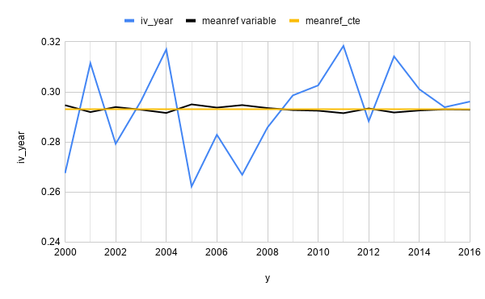

Figure R1. Time series value of annual mean EVI for a pixel (blue line).

Average of the annual EVI values for the period of reference (2000-2016) by extracting the value of year $i$ (black line) and without extracting it (yellow line)

We found that both approaches have been frequently used to detect anomalies in the literature (e.g. Saleska and others 2007; Samanta and others 2010, 2012 for examples of extracting year; Kuenzer and others 2015; Meroni and others 2019 examples of retain the year i).

Independently, we have calculated the standardized anomalies following the reviewer's suggestion and we have obtained very small differences in our results suggesting no alteration in our pattern (Figure R2; Table R1).

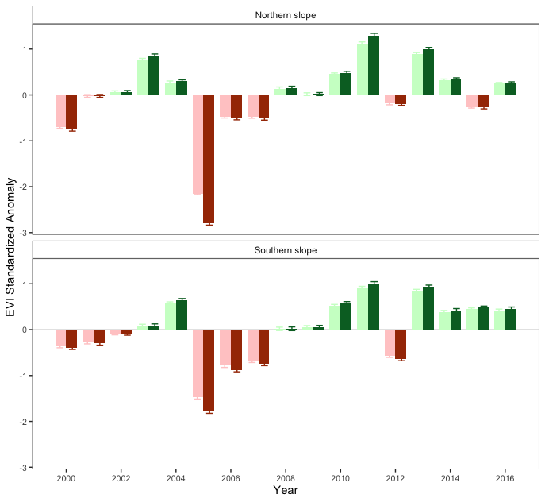

Figure R2. EVI standardized anomaly during the period 2000-2016 for northern and southern populations. Error bars show standard error. Dark green and dark red bars correspond to the values as calculated in the manuscript (see Figure 2a in the manuscript) and light green and light red correspond to the standardized anomalies calculated according to the reviewer's suggestion.

|  |  |  |  |  |
| --- | --- | --- | --- | --- |
|  | **type** | **Year** | **% pixels**  **Original computation** | **% pixels**  **new computation** |
|  | browning | 2005 | 99.36 | 99.36 |
|  | browning | 2012 | 7.22 | 5.94 |
|  | greening | 2005 | 0 | 0 |
| Northern slope | greening | 2012 | 3.18 | 2.55 |
|  | no change | 2005 | 0.64 | 0.64 |
|  | no change | 2012 | 89.6 | 91.51 |
|  |  |  |  |  |
|  | browning | 2005 | 79.37 | 76.87 |
|  | browning | 2012 | 29.02 | 27.44 |
| Southern slope | greening | 2005 | 1.13 | 1.13 |
|  | greening | 2012 | 0.91 | 0.68 |
|  | no change | 2005 | 19.5 | 22 |
|  | no change | 2012 | 70.07 | 71.88 |

Table R1. Percentage of pixels showing browning, greening or no changes during the 2005 and 2012 drought events according to EVI standardized anomalies. We show the percentage of pixels obtained following the “original computation” (as in the manuscript) and the “new computation” according to reviewer suggestion.

**#8. Line 220 –  For tree-ring analyses, are site-level metrics only ever used? This seems to lead a very limited dataset of 3 sites, two of which are much closer together. Is it possible to use the variation of the individual trees? Or why is it best to take a site average?**

R8. We used tree-ring analysis as follows:

* Ring-width index (RWI). We used pre-whitened residual chronologies to study the growth response to the inter-annual variability of climate (short-term response). It was computed using ratios between raw growth measurements and individual cubic splines with a 50% frequency cutoff at 30 years (Fritts 1976). Mean residual site chronologies were established by computing the biweight robust mean of all prewhitened growth indices for the trees of the same site (Fritts 1976).
* Disturbance site chronologies. Using individual series of tree-ring width, we computed growth changes (GC) (See L228-245). Then we built site-disturbance chronologies by annually averaging the individual disturbance series.
* Basal Area Increment (BAI) were computed using raw tree-ring widths and measured DBH (Se L223-224). We used BAI at several ways. On the one hand, individual BAI series were used to compute resilience metrics (*tree level*) of the different drought events. On the other hand, mean site BAI chronologies (averaging individual tree BAI time series) were built to explore temporal trends.

We have included a new figure (see Figure 2) explaining the metrics used and also the analysis carried out.

**#9. L233 Why was BAI and not RWI used for individual tree resilience metrics?**

R9. Thanks for the comment. We used BAI because it represents a more accurate indicator of growth than ring width, since it removes variation in growth attributable to increasing stem circumference after 30-40 years of juvenile growth (Biondi and Qeadan 2008) (See Lines 220-223). The use BAI effectively removes the apparent decline in ring-width as a result of increasing stem circumference, and the inverse relationship between radial growth (ring-width) and age disappears when analysed as basal area increments (BAI) (Biondi and Qeadan 2008).

However, despite its widespread use in dendroecological studies, Schwarz and others 2020, in a recent critical review about the resilience metrics proposed by Lloret and others (2011) (i.e. those that we used in our analysis), noted that resilience metrics are sensitive to the growth variable used. They found that resilience values calculated based on BAI seems to be higher than those calculated for RWI. However, there does not seem to be a clear pattern and it has been pointed out that it also depends on the other factors (*i.e.* period of years considered).

Nonetheless, considering the interesting point noted by the reviewer #1, and following the recommendation of Schwarz and others (2020), we have computed the resilience metrics using RWI and compared with results obtained when BAI is used. As you can see in the Figure R3, resilience metrics values were slightly lower when RWI were used than those obtained when resilience metrics are computed using BAI. The difference obtained is very small and the pattern doesn’t change.

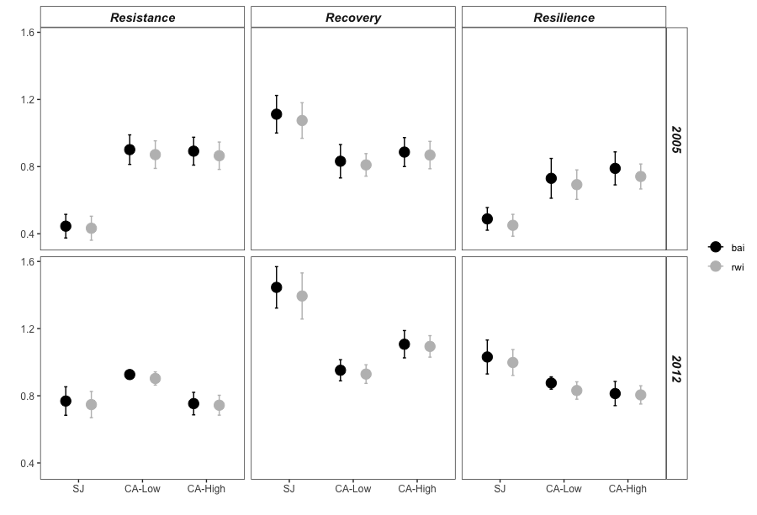

Figure R3. Comparison of the resilience metrics (resilience, recovery and resistance) computed using BAI (black) and RWI (grey)

**#10. Line 283 – These terms are used rarely enough that I think that resistance, resilience, and recovery should be written out fully.**

R10. Thanks for suggestions. We removed the abbreviations Rt, Rc and Rs and we have written those terms out fully (resistance, recovery and resilience) thorough the manuscript. (e.g. see L247-260 and L320-L338).

**#11. L 290 _ When stating the resistance, resilience, and recovery results, state the BAI vs EVI results separately. They are currently difficult to follow, and unclear when both metrics are being considered.**

R11. Thanks for this comment. It was only a style issue. We thought it would be easier to follow them if they were written in a grouped way. We have re-written them separately for each of the variables. See L320-L338

**#12. L300 – Which study aim does growth responses to climate fall under? I am getting mixed up about which question this addresses.**

R12. It is a common procedure in dendrochronological studies. The idea is to analyze the relationships between climate and growth. The aim is to explore the effect of climatic variables on growth and then to infer how extreme climatic events could affect the tree growth. We have included this section to show the effect of climate on growth, as is generally done in dendrochronological studies. However, we agree with the reviewer that it could be a bit confused if it is presented as a separate subsection. We have reduced and rewritten this paragraph, including it as part of another section. See L310-314.

**#13. L319 – 322 – This land-use section fills disconnected currently to the rest of the analyses. See major comment B.**

R13. Please see our response to major comment B of the revierwer #1

**#14. L 439 – Did these droughts impact these edge populations more than any central populations? That seems like the central questions to address to test if the geographic edge is ecologically marginal. There could potentially be overall increase in growth across the species range, but the extreme events have a larger impact in the edge populations.**  

R14. Thanks for the comment. Our work focuses only on the rear edge, and with our data (we did not sample along the whole latitudinal gradient of the species) we cannot figure out how droughts impacted populations located in the rear edge in comparison with those located at the central area. However, in a previous study, where *Q. pyrenaica* populations were sampled along its distribution, Gea-Izquierdo and Cañellas (2014) found a stronger effect of the droughts related variables on the populations located in the rear-edge than those in the central area.

Anyway, thanks for the comment, we think it would be interesting to assess the resilience of growth variables (e.g. BAI) to the past drought events along the distribution gradient.

*Reviewer: 2*  
**C1.**

**I have minor suggestions that I think will help clarify the message and resolve some issues I see in the manuscript. The authors focus on precipitation and drought as a driver of the southern range edge of this species. While I no doubt believe this plays a major role in determining species distributional limits in the Mediterranean region I would like to see some additional thought given to the role of temperature to their southern range limit. Or at least give more details of how drought and precipitation affect other species in this region.**

R.C1. Thanks for this suggestion. As we stated at L376-378, a study along the range distribution of *Q. pyrenaica* revealed that moisture availability was the main climatic factor driving growth (Gea-Izquierdo and Cañellas 2014). Our results also point in this direction and are consistent with previous studies highlighting the influence of precipitation on tree-ring growth in different oak species (see L379-381) (*e.g.* Tessier and others 1994; Di Filippo and others 2010; Gea-Izquierdo and others 2011; García-González and Souto-Herrero 2017). If we explore the role of climate variables at rear edge of other species we found a variety of responses. For instance, some species at the rear edge (e.g. *Abies alba*), the growth variables are more related to precipitation than to temperature (Martínez-Sancho and Gutiérrez 2019), which is in line with our results. Another species showed similar importance of the temperature and the moisture related variables on growth in their rear edge (e.g. *Fagus sylvatica* (Dorado-Liñán and others 2017a, 2017b); *Pinus nigra* subsp*. salzmanii, P. sylvestris* (Sánchez-Salguero and others 2012)*).*  Other species showed more dependence of temperature than precipitation at the rear edge (Herrero and others 2013)*.* It has been noted that vulnerability to climate is not even consistent within the rear edge of different species, evidencing that geographically marginal forests are not necessarily climatically marginal (see Dorado-Liñan et al. 2018 and references therein).

Regarding our results, we assessed the climate-growth relationships and we found only marginal relationships of temperatures and tree-growth: spring maximum temperature was the most significant limitation for tree growth only for the southern populations (Figures S6b, S6c), whereas minimum and maximum temperatures of the current September positively influenced tree growth only in the northern population.

**C2.**

**The authors use the term ‘ecological edge’ but I think they are really referring to a climatic range-edge. These aren’t necessarily the same thing as an ecological edge could be determined by biotic interactions or other abiotic limits (e.g. soils). But this raises another point, are the authors sure that climate is the true determinate of this range edge? Is it possible human land-use has artificially restricted this species or that biotic interactions (e.g. competition with more southern oaks) limits their distribution? This should be clarified and discussed if possible.**

RC2. Thanks for this comments. The suggestions provided by the reviewer served us to elaborate a new version of introduction and discussion sections, where the different geographical and historical ecological aspects are now adequately explained (see LXX, LXX and LXX).   
  
**C3.**

**The authors also need to do a better job showing that drought severity was equal at the southern and northern sites, especially during the 2005 drought. This may be difficult to do if there are not site-specific data. The sites appear ~20 km apart and this could mean large differences in drought severity, especially if the northern sites are already known to be drier. If drought severity was higher at the SJ site then this would explain the drop in the EVI at SJ and not such a severe drop at the southern facing sites. At the very least, the authors should acknowledge that the differences in population response to droughts may be related to drought severity rather than just genetic variation of the individuals within the different populations.**

Thanks for the comment. Effectively, the climatic data around the site are intermittent and they are not continuously and site-specific data. However we agree with the reviewer the importance of comparing values in drought severity among sites. We followed two approach. First, we built a series of precipitation using data coming from several stations close to each of the sites (n= 4 for northern site, SJ; and n=3 for southern sites, CA). As we can see in the figure R4, the cumulative precipitation of the hydrological year (a measure of the water stress) was similar from 2005 for both sites, while was slightly lower for SJ sites during the 2012 drought events. Secondly, we explored other nearby stations that had long thermopluviometric data series (temperature, precipitation and potential evapotranspiration), to evaluate the SPEI index among the two sites since 1990 (Figure R5). We observed that the 2005 drought event were similarly in intensity and duration at both sites, while the 2012 was shorter and less intense at southern sites.

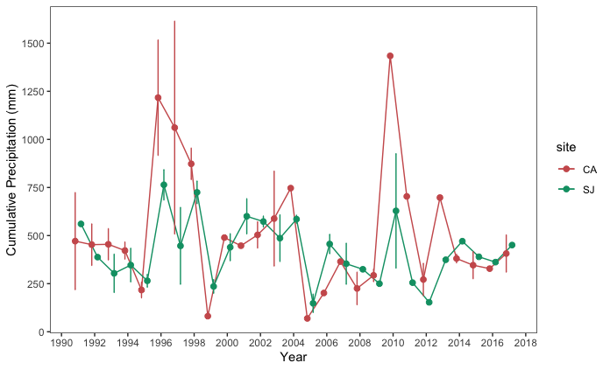

Figure R4. Temporal evolution of cumulative precipitation (hydrological year) during the period 1990-2017. Points represent the mean, and error bars the standard error. Data from meteorological stations distributed around northern (SJ, n=4) and southern (CA, n=4) sites respectively.

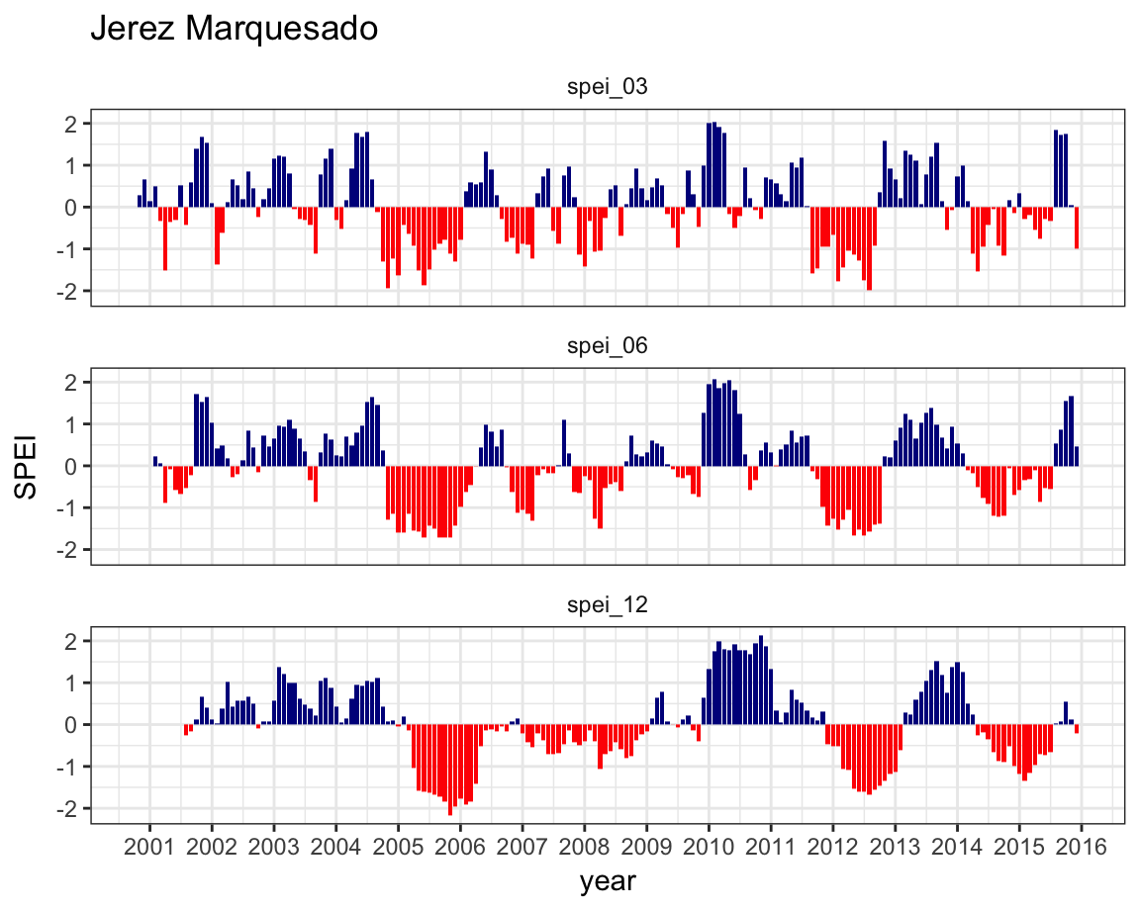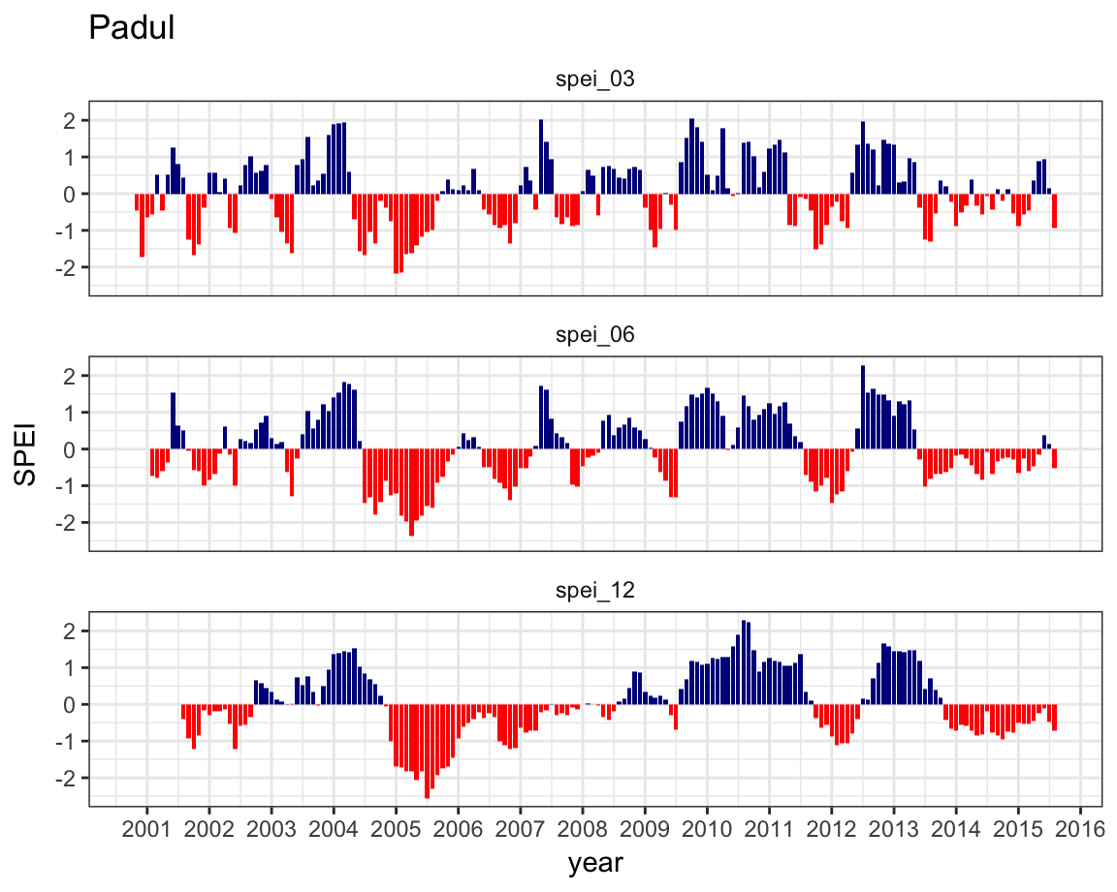

Figure R5. SPEI index for northern (left) and southern (right) population of the Sierra Nevada mountains.

**C4.   
The manuscript could also use some shortening. Consider moving some of the many figures into the supplement.**

Thanks for the suggestions. We revised the text removing redundant and unnecessary text. We combined several figures: the old figures 3 and 4 were combined into new Figure 3. The old figures 5 and 6 were combined into new figure 4.

We also moved old figure 7 into supplementary figures as Figure S6.

More detailed edits:  
  
**#15. L44-46 – Should review Rehm et al 2015 Ecology and Evolution for additional references and possible cite.**

R15. Thanks for the suggestions. We include the reference. See L43

**#16. L47-48 –A true ecological edge would also account for biotic interactions.**

R16. Thanks for this comment. We agree with the reviewer suggestions. We have also included in the new introduction (see L51-52)  
  
**#17. L58-62 – the sentence is poorly worded. Consider dropping the second part of the sentence after the Navarro-Gonzalez citation or breaking this into two sentences.**

R17. Thanks for the suggestions. We remove the second part of the sentence. Anyway, as we stated in previous responses (*e.g.* see response RB) we have restructured and rewritten the introduction section, so we removed the unnecessary and confounding sentences.

**#18. L68 – sentence seems unnecessary**

R18. See R17.

**#19. L69 – sentence starts with “this” but what does “this” refer to? The response of rear-edge populations stated two sentences before?**

R19. Yes. It is. We deleted the unnecessary sentences (see last two responses).

**#20. L76 – the authors use dendrochronology and then dendroecology. Are they the same thing? If so I suggest just using dendroecology throughout the paper and avoid mixing terms.**

R20. We have indistinctly used the terms dendrochronology and dendroecology throughout the text. Both concepts are closely related. Dendrochronology refers to the science of dating tree rings and studying their structure to interpret information about environmental and historical events and processes (Kaennel and Schweingruber 1995); while dendroecology is a subfield of dendrochronology applied to ecological questions (Fritts and Swetnam 1989). It uses the variation in tree-ring structure and width to understand ecological and environmental variability and its impacts on forests.

Following your recommendation, we have used the term dendroecology throughout the manuscript.

**#21. L94 – climate change ‘along’ a small-scale gradient?**

R21. Thanks. We include the missed adverb. See L110

**#22. L119 – should be clear on what you mean by ‘richest’. Is this species richness?**

R22. Yes. It refers to plant species richness. We clarified this in the text. See L138

**#23. L142-144 Are severe droughts and drought events different criteria?**

R23. A severe drought is a type of drought event. As we stated at L152-L166, a drought event starts when drought index values (SPEI in our case) fall below a certain threshold for at least two consecutive months, and ends when it turns above the mean value of the series (Spinoni and others 2015). The drought events can be classified in the following classes: moderate, severe and extreme depending on the value of the threshold. We followed the classification proposed by (Agnew 2000) that have been used in several works (e.g. Spinoni and others 2015, 2017; Páscoa and others 2017), that uses the following threshold values: moderate if −0.84 > drought index ≥ −1.28; severe, if −1.28 > drought index ≥ −1.65; and extreme, if −1.65 > drought index.

**#24. L173-182 – why weren’t multiple elevations sampled at SJ?**

R24.Our initial scheme was to sampled in each locality at two elevations, but in SJ it is distributed in a narrow altitudinal band (see Figure 1 of the manuscript) located at the bottom of the valley, in contrast to those located in the southern area (CA sites), where they occupy a wider elevational band. We decided to sampled 20 trees at SJ site distributed along the elevational gradient. If we split SJ dataset into two sets (each with 10 trees), i.e. SJ-low and SJ-high elevation, we observe that the difference in elevation between low and high is less than 70 meters (SJ-high = 1357 vs. SJ-low = 1288; average values) while in the population of the CA site this difference (between high and low site) is more than 150 meters (CA-high = 1894 vs. CA-low = 1742, average values).

Additionally we computed separated BAI-chronologies between SJ-High and SJ-Low, and we observed no pattern differences between the two sites (Figure R6), so we decided not to include two separate elevation-groups in the analysis for SJ site.

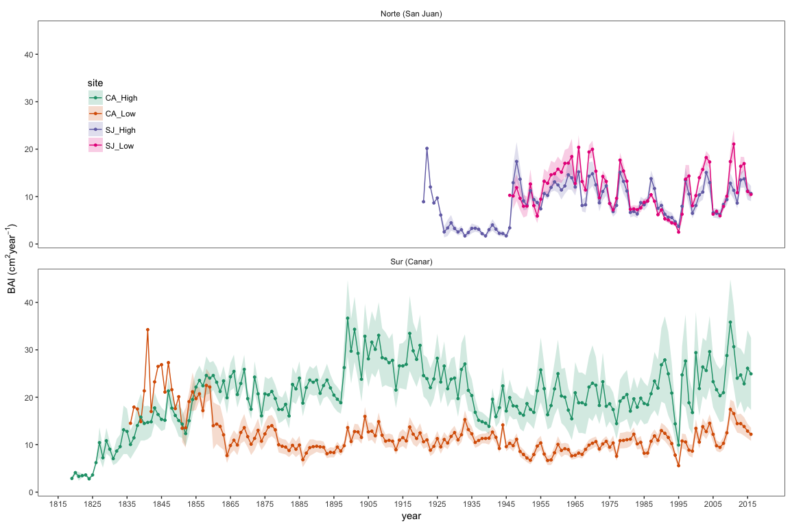

Figure R6. Basal Area Increment (BAI) chronologies of *Q. pyrenaica* for northern populations low-elevation (SJ-Low) and high-elevation (SJ-High); and southern ones: low-elevation (CA-Low; and high-elevation (CA-High) sites. Shading areas correspond to standard error of the mean.

**#25. L267 – consider changing ‘growth was significantly faster’ to “growth was significantly greater’.**

R25. Thanks for the suggestion. We corrected the sentence. See L298

**#26. L330-334 – can the dendroecology work or historical records give an estimate of stand density during these times?**

R26. Thanks for the comment. We agree that it is important to considered the stand density because it affects to growth. Dendroecological methods provide us series of growth data with an annual resolution, that can be used to analyze forest’s responses to spatio-temporal changes in climate. However, due to a lack of long-term competition series, there are few studies that have been able to profit from the valuable long time span of this type of data to investigate the effect of the interaction between competition and climate on tree growth (see Fernández-de-Uña and others 2015 for a revision). Most dendrochronological studies have sampled the current stand density and used it as a surrogate for the past stand density and only fewer studies explicitly modelled growth as a function of both climate and competition (see Fernández-de-Uña and others 2015 for a revision). A way to obtain estimates of stand density in the past is using historical forest inventories and/or permanent plots that inform us about the forest structure and their dynamics. We exhaustively review historical forest inventory and also historical data

but we did not find density estimates that match spatially or temporally with our growth data. In the table S4 we show a summary of main relevant data obtained from the review of historical documents.

**#27. L430 – can the authors offer a new definition?**

R27. Thanks for the suggestions. We have discussed about that and included some thoughts (see L475-490; and also the concluding comments section) Our contribution is a clear case study where we highlight the need to also take into account land-use, which adds more evidence to what other authors suggested (e.g. Vilà-Cabrera and others 2019): in order to define the rear edge, at least in the Mediterranean region, it is necessary to also consider other elements such as land-legacies.

**References used**

Agnew CT. 2000. Using the SPI to Identify Drought. 12:8.

Biondi F, Qeadan F. 2008. A theory-driven approach to tree-ring standardization: defining the biological trend from expected basal area increment. Tree-Ring Res 64:81–96. https://doi.org/10.3959/2008-6.1

Camacho-Olmedo M, García-Martínez P, Jiménez-Olivencia Y, Menor-Toribio J, Paniza-Cabrera A. 2002. Dinámica evolutiva del paisaje vegetal de la Alta Alpujarra granadina en la segunda mitad del s. XX. Cuad Geográficos 32:25–42.

Dorado-Liñán I, Akhmetzyanov L, Menzel A. 2017a. Climate threats on growth of rear-edge European beech peripheral populations in Spain. Int J Biometeorol 61:2097–2110.

Dorado-Liñán I, Cañellas I, Valbuena-Carabaña M, Gil L, Gea-Izquierdo G. 2017b. Coexistence in the Mediterranean-Temperate transitional border: Multi-century dynamics of a mixed old-growth forest under global change. Dendrochronologia 44:48–57.

Fernández-de-Uña L, Cañellas I, Gea-Izquierdo G. 2015. Stand Competition Determines How Different Tree Species Will Cope with a Warming Climate. Liang E, editor. PLOS ONE 10:e0122255. https://dx.plos.org/10.1371/journal.pone.0122255. Last accessed 19/05/2020

Fernández-de-Uña L, McDowell NG, Cañellas I, Gea-Izquierdo G. 2016. Disentangling the effect of competition, CO 2 and climate on intrinsic water-use efficiency and tree growth. Canham C, editor. J Ecol 104:678–90. http://doi.wiley.com/10.1111/1365-2745.12544. Last accessed 19/05/2020

Fritts HC, Swetnam TW. 1989. Dendroecology: A Tool for Evaluating Variations in Past and Present Forest Environments. In: Begon M, Fitter AH, Ford ED, MacFadyen A, editors. Advances in Ecological Research. Vol. 19. Academic Press. pp 111–88. http://www.sciencedirect.com/science/article/pii/S0065250408601580. Last accessed 11/05/2020

Gea-Izquierdo G, Cañellas I. 2014. Local Climate Forces Instability in Long-Term Productivity of a Mediterranean Oak Along Climatic Gradients. Ecosystems 17:228–241. http://dx.doi.org/10.1007/s10021-013-9719-3

Herrero A, Rigling A, Zamora R. 2013. Varying climate sensitivity at the dry distribution edge of *P*inus sylvestris and *P*. nigra. For Ecol Manag 308:50–61. http://www.sciencedirect.com/science/article/pii/S0378112713004763

Hodgson D, McDonald JL, Hosken DJ. 2015. What do you mean, ‘resilient’? Trends Ecol Evol 30:503–6. https://www.cell.com/trends/ecology-evolution/abstract/S0169-5347(15)00162-7. Last accessed 13/05/2020

Holling CS. 1973. Resilience and Stability of Ecological Systems. Annu Rev Ecol Syst 4:1–23. https://doi.org/10.1146/annurev.es.04.110173.000245. Last accessed 13/05/2020

Ingrisch J, Bahn M. 2018. Towards a Comparable Quantification of Resilience. Trends Ecol Evol 33:251–9. https://linkinghub.elsevier.com/retrieve/pii/S0169534718300296. Last accessed 11/05/2020

Jiménez Olivencia Y. 1991. Los paisajes de Sierra Nevada : cartografía de los sistemas naturales de una montaña mediterránea. Granada: Universidad de Granada

Jiménez-Olivencia Y, Porcel L, Caballero A. 2015. Medio siglo en la evolución de los paisajes naturales y agrarios de Sierra Nevada (España). Bol Asoc Geógrafos Esp 68:205–32.

Kaennel M, Schweingruber FH, editors. 1995. Multilingual glossary of dendrochronology: terms and definitions in English, German, French, Spanish, Italian, Portuguese and Russian. Bern: Haupt

Kuenzer C, Dech S, Wagner W, editors. 2015. Remote sensing time series: revealing land surface dynamics. Cham Heidelberg New York Dordrecht London: Springer

Lloret F, Keeling EG, Sala A. 2011. Components of tree resilience: effects of successive low-growth episodes in old ponderosa pine forests. Oikos 120:1909–1920. http://dx.doi.org/10.1111/j.1600-0706.2011.19372.x

Martínez-Sancho E, Gutiérrez E. 2019. Evidence that the Montseny Mountains are still a good climatic refugium for the southernmost silver fir forest on the Iberian Peninsula. Dendrochronologia 56:125593. https://linkinghub.elsevier.com/retrieve/pii/S1125786518301589. Last accessed 25/05/2020

Meroni M, Fasbender D, Rembold F, Atzberger C, Klisch A. 2019. Near real-time vegetation anomaly detection with MODIS NDVI: Timeliness vs. accuracy and effect of anomaly computation options. Remote Sens Environ 221:508–21. https://linkinghub.elsevier.com/retrieve/pii/S0034425718305509. Last accessed 14/05/2020

Páscoa P, Gouveia C, Russo A, Trigo R. 2017. Drought Trends in the Iberian Peninsula over the Last 112 Years. Adv Meteorol:ID4653126.

Saleska SR, Didan K, Huete AR, da Rocha HR. 2007. Amazon Forests Green-Up During 2005 Drought. Science 318:612–612. https://www.sciencemag.org/lookup/doi/10.1126/science.1146663. Last accessed 13/05/2020

Samanta A, Ganguly S, Hashimoto H, Devadiga S, Vermote E, Knyazikhin Y, Nemani RR, Myneni RB. 2010. Amazon forests did not green-up during the 2005 drought. Geophys Res Lett 37:L05401.

Samanta A, Ganguly S, Vermote E, Nemani RR, Myneni RB. 2012. Interpretation of variations in MODIS-measured greenness levels of Amazon forests during 2000 to 2009. Environ Res Lett 7:024018.

Sánchez-Salguero R, Navarro-Cerrillo RM, Swetnam TW, Zavala MA. 2012. Is drought the main decline factor at the rear edge of Europe? The case of southern Iberian pine plantations. For Ecol Manag 271:158–69.

Schwarz J, Skiadaresis G, Kohler M, Kunz J, Schnabel F, Vitali V, Bauhus J. 2020. Quantifying Growth Responses of Trees to Drought—a Critique of Commonly Used Resilience Indices and Recommendations for Future Studies. Curr For Rep. http://link.springer.com/10.1007/s40725-020-00119-2. Last accessed 04/06/2020

Spinoni J, Naumann G, Vogt JV. 2017. Pan-European seasonal trends and recent changes of drought frequency and severity. Glob Planet Change 148:113–30.

Spinoni J, Naumann G, Vogt JV, Barbosa P. 2015. The biggest drought events in Europe from 1950 to 2012. J Hydrol Reg Stud 3:509–24.

Vilà‐Cabrera A, Premoli AC, Jump AS. 2019. Refining predictions of population decline at species’ rear edges. Glob Change Biol 25:1549–60. https://onlinelibrary.wiley.com/doi/abs/10.1111/gcb.14597. Last accessed 19/08/2019