Dear Co-Editor-in-Chief Monica Turner,

Thank you for your correspondence regarding our manuscript entitled

“*Land-use legacies and climate change as a double challenge to oak forest resilience: mismatches of geographical and ecological rear edges*” (ECO19_0444R1).

We appreciate the helpful comments and suggestions from the two reviewers and the subject-matter editor. They have highlighted several points that were not clear in the previous version as well as weak points that needed to be strengthened.

Following their suggestions, we have restructured and rewritten the Introduction and Discussion sections for clarity. Specifically, we have addressed the importance of considering not only climatic or geographical aspects but other dimensions (e.g. land-use legacies) in the definition of the “ecological rear edge.” This has implications for the assessment of resilience in rear-edge populations.

In addition, we have improved our explanation of the different metrics and methods used. Also, we have re-formatted and rewritten the statistical analysis section. We have added a new figure to explain the general outline of our manuscript and the methods used. This new figure will aid the readers in understanding the aims, methods, and the results.

Below, please find our detailed point-by-point responses (indicated with “R”) to the reviewer comments and suggestions (in bold). We have numbered each comment and reply for easy reference and have indicated the line(s) (“L”) where the changes have been made in the manuscript.

A revised version of our manuscript with the new versions of figures and tables has been uploaded through the ECOSYSTEMS MANUSCRIPT CENTRAL.

With these changes, we hope that the manuscript will now be suitable for publication in *ECOSYSTEMS*.

Sincerely,

Antonio J. Pérez-Luque and co-authors.

Reviewer: 1  
Major comments -  
  
**A. This work is strongest in its test of the impact of two recent droughts on the growth at the southern edge of a species range. I appreciated the multiple metrics used to quantify these drought responses: resistance, resilience, and recovery. However, I think these metrics needs to be defined in the introduction. They are currently not defined until part way into the methods, which makes the interpretation of the second and third tests of the main hypothesis (L96-103) difficult when they are first introduced. I would also appreciate a discussion of how you might expect the different metrics compare to one another. For example - would you expect resistance but not recovery to be high in edge populations due to past climate extremes? Would you expect each of these metrics to be equally meaningful for range edge vulnerability?**

R.A*.* We appreciate this comment. We have included definitions of resilience in the Introduction section, explaining their complementary nature (L76-88).

We can expect these southernmost populations of Pyrenean oak growing at dry sites to be more vulnerable to drought than similar populations at wetter sites (Gea-Izquierdo et al. 2013; Gea-Izquierdo and Cañellas 2014).

**B. The component of the study focused on land-use is very interesting and I agree that historical land-use complicates the assumption of geographic range edges as climate edges and therefore as a metric of climate vulnerability. Despite the focus on the land-use in the introduction and discussion, it is not part of the study objectives. Is there testable question about the growth responses either directly in response to the previous land-use or interactions between previous land-use and drought responses? I realize this may be difficult with only three study sites, but currently the land-use section in the discussion does not seem totally connected to the rest of the study.**

R.B. We agree with the reviewer that the land-use component was not explicitly defined in the study. In line with the commentary, we have rewritten the Introduction and Discussion sections, including some sentences concerning the importance of the land-use dimension at the rear-edge of the species (Vilà-Cabrera and others 2019). In addition to the objectives already defined in the manuscript, we examine forest-management history and how it has influenced tree growth and resilience. Thus, we have also explicitly stated this as a specific objective of the study (L110-112).

**C. The section on statistical analyses needs to be expanded to explicitly lay out what metrics were put in what models. Please format this section into what models addresses what study objective (i-iii). It would be helpful to walk through each of the climate variables used for these models. Were their separate models for BIA, EVI and RWI metrics of resistance (rt), resilience (rs), and recovery (rc)? Were all three drought metrics used (intensity, duration, lowest) in any models? Were the disturbance response metrics (changes in growth - GC) statistically analyzed? Was the local density of trees included in the models when considering drought responses?**

RC. We agree with the reviewer that the use of different metrics can lead to confusion for the reader. We have prepared a figure (Figure 2 in the reviewed version), where we show the different metrics used in our methods and their relation to each of the objectives (numbered from 1 to 4). We also show the main analyses done. As this new figure indicates, resilience metrics were computed for BAI and EVI.

We also have re-formatted the statistical section following to the reviewer’s suggestion (L259-286). We indicated the models and the metrics used specifically and their relationships with each of the objectives of the study.

Regarding the drought metrics, our approach was as follows. First, we identified severe drought events since 1901 in our study area following the approach proposed by (Spinoni and others 2015). Secondly, we characterized them using several metrics, i.e. intensity, duration, severity (Table S3). Then, we used this information in two ways. On the one hand, it served to check whether the droughts of 2005 and 2012 were indeed among the worst drought events in our area of study, as stated in other works (e.g. Páscoa and others 2017). On the other hand, we explored the relationship between drought severity and the resilience metrics used (See Figure 5a).

As stated in L226-243, we used the Growth Changes (GC) in time to indirectly identify possible past disturbance events (e.g. logging, drought-induced neighbor mortality). To separate growth peaks caused by disturbance events from those caused by climate, we considered a threshold of 50% of GC and more than 50% of the individual trees displaying the same growth changes (Gea-Izquierdo and Cañellas 2014). GC was computed at the tree level using tree-ring width (TRW) and then we built site-disturbance chronologies (as stated in the manuscript, L233-236). We do not statistically compare site-disturbance chronologies because we use them only to explore past disturbances.

We are aware that competition interacts with growth responses to climate (Fernández-de-Uña and others 2015, 2016); however it was not possible to determine the local density of trees for each of the past drought events. Like many other studies, we have a picture of competition from a recent sampling. Following this, we computed several competition indices for the present stands (L201-204) and we assumed that current competition is an indicator of past competition.

Line-specific comments-  
  
**#1. L38 – Perhaps clarify that this statement holds true for distributional shifts, but potentially not all types of responses**

R1. We have clarified this in the text (L35).

**#2. L41 –  I think the phrasing “It has been often assumed that geographically marginal populations represent ecological marginal populations” may be clearer.**

R2. We appreciate this suggestion, as it makes the sentence clearer. We have made the change suggested (L39-40).

**#3. L44 – Potentially also reference Oldfather et al 2019 Global Change Biology as a more recent review**

R3.. We have included this suggestion in the text (L43 and the references).

**#4. P63-72 – This paragraph does not clarify why drought in particular is important at range edges (relative to other climate drivers?). Perhaps I do not fully follow the main take-away from this paragraph. Is it highlighting the importance of studying range edges, or drought? Or considering land-use impacts?  This paragraph seems to contradict the first paragraph about how there may be a disconnect between range edges and climate edges.**

R4. We agree with the reviewer that the paragraph was somewhat confusing. We have restructured and rewritten part of the Introduction section to present the ideas more clearly, as for example*:* the importance of the study of the rear-edge populations; the effects of climate change (e.g. droughts) on these rear-edge populations; the effect of past legacies (land-use legacies) on these populations; and the assessment of resilience by addressing both of the drivers of change in rear-edge populations.

**#5. L92 – How is it known that the rear-edge is set by land use?  Is there an associated reference for this? I thought this was a question that this paper was addressing. Also, there needs to be a more in-depth introduction on why land-use would limit resilience to drought prior to this.**

R5. We agree that this sentence is one of the main issues addressed by our manuscript, and now is highlighted in the Discussion section. We have removed this sentence from the Introduction. As we mentioned in the previous comment, we have included a specific paragraph about how the anthropogenic habitat modification and its legacies are key for rear-edge populations (L60-75). We have also added sentences concerning how the past legacies would limit resilience as they may intensify, confound or delay climate-driven population declines at rear edges (L68-75; L101-104 among others).

**#6. L103 – What is the difference between resistance, resilience, and recovery?**

R6. We have specifically included the definitions of these terms in a subsection of the Material and Methods (L244-258). Additionally we have included some sentences in the Introduction (L76-96) addressing another comment of Reviewer 1 (see Major Comment A).

Resilience is a key concept in Ecology describing the capacity of an ecosystem to maintain its state and recover from disturbances (Holling 1973; Hodgson and others 2015). There are different metrics that have been used to quantify the ecosystem responses to disturbance events (see Ingrisch and Bahn 2018 for a recent review and references therein). One of the most widely used appears in the approach proposed by Lloret and others (2011), which describes resistance and recovery as different but complementary components of resilience. These authors proposed three indices to quantify the resilience of tree growth to drought based on the differences in growth before, during, and after the drought event. Their approach breaks down resilience to drought into three components: resistance to drought, recovery after drought, and resilience. It has been very widely accepted because it allows a simple, yet highly efficient assessment of short-term responses of trees to drought, although it is not exempt from some criticism (Schwarz and others 2020). Resilience is the capacity of an ecosystem to persist and maintain its state and functions in the face of disturbance. It is determined by the capacity to reduce the impact (resistance) and the capacity to recover from the impact of disturbance (recovery).

**#7. L162 – Is it necessary/correct to remove year i from the calculation of EVImean, ref?**

R7. We appreciate this comment. As we indicated at L177-180, the computation of the EVI standardized anomaly ($EVI_{sa,i}$) for year $i$, were done according to: $EVI_{sa,i}=(EVI_{mean,i}-EVI_{mean,ref})/σ_{ref}$, where $EVI_{mean,i}$ is the annual mean value of EVI for year $i$, and $EVI_{mean,ref}$ the average of the annual EVI values for the period of reference 2000-2016 (all except year $i$); and $σ_{ref}$ the standard deviation for the reference period.

We had removed the year $i$ for the calculation of the $EVI_{mean,ref}$ because we found that this produces a more sensitive metric than when keeping the year $i$ in the computation. We illustrate this in the Figure R1.

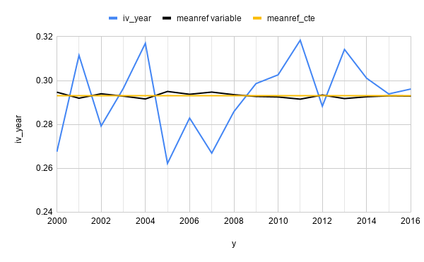

Figure R1. Time-series value of annual mean EVI for a pixel (blue line).

Average of the annual EVI values for the study period (2000-2016) by removing the value of year $i$ (black line) and without removing it (yellow line)

We found that both approaches have been frequently used to detect anomalies in the literature (e.g. Saleska and others 2007; Samanta and others 2010, 2012 for examples of removing year; Kuenzer and others 2015; Meroni and others 2019 examples of not removing the year i).

Also, we have calculated the standardized anomalies following the reviewer's suggestion and we have found very small differences in our results, suggesting no alteration in our pattern (Figure R2; Table R1).

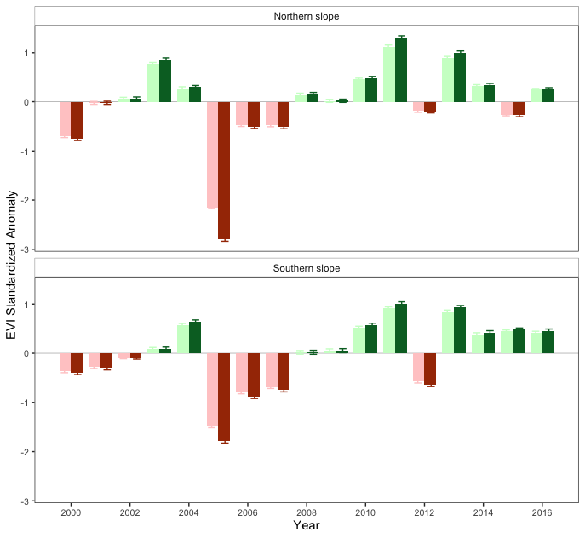

Figure R2. EVI standardized anomaly during the period 2000-2016 for the northern and southern populations. Error bars show standard error. Dark-green and dark-red bars correspond to the values as calculated in the manuscript (see Figure 3a in the manuscript) and light green and light red correspond to the standardized anomalies calculated according to the reviewer's suggestion.

|  |  |  |  |  |
| --- | --- | --- | --- | --- |
|  | **type** | **Year** | **% pixels**  **Original computation** | **% pixels**  **new computation** |
|  | browning | 2005 | 99.36 | 99.36 |
|  | browning | 2012 | 7.22 | 5.94 |
|  | greening | 2005 | 0 | 0 |
| Northern slope | greening | 2012 | 3.18 | 2.55 |
|  | no change | 2005 | 0.64 | 0.64 |
|  | no change | 2012 | 89.6 | 91.51 |
|  |  |  |  |  |
|  | browning | 2005 | 79.37 | 76.87 |
|  | browning | 2012 | 29.02 | 27.44 |
| Southern slope | greening | 2005 | 1.13 | 1.13 |
|  | greening | 2012 | 0.91 | 0.68 |
|  | no change | 2005 | 19.5 | 22 |
|  | no change | 2012 | 70.07 | 71.88 |

Table R1. Percentage of pixels showing browning, greening or no changes during the 2005 and 2012 drought events according to EVI standardized anomalies. We show the percentage of pixels calculated following the “original computation” (as in the manuscript) and the “new computation” according to the reviewer’s suggestion.

**#8. Line 220 –  For tree-ring analyses, are site-level metrics only ever used? This seems to lead a very limited dataset of 3 sites, two of which are much closer together. Is it possible to use the variation of the individual trees? Or why is it best to take a site average?**

R8. Please note that we used individual analyses for tree-growth resilience and also calculated indices of individual competition. We combined this analysis with a climate-growth analysis in growth chronologies, which is an widely accepted analysis in dendroecological studies. The fact that we found great variability and differences in the response of trees between sites that are very close is one of the main results of our study: the forest studied is relict and covers a small surface area, and thus is ‘a priori’ considered a rear-edge. Despite the limited size of this forest, we report great variability along the rear edge, and therefore we discuss why it should be redefined in our study area.

We have also included a new figure (see Figure 2) explaining the metrics used and also the analysis carried out.

**#9. L233 Why was BAI and not RWI used for individual tree resilience metrics?**

R9. We appreciate the question. We used BAI because it represents a more accurate indicator of growth than does ring width, particularly for non-juvenile ages, since it removes variation in growth attributable to increasing stem circumference after 30-40 years of juvenile growth (Biondi and Qeadan 2008) (L219-221). We specifically tried to avoid possible bias in resilience metrics that could arise from negative exponential biological growth in RWI (i.e. from decreasing RW not related to climate or drought). The use BAI effectively removes the apparent decline in ring-width as a result of increasing stem circumference, and the inverse relationship between radial growth (ring width) and age disappears when analyzed as basal area increments (BAI) (Biondi and Qeadan 2008).

However, despite the widespread use of this approach in dendroecological studies, Schwarz and others (2020), in a recent critical review on the resilience metrics proposed by Lloret and others (2011) (i.e. those that we used in our analysis), noted that resilience metrics are sensitive to the growth variable used. They found that resilience values calculated based on BAI were higher than those calculated for RWI. However, there does not seem to be a clear pattern and it has been pointed out that it also depends on other factors (e.g. period of years considered).

Nonetheless, considering the importance of the point raised by Reviewer #1, and following the recommendation of Schwarz and others (2020), we have computed the resilience metrics using RWI and have made comparisons with the results found when BAI is used. As reflected in the Figure R3, the resilience metrics values were slightly lower with RWI than when resilience metrics were computed using BAI. The difference is minor and, most importantly, the spatio-temporal pattern discussed does not change.

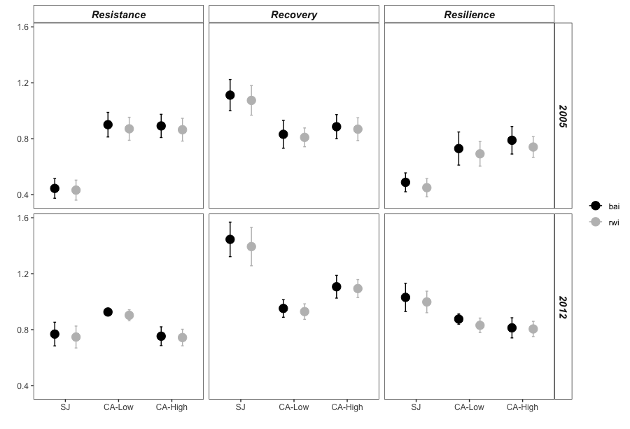

Figure R3. Comparison of the resilience metrics (resilience, recovery, and resistance) computed using BAI (black) and RWI (grey)

**#10. Line 283 – These terms are used rarely enough that I think that resistance, resilience, and recovery should be written out fully.**

R10. We have removed the abbreviations Rt, Rc, and Rs and have written out those terms (resistance, recovery, and resilience) throughout the manuscript. (e.g. L245-258 and L318-L336).

**#11. L 290 _ When stating the resistance, resilience, and recovery results, state the BAI vs EVI results separately. They are currently difficult to follow, and unclear when both metrics are being considered.**

R11. As suggested, we have re-written these terms separately for each of the variables (L318-L336).

**#12. L300 – Which study aim does growth responses to climate fall under? I am getting mixed up about which question this addresses.**

R12. It is a common procedure in dendrochronological studies. The idea is to analyze the relationships between climate and growth. The aim is to explore the effect of climatic variables on growth and then to infer how extreme climatic events could affect the tree growth. We have included this section to show the effect of climate on growth, as is generally done in dendrochronological studies. However, we agree with the reviewer that it could be somewhat confusing if presented as a separate subsection. We have reduced and rewritten this paragraph, including it as part of another section (L308-312).

**#13. L319 – 322 – This land-use section fills disconnected currently to the rest of the analyses. See major comment B.**

R13. Please see our response to major comment B of the Reviewer #1

**#14. L 439 – Did these droughts impact these edge populations more than any central populations? That seems like the central questions to address to test if the geographic edge is ecologically marginal. There could potentially be overall increase in growth across the species range, but the extreme events have a larger impact in the edge populations.**  

R14. We appreciate the comment. Our work focuses only on the rear edge, and with our data (we did not sample the entire latitudinal gradient of the species) we cannot determine how droughts impacted populations located on the rear edge in comparison with those located in the central area. However, in a previous study, where *Q. pyrenaica* populations were sampled along a latitudinal gradient in the Iberian Peninsula, Gea-Izquierdo and Cañellas (2014) found a stronger effect of the drought-related variables on the populations located in the rear-edge than those in the central area.

In any case, we agree that it would be helpful to assess the resilience of growth variables (e.g. BAI) to the past drought events along climatic gradients across the geographical distribution of the species.

*Reviewer: 2*  
**C1.**

**I have minor suggestions that I think will help clarify the message and resolve some issues I see in the manuscript. The authors focus on precipitation and drought as a driver of the southern range edge of this species. While I no doubt believe this plays a major role in determining species distributional limits in the Mediterranean region I would like to see some additional thought given to the role of temperature to their southern range limit. Or at least give more details of how drought and precipitation affect other species in this region.**

R.C1. We appreciate this suggestion. On this basis, we further discuss the temperature-growth relationships found and highlight the importance of high vapor-pressure deficit and heat waves that should increase with warming and climate change. See L372-387, where we also discuss the importance of temperature on the rear edge of other species.

**C2.**

**The authors use the term ‘ecological edge’ but I think they are really referring to a climatic range-edge. These aren’t necessarily the same thing as an ecological edge could be determined by biotic interactions or other abiotic limits (e.g. soils). But this raises another point, are the authors sure that climate is the true determinate of this range edge? Is it possible human land-use has artificially restricted this species or that biotic interactions (e.g. competition with more southern oaks) limits their distribution? This should be clarified and discussed if possible.**

RC2. We appreciate these suggestions, which have served us in writing the new version of the Introduction and Discussion sections, where the different geographical and historical ecological aspects are now explained in more detail (e.g. L42-48, L68-75, L385-387, and L457-483).   
  
**C3.**

**The authors also need to do a better job showing that drought severity was equal at the southern and northern sites, especially during the 2005 drought. This may be difficult to do if there are not site-specific data. The sites appear ~20 km apart and this could mean large differences in drought severity, especially if the northern sites are already known to be drier. If drought severity was higher at the SJ site then this would explain the drop in the EVI at SJ and not such a severe drop at the southern facing sites. At the very least, the authors should acknowledge that the differences in population response to droughts may be related to drought severity rather than just genetic variation of the individuals within the different populations.**

The reviewer is correct. The climatic data around each site are not site-specific or continuously recorded. We fully agree with the reviewer on the importance of comparing values in drought severity among sites. We followed two approaches. First, we built a series of precipitation using data coming from several stations close to each of the sites (n= 4 for northern site, SJ; and n=3 for southern sites, CA). As shown in the figure R4, the cumulative precipitation of the hydrological year (a measure of the water stress) was similar from 2005 for both sites, while was slightly lower for SJ sites during the 2012 drought events. Secondly, we explored other nearby stations that had long thermopluviometric data series (temperature, precipitation, and potential evapotranspiration), to evaluate the SPEI index between the two sites since 1990 (Figure R5). We found that the 2005 drought event was similar in intensity and duration at both sites, while the 2012 event was shorter and less intense at the southern sites.

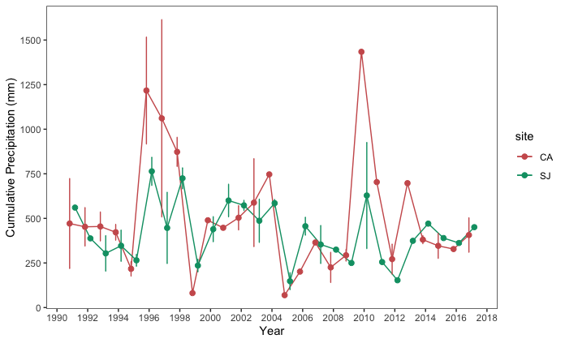

Figure R4. Temporal evolution of cumulative precipitation (hydrological year) during the period 1990-2017. Points represent the mean, and error bars the standard error. Data from meteorological stations distributed around northern (SJ, n=4) and southern (CA, n=4), sites respectively.

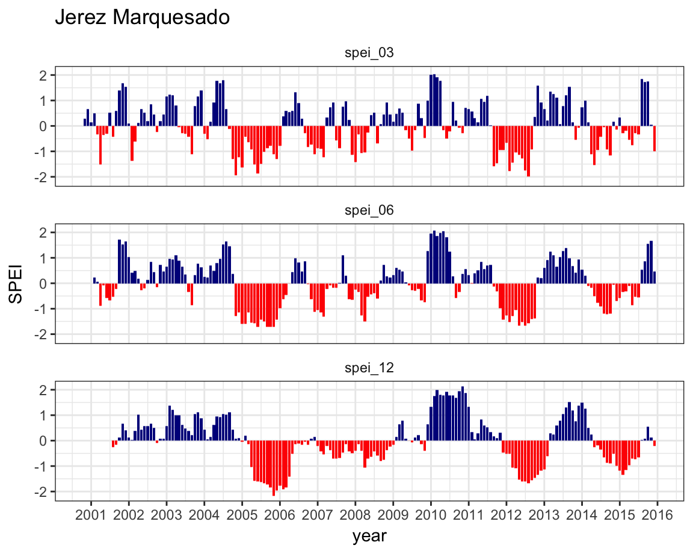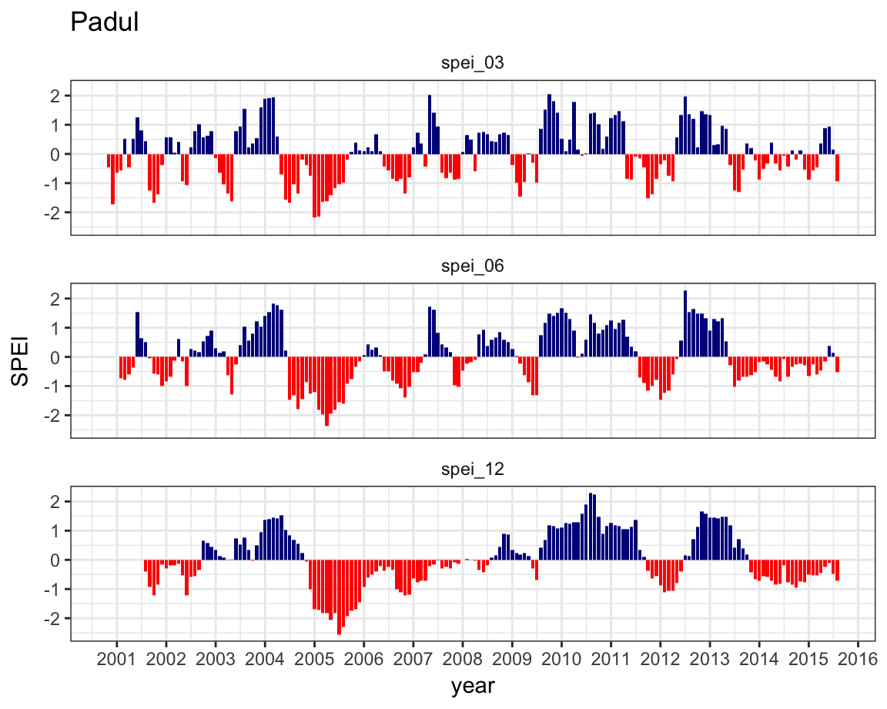

Figure R5. SPEI index for northern (left) and southern (right) population of the Sierra Nevada mountains.

**C4.   
The manuscript could also use some shortening. Consider moving some of the many figures into the supplement.**

We appreciate the suggestion. We have revised the text to remove redundant and unnecessary text. We have combined several figures: the old Figures 3 and 4 were combined into new Figure 3. The old Figures 5 and 6 were combined into new Figure 4. Also, we have moved old Figure 7 into supplementary figures as Figure S6.

More detailed edits:  
  
**#15. L44-46 – Should review Rehm et al 2015 Ecology and Evolution for additional references and possible cite.**

R15. We appreciate the suggestion. We have included the reference (L41).

**#16. L47-48 –A true ecological edge would also account for biotic interactions.**

R16. We agree with the reviewer and have included this idea in the new Introduction (L49-50).  
  
**#17. L58-62 – the sentence is poorly worded. Consider dropping the second part of the sentence after the Navarro-Gonzalez citation or breaking this into two sentences.**

R17. We have removed the second part of the sentence. In any case, as we stated in previous responses (e.g. see response RB) we have restructured and rewritten the Introduction section, removing unnecessary and confounding sentences.

**#18. L68 – sentence seems unnecessary**

R18. We removed it. See R17.

**#19. L69 – sentence starts with “this” but what does “this” refer to? The response of rear-edge populations stated two sentences before?**

R19. We have explained this more clearly now, and we have deleted the unnecessary sentences (see last two responses).

**#20. L76 – the authors use dendrochronology and then dendroecology. Are they the same thing? If so I suggest just using dendroecology throughout the paper and avoid mixing terms.**

R20. The two concepts are closely related. Dendrochronology refers to the science of dating tree rings and studying their structure to interpret information about environmental and historical events and processes (Kaennel and Schweingruber 1995), while dendroecology is a subfield of dendrochronology applied to ecological questions (Fritts and Swetnam 1989). It uses the variation in tree-ring structure and width to determine ecological and environmental variability and its implications for forests.

Following the recommendation, we have restricted ourselves to using the term “dendroecology” throughout the manuscript.

**#21. L94 – climate change ‘along’ a small-scale gradient?**

R21. We appreciate the suggestion and have incorporated the change in the text (L108).

**#22. L119 – should be clear on what you mean by ‘richest’. Is this species richness?**

R22. Yes, it refers to species richness of plants. We have clarified this in the text (L136).

**#23. L142-144 Are severe droughts and drought events different criteria?**

R23. A severe drought is a type of drought event. As we stated at L150-L164, a drought event starts when drought index values (SPEI in our case) fall below a certain threshold for at least two consecutive months, and ends when it turns above the mean value of the series (Spinoni and others 2015). The drought events can be classified in the following classes: moderate, severe, and extreme depending on the value of the threshold. We followed the classification proposed by Agnew (2000), which has been used in several works (e.g. Spinoni and others 2015, 2017; Páscoa and others 2017). This approach uses the following threshold values: moderate if −0.84 > drought index ≥ −1.28; severe, if −1.28 > drought index ≥ −1.65; and extreme, if −1.65 > drought index.

**#24. L173-182 – why weren’t multiple elevations sampled at SJ?**

R24.Our initial scheme was to sample in each locality at two elevations, but in SJ it is distributed in a narrow altitudinal band (see Figure 1 of the manuscript) located at the bottom of the valley, in contrast to those located in the southern area (CA sites), where they occupy a wider elevational band. We sampled 20 trees at SJ site distributed along the elevational gradient because this was small and we found no ecological heterogeneity to split into two different altitudes. If we split the SJ dataset into two sets (each with 10 trees), i.e. SJ-low and SJ-high elevation, we observe that the difference in elevation between low and high is less than 70 m (SJ-high = 1357 vs. SJ-low = 1288; average values) while in the population of the CA site this difference (between high and low site) is more than 150 m (CA-high = 1894 vs. CA-low = 1742, average values). Furthermore, the stand structure in SJ is homogeneous along the small gradient whereas that in CA differs markedly between the two altitudinal areas sampled (see Table 1 in the main text).

Below, for clarity, we compute separated BAI-chronologies for SJ-High and SJ-Low (had we split data into two), and we find no pattern differences between the two sites (Figure R6). Therefore we did not include two separate elevation groups in the analysis for SJ site.

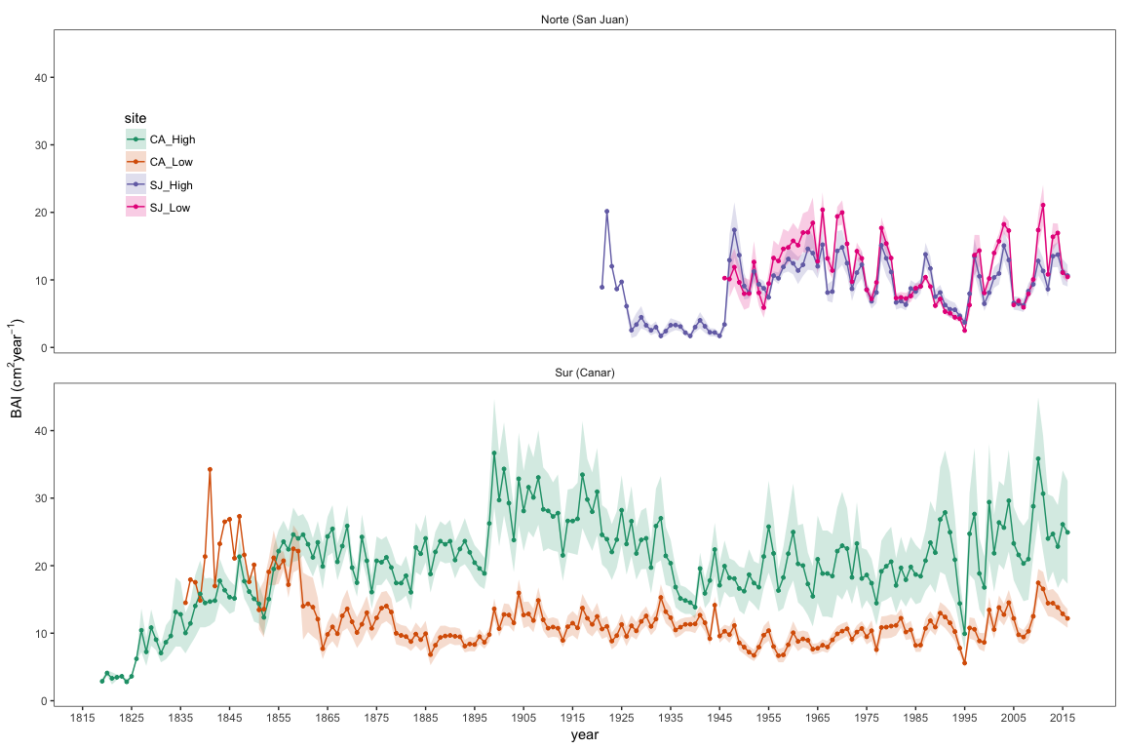

Figure R6. Basal Area Increment (BAI) chronologies of *Q. pyrenaica* for northern populations at the low elevation (SJ-Low) and the high elevation (SJ-High); and southern ones: low-elevation (CA-Low; and high-elevation (CA-High) sites. Shaded areas correspond to the standard error of the mean.

**#25. L267 – consider changing ‘growth was significantly faster’ to “growth was significantly greater’.**

R25. We have changed the sentence accordingly (L296).

**#26. L330-334 – can the dendroecology work or historical records give an estimate of stand density during these times?**

R26. We appreciate the question. We agree that it is important to consider stand density because it greatly affects growth (see references in the main text). Dendroecological methods provide a series of growth data with an annual resolution, which can be used to analyze the forest’s responses to spatio-temporal changes in climate. However, due to a lack of long-term competition series, few studies have been able to profit from the valuable long time span of this type of data in order to investigate the effect of the interaction between competition and climate on tree growth (see Fernández-de-Uña and others 2015 for a revision). Most dendrochronological studies sample only the current stand density, using this as a surrogate for the past stand density (for the 10-20 previous years, maximum) and fewer studies have explicitly modeled growth as a function of both climate and competition (see Fernández-de-Uña and others 2015 for a revision). A way to estimate stand density in the past is to use historical forest inventories and/or permanent plots that provide information on the forest structure and its dynamics. We exhaustively reviewed historical forest inventory and also historical data but found no density estimates that match spatially or temporally with our growth data. In Table S4 summarizes the main data from the review of historical documents.

**#27. L430 – can the authors offer a new definition?**

R27. We have included some commentary on this issue (L468-483; and also the Concluding Comments section). Our contribution is a case study where we highlight the need to take into account land-use for the definition of rear-edge, which adds more evidence to what other authors suggested (*e.g.* Vilà-Cabrera and others 2019): in order to define the rear edge, at least in the Mediterranean region, it is necessary also to consider other elements such as land legacies.

**References used**

Agnew CT. 2000. Using the SPI to Identify Drought. Drought Network News (1994-2001): 12:8.

Biondi F, Qeadan F. 2008. A theory-driven approach to tree-ring standardization: defining the biological trend from expected basal area increment. Tree-Ring Res 64:81–96.

Fernández-de-Uña L, Cañellas I, Gea-Izquierdo G. 2015. Stand Competition Determines How Different Tree Species Will Cope with a Warming Climate. PLOS ONE 10:e0122255.

Fernández-de-Uña L, McDowell NG, Cañellas I, Gea-Izquierdo G. 2016. Disentangling the effect of competition, CO 2 and climate on intrinsic water-use efficiency and tree growth. J Ecol 104:678–90.

Fritts HC, Swetnam TW. 1989. Dendroecology: A Tool for Evaluating Variations in Past and Present Forest Environments. In: Begon M, Fitter AH, Ford ED, MacFadyen A, editors. Advances in Ecological Research. Vol. 19. Academic Press. pp 111–88.

Gea-Izquierdo G, Cañellas I. 2014. Local Climate Forces Instability in Long-Term Productivity of a Mediterranean Oak Along Climatic Gradients. Ecosystems 17:228–241.

Gea-Izquierdo G, Fernández-de-Uña L, Cañellas I. 2013. Growth projections reveal local vulnerability of Mediterranean oaks with rising temperatures. Forest Ecology and Management 305:282–93.

Hodgson D, McDonald JL, Hosken DJ. 2015. What do you mean, ‘resilient’? Trends Ecol Evol 30:503–6.

Holling CS. 1973. Resilience and Stability of Ecological Systems. Annu Rev Ecol Syst 4:1–23.

Ingrisch J, Bahn M. 2018. Towards a Comparable Quantification of Resilience. Trends Ecol Evol 33:251–9.

Kaennel M, Schweingruber FH, editors. 1995. Multilingual glossary of dendrochronology: terms and definitions in English, German, French, Spanish, Italian, Portuguese and Russian. Bern: Haupt

Kuenzer C, Dech S, Wagner W, editors. 2015. Remote sensing time series: revealing land surface dynamics. Cham Heidelberg New York Dordrecht London: Springer

Lloret F, Keeling EG, Sala A. 2011. Components of tree resilience: effects of successive low-growth episodes in old ponderosa pine forests. Oikos 120:1909–1920.

Meroni M, Fasbender D, Rembold F, Atzberger C, Klisch A. 2019. Near real-time vegetation anomaly detection with MODIS NDVI: Timeliness vs. accuracy and effect of anomaly computation options. Remote Sens Environ 221:508–21.

Páscoa P, Gouveia C, Russo A, Trigo R. 2017. Drought Trends in the Iberian Peninsula over the Last 112 Years. Adv Meteorol:ID4653126.

Saleska SR, Didan K, Huete AR, da Rocha HR. 2007. Amazon Forests Green-Up During 2005 Drought. Science 318:612–612.

Samanta A, Ganguly S, Hashimoto H, Devadiga S, Vermote E, Knyazikhin Y, Nemani RR, Myneni RB. 2010. Amazon forests did not green-up during the 2005 drought. Geophys Res Lett 37:L05401.

Samanta A, Ganguly S, Vermote E, Nemani RR, Myneni RB. 2012. Interpretation of variations in MODIS-measured greenness levels of Amazon forests during 2000 to 2009. Environ Res Lett 7:024018.

Schwarz J, Skiadaresis G, Kohler M, Kunz J, Schnabel F, Vitali V, Bauhus J. 2020. Quantifying Growth Responses of Trees to Drought—a Critique of Commonly Used Resilience Indices and Recommendations for Future Studies. Curr For Rep. http://link.springer.com/10.1007/s40725-020-00119-2.

Spinoni J, Naumann G, Vogt JV. 2017. Pan-European seasonal trends and recent changes of drought frequency and severity. Glob Planet Change 148:113–30.

Spinoni J, Naumann G, Vogt JV, Barbosa P. 2015. The biggest drought events in Europe from 1950 to 2012. J Hydrol Reg Stud 3:509–24.

Vilà‐Cabrera A, Premoli AC, Jump AS. 2019. Refining predictions of population decline at species’ rear edges. Glob Change Biol 25:1549–60.