##### Supplemental Material

**Table S1.** Robust two-way ANOVAs of the resilience metrics of greenness (EVI) and tree growth (BAI) for the two drought events (in 2005 and 2012) and site.

**Table S2.** Robust measures of central tendency of resilience indices for greenness (EVI) and tree growth (BAI), grouped by drought events, site, and interaction. Measures of central tendency are M-estimators based on Huber’s Psi (see Materials and methods). In parentheses are the 95% confidence intervals using 3000 bootstraps. *Total* corresponds to the average of 2005 and 2012.

**Table S3.** Drought events for the 1901-2016 period for Sierra Nevada ranked according to drought severity calculated from the SPEI index (12 months scale). See Materials and methods for details.

**Table S4.** Review of the forest and management history of the sampling sites. Historical documents were exhaustively reviewed to compile information on socio-economical activities affecting forests: historical documents and maps (*e.g.* Titos 1990); detailed mining reports (*e.g.* Maestre 1858); official information on recent wildfire events and forest-management practices (*e.g.* Bonet and others 2016); livestock farming (*e.g.* Moreno-Llorca and others 2016); traditional irrigation ditches (*e.g.* Ruiz-Ruiz 2017) and other studies reviewing the socioeconomic dynamics of forest of Sierra Nevada at different scales (*e.g.* Jiménez-Olivencia and others 2015).

**Table S1**

|  |  |  | **Resistance** | |  | **Recovery** | |  | **Resilience** | |
| --- | --- | --- | --- | --- | --- | --- | --- | --- | --- | --- |
| **Variable** | **Factor** |  | **F** | **p** |  | **F** | **p** |  | **F** | **p** |
| EVI | Drought event |  | 799.9 | *< 0.001* |  | 312.0 | *< 0.001* |  | 207.2 | *< 0.001* |
| Site |  | 153.2 | *< 0.001* |  | 105.4 | *< 0.001* |  | 29.8 | *< 0.001* |
| Drought event:Site |  | 234.7 | *< 0.001* |  | 364.3 | *< 0.001* |  | 6.1 | 0.014 |
| BAI | Drought event |  | 6.0 | 0.019 |  | 29.5 | *< 0.001* |  | 44.3 | *< 0.001* |
| Site |  | 59.3 | *< 0.001* |  | 53.1 | *< 0.001* |  | 1.3 | 0.534 |
| Drought event*Site |  | 32.2 | *< 0.001* |  | 4.4 | 0.134 |  | 30.0 | *< 0.001* |

**Table S2**

|  |  |  | **2005** | | | | **2012** | | |  | **Total** | | |
| --- | --- | --- | --- | --- | --- | --- | --- | --- | --- | --- | --- | --- | --- |
| **Variable** | **Sites** |  | **Resistance** | **Recovery** | **Resilience** |  | **Resistance** | **Recovery** | **Resilience** |  | **Resistance** | **Recovery** | **Resilience** |
| ***EVI*** | *Northern slope* |  | 0.819 | 1.169 | 0.955 |  | 0.947 | 1.042 | 0.986 |  | 0.884 | 1.102 | 0.970 |
|  | (0.814 - 0.824) | (1.161 - 1.177) | (0.951 - 0.960) |  | (0.942 - 0.952) | (1.036 - 1.047) | (0.980 - 0.990) |  | (0.878 - 0.889) | (1.096 - 1.108) | (0.967 - 0.974) |
| *Southern slope* |  | 0.902 | 1.066 | 0.962 |  | 0.939 | 1.071 | 1.004 |  | 0.921 | 1.069 | 0.983 |
|  | (0.896 - 0.907) | (1.058 - 1.074) | (0.957 - 0.966) |  | (0.934 - 0.944) | (1.067 - 1.075) | (1.000 - 1.008) |  | (0.917 - 0.925) | (1.065 - 1.073) | (0.980 - 0.986) |
| *All* |  | 0.858 | 1.120 | 0.958 |  | 0.943 | 1.057 | 0.995 |  |  |  |  |
|  | (0.854 - 0.863) | (1.113 - 1.126) | (0.955 - 0.962) |  | (0.940 - 0.947) | (1.054 - 1.060) | (0.991 - 0.998) |  |  |  |  |
| ***BAI*** | *CA-High* |  | 0.892 | 0.887 | 0.790 |  | 0.753 | 1.107 | 0.813 |  | 0.816 | 0.996 | 0.798 |
|  | ( 0.809 - 0.975) | ( 0.800 - 0.973) | ( 0.691 - 0.888) |  | ( 0.686 - 0.820) | ( 1.026 - 1.188) | ( 0.741 - 0.885) |  | ( 0.755 - 0.876) | ( 0.917 - 1.075) | ( 0.744 - 0.851) |
| *CA-Low* |  | 0.901 | 0.832 | 0.730 |  | 0.926 | 0.952 | 0.876 |  | 0.921 | 0.897 | 0.817 |
|  | ( 0.813 - 0.989) | ( 0.733 - 0.932) | ( 0.612 - 0.849) |  | ( 0.900 - 0.953) | ( 0.889 - 1.015) | ( 0.839 - 0.913) |  | ( 0.883 - 0.958) | ( 0.843 - 0.951) | ( 0.755 - 0.879) |
| *SJ* |  | 0.445 | 1.112 | 0.489 |  | 0.769 | 1.446 | 1.031 |  | 0.612 | 1.282 | 0.769 |
|  | ( 0.375 - 0.516) | ( 1.000 - 1.224) | ( 0.421 - 0.556) |  | ( 0.684 - 0.853) | ( 1.322 - 1.569) | ( 0.930 - 1.132) |  | ( 0.539 - 0.685) | ( 1.179 - 1.386) | ( 0.652 - 0.886) |
| *All* |  | 0.721 | 0.946 | 0.653 |  | 0.819 | 1.161 | 0.911 |  |  |  |  |
|  | ( 0.644 - 0.798) | ( 0.879 - 1.013) | ( 0.585 - 0.721) |  | ( 0.776 - 0.863) | ( 1.081 - 1.240) | ( 0.865 - 0.957) |  |  |  |  |

**Table S3**

| **Duration  (months)** | **Intensity** | **Severity** | **Lowest  SPEI** | **Months** | **Year** |
| --- | --- | --- | --- | --- | --- |
| 11 | -1.957 | 21.524 | -2.585 | Jan - Nov | 1995 |
| 11 | -1.581 | 17.391 | -2.024 | Nov - Sep | 1913-1914 |
| 9 | -1.823 | 16.409 | -2.42 | May - Jan | 1945-1946 |
| 9 | -1.764 | 15.880 | -2.056 | Dec - Aug | 1998-1999 |
| 8 | -1.482 | 11.859 | -1.654 | Feb - Sep | 1983 |
| 6 | -1.728 | 10.367 | -1.906 | Mar - Aug | 2012 |
| 5 | -1.905 | 9.527 | -2.300 | Jan - May | 1925 |
| 5 | -1.522 | 7.611 | -1.571 | May - Sep | 2005 |
| 5 | -1.493 | 7.463 | -1.537 | May - Sep | 1985 |
| 5 | -1.385 | 6.926 | -1.444 | Apr - Aug | 1991 |
| 4 | -1.714 | 6.855 | -1.833 | May - Aug | 1931 |
| 4 | -1.363 | 5.453 | -1.441 | May - Aug | 1927 |

**Table S4**

| Use | **Cáñar (CA sites)** | **Güejar-Sierra (SJ site)** | **References** |
| --- | --- | --- | --- |
| **Land use** | Oak Woodlands mixed with a high percentage of croplands even reached high elevations (mainly barley, rye, and potatoes). Irrigated crops near the village (“*regadío de vega*”) | Grasslands and shrublands for cattle raising located at high elevations. Then forest formations (oak woodlands) with some croplands (mainly herbaceous and potatoes). Irrigated terraces with tree crops (chestnut trees, cherry trees) | Jiménez-Olivencia and others (2015); Zoido and Jiménez Olivencia (2015); Moreno-Llorca and others (2016); Calatrava and Sayadi (2019) |
| **Forest Management Practices** | Nearby areas were afforested (pine plantations) to avoid soil erosion in 1925, 1928, 1950, and 1970  Selective thinning during 2007 in a small area near “*Casa Forestal*”  Tree cleaning near trails/paths (2009-2010) | Afforestation of the upper areas of the Genil River basin (1942)  Tree cleaning (2006 - 2007) near our study site (*La Hortichuela*)  Scattered afforestation (creation of small, scattered islands of oaks) (2008) | Bonet and others (2016); Moreno-Llorca and others (2016); J. Navarro and F.J. Cano-Manuel *personal communications;* Romero-Zurbano (1909) |
| **Forest structure** | Inventories of trees made by the Spanish Navy during the second half of 18th century: 2,010,200 new trees; 10,791 growing trees . For the Cáñar site, more than 2,000,000 trees were reported, most of them new, and no old trees were counted, suggesting recent tree felling. | Inventories of trees made by the Spanish Navy during the second half of 18th century: 639 550new trees; 56 700growing trees; 220 old trees | Cruz (1991); Wing (2015) |
| **Fires** | Several small fires.  1979: 44 Has of Pyrenean oak forests (near "*Casa Forestal*")  1984: 189 Has of Pine plantations and Holm oak forests ("*El Jaral*")  1994: 65 Has of Pine plantation ("*Puente Palo*") | Not recorded in the area since 1975 | Bonet and others (2014); Moreno-Llorca and others (2016); CMA (2018) |
| **Fruit production (acorns)** | Old references have indicated traditional acorn gathering. Auctions of public forests to collect acorns (1927; 1954) |  | Catastro (1752); Mesa-Torres (2009); Bonet and others (2014) |
| **Wood** | Traditional charcoal ("*carboneo*") making and firewood cutting throughout history. Several references have indicated firewood collection at this site at least since 1572.  At the beginning of the last century (1900s), 3 - 4 woodcutters collected firewood from Pyrenean forests daily. | Some references of wood removal for subsistence (1826; 1847). Massive logging during the first decades of 20th century. As a result, several old photos show areas without trees where oak forests stand today (1925; 1932) | Catastro (1752); López (1776); Madoz (1846); Titos Martínez (1997); Ferrer (1999); Jiménez-Serrano and Serrano-Gutiérrez (2004); Mesa-Torres (2009); Bonet and others (2014) |
| **Mining activities** | No mining in the area, only scattered private excavations | Intermittent exploitation throughout history. Historical documents indicated two periods of intense mining: the second half of the 19th century after the publication of detailed mineralogical reports and during the first decades of the 20th century until 1960, which is the last year with evidence of mining. Evidence of several furnaces to melt minerals (Cooper) | Maestre (1852); Maestre (1858); Titos (1990); Arnedo (2007); Mesa-Torres (2009) |
| **Quarries** |  | Exploitation of serpentine quarries from the 16th to 19th century (*Jaspe Verde*) | Navarro and others (2014) |
| **Traditional irrigation channel** | An irrigation channel (“*Acequia de la Era Alta”)* is located uphill of the CA-High site (*i.e.* >2000 m), which functioned from March to June | Several historical irrigation channels, known as *acequias de careo*, were used since the Middle Ages to cultivate these valleys. Most are abandoned and deteriorated, probably at least since the 1960s. | Martín-Civantos (2014); Martín-Montañés and others (2015); Ruiz-Ruiz (2017) |

**Figure S1.** ***a)*** Temporal evolution of cumulative precipitation (hydrological year) during the period 1950-2017. Points represent the mean, and error bars the standard error. The black line indicates mean for the entire period (585 mm). The red lines represent -1 and -2 standard deviation (dotted and dashed lines, respectively). The blue lines represent +1 and +2 standard deviation (dotted and dashed lines, respectively). Years with average values below -1SD are labeled. Data from 28 meteorological stations distributed around the Sierra Nevada area (from the National Spanish Meteorological Services, AEMET). ***Inset plot***: cumulative precipitation during the hydrological years 2004-2005 (blue line) and 2011-2012 (red line). The boxplot representing the average from 1950-2015 period. Data from meteorological station Granada, Base Aérea. ***b)*** Drought severity in Sierra Nevada for the 1901-2016 period based on the Standardized Precipitation-Evapotranspiration Index (SPEI). Data from Global SPEI database (<http://spei.csic.es/database.html>). We took the SPEI data for a 12-month scale and for all 0.5º grid cells covering Sierra Nevada. Horizontal gray bars indicate the years 2005 and 2012.

**Figure S2.** ***a)*** Residual tree-ring chronologies determined for the *Q. pyrenaica* sites. Dashed red lines indicate the start of the reliable period (EPS > 0.85). Dotted black lines show the severe drought years identified in our climatic data (Table S3 and Figure S1). ***b)*** Percentage of *Q. pyrenaica* trees affected by GC > 50 % by site. *Black* line shows number of trees (right-axis). Data for number of trees > 2 is shown.

**Figure S3.** ***a)*** Correlation among site chronologies (CA-High, CA-Low and SJ) in different time domains after pre-filtering the time series with increasing size of the moving-average window (1 to 40 years). Each site chronology was smoothed using centered moving averages with different window sizes (1 to 40 years), and then Pearson’s correlation coefficient between the each pair of chronologies was calculated. Significance was tested using 1000 bootstrap replicates and with 95% confidence intervals built using the R package boot. ***b)*** Correlation between indices of resilience (*Rt*, resistance; *Rc*, recovery; *Rs*, Resilience) using periods of several lengths (2, 3 and 4 years after a drought).

**Figure S4.** EVI annual profile (average of the period 2000-2016) for *Q. pyrenaica* forests in Sierra Nevada and drought events. Horizontal bars correspond to the most severe droughts for Sierra Nevada since 1900 (computed as in Table S3). Their position indicates the start and end months of each drought event. Bars lengths show the duration of the drought event (number of consecutive months with SPEI lower than -1.28, see (Páscoa et al. 2017).

**Figure S5.** Resilience metrics of the tree growth for severe drought events since 1950 (excluding 1995 drought event). *Left*: Resistance; *Center*: Recovery; *Right*: Resilience. Points indicate resilience metrics for oak populations: SJ (*blue*), CA-High (*red*) and CA-Low (*green*). Resilience metrics were computed for each population (sample depth > 10) and drought event. The gray line represents overall relationship for each Resilience metrics.

**Figure S6.** Correlation coefficients found by relating tree-ring residual chronologies (RWI) of *Q. pyrenaica* and monthly climatic data: precipitation and 6-month SPEI (a), minimum (b) and maximum (c) temperatures. *green* bars: northern site (SJ); *light blue* bars: low-elevation southern site (CA-Low); and *dark blue* bars: high-elevation southern site (CA-High). Asterisks indicate significant () correlation coefficients.

**Figure S1** 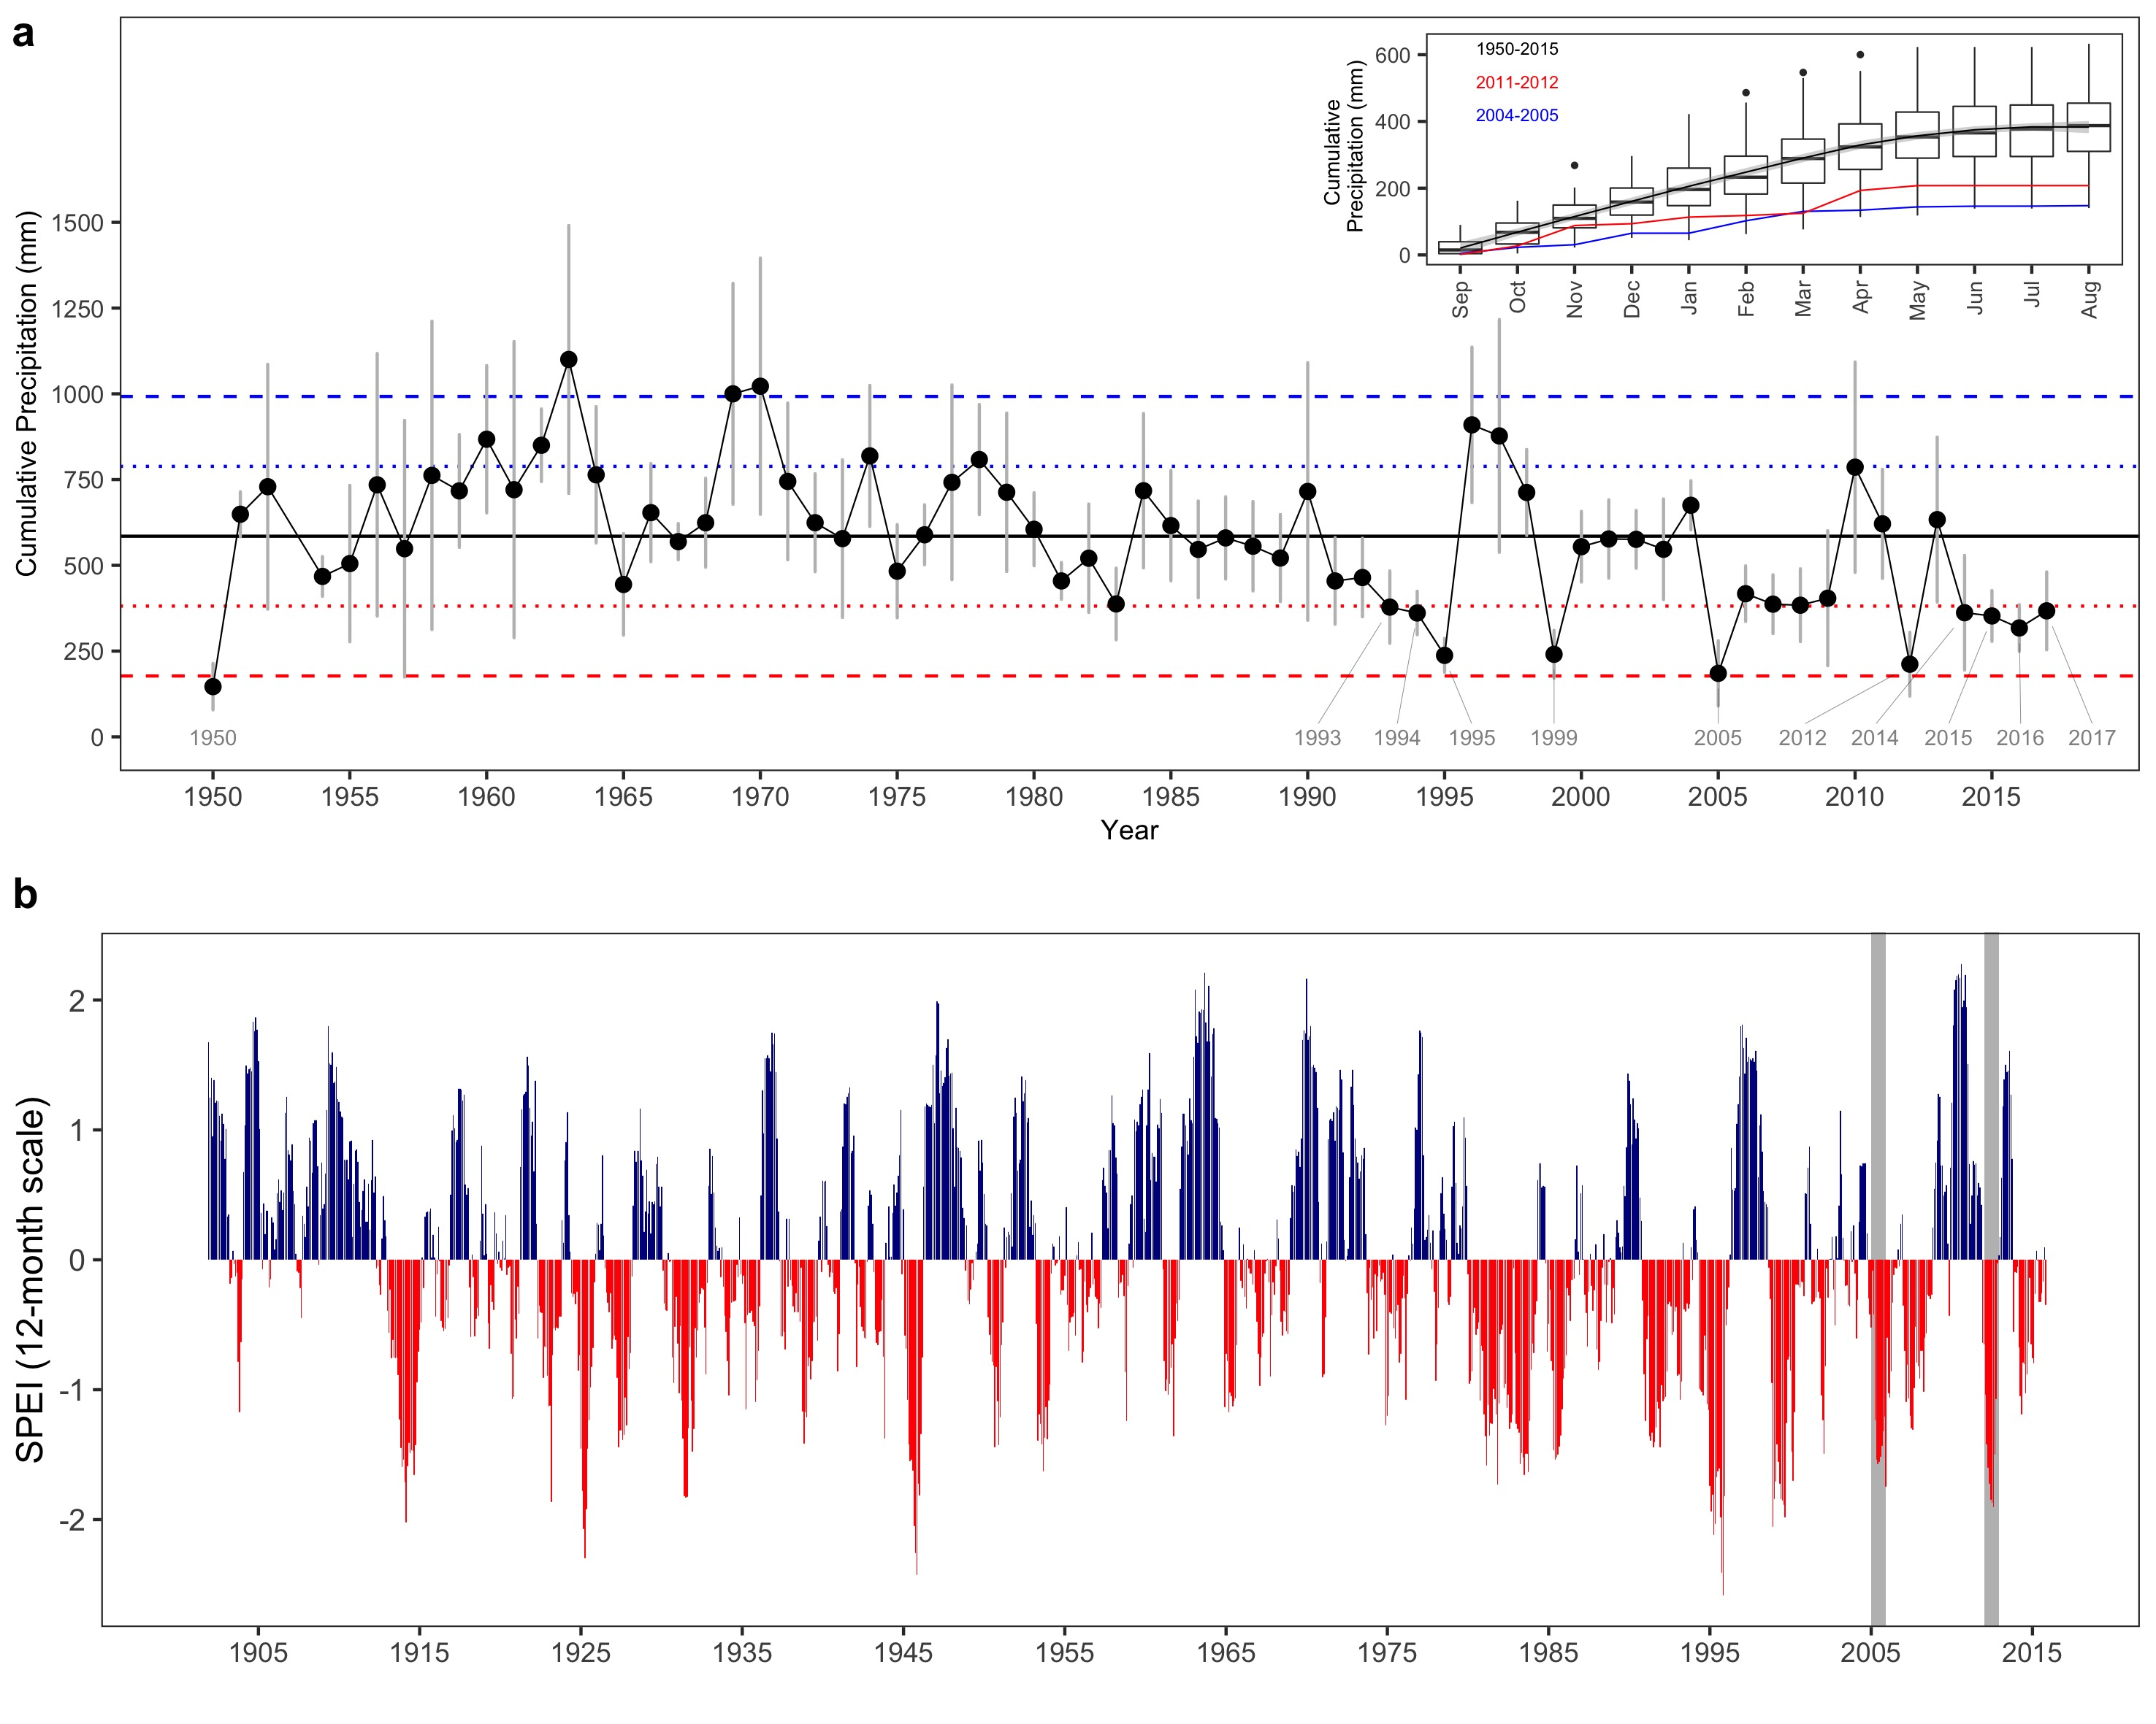

##### 

**Figure S2** 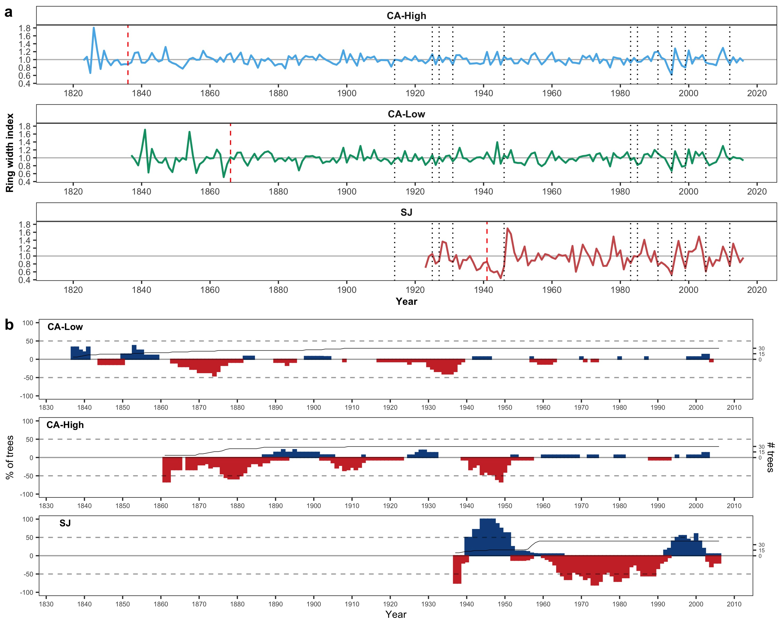

**Figure S3** 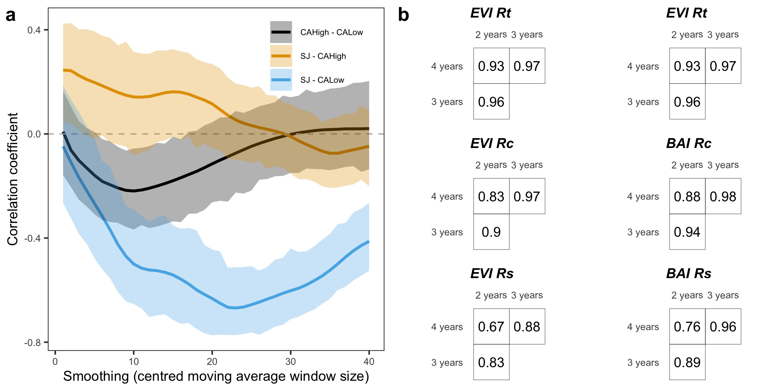

##### 

**Figure S4**

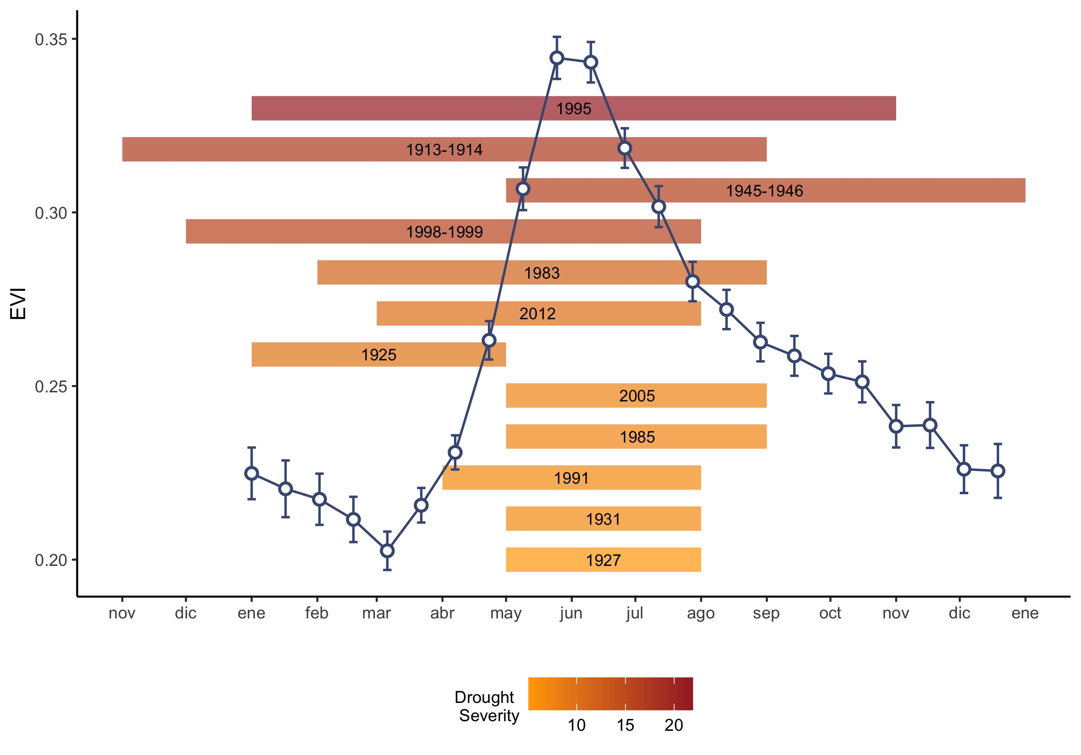

##### 

**Figure S5** 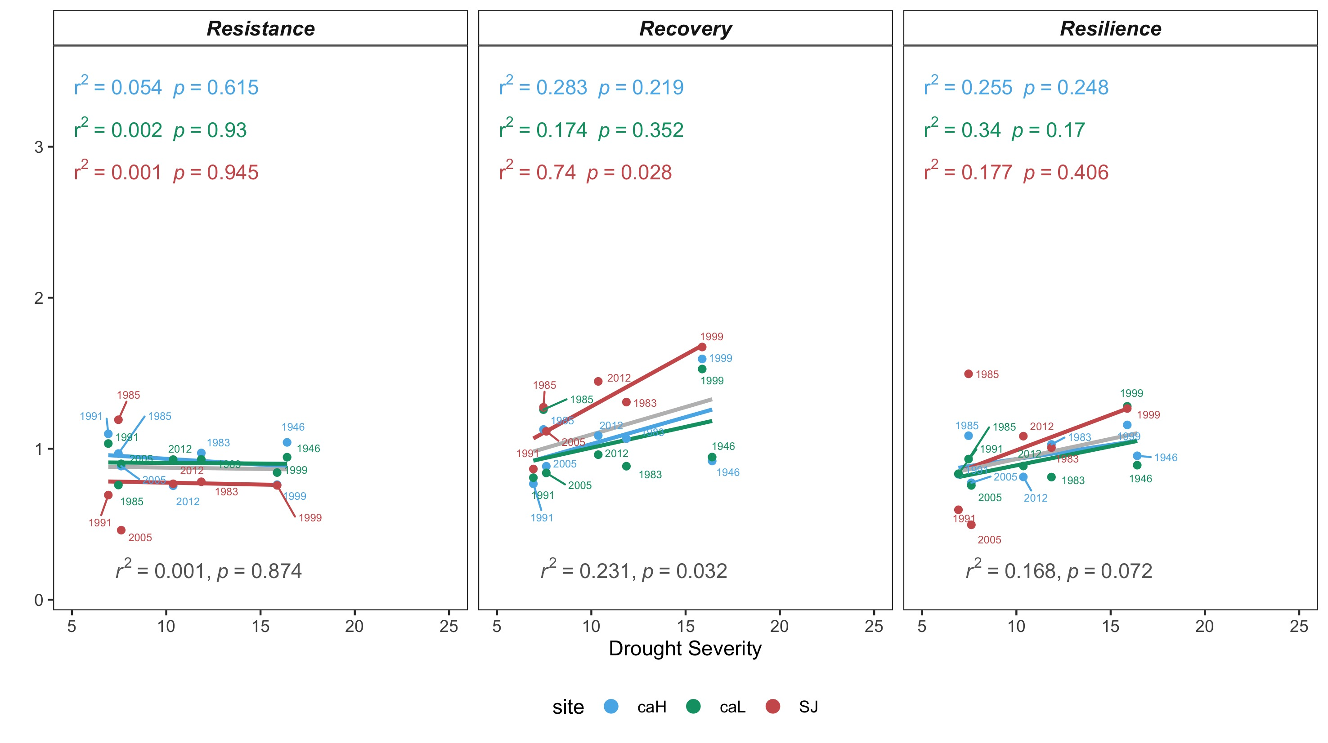

##### 

**Figure S6** 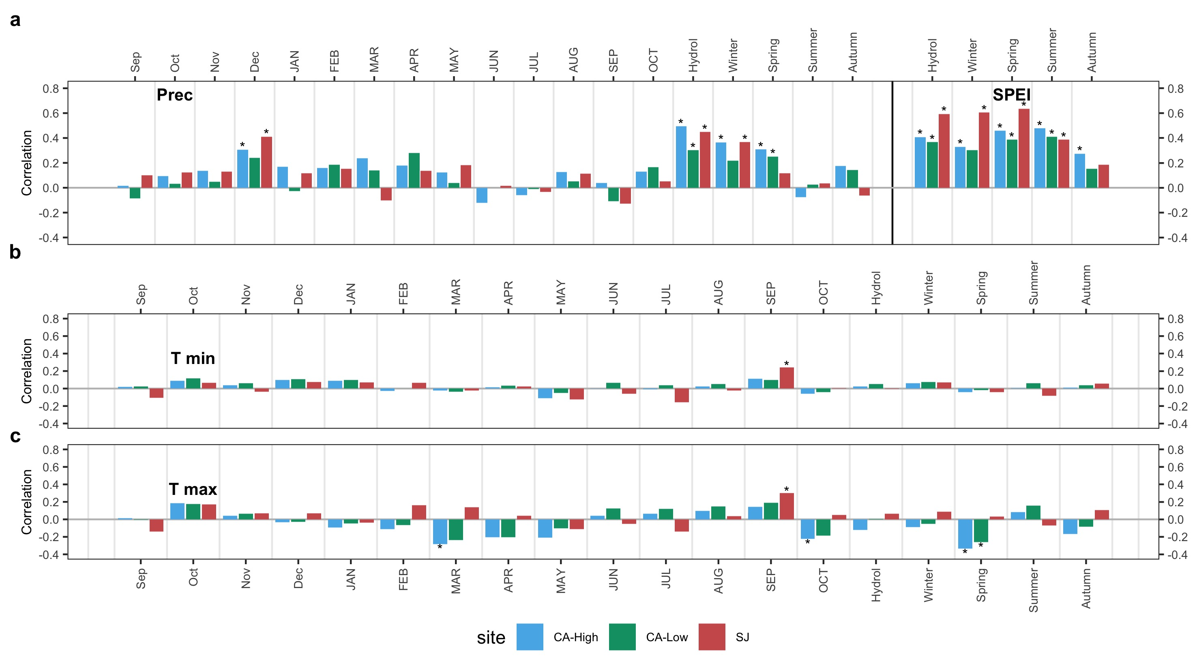

**References**

Arnedo R. 2007. Historia de Güéjar Sierra, de mora a cristiana. Ayuntamiento de Güéjar Sierra

Bonet F, Aspizua R, Navarro J. 2016. History of Sierra Nevada forest management: Implications for adaptation to global change. In: Zamora R, Pérez-Luque A, Bonet F, Barea-Azcón J, Aspizua R, editors. Global change impacts in Sierra Nevada: Challenges for conservation. Consejería de Medio Ambiente y Ordenación del Territorio. Junta de Andalucía. pp 153–6.

Bonet FJ, Moreno-Llorca RA, Pérez-Luque AJ, Pérez-Pérez R, Zamora R. 2014. Estudio de cambios de la biodiversidad a través de talleres de participación ciudadana. In: XII Congreso Nacional de Medio Ambiente (CONAMA 2014). Madrid, Spain <http://www.conama11.vsf.es/conama10/download/files/conama2014/CT%202014/1896711638.pdf>

Calatrava J, Sayadi S. 2019. Evolution of farming systems in the mediterranean high mountain: The case of the Alpujarra Alta (Spain). Sustainability 11:704. <https://doi.org/10.3390/su11030704>

Catastro. 1752. Respuestas Generales del Catastro del Marqués de la Ensenada. <http://pares.mcu.es/Catastro/>

CMA, Consejería de Medio Ambiente. Junta de Andalucía. 2018. Áreas recorridas por el fuego en Andalucía (1975-2017). <http://www.juntadeandalucia.es/medioambiente/site/rediam/menuitem.04dc44281e5d53cf8ca78ca731525ea0/?vgnextoid=0a380c29bd9bc310VgnVCM2000000624e50aRCRD&vgnextchannel=6164fa937370f210VgnVCM1000001325e50aRCRD&vgnextfmt=rediam&lr=lang_es&vgnextrefresh=1>. Last accessed 09/08/2018

Cruz M. 1991. Atlas historico-forestal de Andalucia: siglo XVIII. Granada: Universidad de Granada

Ferrer M. 1999. Libro de apeo y repartimiento de suertes de Guexar de la Sierra. Ayuntamiento de Güéjar Sierra

Jiménez-Olivencia Y, Porcel L, Caballero A. 2015. Medio siglo en la evolución de los paisajes naturales y agrarios de Sierra Nevada (España). Boletín de la Asociación de Geógrafos Españoles 68:205–32.

Jiménez-Serrano B, Serrano-Gutiérrez J. 2004. El Catastro del Marqués de la Ensenada en el antiguo Reino de Granada.

López T. 1776. Diccionario Geográfico-Histórico. Don Quijote. Madrid, Spain

Madoz P. 1846. Diccionario geográfico-estadístico-histórico de España y sus posesiones de ultramar. Establecimiento tipográfico de P. Madoz y L. Sagasti <http://www.bibliotecavirtualdeandalucia.es/catalogo/es/consulta/registro.cmd?id=6353>

Maestre A. 1852. Dictamen científico relativo a la explotación de varios criaderos metalíferos de Sierra Nevada por medio de galerías o socavones, dirigido a la Sociedad Minera Feliz Pensamiento. Revista Minera, Serie A III:683–94.

Maestre A. 1858. Memoria sobre los criaderos de mineral de Sierra Nevada en el término municipal de Güejar-Sierra, provincia de Granada. Boletín del Ministerio de Fomento XXVIII:371–7.

Martín-Civantos JM. 2014. Mountainous landscape domestication. Management of non-cultivated productive areas in Sierra Nevada (granada-almeria, Spain). European Journal of Post-Classical Archaeologies 4:99–130.

Martín-Montañés C, Ruiz-Constán A, Martín-Civantos JM, Herrero-Lantarón J, Rubio-Campos JC, Esteban-Álvarez A. 2015. Caracterización hidrogeológica de un sector de la cuenca del Río Chico en relación con la rehabilitación de la acequia de Barjas en Cáñar (Granada). In: Navarro A, López-Geta JA, Ramos G, Durán J, Carrasco F, Vadillo I, Jiménez P, editors. El agua en Andalucía. El agua clave medioambiental y socioeconómica. IX Simposio del Agua en Andalucía (SIAGA 2015). IGME, Madrid, Spain. pp 193–201.

Mesa-Torres M. 2009. Cáñar: Balcón de la Alpujarra. Fundación Caja General de Ahorros de Granada

Moreno-Llorca R, Pérez-Luque A, Bonet F, R. Z. 2016. Historical analysis of socio-ecological changes in the municipality of Cáñar (Alpujarra, Sierra Nevada) over the last 5 centuries. In: Zamora R, Pérez-Luque A, Bonet F, Barea-Azcón J, Aspizua R, editors. Global change impacts in Sierra Nevada: Challenges for conservation. Consejería de Medio Ambiente y Ordenación del Territorio. Junta de Andalucía. pp 59–62.

Navarro R, Pereira D, Rodríguez-Navarro C, Sebastián-Pardo E. 2014. The Sierra Nevada serpentinites: the serpentinites most used in Spanish heritage buildings. Geological Society, London, Special Publications 407:101–8. <https://doi.org/10.1144/sp407.7>

Romero-Zurbano A. 1909. Reseña de los trabajos ejecutados en la 1ª sección de la Cuenca del Guadalfeo hasta fin del año 1908. Revista de Montes 772:201–7.

Ruiz-Ruiz F. 2017. Gestión del agua y resiliencia en los sistemas de riego tradicionales. Una comparativa socioecológica entre los agroecosistemas del sureste español y los del centro de México. PhD Thesis. University of Granada.

Titos M. 1990. Las minas de la Estrella. In: Titos M, editor. La aventura de Sierra-Nevada 1717-1915. Editorial Universidad de Granada. pp 226–36.

Titos M. 1997. Pasar por Güéjar. Güejar-Sierra, Granada: Ayuntamiento de Güejar Sierra

Wing JT. 2015. Roots of Empire. Brill <https://doi.org/10.1163/9789004261372>

Zoido F, Jiménez Olivencia Y, editors. 2015. Catálogo de Paisajes de la provincia de Granada. Centro de Estudios Paisaje y Territorio, Sevilla: Consejería de Medio Ambiente y Ordenación del Territorio. Junta de Andalucía.