**Figure 1**. Distribution of *Quercus pyrenaica* forests in the Iberian Peninsula (a) and in Sierra Nevada mountain range (b). Different colours indicate oak population cluster’s identified in Sierra Nevada (Pérez-Luque et al. 2015). For each population, a grid with the MODIS pixels is shown (see material and methods). Detailed location of the dendroecological sampling sites: northern (San Juan, SJ) (c), and southern ones (Cáñar: CA-Low and CA-High) (d). Colour orthophotography of 2009 from Regional Ministry of the Environment (IECA 2009).

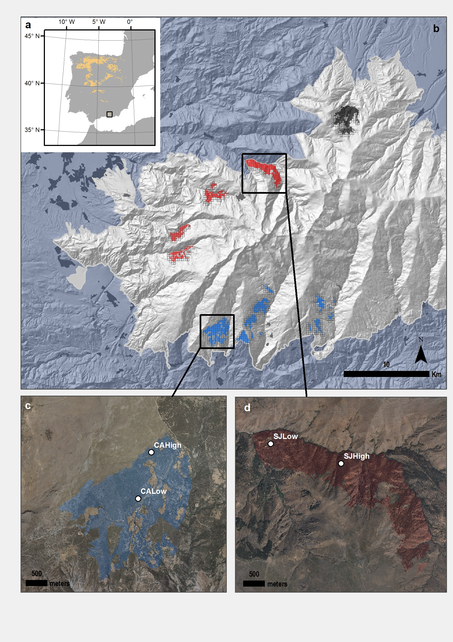

##### 

**Figure 2.** EVI standardized anomaly during the period 2000-2016 for northern and southern populations. Error bars show standard error.

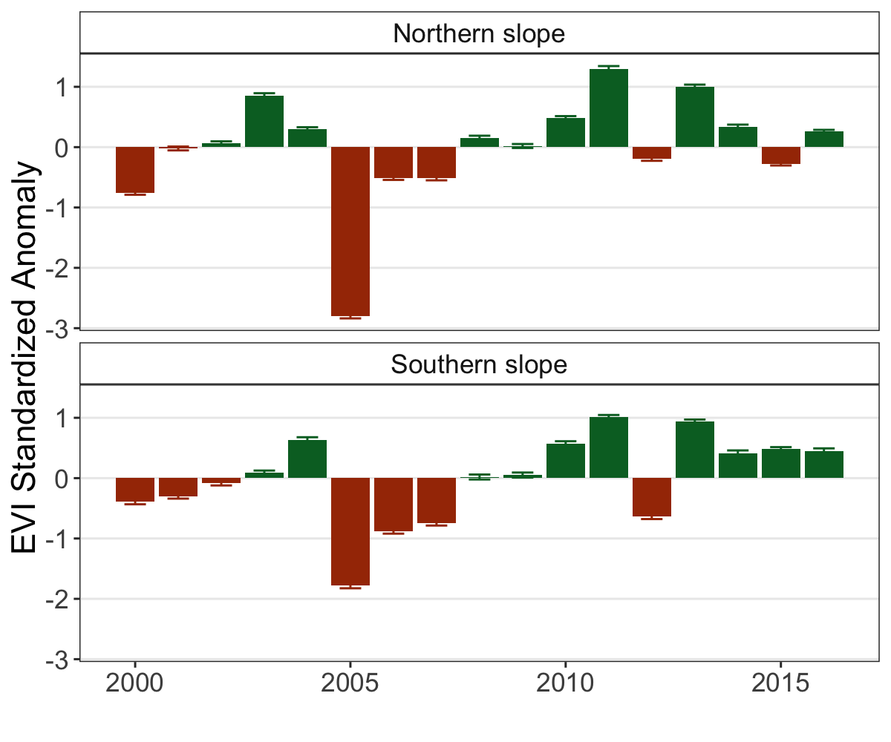

IECA, I. de E. y C. de A. 2009. Digital colour orthophotograph of andalusia 2008-2009. Sevilla. Regional Government of Andalusia.

Pérez-Luque, A. J., R. Zamora, F. J. Bonet, and R. Pérez-Pérez. 2015. Dataset of migrame project (global change, altitudinal range shift and colonization of degraded habitats in mediterranean mountains). PhytoKeys 56:61–81.