To: Professor John Calandra

From: AJ Ierulli

Date: 11 September 2016

Subject: Week 2 Assignment Short Report

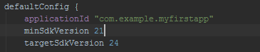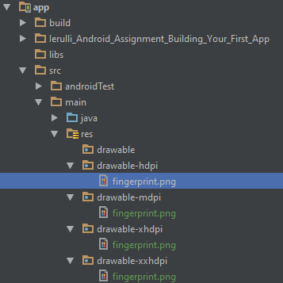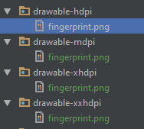There are multiple resources that are available to a mobile application. Those resources enable the application to display properly on multiple types of screen sizes. The bitmaps associated with an application are defined to work with certain screen sizes. There are certain locations that those bitmaps reside in that make them easily recognizable as being used by the system.