16BIS0046 AJINKYA PRABHU

DSC VIT 2CC project Report

Topic :

1. Find the details of people who are currently on the International Space Station and mark the current position of the ISS overhead Earth’s map.

Abstract :
The project consists of using the open source api for getting the names and location of the people on the ISS or the International space station.This api and application can be used to visualize the lothecation of ISS in realtime and also get the names of the people currently on it.

Introduction:

This project consists of using the the python requests library to make RESTful requests to the Api server from where the location of the ISS is obtained. The library matplot lib is used to
plot it on a actual map of the earth given its latitude and longitude.

Methodlogy Used:

The methodology used is by using requests package in python which allows the programmer to make RESTful API calls very easily.The response is then decoded into a python dictionary and then sent for plotting. The code has been designed in such way that everytime the step() is called the new location of ISS is obtained and plotted.plotting is done is using matplotlib which has mpl_toolkits with Basemap to allow using latitude and longitude to plot on the map.

CODE:
from mpl_toolkits.basemap import Basemap
import matplotlib.pyplot as plt
import numpy as np
plt.ion()
import random
import requests
import json
class ISSlocation:
'''
A library to get the location of the International Space Station
'''
def __init__(self,url='http://api.open-notify.org/iss-now.json',name_url = 'http://api.open-notify.org/astros.json'):
'''
pass in the url to get the json response

default:'http://api.open-notify.org/iss-now.json
'''
self.url = url
self.lat = None
self.long = None
self.timestamp = None
self.json_string = None
self.dictionary = None
self.prev_lats = []
self.prev_longs = []
self.names = requests.gaet(name_url).json()
print(self.names)
def step(self):
'''
step everytime you want to update the location by getting a new response
'''
self.dictionary = requests.get(self.url).json()
if self.dictionary['message'] == 'success' and self.names['message']=='success':
self.lat = float(self.dictionary['iss_position']['latitude'])
self.long = float(self.dictionary['iss_position']['longitude'])
self.timestamp = self.dictionary['timestamp']
self.prev_lats.append(self.lat)
self.prev_longs.append(self.long)
print("Names:")
for people in self.names['people']:
print("\tCraft:{},Name:{}".format(people['craft'],people['name']))

else:
'''
for python2
'''
raise BaseException("Unable to contact ISS server")
'''
for python3
raise ConnectionError("Unable to contact ISS server")

'''

def __str__(self):
'''
returns current Lat and Lon
'''
return str(self.__class__.__name__)+"("+str(self.lat)+","+str(self.long)+")"

def plot_on_globle(self,iterations=10):
'''
pass in number of iterations to plot on map number of times
default iterations=10
'''
for i in range(iterations):
self.step()
print(self)
map = Basemap(projection='ortho',lat_0=self.lat,lon_0=self.long,resolution='l')
map.drawcoastlines(linewidth=0.01)
map.drawcountries(linewidth=0.01)
map.fillcontinents(color='coral',lake_color='aqua')
map.drawmapboundary(fill_color='aqua')

# map.drawmeridians(np.arange(0,360,30))
# map.drawparallels(np.arange(-90,90,30))
map.plot(self.prev_lats,self.prev_longs,'mo',markersize=12,latlon=True)
plt.title('Realtime Location of ISS')
plt.pause(0.05)
plt.clf()

if __name__=='__main__':
lo = ISSlocation()
lo.plot_on_globle(100)

Output:

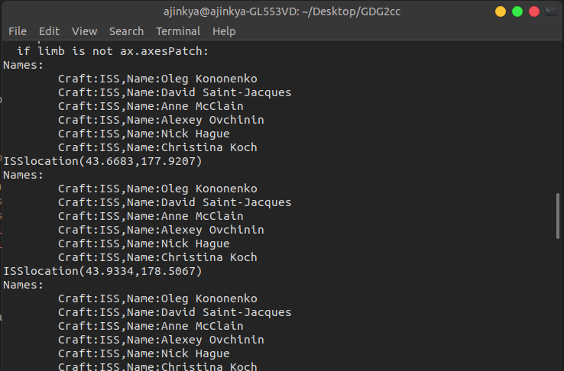
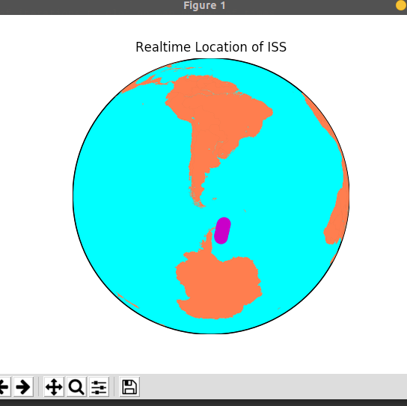

Problems faced:
1)The location and names were not being received.
2)Plotting was not working on windows therefore it was built using Linux ubuntu .
3)Still slow due to requests

Conclusion:
The project was successfully implemented and is working. It was a fun project to and helped me learn many new things.

References:

http://api.open-notify.org/
https://matplotlib.org/basemap/users/examples.html
http://docs.python-requests.org/en/master/

