PROJECT TITLE: An Efficient DeepFake Face Detection Model
Group No.: 33
Project Group Members:
- Aditya Gaur (C(3)/12584200012) 2. Jatin (C(24)/12584200089)
3. Piyush Sharma (C(36)/12584200138) 4. Vipin Kumar (C(50)/12584200209)

Project Supervisor: Dr. Sachendra Singh Chauhan , Designation: Assistant Professor

About the Project:
This project focuses on detecting fake facial images created using technologies like DeepFake. With the growing misuse of such tools, it has become difficult to trust digital content. The proposed system uses deep learning to analyze facial features and identify manipulated images. A Convolutional Neural Network (CNN) is used to extract important patterns from images.
The model is trained on both real and fake image data to learn subtle differences that are not easily visible to humans, such as lighting issues or unnatural facial details. The system aims to accurately classify images as real or fake. This project helps improve digital security and can be useful in areas like social media and digital forensics. In future scope, the system can be extended to support video and webcam-based real-time detection.
Motivation:
With the rapid rise of deepfake technology, it has become harder to trust what we see online. This project is driven by the need to identify fake facial content and stop its misuse. It aims to make digital platforms safer and ensure the authenticity of online media.
Project Planning:
The project begins by clearly defining the goal and collecting real and fake image data. The data is then cleaned and prepared so it can be used effectively for training. A CNN model is built and trained to recognize patterns in the images. After that, the model is tested to check how accurately it performs. Finally, the system is deployed and the results are properly documented and analyzed.
Project Gantt Chart: 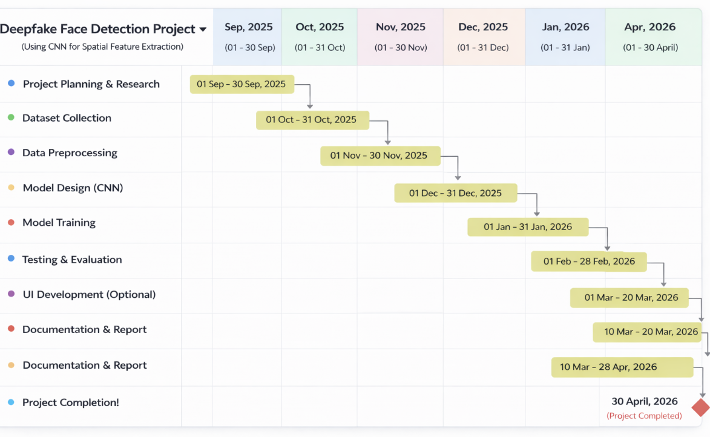
Tools required:
- Hardware Requirements:
- Processor (CPU): Minimum Intel i5 or AMD Ryzen 5 (recommended i7/Ryzen 7 for faster training).
- RAM: Minimum 8 GB (recommended 16 GB or higher for handling large datasets).
- Storage:
At least 256 GB SSD (recommended 512 GB or more for datasets and models).
- GPU (Optional but Recommended):
- NVIDIA GPU (e.g., GTX 1650 or higher) for faster deep learning model training.
- Display & Peripherals: Standard monitor, keyboard, and mouse for development and testing.
- Software Requirements:
- Operating System: Windows 10/11, Linux (Ubuntu), or macOS.
- Programming Language: Python (preferred for deep learning projects), Next.js, React.js and Tailwindcss (for frontend).
- Libraries & Frameworks: flask, TensorFlow,keras for model building, NumPy for data handling, Matplotlib for visualization, PIL for images.
- Development Tools: VS Code
- Dataset: KaggleFaceForensics , Real vs Fake 10K Dataset
- (https://www.kaggle.com/datasets/greatgamedota/faceforensics)
- Version Control (Optional): Git and GitHub for project management

Signature of Project Supervisor: _____________________

