# Aggregate State Retrieving

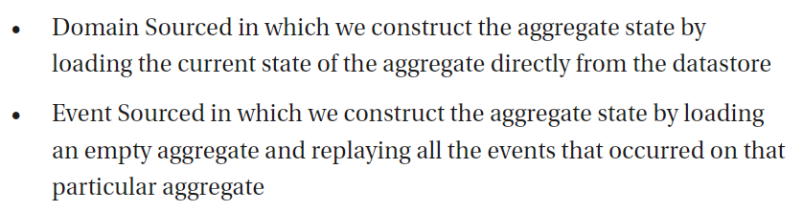

# Monolith Advantages

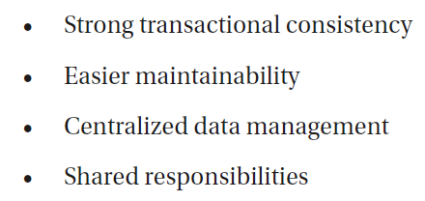

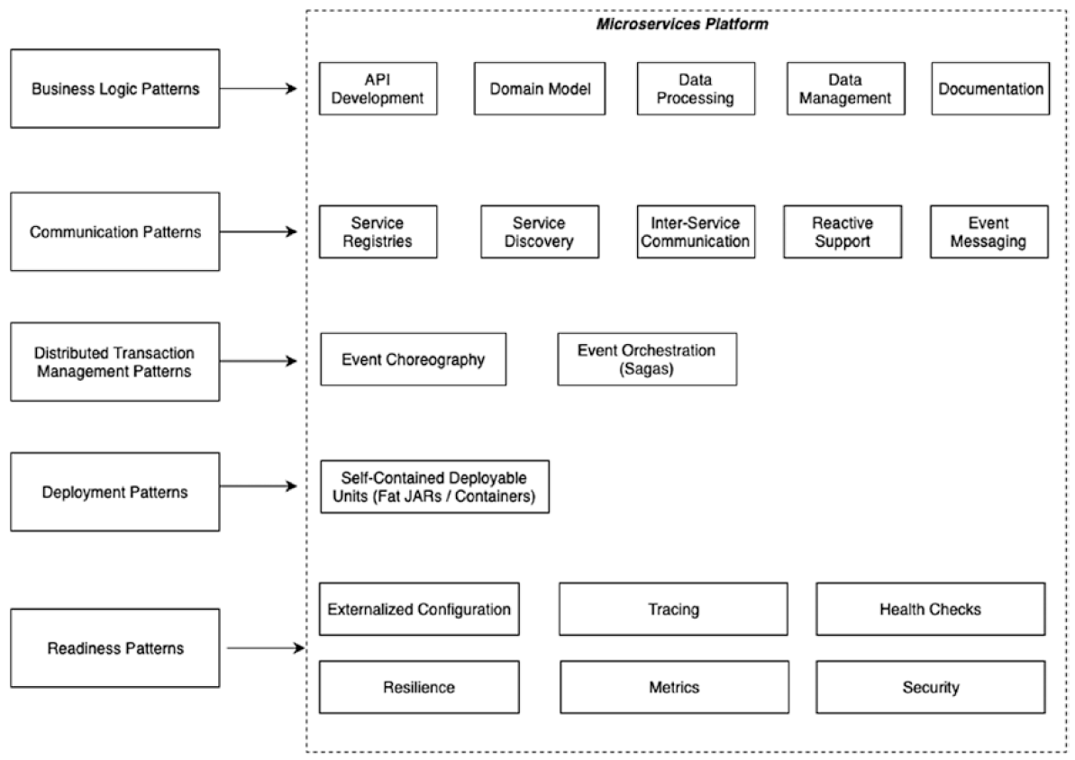

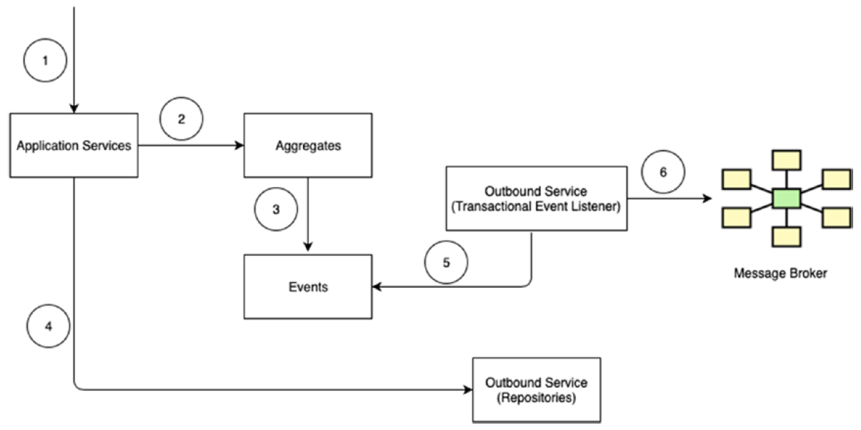

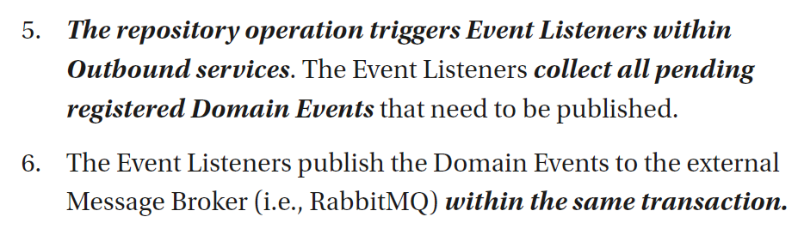

In fact, aggregate register (? publish) event by addDomainEvent(event) { registerEvent(event) }