# 1. Такая вот панель в SceneBuilder

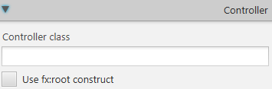

# 2. В приложении по шаблону JavaFX FXML Application

|  |  |
| --- | --- |
|  | <AnchorPane id="AnchorPane" … fx:controller="ru.wts.MainController" |

Parent root = FXMLLoader.load(getClass().getResource("main.fxml"));

# 3. If we use fx:root construct

|  |  |
| --- | --- |
|  | <fx:root id="AnchorPane" … |

AnchorPane root = new AnchorPane();

FXMLLoader loader = new FXMLLoader(getClass().getResource("main_as_root.fxml"));

loader.setRoot(root);

loader.load();

# 4. set custom controller

loader.setController(new MainController());