Assignment 1

Assignment 2

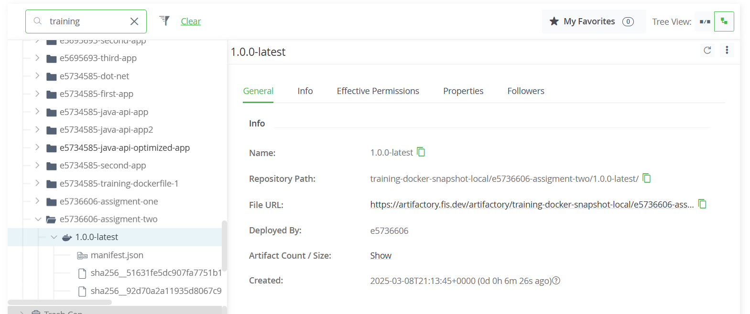

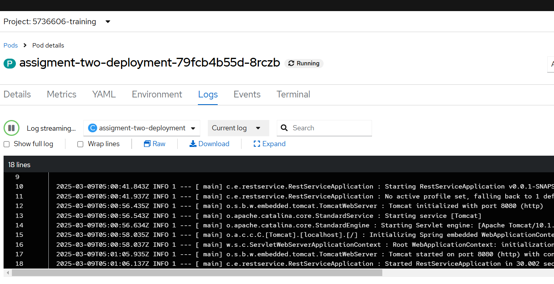

**Assignment 3**

**$ curl http://assigment-two-service.5736606-training.svc.cluster.local:80/greeting**

**{"id":5,"content":"Hello, World!"}$**

Assignment 4





