
Weight: ?%

Atmel Studio Installation

Objective
The "Resources.zip" file (provide by the Course Director) contains all the documents and programs required for Computer Organization and Architecture course lab development. Within this resource folder an Atmel Studio "COASolutions" solutions project exists which contains all the libraries need for this course. Any additional libraries or executable projects you create will be created within this COASolutions solutions project.
This installation document describes how to setup the Atmel Studio IDE, open the "COASolutions" solutions project, and create new library and executable projects.

Setting up the Atmel Studio Integrated Development Environment
This section provides the necessary steps for installing the Atmel Studio IDE. Please follow the sequence of steps in the order given below. If you get stuck along the way, ask the Course Director or Lab Specialist for clarification or guidance.
[ ] The course director will pass around an SD card containing the "Resouces.zip" file. Copy the contents of this file to your computer.
[ ] Unzip the "Resources.zip" file to your disk drive (recommended: "x:\COA\Resources\...")
[ ] Search on Internet and install the latest version of "Atmel Studio 7.0 IDE" WEB installer. Installation does take a while. Be careful not to close any popup windows until it says it is complete, and be sure to use all the recommended default installation settings.
[ ] Startup the Atmel Studio IDE. A dialog box may pop up during startup indicating a program update is available. If this occurs, then follow the update procedures. You may also click on Atmel Studio " Tools->Extension Manager->Updates" to determine if any updates are available. Click on the "Updates" which will display recommended updates. Click the corresponding update "Free" button, then click the "Download" button to download the installation (*.msi) file. Once the file is downloaded, you must execute the downloaded file to install the update.
NOTE: You may be prompted to create a login account to download Atmel Studio updates. You may use "Full Sail University" when prompted for the company name.
NOTE: To avoid introducing unnecessary complexity or bugs, DO NOT install any Atmel Studio extensions listed in the "Extension Manager". If you do and it causes problems... we will not investigate it... our answer to you will be to re-install Atmel Studio.
[ ] Plug the Sparkfun "RedBoard" (ArduinoUNO) into a Laptop USB port using the provided Sparkfun USB cable.
[ ] On Laptop click on "Control Panel->Device Manager->Ports(COM & LPT1)->USB Serial Port (COM#)" and make note of which COM port # is used, since this is needed for the next step.
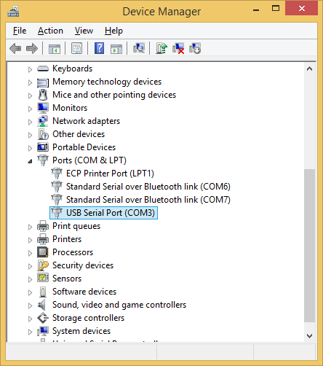
NOTE: If the "USB Serial Port" does not show up in "Device Drivers" then locate and execute the CDM_v2.12.00_WHQL_Certified.exe" program provided to you on the SD card. You must execute this program in "Run as Administrator" mode. The "CDM" program and installation instructions can also be found online at: "How to Install FTDI Drivers". Click and download the "FDTI Driver here" in step 2, then execute the program in "Run as Administrator" mode.
[ ] On Atmel Studio click "Tools->SelectProfile->Advanced", then click "Apply".

[ ] Click "Tools->External Tools" and perform the following steps to setup an "AVRDude" hot key:

NOTE: In both step 2 & 3 you must modified the AVRDude program directory location to match where you have installed COASolutions.

NOTE: In the step 3 below you must change "COM3" to match the COM port # you identified in a previous step. Be sure to include ALL of the parameters from the "-C" to the ":i".

- Set the "Title" field to: AVRDude
- Set the "Command" field to: d:\coa\Resources\COASolutions\AVRDude\avrdude.exe
- Set the "Arguments" field to: -C "d:\coa\Resources\COASolutions\AVRDude\avrdude.conf" -v -v -patmega328p -carduino -V -P\\.\COM3 -b115200 -D -Uflash:w:"$(TargetDir)$(TargetName).hex":i
- Leave the "Initial Directory" field blank
- Check the "Use Output Window" field
- Do not check the "Treat Output As Unicode" field
- Do not check the "Prompt For Arguments" field
- Click "Apply" then "OK"

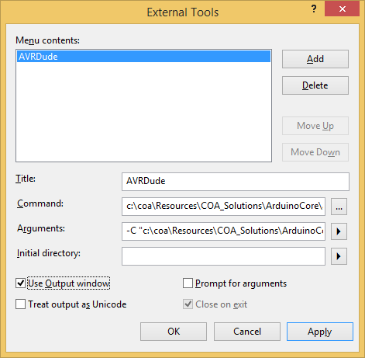

[ ] On Atmel Studio click "Tools->Options->Environment->Keyboard" and add the "AVRDude" hot key as follows:

- Set the "Show Commands Containing" field to "Tools.ExternalCommand1"
- Press the "Alt+P" key, which will set the "Press Shortcut Keys" field
- Press click "Assign" then "OK".

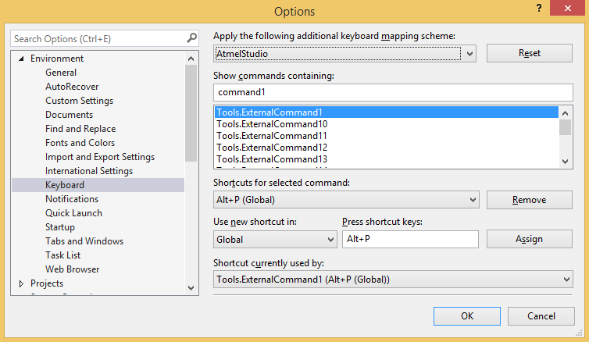

[ ] On Atmel Studio click "Tools->External Tools" and perform the following steps to setup an "CoolTerm" hot key:
- Set the "Title" field to: CoolTerm
- Click the "Command" browse button "...", then locate and select the "CoolTerm" executable program within the "\Resources\CoolTerm\*" folder.
- Click "Apply" then "OK"

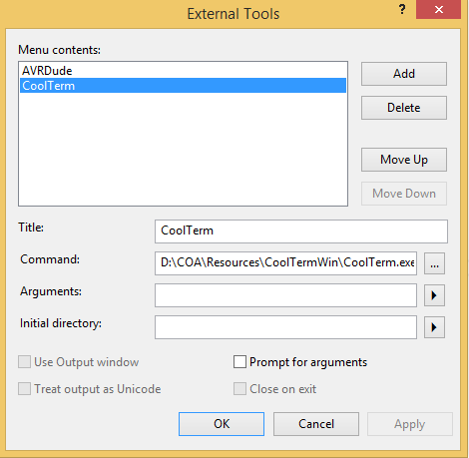

[ ] On Atmel Studio click "Tools->Options->Environment->Keyboard" and add the CoolTerm hot key as follows:

- Set the "Show Commands Containing" field to "Tools.ExternalCommand2"
- Press the "Alt+T" key, which will set the "Press Shortcut Keys" field
- Press click "Assign" then "OK".

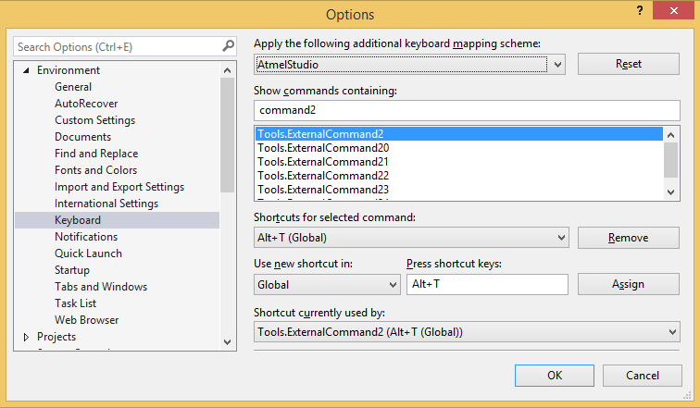

[ ] Atmel Studio click "Tools->Options->Text Editor->All Languages" to modify preferences as follows:

- Check the "LineNumbers" field under the "General" section to enable source file line numbering
- Change the "Tab Size", "Indent Size" and "Insert Spaces" fields under the "Tabs" section as desired
- Click "OK"

Creating Executable Projects
The SparkFun SIK Guide is a great resource for exploring and understanding how the various components contained within the kit can be assemble and programmed. This SIK Guide is based on use of the Arduino IDE software development environment. Each circuit described in the SparkFun SIK Guide requires creating, compiling and executing an Arduino IDE "Sketch". A Sketch is a text based file written in the "C" or "CPP" language, but instead of using a *.c or *.cpp filename extension, a Sketch uses a *.ino filename extension. Also, a "Sketch" source file does not contain main() program entry function. The main() function is buried within Arduino Core code, which you do not have access too from the Arduino IDE. The Arduino main() calls only two functions within your "Sketch". The first function the Arduino main() function calls is the Sketch setup() function, which is called only once. The setup() function must perform all the startup initialization required by your Sketch. Once setup() returns, the Arduino main() function repeatedly calls the Sketch loop() function to perform the periodic functions required by your Sketch. The SIK Guide Code is a great coding reference for the SIK Circuits and Sketches.
In COA we are going to do things a bit differently. Instead of using the Arduino IDE and creating Sketches, we will be using the Atmel Studio IDE (a professional development environment) and creating executable projects that contain the main() function within a *.cpp file. The Arduino Core software has been ported to Atmel Studio as a library project named "ArduinoCore", which you must add to your executable projects as you create them. You are provided an Atmel Studio solutions project named "COASolutions.atsln" that contains all the libraries projects you will need for the COA course (located in the "Resources.zip" file provided you).
When you create a new executable project within COASolutions, you must modify the projects main.cpp file to contain the base code as shown below. Be sure to add the required library directory paths to the projects GCC 'C' & "CPP" tool chain configuration, and also add the required libraries to the projects library tab within the "Solutions Explorer" window. Now that you understand the difference between an Arduino IDE Sketch and an Atmel Studio Executable, you should find it easy to port any Arduino Sketch *.ino source code into your executable main.cpp file.
The COASolutions solutions folder contains a number of library projects (ArduinoCore, NeoPixel, OneSheeld, SecureDigital and SoftwareSerial) created for use during this course. However, only ArduinoCore library has been added to COASolutions. You must add additional libraries to COASolutions when required in lab development.

NOTE: With Atmel Studio you can create "Solution", "Executable" and "Library" projects. Be sure to select the correct project type when creating a new project. In most cases, you will be creating an "Executable" project.

[ ] Open the COASolutions file with Atmel Studio by selecting the following:

"File->Open->Project/Solution->C:/COA/Resources/COASolutions/COASolutions.atsln"

[ ] To create a new "Executable" project within COASolutions, do the following:
- Right click on "Solution Explorer" then click on "Add->New Project->C/C++->GCC C++ Executable Project".
- Set the project "Name" field to the name of your new project, then click "OK".
- A "Device Selection" dialog box will open. Select "ATmega328P", then click "OK".
- Within "Solution Explorer", click to open project tree of you new project to expose the subdirectories.
- Right click on "Libraries" then click on "Add Libraries->Toolchain Libraries" and unclick (remove) "libm", then click on "Project Libraries" and add "ArduinoCore" and any other project libraries required by your project.
- Within "Solutions Explorer", right click on your new project and then click on "Properties".
- Set your "Configuration" to "All Configurations"
- Click on "AVR/GNU C Compiler->Symbols" and add the following to the "Defined symbols (-D)" section:
  - "F_CPU=16000000L"
  - "ARDUINO=165"
- Click on "AVR/GNU C Compiler->Directories" and add the "ArduinoCore" library directory to the "Include Paths (-I)". Be sure to add any other project Library directories for libraries you added in Step 5.
- Repeat steps the previous 8 and 9 steps for the "AVR/GNU C++ Compiler" section.
- Click on ""AVR/GNU Assembler->General" and add "ArduinoCore" library directory to the "Include Paths (-I)".
- Double click on the new main "*.cpp" source file created for your new project, to open it for editing. Delete the "#include <avr/io.h" header and add the "#include <Arduino.h>" header. Then add any other project library headers required for your project.

[ ] For "Executable" projects, modify the generated main.cpp project file as given below. Once modified, you should be able to right click on your project and click "Build", and it should compile successfully. Plug in your RedBoard and press "ALT-P", and it should download the code to your RedBoard. You can now begin adding your code.

MAIN.CPP file
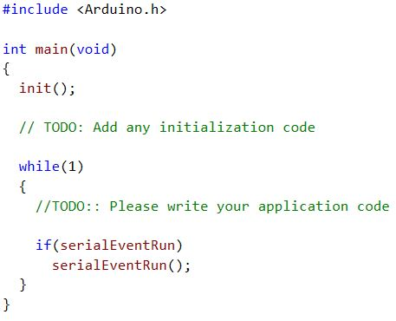

Creating Library Projects
The only difference between creating a "Library Project", as compared to an "Executable Project", is that within the Atmel Studio "Add New Project" dialog window, you will instead select "GCC C++ Static Library Project" to create a library project (see Step #1 above). Be sure to add the appropriate symbols and directories to the GCC tool chain that are required by the new library project you create.

