

Microsoft Azure Tenant
Health Check Report

Prepared for <CUSTOMER>

Author: [Author]
Date: Click or tap here to enter text.
Revision: 1.1
Engagement Reference: Click or tap here to enter text.


Contents
Preface 4
1 Executive Summary 5
1.1 Document Purpose 5
2 Azure Governance 6
2.1 Azure Regions 6
2.2 Management Groups 7
2.3 Subscriptions 8
2.4 Resource Groups 8
2.5 Naming Standards 10
2.6 Tagging Standards 12
2.7 Azure Policies 13
2.8 Cost Management 15
2.9 Azure Advisor 16
3 Identity and Access Management 18
3.1 Azure AD Tenant Overview 18
3.2 Azure AD Identity Synchronisation 18
3.3 Custom Domains 20
3.4 Role Based Access Control (RBAC) 21
3.5 Multi-Factor Authentication (MFA) 22
3.6 Conditional Access Policies 22
3.7 Azure AD Administrative Units 23
3.8 Azure AD Password Protection 24
3.9 Azure AD Secure Score 25
4 Networking 26
4.1 Overview 26
4.2 Virtual Networks 26
4.3 Load Balancers 26
4.4 Network Security Groups 27
4.5 Route Tables 28
4.6 Public IP Addresses 29
4.7 Recommendations 29
5 Compute 30
5.1 Virtual Machines 30
6 Storage 32
6.1 Managed Disks 32
6.2 Storage Accounts 34
7 Security 37
7.1 Azure Security Center 37
7.2 Azure Key Vault 38
7.3 Azure Update Management 39
7.4 Azure Remote Access 40
8 Monitoring and Logging 41
8.1 Azure Monitor 41
8.2 Log Analytics Workspaces 42
8.3 Platform Logs 43
9 Backup and Disaster Recovery 45
9.1 Backup 45
9.2 Disaster Recovery 46
10 Terms and Conditions 47
11 Appendix 48
11.1 Azure Resources List 48
11.2 Summary of Recommendations 48
11.3 Service Improvement Plan 48
12 Glossary of Terms 49

Preface
The information contained within this document will be treated with confidentiality and shall be only used by <COMPANY> for the purposes of this engagement.

Document Authors
Name | Role

Contact Details
Method | Details | Method | Details

Document Revision Details
Revision | Date | Author | Comments
0.1 | 01/11/2021 | Hani Jafri | First draft
1.0 | 12/11/2021 | Hani Jafri | Client-facing release
1.1 | 18/11/2021 | Hani Jafri | Added sections 11.2: Summary of Recommendations, 11.3: Service Improvement Plan

Distribution List
Name | Company

Disclaimer
Whilst every precaution has been taken in the preparation of this document, no responsibility is assumed for errors or omissions nor is any liability assumed for loss or damage resulting from the use of the information it contains, to the extent such error or omission is a result of any information, data or documents provided to <COMPANY> by the customer and relied on by <COMPANY> in the preparation of this document.

Executive Summary

<PARTNER> recently approached <COMPANY> to explore the opportunity to deliver a Managed Service for <CUSTOMER> on their behalf.

As part of the service onboarding stage, it is expected that a health check will be performed across the existing Azure server environment, seeing the delivery of a detailed environment familiarisation exercise, along with cost, license and health analysis, to gain a better understanding of the underlying Azure services and resources in use within the current tenant along with ancillary components – such as identity and networking.

Document Purpose

Following the completion of the health check assessment, the purpose of this document is to outline the current state of the Azure tenant and highlight areas of improvement, for the following discovery elements:

- Existing Azure tenant
  - Azure tenant, governance and subscriptions
  - Azure cost monitoring / snapshot
  - Azure Active Directory (incl. identity synchronisation)
  - Azure networking services – To include hybrid connectivity health
  - Azure compute services – To include circa 30 servers
  - Azure database and storage services
  - Azure platform integration services
  - Azure service security and management (inc. Azure advisor)
  - Review existing Azure focused governance controls and policies

Azure Governance

Azure governance is what defines the scaffolding for building everything else. Some key topics that should be covered here are naming and tagging convention, subscription model, policies, and compliance. Changing many of these things after resources have been deployed is time-consuming and introduces downtimes and risks – so it is very important to establish solid governance approach as early as possible. Another important consideration is flexibility – constant changes are intrinsic to a public cloud environment and it is vital to ensure that the governance approach will be able to accommodate and will speed up (rather than impede) expanding to the public cloud.

Azure Regions

Current State

Azure Regions in use
Central US
East US
North Europe
Southeast Asia
West Europe
UK South
UK West

Recommendations

Azure Region Selection Recommendations
Recommendation | Rationale
Data Sovereignty: Ensure the correct regions have been selected for residency and compliance needs. | For regulatory compliance considerations, data residency considerations may support or even mandate the physical locations where data can be stored, and how and when it can be transferred internationally. These regulations can differ significantly depending on jurisdiction.
Disaster Recovery: Identify primary and secondary regions for applications requiring regional resiliency. | If the primary region fails, a secondary region becomes crucial for business continuity.
Performance: Ensure resources are deployed in close proximity to target users. | There is global latency in how networks are distributed. Applications should be located close to target users for best performance.
Pricing: Factor cost into the decision-making process. | There is a price disparity between region with some regions offering lower costs per resource.
Service Availability: Ensure that the required Azure services are available in the selected regions. | Some Azure resources while under General Availability (GA) are not available in all regions.

Management Groups

Current State

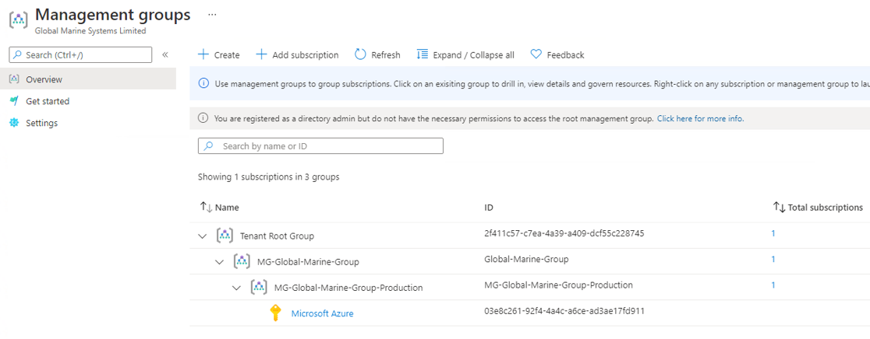

Recommendations

Management Group Recommendations
Recommendation | Rationale
Consider the creation of an additional Management Group for Non-production environments under the ‘MG-Global-Marine-Group’ Management Group. | Provides the flexibility to apply RBAC roles and Azure Policies at the Management Group level for Non-production and Production environments, to provide segregation of duties and separation of functional policies.
Enable ‘Require write permission for creating new management groups’ in Management Group settings. | Any user, by default, can create new management groups within a tenant. Admins of a tenant may wish to only provide these permissions to specific users to maintain consistency and conformity in the management group hierarchy. If enabled, a user requires the Microsoft.Management/managementGroups/write operation on the root management group to create new child management groups.

Subscriptions

Current State

A single Subscription has been created for Production and Development environments.

Subscriptions
Subscription Name | Subscription ID | Subscription Plan | Directory
Microsoft Azure | 03e8c261-92f4-4a4c-a6ce-ad3ae17fd911 | Azure Plan | Global Marine Systems Limited (globalmarinesystems.onmicrosoft.com)

Recommendations

Subscription Recommendations
Recommendation | Rationale
Consider the creation of an additional Subscription for non-production workloads. | Provides the flexibility to apply RBAC roles and Azure Policies at the Management Group level for Non-production and Production environments, to provide segregation of duties and separation of functional policies.

Resource Groups

Current State

Resource Groups
Resource Group Name | Subscription | Location
AzureBackupRG_southeastasia_1 | Microsoft Azure | Southeast Asia
AzureBackupRG_uksouth_1 | Microsoft Azure | UK South
cloud-shell-storage-northeurope | Microsoft Azure | North Europe
cloud-shell-storage-westeurope | Microsoft Azure | West Europe
Core-BootDiagStorageAccounts | Microsoft Azure | UK West
Core-DirectoryServices | Microsoft Azure | UK West
Core-DirectoryServices-ASR | Microsoft Azure | UK West
Core-Management | Microsoft Azure | UK West
Core-Networking | Microsoft Azure | UK West
core-networking-asr | Microsoft Azure | UK West
Dashboards | Microsoft Azure | UK South
DefaultResourceGroup-SEA | Microsoft Azure | Southeast Asia
DefaultResourceGroup-SUK | Microsoft Azure | UK South
FS03-DMZ | Microsoft Azure | UK South
gbazfsstorage | Microsoft Azure | UK South
GM-Azure-Storage | Microsoft Azure | UK South
HMNRecoveryService | Microsoft Azure | UK South
LogAnalyticsRG | Microsoft Azure | UK South
Meraki-UKS | Microsoft Azure | UK South
Meraki-UKSemtu7tifmoczk | Microsoft Azure | UK South
NetworkWatcherRG | Microsoft Azure | UK West
O365_Resources | Microsoft Azure | UK South
RG-Core-Monitoring | Microsoft Azure | North Europe
RG-EUS-PROD-LogAnalytics | Microsoft Azure | East US
RG-EUS-Production | Microsoft Azure | East US
RG-SEA-AKV | Microsoft Azure | Southeast Asia
RG-SEA-Azure-Migrate | Microsoft Azure | Southeast Asia
RG-SEA-PROD-LogAnalytics | Microsoft Azure | Southeast Asia
RG-SEA-PROD-MERAKI | Microsoft Azure | Southeast Asia
RG-SEA-PROD-MERAKI-MANAGED | Microsoft Azure | Southeast Asia
RG-SEA-PROD-SINGAPORE | Microsoft Azure | Southeast Asia
RG-SEA-PROD-TAIWAN | Microsoft Azure | Southeast Asia
RG-SEA-TEST | Microsoft Azure | Southeast Asia
RG-UKS-ASR | Microsoft Azure | UK South
RG-UKS-AZURE-DIGITAL-TWINS | Microsoft Azure | UK South
RG-UKS-Azure-Migrate | Microsoft Azure | UK South
RG-UKS-AZURE-MIGRATE-SQL | Microsoft Azure | UK South
RG-UKS-AZURE-SQL-MI | Microsoft Azure | UK South
RG-UKS-CHECKPOINT-CLOUDGUARD | Microsoft Azure | UK South
RG-UKS-DEV-Azure-Backups | Microsoft Azure | UK South
RG-UKS-DEV-O365 | Microsoft Azure | UK South
RG-UKS-DEV-SSH | Microsoft Azure | UK South
RG-UKS-DEV-TEST | Microsoft Azure | UK South
RG-UKS-DEV-WVD-FULL | Microsoft Azure | UK South
RG-UKS-IFS-P6 | Microsoft Azure | UK South
RG-UKS-PROD-ABERDEEN-STORAGE | Microsoft Azure | UK South
RG-UKS-PROD-AKV | Microsoft Azure | UK South
RG-UKS-PROD-FILE-SYNC | Microsoft Azure | UK South
RG-UKS-PROD-LogAnalytics | Microsoft Azure | UK South
RG-UKS-PROD-ROVCO-CWIND | Microsoft Azure | UK South
RG-UKS-PROD-WVD-IT | Microsoft Azure | UK South
RG-UKS-PURVIEW | Microsoft Azure | UK South
RG-UKS-SECURITY-CENTRE | Microsoft Azure | UK South
RG-UKS-STATIC-WEB-APP | Microsoft Azure | UK South
RG-UKS-WATCHGUARD-DEV | Microsoft Azure | UK South
RG-UKS-WATCHGUARD-FIREBOX-CLOUD | Microsoft Azure | UK South
RG-UKS-WATCHGUARD-FIREBOX-CLOUD-STORAGE | Microsoft Azure | UK South
RG-UKS-WEBAPP | Microsoft Azure | UK South
RG-UKS-WEBAPP-SCOTNIPAC | Microsoft Azure | UK South
RG-UKS-WVD-IT | Microsoft Azure | UK South
RG-UKS-WVD-OceanIQ | Microsoft Azure | UK South
RG-UKW-AKV | Microsoft Azure | UK West
RG-UKW-ASR | Microsoft Azure | UK West
Services-Exchange | Microsoft Azure | UK South

Recommendations

Resource Group Recommendations
Recommendation | Rationale
Use resource groups to logically group resources together which share the same lifecycle. | Resources are deployed, updated, and deleted together. If one resource, such as a server, needs to exist on a different deployment cycle it should be in another resource group.
Review and delete empty resource groups:  - FS03-DMZ  - gbazfsstorage  - HMNRecoveryService  - RG-SEA-PROD-TAIWAN  - RG-SEA-TEST  - RG-UKS-ASR  - RG-UKS-DEV-Azure-Backups  - RG-UKS-DEV-WVD-FULL  - RG-UKS-PURVIEW  - RG-UKS-STATIC-WEB-APP  - RG-UKW-ASR | Prevents cloud sprawl and improves management of resources
Ensure resource locks are set for resource groups containing mission critical Azure resources. | Prevents against accidental deletion of resources.

Naming Standards

Current State

Current Naming Standards
Naming Convention Prefixes
Resource Type | Value |  | Notes
Virtual Machine | AZ<REGION><ENVIRONMENT><SERVICE><NODE> |  | Used to identify Azure virtual machines
Resource Groups | RG-<REGION>-<ENVIRONMENT>-<SERVICE> |  | Used to identify Azure Resource Groups
Other resources | LB-<REGION>-<ENVIRONMENT>-<SERVICE> |  | Used to identify all other resource types e.g. LB for Load Balancer
GMG Azure Regions
Region | Value |  | Notes
UK South | <PREFIX>UKS |  | Used to identify resources in UK South
UK West | <PREFIX>UKW |  | Used to identify resources in UK West
East US | <PREFIX>EUS |  | Used to identify resources in East US
South-East Asia | <PREFIX>SEA |  | Used to identify resources in South-East Asia
Azure Environments
Environment Name | Value | Notes
Production | <PREFIX><REGION>PROD | Used to identify resources in Production
Development | <PREFIX>DEV | Used to identify resources in Development
Service
Service Name | Value | Notes
E.g. Exchange | <ENVIRONMENT>EXC | Used to identify service or application name
E.g. Meraki | <ENVIRONMENT>MER | Used to identify service or application name
Note: Service or application names longer than three letters can be truncated to the first three characters or any recognisable abbreviation e.g. Exchange can be truncated to EXC.
Resource Digits
Resource ID Digit | Value | Notes
E.g. 01,02,03 | <SERVICE>01 | Used to identify a double-digit resource ID

Examples:

- RG-UKS-PROD-FTP – a production resource group in UK South for hosting FTP services
- AZUKSPRODEXC01 – a production exchange server in UK South region
- AZSEADEVDUO01 – a development Duo application server in South-East Asia region
- AZUKWPRODDOC01 – a production domain controller in UK West region
- LB-UKS-PROD-NLB1- a production load-balancer in UK South region
- FW-SEA-PROD-FW1 – a production firewall in South-East Asia region

Recommendations

Naming Standards Recommendations
Recommendation | Rationale
Ensure all resources are named in adherence to naming standards | Consistent naming of resources is crucial to identifying resources not only in the Azure portal and in bills, but also in scripts that support Azure DevOps automation/orchestration for release management.
Use recommended abbreviations for Azure resource types as prefixes in resource names: https://docs.microsoft.com/en-us/azure/cloud-adoption-framework/ready/azure-best-practices/resource-abbreviations | Using the recommended abbreviations for Azure resource types in resource names that represents the type of the Azure resource makes it easier to visually recognize application or service components.
Consider enforcing or auditing naming standards using custom Azure policies | Consistent naming of resources is crucial to identifying resources not only in the Azure portal and in bills, but also in scripts that support Azure DevOps automation/orchestration for release management.
Document naming rules and restrictions as part of the naming standards | Resource names can vary in length limits, valid characters and letter case types. Balancing the context embedded in a name with its scope and rules is important when develop naming standards.

Tagging Standards

Current State

The following tags are required as a minimum when creating a resource group in the GMG cloud:

Tagging Standards Current State
Tag | Value
Owner | <Owner’s Full Name>
Department | <Department Name e.g. IT>
Service | <Service or Application Name>
Environment | <Production or Dev>
Budget | <Budget Code>
Created | <Date Created e.g. 20/08/20)>
Expires | <Expiry Date if known>

Tags are applied using the following policy initiatives:

Tagging Policies
Policy Initiative Name | Policy Initiative Effect | Policy Scope
Append a tag and its value from the resource group | Append | Subscription: Microsoft Azure
Require tags on resource groups | Deny | Subscription: Microsoft Azure

Recommendations

Tagging Standards Recommendations
Recommendation | Rationale
Consider creating an allowed set of tag values for Department, Service, Environment and Budget tags by using the policy ‘Require a tag and its value on resources’ | Using an allowed set of tag values will ensure valid tag values are applied to all resources. For example, the VM AZSEAINDOC02 has the tag Service with value IaaS/PaaS. Using an allowed set of tag values for the Service tag based on a list of defined services will allow for easier identification of the resource, for example, tag value Active Directory Domain Services.

Azure Policies

Current State

Assigned Policies
Assignment Name | Policy Type | Policy Scope
A security contact email address should be provided for your subscription | Policy | Management Group: MG-Global-Marine-Group
ASC DataProtection | Initiative | Subscription: Microsoft Azure
ASC Default | Initiative | Subscription: Microsoft Azure
Allowed virtual machine SKUs | Initiative | Subscription: Microsoft Azure
Append a tag and its value from the resource group | Initiative | Subscription: Microsoft Azure
Azure Defender for servers should be enabled | Policy | Subscription: Microsoft Azure
CIS Microsoft Azure Foundations Benchmark 1.1.0 | Initiative | Subscription: Microsoft Azure
Configure Azure Defender to be enabled on SQL servers | Policy | Subscription: Microsoft Azure
Deploy Advanced Threat Protection on Storage Accounts | Initiative | Subscription: Microsoft Azure
Deploy Advanced Threat Protection on Storage Accounts | Policy | Management Group: MG-Global-Marine-Group
Enforce Hybrid Use Benefit on Windows Servers | Initiative | Subscription: Microsoft Azure
Require tags on resource groups | Initiative | Subscription: Microsoft Azure

The following policy exemptions have been created:

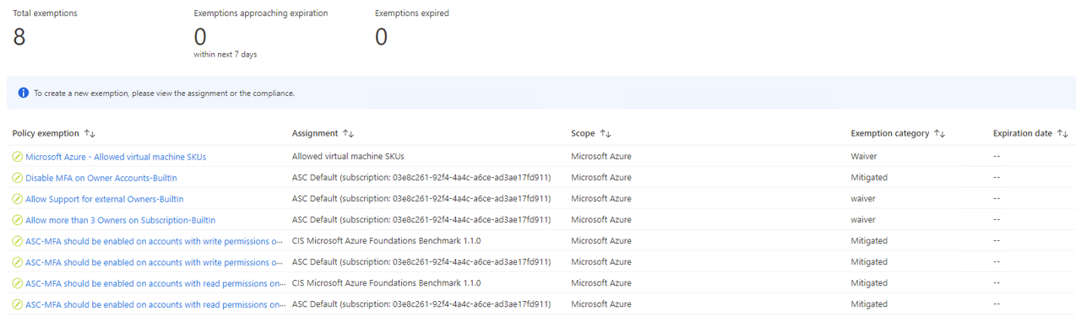

The overall resource compliance is currently 71% as per below:

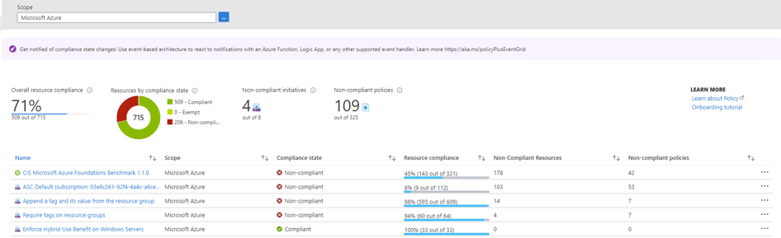

Recommendations

Azure Policies Recommendations
Recommendation | Rationale
Create the following policies:  - Allowed locations  - Allowed locations for resource groups  - Audit resource location matches resource group location  - Audit VMs that do not use managed disks  - Automation account variables should be encrypted  - Configure Azure Defender for DNS to be enabled  - Configure Azure Defender for Key Vaults to be enabled  - Configure Azure Defender for Resource Manager to be enabled  - Configure Azure Defender for Storage to be enabled  - Configure Azure Defender for servers to be enabled  - Custom subscription owner roles should not exist  - Enable Azure Monitor for VMs  - RDP access from the Internet should be blocked  - SSH access from the Internet should be blocked | The listed policies are an example of common recommended policies to enforce governance for resource consistency, regulatory compliance, security, cost, and management across the Azure environment.
Review non-compliant policies and execute remediation tasks to put resources in to a compliant state. | Non-compliant resources will not adhere to organizational governance standard.
Review policy exemption for Allowed Virtual Machine SKUs, update corresponding policy assignment and remove exemption | The policy assignment should be updated to reflect any additional Virtual Machine SKUs required to avoid having to create an exemption
Use policy exemptions sparingly and add ensure each exemption has sufficient justification | Creating too many policy exemptions without justification can result in non-compliance of Azure resources

Cost Management

Current State

Cost Management Features
Feature Name | Status
Azure Hybrid Use Benefit on SQL Servers | Not enabled
Azure Hybrid Use Benefit on Windows Servers | Enabled via Azure Policy
Azure VM Reserved Instances | Not enabled
Subscription Budgets and Alerts | Enabled
Tags for cost reporting | Enabled – refer to tagging section

Subscription budgets and alerts have been created and scoped at the resource group level as follows:

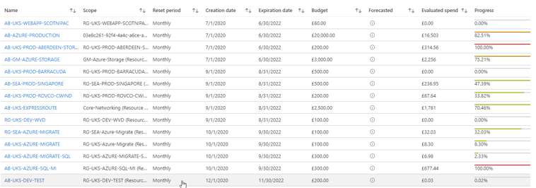

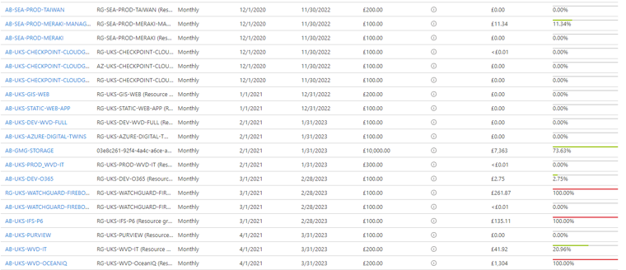

Recommendations

Cost Management Recommendations
Recommendation | Rationale
Consider the use of 1 year/3 year VM Reserved Instances for predictable, long-running workloads | Reduces cost by up to 72% in comparison to pay-as-you-go prices
Consider modernising application workloads to make use of PaaS services as a replacement of IaaS services | PaaS Services are cost-efficient and offer built-in reliability, scalability and security. For example, the replacement of SQL Server on VM with Azure SQL database.
Implement Azure Hybrid Use Benefit on SQL Servers using Azure Policy (dependent on eligibility with Software Assurance) | Reduces costs of SQL Server licenses.
Implement shutdown schedules for development workloads using Azure Automation runbooks | Reduces overall compute costs.
Review and delete resources no longer in use | Reduces overall cloud spend; improves management and visibility of resources.
Right-size underused resources based on Azure Advisor recommendations | Reduces overall compute costs.

Azure Advisor

Current State

The following attachment contains a full list of Azure Advisor recommendations exported as a CSV file:

The following attachment contains a full list of Azure Advisor recommendations exported as a PDF file:

Recommendations

Azure Advisor Recommendations
Recommendation | Rationale
Review Advisor recommendations with priority to high business impact recommendations | Improve the cost effectiveness, performance, Reliability and security of Azure resources.
Create Advisor alerts for high impact for cost, performance, reliability and operational excellence categories | Alerts will provide notifications for Advisor recommendations to allow issues to be identified and addressed proactively.

Identity and Access Management

Many consider identity to be the primary perimeter for security. This is a shift from the traditional focus on network security. Network perimeters keep getting more porous, and that perimeter defence cannot be as effective as it was before the explosion of BYOD devices and cloud applications. Azure Active Directory is the Azure solution for identity and access management. Azure AD is a multitenant, cloud-based directory and identity management service from Microsoft. It combines core directory services, application access management, and identity protection into a single solution.

A well-defined modern Identity strategy should allow organisations to protect their applications and data at the front gate with Azure identity and access management solutions, to defend against malicious login attempts and to safeguard credentials with risk-based access controls, identity protection tools, and strong authentication options – without disrupting productivity.

Azure AD Tenant Overview

A single Azure AD tenant has been created for the organisation.

Azure AD Tenants
Tenant Name | Tenant ID | Primary Domain | License
Global Marine Systems Limited | 2f411c57-c7ea-4a39-a409-dcf55c228745 | globalmarinesystems.onmicrosoft.com | Azure AD Premium P2

Azure AD Identity Synchronisation

Current State

A single Azure AD Connect server has been deployed to synchronise identities from Active Directory to Azure Active Directory.

Azure AD Connect Servers
Server FQDN | Resource Group | Location | VM SKU | AAD Connect Version
GMSAZ019106.uk.gms.com | core-directoryservices | UK South | Standard_D2_v3 | 1.4.18.0

Azure AD Connect Health Settings
Setting | State
Use auto update to automatically update your installed Azure Active Directory Connect Health Agent with the latest version | On
Allow Microsoft access to your tenant’s health data for troubleshooting purposes. This is typically done when you have an ongoing support call or if you are part of the preview program for this service. | Off
Use the notification to get notified when there are new alerts | On:  - Notify all global administrators  - No additional email recipients specified

Pass-through Authentication (PTA) has been configured to allow users to sign in to both on-premises and cloud-based applications using the same passwords.

Azure AD Connect PTA Agents
Server FQDN | Resource Group | Location | VM SKU
GMSAZ019106.uk.gms.com | core-directoryservices | UK South | Standard_D2_v3
GMSAZ019105.uk.gms.com | core-directoryservices | UK South | Standard_D2_v3

The state of AAD Connect is Healthy with zero active alerts:

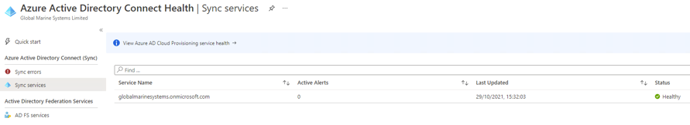

There are currently twelve sync errors due to duplicate attributes. The following attachment contains a list of all sync errors:

Recommendations

Azure AD Identity Synchronisation Recommendations
Recommendation | Rationale
Deploy additional PTA agents in UK West | Provides regional resiliency for hybrid authentication in the event of an issue in UK South
Deploy an additional AAD Connect server in UK West in staging mode | Enables high availability for AAD Connect and allows new configuration changes to be tested in a staged approach
Review and resolve sync errors | Resolution of sync errors ensures that the synchronisation of identities between Active Directory and Azure Active Directory is up to date with no conflicting identities
Upgrade to the latest version of Azure AD Connect v2.0 | On 31 August 2022, all 1.x versions of Azure Active Directory (Azure AD) Connect will be retired because they include SQL Server 2012 components that will no longer be supported.

Custom Domains

Current State

Custom Domains
Domain Name | Status
cwind.global | Verified
cwindtw.global | Verified
globalmarine.asia | Verified
globalmarine.co.uk | Verified
globalmarine.group | Verified
globalmarinesystems.com | Verified
globalmarinesystems.onmicrosoft.com | Available
globalmarinetest.co.uk | Verified
globaloffshore.co.uk | Verified
innovator.globalmarine.co.uk | Verified
normandclipper.globaloffshore.co.uk | Verified
oceaniq.co.uk | Verified
recorder.globalmarine.co.uk | Verified
recruitment.globalmarine.group | Verified
retriever.globalmarine.co.uk | Verified
sentinel.globalmarine.co.uk | Verified
sovereign.globalmarine.co.uk | Verified
symphony.globaloffshore.co.uk | Verified
wavemailuk.com | Verified
xvntn4j624p4.AEUWA03.msteams.8x8.com | Verified
Xvntn4j624p4.AUSEA02.msteams.8x8.com | Verified

Recommendations

Custom Domain Recommendations
No recommendations, all domains have been successfully verified.

Role Based Access Control (RBAC)

Current State

The following attachment contains a list of Azure AD Global Administrators:

The following attachment contains a list of Azure Subscription role assignments:

Recommendations

RBAC Recommendations
Recommendation | Rationale
Adopt least privileged access or Just Enough Access principles. Segregate duties and grant only the amount of access to users that they need to perform their jobs | - PIM best practices  - Instead of giving everybody unrestricted permissions in the Azure subscription or resources, allow only certain actions at a particular scope
The most appropriate Azure built-in RBAC role will be used as a first principle | - Management simplicity  - Microsoft do frequently revise and add/modify the existing list of built-in roles
Avoid resource-specific RBAC permissions, use management groups for enterprise-wide access control and resource groups for access control within subscriptions | - Complex and difficult to manage
Avoid user-specific RBAC, assign RBAC roles to groups in Azure AD. Use Azure-AD-only groups for Azure control-plane resources when granting access to resources. Add on-premises groups to the Azure-AD-only groups if needed | - Direct user assignments circumvent centralized management, greatly increasing the management required to prevent unauthorized access to restricted data
Create two emergency access accounts. These accounts should be cloud-only accounts that use the *.onmicrosoft.com domain and that are not federated or synchronized from an on-premises environment | - Mitigate the impact of accidental lack of administrative access  - AAD federation is unavailable  - Azure AD MFA service is unavailable  - Mobile phone or other networks might be unavailable
Exclude at least one emergency account from phone-based multi-factor authentication, Conditional Access policies & Azure AD PIM | Emergency access in the event Azure AD MFA, Conditional Access, Azure AD PIM services are unavailable
Restrict emergency account use to only the times when it is necessary | Emergency access accounts are highly privileged, and they are not assigned to specific individuals
Validate emergency accounts regularly | Validation should be performed at regular intervals and for key changes
Leverage the benefits of PIM and integrate it as part of an effective Security and Identity baseline to be used in the Azure RBAC resource access workflow | Provide time-based and approval-based role activation to mitigate the risks of excessive, unnecessary, or misused access permissions on resources

Multi-Factor Authentication (MFA)

Current State

Multi-Factor Authentication (MFA)
Duo is a third-party service which is used to provide MFA

Recommendations

Multi-Factor Authentication (MFA)
Azure AD is currently licensed with P2 licenses which includes Azure MFA. Evaluate the features and capabilities between Duo MFA and Azure MFA to determine the most appropriate solution to fulfil business requirements.

Conditional Access Policies

Current State

The following conditional access policies have been created:

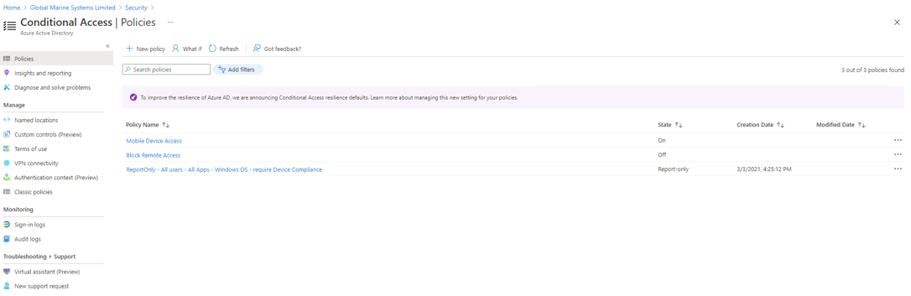

Note: The Mobile Device Access policy is the only policy that is On, however, this appears to be for a proof of concept targeting a specific Azure AD group named Intune POC.

Recommendations

Conditional Access Policies Recommendations
Recommendation | Rationale
Integrate Duo with Conditional Access Policies to add MFA to Azure AD logons.  https://duo.com/docs/azure-ca | Conditional Access Policies will allow for easier management of Duo MFA enablement to secure Azure AD applications.
Implement additional Conditional Access Policies to secure Azure AD applications. Common examples include:  - Requiring MFA for users with administrative roles  - Requiring MFA for Azure management tasks  - Blocking sign-ins for users attempting to use legacy authentication protocols  - Blocking or granting access from specific locations  - Blocking risky sign-in behaviours  - Requiring organization-managed devices for specific applications | Improves identity security posture in adherence to zero-trust security and enforces organisational policies.
Use report-only mode to evaluate the impact of Conditional Access policies before enabling them in their environment. | Allows administrators to evaluate the impact of Conditional Access policies before enabling them in their environment

Azure AD Administrative Units

Current State

Azure AD Administrative Units
Administrative Units are not in use

Recommendations

Azure AD Administrative Units Recommendations
Recommendation | Rationale
Consider implementing Administrative Units to restrict administrative scope | An administrative unit is an Azure AD resource that can be a container for other Azure AD resources. An administrative unit can contain only users and groups.  Administrative units restrict permissions in a role to any portion of your organization that you define. For example, administrative units could be used to delegate the Helpdesk Administrator role to regional support specialists, so they can manage users only in the region that they support.

Azure AD Password Protection

Current State

Azure AD Password Protection
Azure AD Password Protection has been enabled in Audit mode

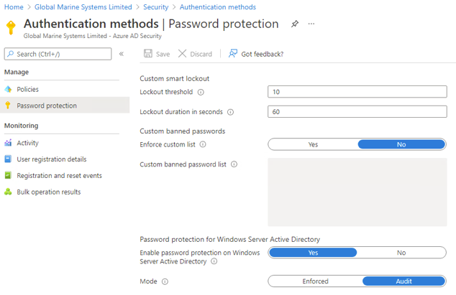

Recommendations

Azure AD Password Protection Recommendations
Recommendation | Rationale
Carry out testing in Audit mode by attempting to reset a test user account password with a simple password. Launch Event Viewer on the server hosting the DC agent and navigate to Applications and Services Logs -> Microsoft -> AzureADPasswordProtection -> DCAgent -> Admin and check events are being logged in relation to the failed password reset (event ID 10016, 30004, 10017, 30005). | Testing in Audit Mode will validate the setup of DC agents and connectivity to Azure AD.
Once testing has been successfully completed, change the mode from Audit to Enforced. | Enforcing password protection will provide active protection against common passwords.

Azure AD Secure Score

Current State

The current Secure Score for Identity is 26.73%.

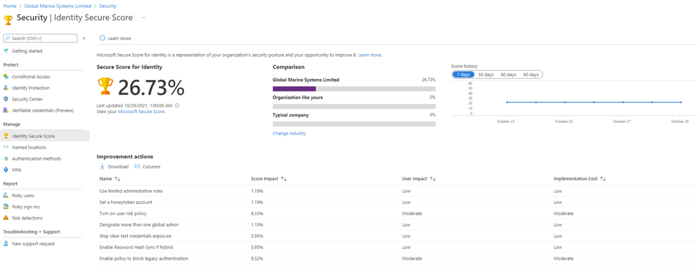

The following attachment contains a list of improvement actions:

Recommendations

Azure AD Secure Score Recommendations
Recommendation | Rationale
Review Azure AD Secure Score improvement actions with priority to high score impact actions | Improves identity security posture

Networking

Overview

Network Overview
WatchGuard Firewall is used to provide ingress and egress to all Azure servers and services.
A Cisco Meraki device (AZUKS01-FW1) is deployed in Azure as a VPN concentrator to provide seamless integration with on-premise traffic and site-to-site VPNs.
Azure public load balancers are deployed to distribute traffic between healthy virtual machine instances and also provide high-availability and resilience to specific services such as Exchange Online, DUO MFA and Backup services.

Network Security Groups have been created and associated to each subnet to secure traffic between subnets within the same virtual network.
Route tables have been created and associated to each subnet with a default route to WatchGuard Firewall.

Virtual Networks

Virtual Networks
Name | Resource Group | Address Space | Location
Core-AZ01-UKS | core-networking | 10.15.0.0/16 | UK South
Core-AZ01-UKS-asr | core-networking-asr | 10.15.0.0/16 | UK West
Core-AZ02-UKW | core-networking | 10.16.0.0/16 | UK West
Core-AZ03-SEA | rg-sea-prod-singapore | 10.17.0.0/16 | Southeast Asia
RG-UKS-WVD-OceanIQ-vnet | rg-uks-wvd-oceaniq | 10.0.0.0/16 | UK South
TestVnet | core-networking | 10.1.0.0/28 | UK West
WatchguardDevVnet | rg-uks-watchguard-dev | 10.20.20.0/24 | UK South
WatchguardVnet | rg-uks-watchguard-firebox-cloud | 10.10.10.0/24 | UK South

Load Balancers

Load Balancers
Name | Resource Group | Location | Load Balancer Type
gms-az01-ex-lb | services-exchange | UK South | Public
GMS-Backup-SS1-Mirror-SEA | rg-sea-prod-singapore | Southeast Asia | Public
GMS-Backup-SS1-UKS | core-networking | UK South | Public
GMS-Backup-SS3-Mirror-UKS | core-networking | UK South | Public
GMS-Backup-SS3-UKW | core-networking | UK West | Public
GMS-UKS-DUO-LB | core-networking | UK South | Public
LB-UKS-IFS-P6-EXT | rg-uks-ifs-p6 | UK South | Public

Network Security Groups

Network Security Groups
Name | Resource Group | Location | Associations
AZ01-AD-Servers | core-networking | UK South | 2 subnets, 4 network interfaces
AZ01-Checkpoint-Test | core-networking | UK South | 0 subnets, 0 network interfaces
AZ01-DMZ | core-networking | UK South | 2 subnets, 0 network interfaces
AZ01-Email-Servers | core-networking | UK South | 1 subnets, 0 network interfaces
az01-exchange | services-exchange | UK South | 1 subnets, 0 network interfaces
AZ01-Mgmt-Servers | core-networking | UK South | 1 subnets, 0 network interfaces
AZ01-UKS-DMS | core-networking | UK South | 1 subnets, 0 network interfaces
AZ01-UKS-WVD | core-networking | UK South | 0 subnets, 0 network interfaces
AZ02-AD-Servers | core-networking | UK West | 1 subnets, 0 network interfaces
AZ02-DMZ | core-networking | UK West | 1 subnets, 0 network interfaces
AZ02-Email-Servers | core-networking | UK West | 1 subnets, 0 network interfaces
AZ02-File-Servers | core-networking | UK West | 0 subnets, 0 network interfaces
AZ02-Mgmt-Servers | core-networking | UK West | 1 subnets, 0 network interfaces
AZ03-AD-Servers | rg-sea-prod-singapore | Southeast Asia | 1 subnets, 0 network interfaces
AZ03-AD-Servers-Test | rg-sea-prod-singapore | Southeast Asia | 0 subnets, 0 network interfaces
AZ03-DMZ | rg-sea-prod-singapore | Southeast Asia | 1 subnets, 0 network interfaces
AZ03-Mgmt-Servers | rg-sea-prod-singapore | Southeast Asia | 1 subnets, 0 network interfaces
AZUKSSQLMGMT01-NSG | core-networking | UK West | 0 subnets, 0 network interfaces
basicNsgWatchGuardVMEth1-NSG | rg-uks-watchguard-firebox-cloud | UK South | 0 subnets, 0 network interfaces
gms-az-mgmt01-nsg | core-management | UK South | 0 subnets, 0 network interfaces
JumpHost-nsg | core-networking | UK West | 0 subnets, 0 network interfaces
JumpHostfromWatchguardVnet-nsg | rg-uks-watchguard-firebox-cloud | UK South | 0 subnets, 0 network interfaces
JumpHostVM-nsg | core-networking | UK West | 0 subnets, 0 network interfaces
nsg-azuksgbsql2 | core-networking | UK South | 1 subnets, 0 network interfaces
NSG-WatchGuardDevEth0None | rg-uks-watchguard-dev | UK South | 0 subnets, 0 network interfaces
NSG-WatchGuardVMEth0Allow | rg-uks-watchguard-firebox-cloud | UK South | 0 subnets, 1 network interfaces
TestVMfromWatchguardVnet-nsg | rg-uks-watchguard-firebox-cloud | UK South | 0 subnets, 0 network interfaces
UKS-Image-OceanIQ-nsg | rg-uks-wvd-oceaniq | UK South | 0 subnets, 1 network interfaces
AZ01-AD-Servers | core-networking | UK South | 2 subnets, 4 network interfaces

Route Tables

Route Tables
Name | Resource Group | Location | Associations
Meraki-SEA-RT01 | rg-sea-prod-singapore | Southeast Asia | 3 subnet associations
Meraki-SEA-RT01-Test | rg-sea-prod-singapore | Southeast Asia | 0 subnet associations
Meraki-UKS-RT01 | meraki-uks | UK South | 7 subnet associations
Meraki-UKW-RT01 | meraki-uks | UK West | 2 subnet associations
rt-azuksgbsql2 | core-networking | UK South | 1 subnet associations
UDRTOWATCHGAURDVM | core-networking | UK West | 1 subnet associations
WatchGuardDev-External-routes | rg-uks-watchguard-dev | UK South | 1 subnet associations
WatchGuardDev-Trusted-routes | rg-uks-watchguard-dev | UK South | 1 subnet associations
WatchGuardVM-External-routes | rg-uks-watchguard-firebox-cloud | UK South | 1 subnet associations
WatchGuardVM-Trusted-routes | rg-uks-watchguard-firebox-cloud | UK South | 1 subnet associations

Public IP Addresses

Public IP Addresses
Name | Resource Group | IP Address | Location
AZ01-ERG | core-networking | 51.104.199.62 | UK South
AZUKSIFSGW01-ip | rg-uks-ifs-p6 | 20.77.107.235 | UK South
cj5aue3mqjasmIP | rg-sea-prod-meraki-managed | 40.119.204.99 | Southeast Asia
GatewayIP-z6wt6w2mrnids | core-networking | - | UK South
GBAZ-DUO-2-ip | core-networking | 40.81.145.85 | UK South
GBAZ-MGMT-01-ip | core-networking | 51.105.59.44 | UK South
GBAZ-WEB-01-ip | core-networking | 51.141.239.193 | UK South
GBAZDUO2ip902 | core-networking | 40.81.147.12 | UK South
gms-az01-ex-lb-ip | services-exchange | 51.145.124.177 | UK South
GMS-Backup-SS1-Mirror-SEA | rg-sea-prod-singapore | - | Southeast Asia

Recommendations

Network Recommendations
Azure Firewall is a cloud-native Azure service offering built-in high availability, scalability and IDS/IPS. Evaluate the features and capabilities of Azure Firewall in comparison with WatchGuard to determine the most appropriate solution to fulfil the requirements.
Azure VPN Gateway is a cloud-native Azure service offering built-in high availability, scalability and resiliency. Evaluate the features and capabilities of Azure VPN Gateway in comparison with Cisco Meraki to determine the most appropriate solution to fulfil the requirements.
Consider implementing DDoS Protection Standard to mitigate against DDoS threats for public facing workloads.
Consider implementing Azure Front Door or Application Gateway with Web Application Firewall to protect web applications from common security threats.
Prevent direct assignment of public IP address to virtual machines, with the exception of Network Virtual Appliances (NVAs).
Prevent IP forwarding on virtual machine network interfaces, with the exception of Network Virtual Appliances (NVAs).
Review and delete unassociated Network Security Groups
Review and delete unassociated Public IP Addresses
Review and delete unassociated Route Tables
Use Private Endpoints where possible to secure access to PaaS resources

Compute

Virtual Machines

Current State

Virtual Machines
Name | Resource Group | Location | Status | Operating System | Size | Public IP
AVD-IMAGE-OIQ | rg-uks-wvd-oceaniq | UK South | Stopped (deallocated) | Windows | Standard_D2s_v3 | -
AZ-UKS-Migrate | rg-uks-azure-migrate | UK South | Stopped (deallocated) | Windows | Standard_D8s_v3 | -
AZSEASINDOC01 | rg-sea-prod-singapore | Southeast Asia | Running | Windows | Standard_D2s_v3 | -
AZSEASINDOC02 | rg-sea-prod-singapore | Southeast Asia | Running | Windows | Standard_D2s_v3 | -
AZSEASINFS01 | rg-sea-prod-singapore | Southeast Asia | Running | Windows | Standard_DS3_v2 | -
AZSEASINFW01 | rg-sea-prod-meraki-managed | Southeast Asia | Running | Linux | Standard_F4s_v2 | 40.119.204.99
AZUKS01-FW1 | meraki-uksemtu7tifmoczk | UK South | Running | Linux | Standard_D2_v2 | 51.140.95.220
AZUKSDOC01 | core-directoryservices | UK South | Running | Windows | Standard_D2s_v3 | -
AZUKSDOC02 | core-directoryservices | UK South | Running | Windows | Standard_D2s_v3 | -
AZUKSDUO01 | core-networking | UK South | Running | Windows | Standard_DS1_v2 | -
AZUKSIFSGW01 | rg-uks-ifs-p6 | UK South | Running | Windows | Standard_D4s_v3 | 20.77.107.235
AZUKSNPS01 | core-networking | UK South | Running | Windows | Standard_DS1_v2 | -
AZUKSRDPOIQ1 | rg-uks-wvd-oceaniq | UK South | Stopped (deallocated) | Windows | Standard_D4s_v3 | -
AZUKSWVDITS-0 | rg-uks-wvd-it | UK South | Stopped (deallocated) | Windows | Standard_D4s_v3 | -
AZUKSWVDOIQ-0 | rg-uks-wvd-oceaniq | UK South | Stopped (deallocated) | Windows | Standard_D4s_v3 | -
GBAZ-DFIRT-01 | rg-uks-azure-migrate-sql | UK South | Stopped (deallocated) | Windows | Standard_D2s_v3 | -
GBAZ-DUO-2 | core-networking | UK South | Running | Windows | Standard_B2s | 40.81.147.12
GBAZ-FS-02 | core-networking | UK South | Running | Windows | Standard_DS3_v2 | -
GBAZ-FS-03 | core-networking | UK South | Running | Windows | Standard_DS3_v2 | -
GBAZ-MGMT-01 | core-networking | UK South | Running | Windows | Standard_B4ms | 51.105.59.44
GBAZ-SQL-OIQ-01 | rg-uks-azure-sql-mi | UK South | Running | Windows | Standard_D2s_v3 | -
GBAZ-WEB-01 | core-networking | UK South | Running | Windows | Standard_DS2_v2 | 51.141.239.193
gms-az01-ex01 | services-exchange | UK South | Running | Windows | Standard_D4s_v3 | -
GMSAZ019105 | core-directoryservices | UK South | Running | Windows | Standard_D2_v3 | -
GMSAZ019106 | core-directoryservices | UK South | Running | Windows | Standard_D2_v3 | -
IT-TEST-WVD-0 | rg-uks-wvd-it | UK South | Stopped (deallocated) | Windows | Standard_D2s_v3 | -
OIQPOCImage | rg-uks-wvd-oceaniq | UK South | Stopped (deallocated) | Windows | Standard_D2s_v3 | -
OIQRestore | rg-uks-wvd-it | UK South | Stopped (deallocated) | Windows | Standard_NV6 | -
TestVM | core-networking | UK West | Stopped (deallocated) | Windows | Standard_D2s_v3 | -
uk-avdpoc | rg-uks-wvd-oceaniq | UK South | Running | Windows | Standard_NV6 | -
WatchGuardDev | rg-uks-watchguard-dev | UK South | Running | Linux | Standard_A1_v2 | 20.90.97.24
WatchGuardVM | rg-uks-watchguard-firebox-cloud | UK South | Running | Linux | Standard_A8_v2 | 20.108.21.51
WVD-GOLDEN-IMAGE | rg-uks-wvd-it | UK South | Stopped (deallocated) | Windows | Standard_D2s_v3 | -

Recommendations

Virtual Machine Recommendations
Recommendation | Rationale
Review and delete stopped and deallocated machines | Reduces compute and storage costs
Review the usage of public IP addresses | Use public IP address only where necessary, for example, Watchguard firewall VM
Review the usage of A-series and B-series VMs | A-series and B-series VMs are intended for use in development environments only
Consider modernising application workloads to make use of PaaS services as a replacement of IaaS services | PaaS Services are cost-efficient and offer built-in reliability, scalability and security. For example, the replacement of SQL Server on VM with Azure SQL database.
Ensure VMs are named in accordance to naming standards | Consistent naming of resources is crucial to identifying resources not only in the Azure portal and in bills, but also in scripts that support Azure DevOps automation/orchestration for release management.

Storage

Managed Disks

Current State

Managed Disks
Name | Storage Account Type | Size (GB) | Owner | Resource Group | Disk State
AVD-IMAGE-OIQ_OsDisk_1_a314abf170cc4d42a131a0b3b9ea11ed | Standard SSD LRS | 127 | AVD-IMAGE-OIQ | rg-uks-wvd-oceaniq | Reserved
AZ-UKS-Migrate_OsDisk_1_5247fb3719d94ea8af89aef6b3c718bf | Standard HDD LRS | 127 | - | rg-uks-azure-migrate | Unattached
az-uks-poc-0_datadisk_1 | Standard SSD LRS | 128 | - | rg-uks-wvd-oceaniq | Unattached
AZ-UKS-POC-0_OsDisk_1_735ff6ff19ac4490b9db026cd937ca33 | Standard SSD LRS | 127 | - | rg-uks-wvd-oceaniq | Unattached
azseainfs01_data2 | Standard SSD LRS | 1024 | AZSEASINFS01 | rg-sea-prod-singapore | Attached
AZSEASINDOC01_OsDisk_1_cf412112083242618634de588b1dbd52 | Standard SSD LRS | 127 | AZSEASINDOC01 | rg-sea-prod-singapore | Attached
AZSEASINDOC02_OsDisk_1_7803884f6ef541ecbffe185d125be286 | Standard SSD LRS | 127 | AZSEASINDOC02 | rg-sea-prod-singapore | Attached
azseasinfs01_data | Standard SSD LRS | 800 | AZSEASINFS01 | rg-sea-prod-singapore | Attached
AZSEASINFS01_OsDisk_1_bf274ef46b104206bc5a360077225be0 | Standard SSD LRS | 127 | AZSEASINFS01 | rg-sea-prod-singapore | Attached
AZSEASINFW01_OsDisk_1_731281e77bea4063892a4a205510006c | Premium SSD LRS | 2 | AZSEASINFW01 | rg-sea-prod-meraki-managed | Attached
AZUKS01-FW1_OsDisk_1_3d99ca1a1c3640b99ba66cef529b0575 | Standard HDD LRS | 2 | AZUKS01-FW1 | meraki-uksemtu7tifmoczk | Attached
AZUKSDOC01_OsDisk_1_9fc67995b8864e26abbf0827c5d292b5 | Standard HDD LRS | 127 | AZUKSDOC01 | core-directoryservices | Attached
AZUKSDOC02_OsDisk_1_a125126846634c5a913c1bb60c57678f | Standard HDD LRS | 127 | AZUKSDOC02 | core-directoryservices | Attached
AZUKSDUO01_disk1_e742e96139c64a5cada8cc49e80d2d31 | Standard SSD LRS | 127 | AZUKSDUO01 | core-networking | Attached
AZUKSIFSGW01_OsDisk_1_47efcac8d919421487265f58e378b148 | Standard HDD LRS | 127 | AZUKSIFSGW01 | rg-uks-ifs-p6 | Attached
azuksmigrate-osdisk-20210821-095247 | Standard HDD LRS | 127 | AZ-UKS-Migrate | rg-uks-azure-migrate | Reserved
AZUKSNPS01_OsDisk_1_af4475a59b0f4540b5822eb0554cb9ee | Standard HDD LRS | 127 | AZUKSNPS01 | core-networking | Attached
azuksrdpoiq1-osdisk-20210506-142702 | Standard SSD LRS | 127 | AZUKSRDPOIQ1 | rg-uks-wvd-oceaniq | Reserved
AZUKSRDPOIQ1_OsDisk_1_69ecbc3cfbd94dea9473cd5ba4dd2e69 | Standard SSD LRS | 127 | - | rg-uks-wvd-oceaniq | Unattached
AZUKSWVDITS-0_disk1_3bf9133d3cbe4a02912c3153871e5402 | Standard SSD LRS | 127 | AZUKSWVDITS-0 | rg-uks-wvd-it | Reserved
AZUKSWVDOIQ-0_OsDisk_1_d5e9ab94b90245a4b65e602bb7b23a1f | Standard SSD LRS | 127 | AZUKSWVDOIQ-0 | rg-uks-wvd-oceaniq | Reserved
GBAZ-DFIRT-01_disk1_92351415ef224d7786d1624bc4c1c554 | Standard SSD LRS | 127 | GBAZ-DFIRT-01 | rg-uks-azure-migrate-sql | Reserved
GBAZ-DUO-2_OsDisk_1_3a85e9936a8b4e68a3057c6e7e662486 | Standard HDD LRS | 127 | GBAZ-DUO-2 | core-networking | Attached
GBAZ-FS-02_DataDisk_0 | Standard HDD LRS | 8192 | GBAZ-FS-02 | core-networking | Attached
GBAZ-FS-02_DataDisk_1 | Standard HDD LRS | 8192 | GBAZ-FS-02 | core-networking | Attached
GBAZ-FS-02_DataDisk_2 | Standard HDD LRS | 8192 | GBAZ-FS-02 | core-networking | Attached
GBAZ-FS-02_DataDisk_3 | Standard HDD LRS | 8192 | GBAZ-FS-02 | core-networking | Attached
GBAZ-FS-02_DataDisk_4 | Standard HDD LRS | 8192 | GBAZ-FS-02 | core-networking | Attached
GBAZ-FS-02_DataDisk_5 | Standard HDD LRS | 8192 | GBAZ-FS-02 | core-networking | Attached
GBAZ-FS-02_DataDisk_6 | Standard HDD LRS | 8192 | GBAZ-FS-02 | core-networking | Attached
GBAZ-FS-02_DataDisk_7 | Standard HDD LRS | 8192 | GBAZ-FS-02 | core-networking | Attached
GBAZ-FS-02_DataDisk_8 | Standard HDD LRS | 8192 | GBAZ-FS-02 | core-networking | Attached
GBAZ-FS-02_DataDisk_9 | Standard HDD LRS | 8192 | GBAZ-FS-02 | core-networking | Attached
GBAZ-FS-02_OsDisk_1_aec55bd4738f4931b09ee95a945ba873 | Standard SSD LRS | 127 | GBAZ-FS-02 | core-networking | Attached
gbaz-fs-03_datadisk0 | Standard HDD LRS | 11000 | GBAZ-FS-03 | core-networking | Attached
GBAZ-FS-03_OsDisk_1_2c181dc326d04a8c809f4bbf92c740db | Standard SSD LRS | 127 | GBAZ-FS-03 | core-networking | Attached
GBAZ-MGMT-01_OsDisk_1_ed7e639f0d264e9b8fe24484c835d592 | Standard HDD LRS | 127 | GBAZ-MGMT-01 | core-networking | Attached
GBAZ-MGMT-01_OsDisk_1_ed7e639f0d264e9b8fe24484c835d592-ASRReplica | Standard HDD LRS | 127 | - | core-networking-asr | ActiveSAS
GBAZ-SQL-OIQ-01_DataDisk_0 | Premium SSD LRS | 1024 | - | rg-uks-azure-sql-mi | Unattached
GBAZ-SQL-OIQ-01_DataDisk_1 | Premium SSD LRS | 1024 | - | rg-uks-azure-sql-mi | Unattached
gbaz-sql-oiq-01_datadisk_2 | Premium SSD LRS | 1024 | GBAZ-SQL-OIQ-01 | rg-uks-azure-sql-mi | Attached
gbaz-sql-oiq-01_datadisk_3 | Premium SSD LRS | 1024 | GBAZ-SQL-OIQ-01 | rg-uks-azure-sql-mi | Attached
GBAZ-SQL-OIQ-01_OsDisk_1_544fd2c79e96499b95c781cfad4c6c3a | Premium SSD LRS | 127 | GBAZ-SQL-OIQ-01 | rg-uks-azure-sql-mi | Attached
GBAZ-WEB-01_DataDisk_0 | Standard SSD LRS | 1023 | GBAZ-WEB-01 | core-networking | Attached
GBAZ-WEB-01_OsDisk_1_3d11fff1df61470fa59d50798d2f2c64 | Standard HDD LRS | 127 | GBAZ-WEB-01 | core-networking | Attached
gms-az01-ex01_OsDisk_1_702c2f0f649d48efbcffeff5ab3d1c9a | Premium SSD LRS | 256 | - | services-exchange | Unattached
gms-az01-ex02_OsDisk_1_bd692f9b18834bfda2618103d397c1e3 | Premium SSD LRS | 120 | - | services-exchange | Unattached
gms-az01-ex03_OsDisk_1_834dd059bf9045cf9b113e580ca15075 | Premium SSD LRS | 127 | - | services-exchange | Unattached
GMSAZ019105_OsDisk_1_ff453ab9c6bf4d548dd561eb5831951a | Standard HDD LRS | 127 | GMSAZ019105 | core-directoryservices | Attached
GMSAZ019105_OsDisk_1_ff453ab9c6bf4d548dd561eb5831951a-ASRReplica | Standard HDD LRS | 127 | - | core-directoryservices-asr | ActiveSAS
GMSAZ019106_OsDisk_1_77e16ba110694133b4f82027cf7d15bc | Standard HDD LRS | 127 | GMSAZ019106 | core-directoryservices | Attached
GMSAZ019106_OsDisk_1_77e16ba110694133b4f82027cf7d15bc-ASRReplica | Standard HDD LRS | 127 | - | core-directoryservices-asr | ActiveSAS
gmsaz01ex01-osdisk-20210821-090210 | Premium SSD LRS | 256 | - | services-exchange | Unattached
gmsaz01ex01-osdisk-20210821-101517 | Premium SSD LRS | 256 | gms-az01-ex01 | services-exchange | Attached
IT-TEST-WVD-0_OsDisk_1_b0ea09662c7f4438b9a22a1f3bb46c7b | Standard SSD LRS | 127 | IT-TEST-WVD-0 | rg-uks-wvd-it | Reserved
JumpHost_OsDisk_1_65047f5e0b2d47e58887ddb00b4c3e5d | Standard SSD LRS | 127 | - | core-networking | Unattached
JumpHost_OsDisk_1_aff2f326bc0d45b9bf2f92e7970ec6d0 | Standard HDD LRS | 127 | - | core-networking | Unattached
Jumphost_OsDisk_1_ec69b07fe24c4a3ab051c0b9b9a4e689 | Premium SSD LRS | 127 | - | core-networking | Unattached
JumpHostfromWatchguardVnet_disk1_90e8c638d95f4438b8cfb67f24176681 | Standard SSD LRS | 127 | - | rg-uks-watchguard-firebox-cloud | Unattached
JumpHostVM_disk1_cb8371d2bfad4f98aa13dd31b776c2b7 | Standard HDD LRS | 127 | - | core-networking | Unattached
OIQPOCImage-osdisk | Standard SSD LRS | 128 | OIQPOCImage | rg-uks-wvd-oceaniq | Reserved
oiqrestore-datadisk-000-20210730-130521 | Standard SSD LRS | 128 | OIQRestore | rg-uks-wvd-it | Reserved
oiqrestore-osdisk-20210730-130521 | Standard SSD LRS | 127 | OIQRestore | rg-uks-wvd-it | Reserved
TestVM_OsDisk_1_14c74dfa85a04bc1b200f427c30b9995 | Standard HDD LRS | 127 | TestVM | core-networking | Reserved
TestVMfromWatchguardVnet_disk1_ca91f941c81c4565be01a163d081a5b0 | Standard SSD LRS | 127 | - | rg-uks-watchguard-firebox-cloud | Unattached
uk-avdpoc-osdisk | Standard SSD LRS | 128 | uk-avdpoc | rg-uks-wvd-oceaniq | Attached
UKS-Image-OceanIQ_OsDisk_1_b8e23ebd3f184218a13a15368e0a07b0 | Standard SSD LRS | 127 | - | rg-uks-wvd-oceaniq | Unattached
WatchGuardDev | Standard HDD LRS | 4 | WatchGuardDev | rg-uks-watchguard-dev | Attached
WatchGuardVM | Standard HDD LRS | 4 | WatchGuardVM | rg-uks-watchguard-firebox-cloud | Attached
WVD-GOLDEN-IMAGE_OsDisk_1_64cc2139b7b942feaf236073c3900195 | Standard SSD LRS | 127 | WVD-GOLDEN-IMAGE | rg-uks-wvd-it | Reserved

Recommendations

Managed Disk Recommendations
Recommendation | Rationale
Review and delete unattached disks | Reduces overall storage costs
Consider the modernisation of file servers to Azure Files | Azure Files offers fully managed SMB file shares and reduces overall infrastructure costs

Storage Accounts

Current State

Storage Accounts
Name | Kind | SKU | Resource Group | Location
cdgcq6gms0backupasrcache | Storage | Standard_LRS | core-networking | UK South
chartingstorage1 | FileStorage | Premium_LRS | gm-azure-storage | UK South
corenetworkingdiag229 | Storage | Standard_LRS | core-networking | East US
corenetworkingdiag275 | Storage | Standard_LRS | core-networking | North Europe
corenetworkingdiag999 | Storage | Standard_LRS | core-networking | UK South
csa03e8c26192f4x4a4cxa6c | StorageV2 | Standard_LRS | cloud-shell-storage-northeurope | North Europe
csb03e8c26192f4x4a4cxa6c | StorageV2 | Standard_LRS | cloud-shell-storage-westeurope | West Europe
csb10032000cb1e6eb1 | StorageV2 | Standard_LRS | cloud-shell-storage-westeurope | West Europe
csb10032000cb23f916 | StorageV2 | Standard_LRS | cloud-shell-storage-westeurope | West Europe
csb1003200138ca6c58 | StorageV2 | Standard_LRS | cloud-shell-storage-westeurope | West Europe
csb100320015f69c96a | StorageV2 | Standard_LRS | cloud-shell-storage-westeurope | West Europe
cssa64457de4fb4b8e20100d | StorageV2 | Standard_LRS | rg-uks-wvd-oceaniq | UK South
dkfproject | StorageV2 | Standard_LRS | core-networking | West Europe
gbazfs01 | Storage | Standard_LRS | core-networking | West Europe
gmazurestoragedkf | Storage | Standard_LRS | gm-azure-storage | UK South
gmguksaberdeen | StorageV2 | Standard_LRS | rg-uks-prod-aberdeen-storage | UK South
gmsblythstoreuks | StorageV2 | Standard_LRS | gm-azure-storage | UK South
rgseaprodsingaporediag | Storage | Standard_LRS | rg-sea-prod-singapore | Southeast Asia
rgukscheckpointcloudg179 | StorageV2 | Standard_LRS | rg-uks-checkpoint-cloudguard | UK South
rguksdev0365datalakegen2 | StorageV2 | Standard_LRS | rg-uks-dev-o365 | UK South
rguksdevo365 | StorageV2 | Standard_LRS | rg-uks-dev-o365 | UK South
spsiteprovisioning202107 | Storage | Standard_LRS | o365_resources | East US
sqlvabcoi3iwxde5oa | StorageV2 | Standard_LRS | rg-uks-azure-sql-mi | UK South
sqlvas01 | Storage | Standard_LRS | rg-uks-azure-sql-mi | UK South
stgazukswvdoiq07f712322 | Storage | Standard_GRS | rg-uks-wvd-oceaniq | UK South
stgittestwvd0f7104674 | Storage | Standard_GRS | rg-uks-wvd-it | UK South
stguksavdpoc0c3832193 | Storage | Standard_GRS | rg-uks-wvd-oceaniq | UK South
stn80c5ba94d38b31cd8b46d | Storage | Standard_LRS | rg-uks-wvd-oceaniq | UK South
storageaccounto365ra6e6 | Storage | Standard_LRS | o365_resources | UK South
storageaccounto365raa50 | Storage | Standard_LRS | o365_resources | Central US
stseafileshare | FileStorage | Premium_ZRS | rg-sea-prod-singapore | Southeast Asia
stuksazuremigratesql | StorageV2 | Standard_GRS | rg-uks-azure-migrate-sql | UK South
stuksdevfileshare | StorageV2 | Standard_ZRS | rg-uks-dev-test | UK South
stuksfileshare1 | FileStorage | Premium_ZRS | gm-azure-storage | UK South
stuksifsp6diag | StorageV2 | Standard_RAGRS | rg-uks-ifs-p6 | UK South
stuksoceanwvd | FileStorage | Premium_LRS | rg-uks-wvd-oceaniq | UK South
stuksprodrovcocwind | StorageV2 | Standard_ZRS | rg-uks-prod-rovco-cwind | UK South
stukswatchguardfirebox | StorageV2 | Standard_GRS | rg-uks-watchguard-firebox-cloud-storage | UK South
ukscorediags | Storage | Standard_LRS | core-bootdiagstorageaccounts | UK South
uksservicesdiags | Storage | Standard_LRS | core-bootdiagstorageaccounts | UK South
ukwcorediags | Storage | Standard_LRS | core-bootdiagstorageaccounts | UK West
ukwservicesdiags | Storage | Standard_LRS | core-bootdiagstorageaccounts | UK West
vmbootup | Storage | Standard_LRS | rg-uks-wvd-it | UK South
vmrestorewvd | StorageV2 | Standard_RAGRS | rg-uks-prod-wvd-it | UK South
w06h5mgmsbackupasrcache | Storage | Standard_LRS | rg-sea-prod-singapore | UK South
watchgaadstorage | Storage | Standard_LRS | rg-uks-watchguard-firebox-cloud | UK South
watchguarddev | Storage | Standard_LRS | rg-uks-watchguard-dev | UK South

Recommendations

Storage Account Recommendations
Recommendation | Rationale
Review and delete storage accounts no longer in use | Improves data security and reduces storage costs
Use General-purpose v2 storage accounts | Reduces cost in comparison to other Azure storage services

Security

Azure Security Center

Current State

Azure Defender has been enabled for the following resources:

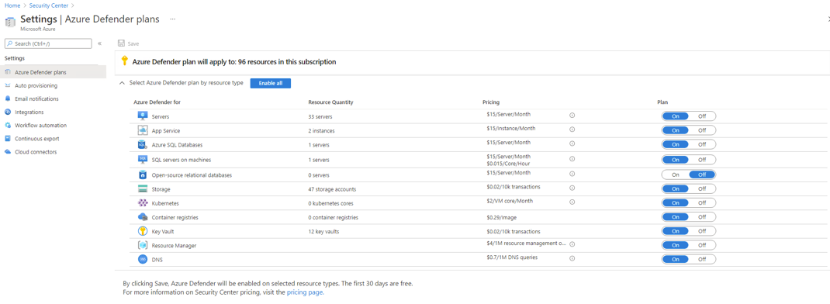

Security Center Email Notifications have been configured as follows:

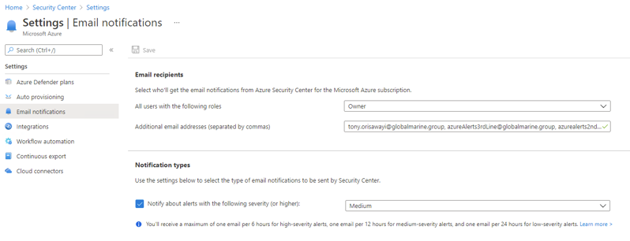

The following Regulatory Compliance standards have been enabled:

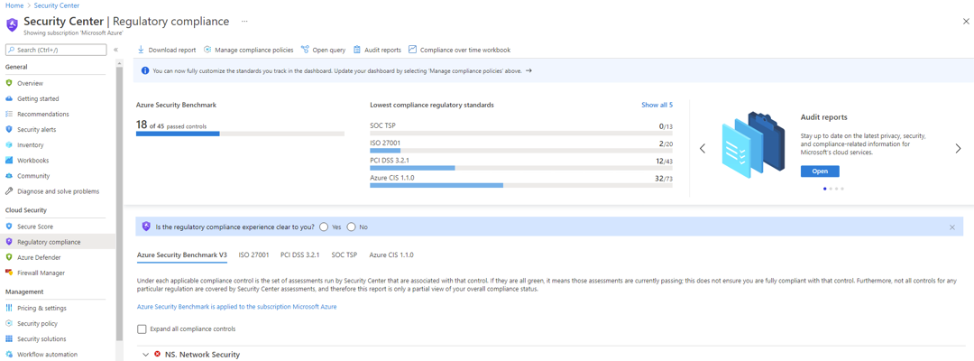

The following attachment contains a list of Azure Security Center alerts:

The following attachment contains a list of Azure Security Center recommendations:

Recommendations

Azure Security Center Recommendations
Recommendation
Enable Azure Defender for all resources
Enable automatic provisioning for Log Analytics agent for Azure VMs
Enable automatic provisioning for Vulnerability assessment for machines
Review and remediate Azure Security Center alerts prioritising high severity alerts
Review and remediate Azure Security Center recommendations prioritising high severity alerts
Review regulatory compliance requirements and disable any standards not required

Azure Key Vault

Current State

Key Vaults
Name | Resource Group | Location
akv-2-7kgt26qkbaht4eb | rg-uks-wvd-oceaniq | UK South
AZ-SEA-MIGRATE1293kv | rg-sea-azure-migrate | Southeast Asia
kv-eus-storage | rg-eus-production | East US
kv-neu-storage | rg-uks-prod-akv | North Europe
KV-SEA-DISKS | rg-sea-prod-singapore | Southeast Asia
kv-sea-storage | rg-sea-akv | Southeast Asia
kv-uks-prod-akv01 | rg-uks-prod-akv | UK South
kv-uks-storage | rg-uks-prod-akv | UK South
kv-ukw-storage | rg-ukw-akv | UK West
kv-weu-storage | rg-uks-prod-akv | West Europe
UKS-DEV-O365-KV | rg-uks-dev-o365 | UK South
uks-vcentre1291kv | rg-sea-azure-migrate | UK West

Recommendations

Key Vault Recommendations
Recommendation | Rationale
Create one Key Vault per application per environment | Separation of Key Vaults
Migrate vault access policies to RBAC | Azure RBAC key benefits over vault access policies:  - Provides a unified access control model for Azure resources by using the same API across Azure services  - Centralized access management for administrators - manage all Azure resources in one view  - Integrated with Privileged Identity Management for time-based access control  - Deny assignments - ability to exclude security principals at a particular scope. For information, see Understand Azure Deny Assignments
Restrict network access using Private Endpoints | Provides private and secure network connectivity by allocating a private IP address from a virtual network, effectively bringing Key Vault in to a virtual network

Azure Update Management

Current State

Update Management
Update Management has been enabled as a solution for one of the Log Analytics workspaces. However, VM’s have not yet been onboarded to Update Management and deployment schedules have not been configured.

Recommendations

Update Management
Enable Update Management on each Log Analytics Workspace and Automation Account in each region. Configure deployment schedules according to uptime requirements and configure automatic onboarding by enabling automatic provisioning the Log Analytics agent to the same workspace in Security Center.

Azure Remote Access

Current State

Azure Remote Access
The current method of remote administrative access to Azure VMs has not been formalised.

Recommendations

Azure Remote Access
Implement Azure Bastion in the hub network to provide secure RDP/SSH access to Azure VMs using the Azure Portal.

Monitoring and Logging

Azure Monitor is a service in Azure that helps collect and analyse data that's generated by Azure resources. It gives real-time insights by using integrated search and custom dashboards by readily analysing records across all workloads. This helps in understanding how the applications are performing and proactively identifies issues affecting them and the resources they depend on.

Azure Monitor collects data from multiple sources into a common data platform where it can be analysed for trends and anomalies. It differentiates between two data types:

- Metrics: Host level or guest level telemetry data gathered in near real time, e.g. CPU utilization.
- Logs: Log data produced by the resources, e.g. Windows event logs.

Azure Monitor

Current State

The following alert rules have been created in Azure Monitor:

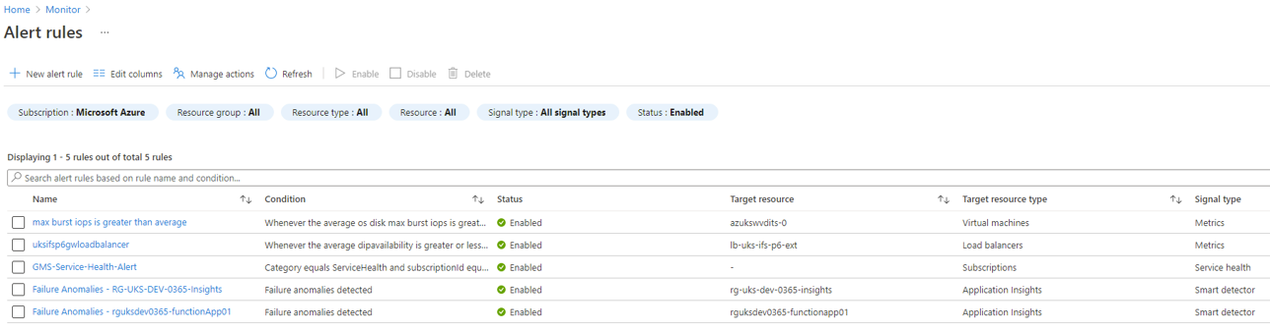

The following actions groups have been created in Azure Monitor:

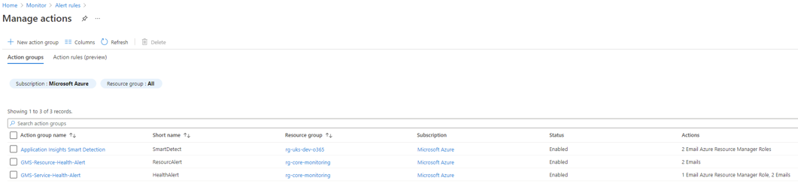

Recommendations

Azure Monitor Recommendations
Recommendation | Rationale
Define monitoring requirements and create Alert Rules for each resource type. For example, the following Alert Rules can be configured for Virtual Machines:  - No Heartbeat alert  - Create or update virtual machine  - Percentage CPU (dynamic threshold)  - Disk Read Ops/Sec (dynamic threshold)  - Disk Write Ops/Sec (dynamic threshold)  - Memory | Alerts will provide notifications for Azure resources to allow issues to be identified and addressed proactively.
Create Azure dashboards to visualize monitoring data | Dashboards are useful to provide an organised view of resources and quickly launch tasks for day-to-day operations. For example, custom dashboards can be created based on projects, tasks, or user roles.

Log Analytics Workspaces

Current State

Log Analytics Workspaces
Workspace Name | Resource Group | Location | Subscription
DefaultWorkspace-03e8c261-92f4-4a4c-a6ce-ad3ae17fd911-SEA | DefaultResourceGroup-SEA | Southeast Asia | Microsoft Azure
DefaultWorkspace-03e8c261-92f4-4a4c-a6ce-ad3ae17fd911-SUK | DefaultResourceGroup-SUK | UK South | Microsoft Azure
GlobalMarine | LogAnalyticsRG | UK South | Microsoft Azure
GMG-EUS-PROD-LogAnalytics | RG-EUS-PROD-LogAnalytics | East US | Microsoft Azure
gmg-sea-prod-loganalytics | rg-sea-prod-loganalytics | Southeast Asia | Microsoft Azure
GMG-UKS-PROD-LogAnalytics | RG-UKS-PROD-LogAnalytics | UK South | Microsoft Azure
RG-LA-OceanIQ-WVD-Monitor | RG-UKS-WVD-OceanIQ | UK South | Microsoft Azure
RG-UKS-DEV-0365-LogAnalytics | RG-UKS-DEV-O365 | UK South | Microsoft Azure
web-admin-portal-law-7kgt26qkbaht4 | RG-UKS-WVD-OceanIQ | UK South | Microsoft Azure
WVD-Monitor | RG-UKS-WVD-IT | UK South | Microsoft Azure

Recommendations

Log Analytics Workspace Recommendations
Recommendation | Rationale
Consolidate multiple workspaces in each region in to a single workspace | It is recommended to create a single workspace per region due to the following benefits:  - All data resides in one place allowing for efficient correlation of data  - Simplified dashboard authoring, using Azure Workbooks, avoiding cross-workspace queries  - Having a workspace in the same region as resources will prevent additional ingress/egress bandwidth costs between Azure regions
Review and delete empty workspaces:  - GMG-EUS-PROD-LogAnalytics  - web-admin-portal-law  - WVD-Monitor | Prevents workspace sprawl and improves management of monitoring and logging capabilities
Review and configure log data retention period | Workspaces have 31 days of data retention by default at no cost. Variable data retention should be used if log data is needed for a longer time period, for example, 365 days of retention for Security and Audit logs. Retention can be configured at the workspace level for all logs, or at the table level for specific logs.
Review usage of daily volume caps | Daily caps can be configured to limit the daily ingestion for a workspace. However, these should be used with caution to prevent reaching the daily limit as this may result in loss of data for the remainder of the day and reduce the ability to observe and receive alerts. The daily cap is intended to be used as a way to manage an unexpected increase in data volume.
Review usage of Log Analytics Workspace Solutions:  - AzureAppGatewayAnalytics  - ChangeTracking  - NetworkMonitoring  - Security  - ServiceMap  - SQLAdvancedThreatProtection  - SQLVulnerabilityAssessment  - Updates  - VMInsights | Azure monitor offers a number of monitoring solutions which provide additional insight into the operation of a particular application or service. These solutions will store their data within a workspace and will affect ingestion costs.

Platform Logs

Current State

Platform Logs
Setting | State
Azure Active Directory Logs | Partially enabled – diagnostics settings enabled for Azure AD Tenant to send AuditLogs, SignInLogs and ProvisioningLogs to Log Analytics Workspace GMG-UKS-Prod-LogAnalytics.
Azure Resource Logs | Partially enabled – diagnostics settings enabled for some resources to send log data to Log Analytics workspace.
Azure Subscription Activity Log | Partially enabled – diagnostics settings enabled for Azure Subscription to send Security logs to Log Analytics Workspace GMG-UKS-Prod-LogAnalytics.

Recommendations

Platform Logs Recommendations
Recommendation | Rationale
Azure Active Directory Logs: Update diagnostics setting to include all Azure AD logs. | Azure AD logs contains the history of sign-in activity and audit trail of changes made in the Azure Active Directory for a particular tenant.
Azure Resource Logs: Implement Azure Policies for each resource type which requires logging to be enabled. | Azure Resource Logs provide insight into operations that were performed within an Azure resource (the data plane), for example getting a secret from a Key Vault or making a request to a database. The content of resource logs varies by the Azure service and resource type. Deploying diagnostics settings using Azure Policy will ensure logging is enabled for existing and new resources.
Azure Subscription Activity Logs: Implement Azure Policy – Configure all Azure Activity logs to stream to specified Log Analytics workspace. | This policy will ensure all Azure Activity logs are streamed to the specified Log Analytics workspace. Azure Activity Logs provide insight into the operations on each Azure resource in the subscription from the outside (the management plane) in addition to updates on Service Health events. The Activity Log is used to determine the what, who, and when for any write operations (PUT, POST, DELETE) taken on the resources in your subscription.

Backup and Disaster Recovery

The Azure Backup service provides the ability to backup on-premises, Azure VMs, SQL servers/databases and other components to Microsoft Cloud.

Azure Site Recovery is a Disaster Recovery as a Service (DRaaS) offering that provides a simple tool to configure complex disaster recovery scenarios for workloads running on physical and virtual machines, either on-premises or on Azure, so that in the case of an outage these workloads are quickly failed over from a primary site to a secondary location.

Backup

Current State

Recovery Services Vaults
Recovery Services Vault Name | Storage Redundancy | Resource Group | Location | Subscription
GMS-Backup-Vault2-UKS | GRS | core-networking | UK South | Microsoft Azure
GMS-Backup-Vault3-SEA | GRS | rg-sea-prod-singapore | Southeast Asia | Microsoft Azure
GMS0Backup-Vault3-SEA | GRS | core-networking | Southeast Asia | Microsoft Azure
Singapore-Servers-MigrateVault-khwcy8gs | GRS | rg-sea-azure-migrate | Southeast Asia | Microsoft Azure
uks-vcentre1291vault | GRS | rg-sea-azure-migrate | UK West | Microsoft Azure

Backup Policies
GMS-Backup-Vault2-UKS Backup Policies
Backup Policy Name | Backup Policy Type
DailyBackup | Azure File Share
DefaultPolicy | Azure Virtual Machine
HourlyLogBackup | SQL Server in Azure VM
GMS-D-8pm | Azure Virtual Machine
GMS-D-W-M-8pm | Azure Virtual Machine
GMS0Backup-Vault3-SEA Backup Policies
Backup Policy Name | Backup Policy Type
DefaultPolicy | Azure Virtual Machine
HourlyLogBackup | SQL Server in Azure VM
GMS-D-8pm | Azure Virtual Machine
GMS-D-W-M-8pm | Azure Virtual Machine

Recommendations

Backup Recommendations
Recommendation | Rationale
Configure diagnostics settings on each Recovery Services Vault via Azure Policy to send data to Log Analytics workspace  https://docs.microsoft.com/en-us/azure/backup/configure-reports | Diagnostics settings are required in order to view Azure Backup Reports.  Azure Backup Reports provide insights on backups based on data that spans a long period of time. Use cases for such a solution include:  - Allocating and forecasting of cloud storage consumed.  - Auditing of backups and restores.  - Identifying key trends at different levels of granularity.
Use built-in RBAC roles to control backup management operations:  - Backup Contributor  - Backup Operator  - Backup Reader | Using the built-in RBAC roles ensures adherence to the principle of least privileges for just enough administration.
Consider implementing Cross Region Restore to allow Azure VMs to be restored to a secondary, paired region. | This option allows an organisation to meet audit or compliance requirements, and to restore the VM or its disk if there's a disaster in the primary region.
Consider implementing Auto-Enable Backup on VM Creation using Azure Policy. https://docs.microsoft.com/en-us/azure/backup/backup-azure-auto-enable-backup | Automatic enablement of VM backups in an organization will ensure that all business-critical machines are backed up with the appropriate retention.

Disaster Recovery

Current State

Disaster Recovery
Azure Site Recovery has not been implemented for the Azure Subscription.

Recommendations

Disaster Recovery
Azure Site Recovery should be considered as part of the overall BCDR strategy to provide resilience against regional Azure issues.

Terms and Conditions
Confidentiality
All information within this document is given in the strictest confidence and is considered as Confidential Information and genuine commercially sensitive information. With regards to this all parties shall treat information detailed in the strictest confidence and shall not, without the prior consent of the other party, disclose any information with regards to this proposal to any other organisations, whosoever they may be. In the event the customer is compelled by law or by any applicable regulatory agency (including a request to disclose information in accordance with the Freedom of Information Act 2000) to disclose any Confidential Information the customer shall immediately consult with <COMPANY> prior to any such pending disclosure so that the parties may discuss whether the Confidential Information is exempt from disclosure or so that a protective order or other appropriate remedy may be obtained. If such an order or other remedy is not available, the customer shall disclose only that minimum portion of Confidential Information that it is legally compelled to disclose, consistent with the advice of its counsel.

Disclaimer
<COMPANY> makes no representations or warranties with respect to the contents or use of this document, and specifically disclaims any express or implied warranties of merchantability or fitness for any particular purpose.

Intellectual Property
Nothing in this document is intended to grant any rights under any patent, copyright, or other intellectual property right of <COMPANY>.

Errors and omissions excepted.

Appendix

Azure Resources List

The following attachment contains a list of all resources exported from the Azure Portal:

Summary of Recommendations

The following attachment contains a summarised list of all recommendations:

Service Improvement Plan

The following attachment contains a prioritised list of service improvement plans:

Glossary of Terms

Abbreviation | Description
API | Application Programming Interface
ARM | Azure Resource Manager
Azure AD | Azure Active Directory
BaaS | Backup as a Service
DNS | Domain Name Services
DRaaS | Disaster Recovery as a Service
GRS | Geo-redundant Storage
IaC | Infrastructure as Code
IDaaS | Identity as a Service
JIT | Just in Time access
LRS | Locally-redundant Storage
MFA | Multi Factor Authentication
MG | Management Group
MMA | Microsoft Monitoring Agent
NSG | Network Security Groups
RBAC | Role Based Access Control
RG | Resource Group(s)
SAML | Security Assertion Mark-up Language
SSL | Secure Socket Layer
SSD  HDD | Solid-State Drive  Hard Disk Drive
TLS | Transport Layer Security
UDR | User Defined Routes
VM | Virtual Machine
VNet | Virtual Network
vWAN | Virtual Wide Area Network
VPN | Virtual Private Network

