Intermediate abundance promotes speciation when dispersal is limited

Abstract
Why do some lineages diversify while others do not? This remains a central question in evolutionary ecology. A long-standing assumption, dating to Darwin and embedded in the Unified Neutral Theory of Biodiversity, holds that abundant species should speciate at higher rates. Conversely, theoretical and empirical work highlights the possibility that rare and dispersal-limited clades might be more prone to speciation. Using a birth-death-immigration model with protracted speciation in a multi-population landscape connected by limited dispersal, we show that abundance has a hump-shaped effect on probability of speciation. Our model reveals that intermediate abundance maximizes speciation probability because larger populations disperse more, swamping regional differentiation and inhibiting speciation completion, while smaller populations lack the persistence and incipient speciation needed to diversify. We find empirical support for this prediction with an analysis of data from arthropods endemic to Hawai`i, where genus-level species richness shows a significant hump-shaped relationship with mean genus abundance. These findings provide a mechanistic explanation for a nuanced relationship between abundance and diversification.

Introduction
A fundamental question in evolutionary ecology concerns why some clades are diverse while others are not. Are there properties of species and lineages that promote speciation? One line of inquiry with a long and convoluted history is the role of commonness and rarity in the process of diversification. Going back over 150 years, Darwin (1859) argued that widespread, abundant species should be superior competitors and thus more likely to give rise to new species.
Building on this foundation, Yule’s (1925) model, which became a landmark contribution to modeling diversification, was initially intended as a way to incorporate demography into predictions for diversification and clade richness (Pennell and MacPherson 2025). Despite these deep roots in evolutionary thinking, little consensus has emerged on the relationship between abundance and diversification. Darwin’s line of thinking carried forward to macroecologists who attempted to model, with some empirical support, the presumed positive association between commonness, fitness, and speciation (Maurer 1999).
In parallel, paleontologists searched for relationships between commonness and diversification, alternately finding evidence for a positive relationship (Krug et al. 2008) but also a negative relationship (Stanley 1986, Jablonski and Roy 2003). Empirical studies of modern taxa have largely found that commonness is negatively or inconclusively related to measures of diversification (Jablonski and Roy 2003, Makarieva and Gorshkov 2004, Greenberg and Mooers 2017, Smyčka et al. 2023, Afonso Silva et al. 2025, but see Hay et al. 2022). While some of these studies focus specifically on average abundance, others on range size, and some on both, the two macroecological properties are most often strongly correlated, a fascinating macroecology pattern in and of itself (Brown 1995, Gaston 2003). This correlation may be caused, at least partly, by the net increase in dispersal of larger populations owing simply to chance: if each individual carries a probability of dispersing, more individuals in a population will lead to more overall dispersal (Hubbell 2001). It is also of course possible that shared underlying mechanisms cause both increased population growth rate and increased dispersal rate (Gaston et al. 1997, Holt et al. 1997).
More recent theoretical and modeling work has largely assumed a positive relationship between commonness and diversification. Hubbell (2001) perhaps started this trend with the inclusion of “point mutation” speciation in the Unified Neutral Theory of Biodiversity (UNTB). Because point mutation speciation assumes a constant probability of speciation for every individual, lineages with more individuals will experience more speciation events in the UNTB (Hubbell 2001, Etienne et al. 2007). The speciation mechanism first proposed by Hubbell (2001) was never an accurate model of real diversification (Ricklefs 2003), but even later attempts to increase the realism of speciation in the UNTB retain the emergent property that more abundant lineages will undergo more speciation. Protracted speciation (Rosindell et al. 2010) again assumes that incipient speciation is constant across individuals and thus full speciation will scale positively with lineage abundance; fission speciation (Etienne and Haegeman 2011) also assumes the probability of fission (the event that leads to speciation) increases with the number of individuals in a species. Largely independently from UNTB and its descendants, phylogenetic models of geographic change and diversification also explicitly assume that more widespread species have greater opportunity for speciation (Goldberg et al. 2011).
The process that underlies speciation itself may suggest something different in terms of the relationship between speciation, commonness, and rarity: dispersal. Dispersal is a key mechanism by which populations can become isolated or connected, potentially leading to speciation or admixture (Yamaguchi 2022). Dispersal figures prominently in phylogenetic models of the geographic range and diversification (Matzke 2014), it is necessary to maintain local biodiversity in the UNTB (Hubbell 2001), and it is the mechanism connecting abundance to range size in both neutral (Hubbell 2001) and non-neutral (Brown 1995) macroecological models.
Due to the potential for dispersal to both create population isolates but also swamp out regional differences that could have led to speciation, the connection between dispersal ability as a biological trait and speciation as an evolutionary outcome remains a fertile line of inquiry. Some empirical studies have found that measures of diversification have a hump-shaped or negative relationship with morphological proxies for dispersal ability (Price and Wagner 2004, Claramunt et al. 2012, Czekanski-Moir and Rundell 2019) while others have found a positive to flat relationship between dispersal ability and diversification (Claramunt et al. 2025). Agent-based model simulations have supported the idea of a trade-off between too little dispersal leading to population instability and too much dispersal leading to admixture with intermediate dispersal balancing the two extremes allowing for speciation (Birand et al. 2012, Ashby et al. 2020, Ciccheto et al. 2024).
But dispersal is not just a trait connected to morphology or imposed in a simulation, it emerges from population dynamics: each individual carries some per-capita probability of dispersing, but because that probability is applied across every individual in the population, the total dispersal rate (the total number of dispersal events per unit time) scales linearly with abundance, thus species with more individuals produce more dispersal overall. This is the assumption, a realistic one, in birth-death-immigration models (Kendall 1948). Therefore, if commonness and dispersal affect speciation, their effects are interconnected because population-level dispersal rate increases both with intrinsic per-capita dispersal probability and with abundance. It also remains an open debate whether their effects result from the determinism of adaptive evolution as Darwin (1859) believed or instead emerge from chance.
Here we develop a birth-death-immigration model with protracted speciation embedded in a landscape of multiple local populations connected with limited dispersal to investigate the role of abundance and stochastic dispersal in modulating the probability of speciation. Contrary to Darwin (1859) and UNTB (Hubbell 2001, Etienne et al. 2007, Rosindell et al. 2010, Etienne and Haegeman 2011), we find that intermediate abundances lead to the greatest probability for speciation. Critically, this result does not depend in any way on whether populations are more or less adaptively fit, it only depends on a balance between large enough abundances to accrue sufficient probability of incipient speciation but small enough abundances to not lose regional differentiation due to increased dispersal. We also analyze real data on the species richness and abundance of arthropod communities in Hawai`i finding empirical evidence for intermediate abundance promoting speciation. The isolation of Hawai`i, leading to tractable endemic radiations, and its known geologic age, ranging from still forming to 4–6 million years, make it an ideal study system for investigating the interplay of abundance and speciation.

Methods

Simulating a birth-death-immigration process with protracted speciation
We simulate a birth-death-immigration process with protracted speciation in a modified metapopulation (Hanski 1998) setting Figure 1. For simplicity, we consider only a single species (not a multi-species) metapopulation. Constraining our simulations to a single species allows us to focus on the processes of interest—population dynamics and speciation—without entering into debates on multi-species dynamics (HilleRisLambers et al. 2012, Rosindell et al. 2012).
In this simulation framework there are a number of local populations (minimum two are needed, we simulate 10) fully connected by local dispersal as well as a global source population connected to each local population by dispersal. The global source population is considered extremely large relative to local populations such that extinction of the global source population is unlikely on the time scale of local dynamics (we approximate this assumption by never allowing the source population to go extinct). Local populations start at size 0 and grow and shrink according to local births and deaths, dispersal between local populations, and dispersal from the source pool.
Our simulation model is consistent with other simulation models derived from the UNTB (Hubbell 2001, Rosindell and Harmon 2013, Rosindell et al. 2015), but unlike the multi-species perspective of those models, we concern ourselves only with a single species and whether that one species undergoes a speciation event. In this way we do not make the assumption of per capita neutrality across species, meaning our results could generalize to multi-species eco-evolutionary models based on niche theories (e.g. Tilman 1982, Chesson 2000, Letten et al. 2017). We also relax the zero-sum and fixed time step approaches of most UNTB-like models. Instead, we initialize all patches as empty and let their numbers of individuals grow and shrink with birth, death, and dispersal. We also use a Gillespie algorithm (Gillespie 1976, 1977) to simulate dynamics. In the Gillespie algorithm each discrete time step is an event chosen at random in proportion to the rate of occurrence of that event (i.e. not the fixed death-replacement cycle of the UNTB; Hubbell (2001)). Although events are sampled at discrete time steps, time itself is measured in actual units of time, not time steps, by sampling sojourn times between events from an exponential distribution with rate equal to the sum of all rates for all possible events.

Protracted speciation
In our simulation model a new species arises via a modified protracted speciation process (Rosindell et al. 2010) similar to the model of Tao et al. (2021). Protracted speciation was first proposed by Rosindell et al. (2010) to try to bring more realism to the speciation process of the UNTB which originally modeled speciation as a point mutation-like process in which a single individual gets randomly flipped to a new species identity with some small probability $ν$ (Hubbell 2001). Protracted speciation instead assumes that this point mutation-like process, again with probability $ν$, only flips an individual to be an incipient species; if the lineage of that incipient species survives $τ$ time steps, the process is said to reach full speciation but if the lineage dies out before $τ$ time steps, no new species is formed (Rosindell et al. 2010).
We extend the protracted speciation model to a multi-patch simulation landscape. In our model, after a population is founded through immigration it, the newly founded population, has a small probability of becoming an incipient new species. If an incipient speciation event occurs, and in the absence of subsequent immigration, the population of the incipient new species must persist $τ$ time units for full speciation. If the population does not persist for $τ$ time units, the incipient new species is lost without ever becoming a fully new species.
After an incipient speciation event, subsequent immigration events slow the progress toward full speciation. We model this by adding a small increment to $τ$ equal to $ξ/n_{i}$ where $ξ$ is a parameter we can set and $n_{i}$ is the size of the population containing the incipient species. Due to $n_{i}$ in the denominator, this slowdown will be felt less by large populations and more by smaller populations in agreement with population genetic theory on the effect of immigration on population differentiation (Wright 1931, Mills and Allendorf 1996).
Tao et al. (2021) also developed a similar multi-patch protracted speciation model, but ours is different in three ways:
- Tao et al. (2021) assume every population founded by immigration is an incipient species; we assume that a new population founded through immigration remains part of the parent species unless an explicit incipient speciation event occurs.
- In our Gillespie algorithm approach, time to full speciation is measured in actual time units, not discrete time steps.
- Tao et al. (2021) assume that a fixed constant is added to $τ$ for every immigration event while we add a constant scaled by local population size ($ξ/n_{i}$).

Simulation rules
The preceding sections explained our simulation model, summarized in Figure 1; here we summarize the rules by which the simulation progresses:
- All local populations are initialized as empty, to be filled by immigration.
- Per capita birth, death, immigration, and incipient speciation all happen independently and are determined by their own respective rates.
- Immigration is modeled as the dispersal of a newly born individual, thus the population from which the individual emigrates is unchanged; this birth-then-emigrate mechanism is a widely used simplification in models inspired by the UNTB (Hubbell 2001, Rosindell and Harmon 2013, Rosindell et al. 2015, Tao et al. 2021). Each individual carries a per capita rate of producing a dispersal event, thus emigration from a patch scales with the population size of that patch, but dispersal from the source pool is not density dependent. The recipient population of an immigration event is chosen uniformly at random, the population size of the receiving population does not impact probability of receiving an immigration event.
- Speciation has 2 steps:
  - After a population is founded through immigration, incipient speciation can change that population to an incipient new species with a per capita rate of $ν$. Subsequent incipient speciation events in the same local population are ignored because the population is already an incipient new species. Multiple incipient species can occur across different patches, but not within the same patch.
  - If an incipient species survives long enough it becomes a new species; “long enough” is determined by a waiting time parameter $τ$—the larger $τ$, the longer the time frame for a fully new species to emerge.
- Immigration between local communities and from the global source pool slows the progress toward full speciation; if an incipient species has to wait $τ$ time units (in the absence of immigration) until it is a full species, each immigration event adds an increment to $τ$ of $ξ/n_{i}$.
- If an individual of an incipient species disperses to a different population, it is subsumed within that population and its incipient status is lost.
- If a local population goes extinct, the speciation tracking for that patch is reset.
- The simulation is stopped under one of two conditions: i) if any incipient species becomes a fully diverged new species, or ii) if the simulation reaches the maximum designated number of iterations.
Because of the stopping conditions, each simulation replicate will either yield one and only one full speciation, or no full speciation events at all.
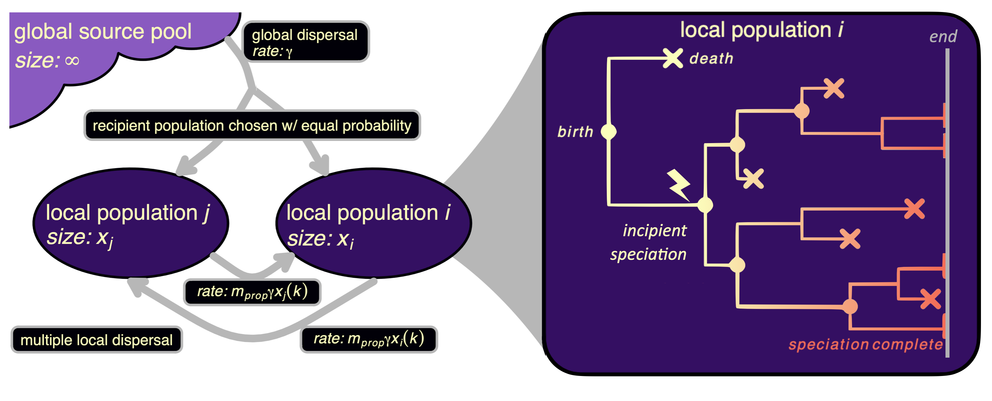
Figure 1: Conceptual overview of our simulation model. Local populations are connected by immigration between populations and also from a global source pool. Within local populations birth and death determine population growth and decline, augmented by immigration. Random incipient speciation events can occur at the local population level but do not lead to full speciation unless the population persists for at least a duration of $τ$ (possibly more in the face of immigration). If full speciation occurs the simulation stops. If no speciation occurs but the maximum number of iterations is reached, the simulation likewise stops.
Further details of the simulation are provided in Supplementary Section S2. All simulation code is written in R (R Core Team 2025) using Rcpp (Eddelbuettel et al. 2025a) and RcppArmadillo (Eddelbuettel et al. 2025b). Underlying C++ and R source code is available in the R package abundolism accompanying this paper. Supplementary Section S1 explains how to access this custom R package.

Simulation experiment
Table 1 summarizes the simulation parameters in our model and the range of values we use in our simulation experiment. In all cases parameter values are drawn from a uniform distribution. A total of 5,000 simulations were run, each with a unique set of randomly sampled parameters. Parameter values and the number of iterations were chosen with three considerations in mind: 1) speciation should be possible to observe in a reasonable number of simulation iterations for computational practicality; 2) abundances should be within realistic ranges; and 3) timescales should be within reasonable bounds.
In the context of the speciation-related parameter values we used, timescales should be interpreted in units of 10,000 years. Thus the maximum value of $τ$ is 2,000,000 years and the maximum rate of incipient speciation $ν$ is 0.1 per individual per 10,000 years, leading to rates of new species divergence roughly in line with published estimates (Hedges et al. 2015).
Table 1: Parameters governing the simulation and their ranges over the simulation experiment. Mathematical parameter names are given first followed by their name in the simulation code. Note np and nstep were fixed throughout the course of the simulation experiment.
parameter |  | range |  | description
$$λ$$ | (la) | 0.1 | 4.0 | per capita local birth rate
$$μ$$ | (mu) | 0.1 | 4.0 | per capita local death rate
$$γ$$ | (g) | 0.1 | 1.0 | dispersal rate from the global source pool to one local population
$$m_{\text{prop}}$$ | (m_prop) | 0.0 | 0.1 | proportional dispersal rate between local populations relative to global rate
$$ν$$ | (nu) | 0.0 | 0.1 | per capita incipient speciation rate
$$τ$$ | (tau) | 20.0 | 200.0 | wait time to full speciation in the absence of dispersal
$$ξ$$ | (xi) | 10.0 | 100.0 | amount each dispersal event sets back the progression toward speciation
$$n_{p}$$ | (np) | 10.0 | 10.0 | number of local populations
$$n_{\text{step}}$$ | (nstep) | 10,000.0 | 10,000.0 | number of simulation iterations

Parameter values were chosen as a balance between biological realism and computational efficiency: rates are sufficiently fast to allow for abundances to reach levels often found in survey data (e.g. the arthropod survey data we analyze here) within 10,000 time steps.

Analysis of simulation experiment results
Our primary focus is on the relationship between abundance and probability of speciation. We do this by comparing the presence or absence of a full speciation event to species abundance averaged over time and patches. However, we must account for the stopping conditions of our simulation being dependent on the very process—speciation—that we are analyzing. Simulation runs reaching full speciation will have fewer time steps than those reaching the pre-determined time step limit. We account for this by cutting each simulation run into a set of time step windows of fixed width (i.e. fixed number of time steps). We then analyze the presence or absence of speciation and average abundance within these non-overlapping windows of fixed width. A window is marked as containing a speciation event or not. We calculate abundance as the average population size across time steps of the entire metapopulation. We apply this approach to the analysis of speciation versus abundance, but also to auxiliary analyses of how speciation and abundance respond to model parameters. Those auxiliary analyses include visualizing average abundance across different birth and death rates and dispersal rates, as well as fitting models of the probability of speciation as a function of model parameters. Because choice of window size could affect analysis results, we re-run the analysis of abundance versus speciation using windows of different width.
In fitting any models with these simulation results cut into fixed-width windows, we must account for the non-independence between windows from the same model run. We do this using generalized linear mixed effects models [using R package glmmTMB; McGillycuddy et al. (2025)] where simulation run is a random effect. We report confidence intervals rather than hypothesis tests because sample sizes from simulations are arbitrary and thus degrees of freedom can be manipulated to produce statistically significant results from biologically meaningless patterns. By contrast, confidence intervals more meaningfully indicate the magnitude of effects in the simulation experiment.

Analysis of arthropod richness and abundance from Hawai`i
To bring real data to bear on our insights from simulations, we analyze the species richness and average per-species abundance of arthropod genera in Hawai`i. Endemic arthropods in Hawai`i are a uniquely ideal study system because, although only an approximation, most arthropod genera only arrived in Hawai`i once, meaning all endemic species of those genera represent in situ diversification (Cowie and Holland 2008). For the purpose of our analysis, we proceed with this approximation. The unique situation in Hawai`i, that each arthropod genus arrived approximately only once on this geologically young archipelago, also avoids the problem that taxonomic ranks are temporally inconsistent at a global level (Avise and Liu 2011).
To calculate species richness per genus we use the Bernice Pauahi Bishop Museum’s checklist of arthropods in Hawai`i (Nishida 2002). This checklist represents the current understanding of terrestrial arthropod species richness in Hawai`i, though is inevitably incomplete for a place supporting rapid diversification. To estimate average per-species abundance for each genus we use an extensive survey of arthropods from across the Hawaiian Archipelago (Gruner 2007). The survey data from Gruner (2007) comprise sample locations from 45 trees across 5 sites. Sites are located on Hawai`i Island, Moloka`i, and Kaua`i and follow the Long Substrate Age Gradient plots established by Vitousek et al. (1995) that are constrained to be within similar montane rainforest environments.
Combining the checklist with survey data resulted in the retention of 118 endemic genera out of 597 total from the checklist, representing a loss of 80.23%. While this is a large percentage, it is also not unexpected. The survey data constitute a very small sample of the geographic space of the Hawaiian Archipelago as well as a small sample of the extremely heterogeneous environmental space of the archipelago. Supplementary Section S5.4 evaluates the impact of these missing genera on our analyses, finding that our results are robust to this subsampling of total genera.
Average per-species abundance was estimated for each genus as the mean of each species’s abundance for all species belonging to that genus across all sample locations. We use average per-species abundance to represent the measure of commonness or rarity of a genus because speciation occurs at the species level, or lower, so abundance of higher taxonomic groups is not as relevant. We can also estimate the average abundance of a species with lower error than the total abundance of a genus. In Supplementary Section S5.5 we further study the choice of using average per-species abundance and find it to be a rigorous one.
We are interested in determining if the number of species per genus (a proxy for diversification) peaks at intermediate per-species abundances. To do this we fit a quadratic generalized linear model with species richness as response and average per-species abundance as explanatory variable. But the question remains, what probability distribution should we assume for number of species? Kendall (1948) showed that a birth-death process will result in a geometric distribution of descendants. Conditional on lineage survival at time $t$ after initial establishment, we can parameterize the geometric probability mass function as

where $y$ is the number of species in a lineage. $ψ\left(t\right)$ is the probability that a lineage survives but we do not observe any bifurcation events by time $t$. Thus $1-ψ\left(t\right)$ is the probability of the complement which is observing at least one bifurcation event leaving multiple descendants at time $t$. We will call $1-ψ\left(t\right)$ the “observable diversification probability.” $ψ\left(t\right)$ depends on rates of speciation and extinction in addition to time $t$.
The number of species in any given lineage $i$ extant at time $t$ will follow a geometric distribution with probability parameter $p_{i}=ψ_{i}\left(t_{i}\right)$. But we do not know $p_{i}$ because we do not know the arrival times of most arthropod lineages in Hawai`i—thus we do not know $t_{i}$—and we do not know their rates of speciation and extinction. However, we can model our uncertainty in $p_{i}$ by letting it be a random variable drawn from a beta distribution. Allowing $p_{i}$ to be a random variable helps statistically account for the confounding effects of variable diversification rate and lineage age on lineage richness (McPeek and Brown 2007, Scholl and Wiens 2016, Yu and Wiens 2024). Drawing $p_{i}$ from a beta distribution averages over these possible confounding effects.
The resulting beta-geometric distribution has parameters $α$ and $β$:

where $B$ is the beta function.
Interestingly enough, the Yule-Simons distribution, historically developed to model number of species in genera (Yule 1925), is a special case of the beta-geometric distribution when $β=1$ (Irwin 1975). In our beta-geometric model we will not fix $β=1$ but instead allow it to be a free parameter, thus not making the strict birth-only assumption of Yule (1925).
Our final, quadratic model relating genus richness to average per-species abundance in a genus is

where $x_{i}$ is average per-species abundance of lineage $i$. This model means that we allow the $α$ parameter of the beta-geometric distribution to change with average per-species abundance but we assume the $β$ parameter is fixed across lineages. A fixed $β$ across lineages still allows sufficient flexibility of the model without introducing additional parameters for which there may be insufficient power to reliably estimate. From this model our estimate for the observable diversification probability for lineage $i$ is $1-\hat{p_{i}}=1-\frac{α_{i}}{α_{i}+β}$.
To evaluate the significance of an intermediate peak in diversification across average per-species abundances (i.e. the quadratic term) we also fit a model without quadratic terms:

We then compare quadratic and linear models with a likelihood ratio test to evaluate significance of the intermediate peak.
While the VGAM package (Yee 2025) in R enables beta-geometric generalized linear modeling, its implementation is based on iterative Fisher scoring which is unnecessary and computationally slow for our application. Therefore, we use functionality from VGAM to write a custom likelihood maximization routine that we use to estimate model parameters. More details on this approach are provided in Supplementary Section S5.

Results

Simulating a birth-death-immigration process with speciation
1,464 out of 5,000 simulation runs (29.28%) resulted in speciation. Using a window size of 100 time steps resulted in 389,945 non-overlapping windows. Of those, 1,464 contained a speciation event. Thus the overall probability of speciation across windows is 0.004.
Figure 2 shows, as expected, that abundance is larger when $λ>μ$ and smaller when $λ<μ$, maintained by immigration. When $λ>μ$ populations will grow indefinitely. When birth and death rates are equal ($λ=μ$) the population could crash or expand depending on small random fluctuations and random immigration. In Figure 2 smaller abundances for $λ>μ$ likely correspond to time bin windows earlier in the simulation as well as those that stochastically drifted to smaller sizes.
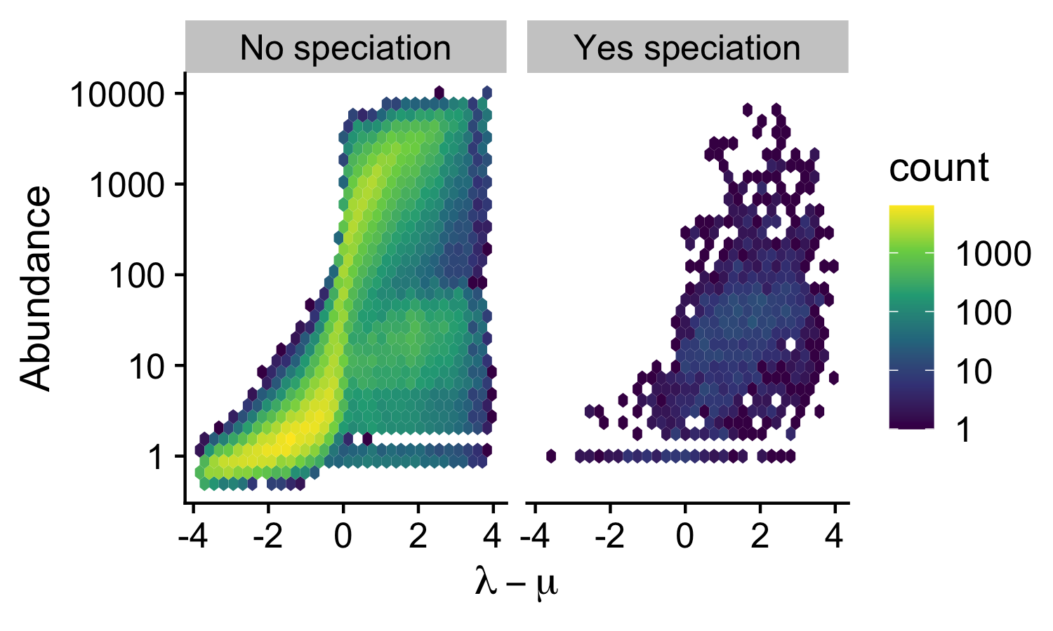
Figure 2: Relationship across simulation run windows between growth rate ($λ-μ$) and abundance. Panels show simulation runs without and with full speciation. Colored hexagons show the number of points with values in that small neighborhood in order to more clearly show the distribution of simulation results.
Figure 3 shows how overall dispersal rate (global plus local) influences abundance. Only when growth rate is low does dispersal rate increase abundance, consistent with small abundances being maintained by immigration via a rescue-effect-like mechanisms (Brown and Kodric-Brown 1977).
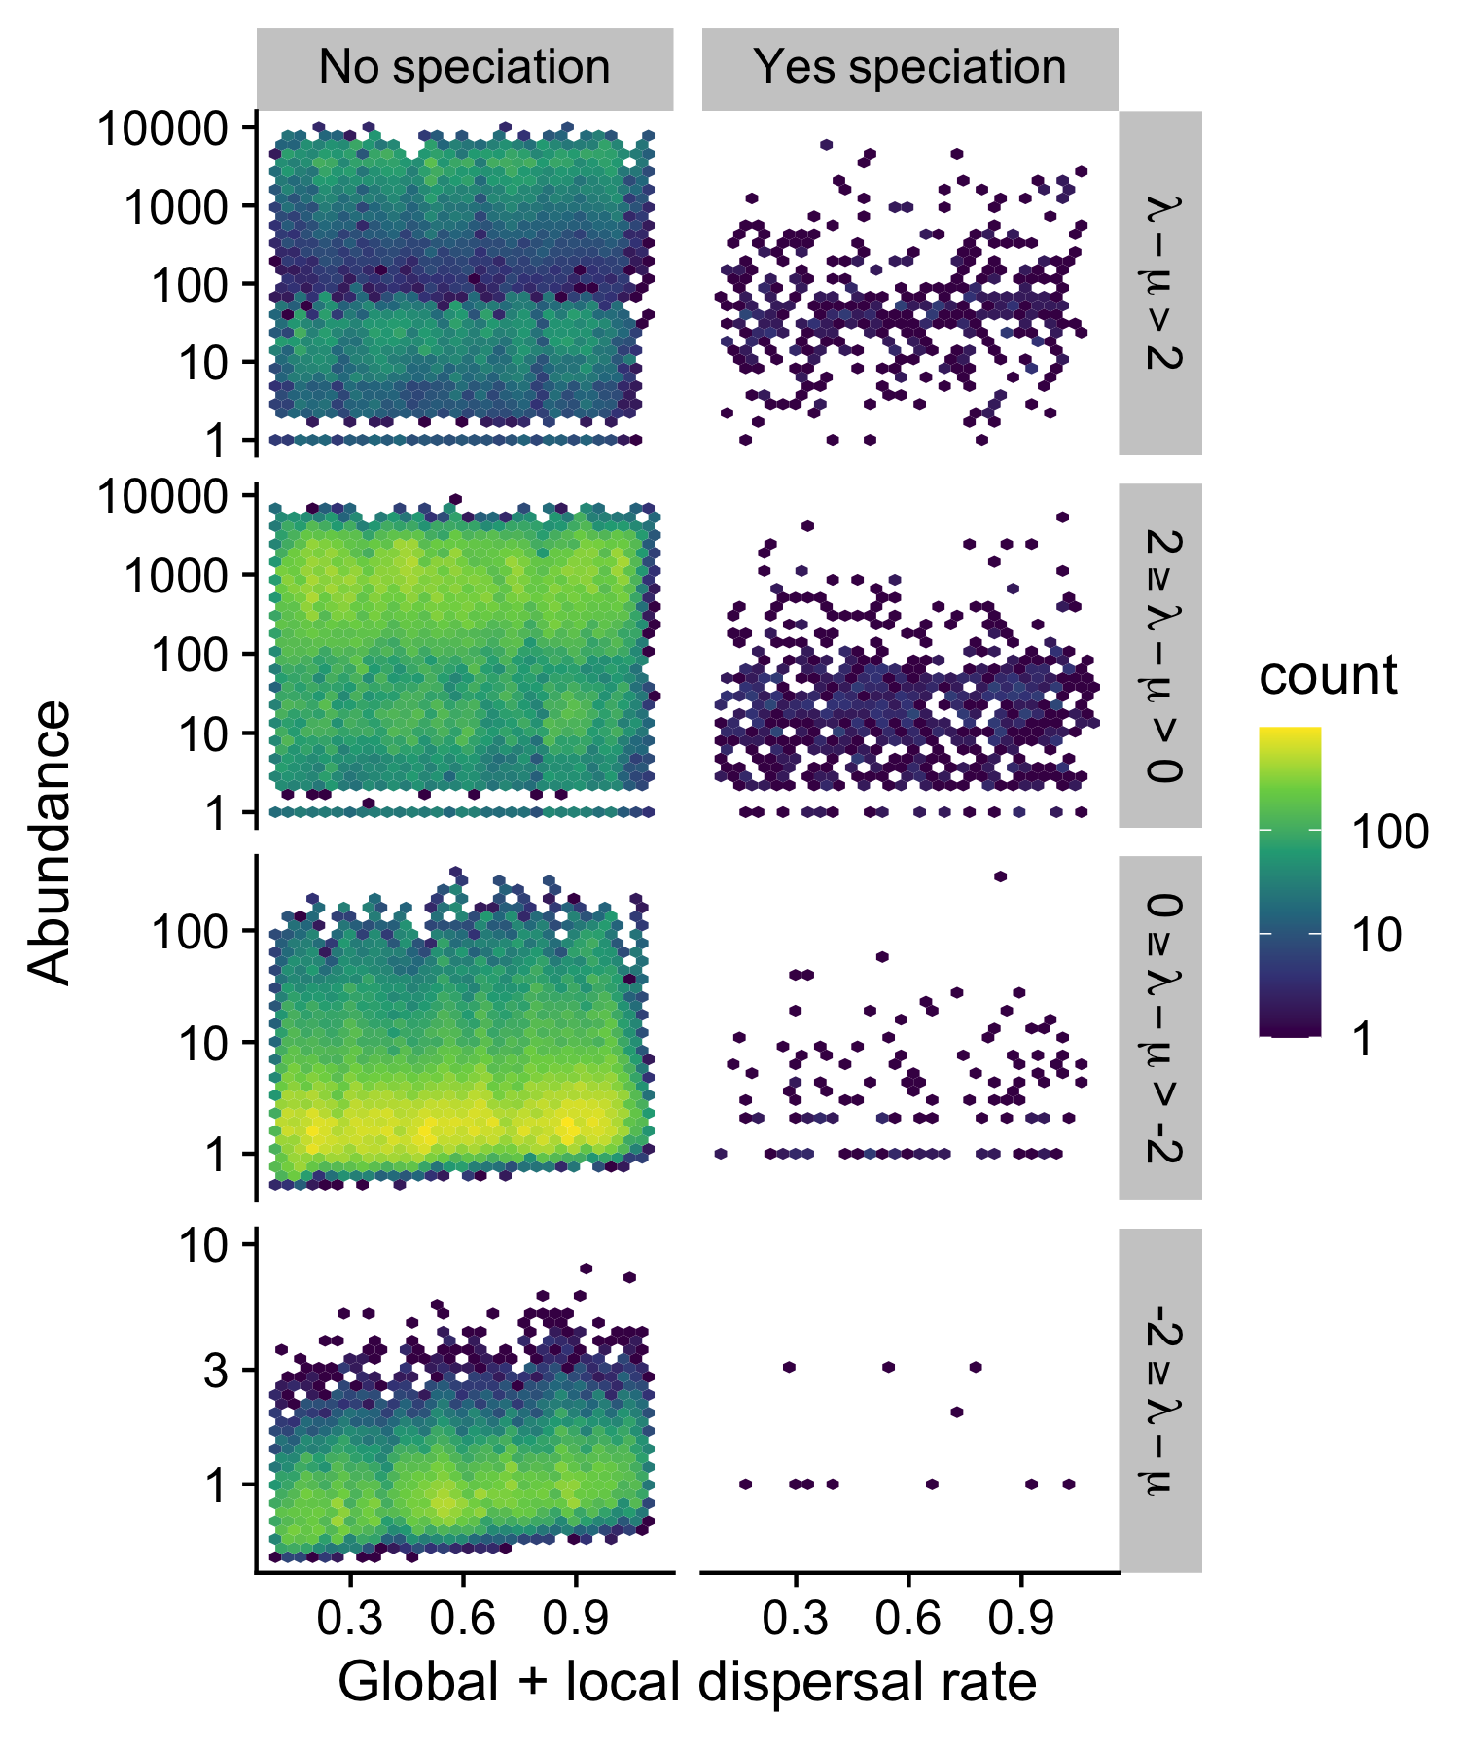
Figure 3: Relationship across simulation run windows between combined dispersal rate (global plus local) and abundance. Panel columns show simulation run windows without and with full speciation while panel rows show simulation run windows of different growth rate ($λ-μ$). Colored hexagons show the number of points with values in that small neighborhood in order to more clearly show the distribution of simulation results.

Effect of abundance on speciation
Figure 4 shows that probability of speciation across simulation run windows peaks at intermediate abundance. A logistic mixed effects model with a random effect for simulation run and a quadratic term for abundance confirms this peak (95% CI of quadratic term is [-0.311, -0.257]). The estimated location of the peak in speciation probability is 105.022 with a 95% CI of [88.853, 124.134]
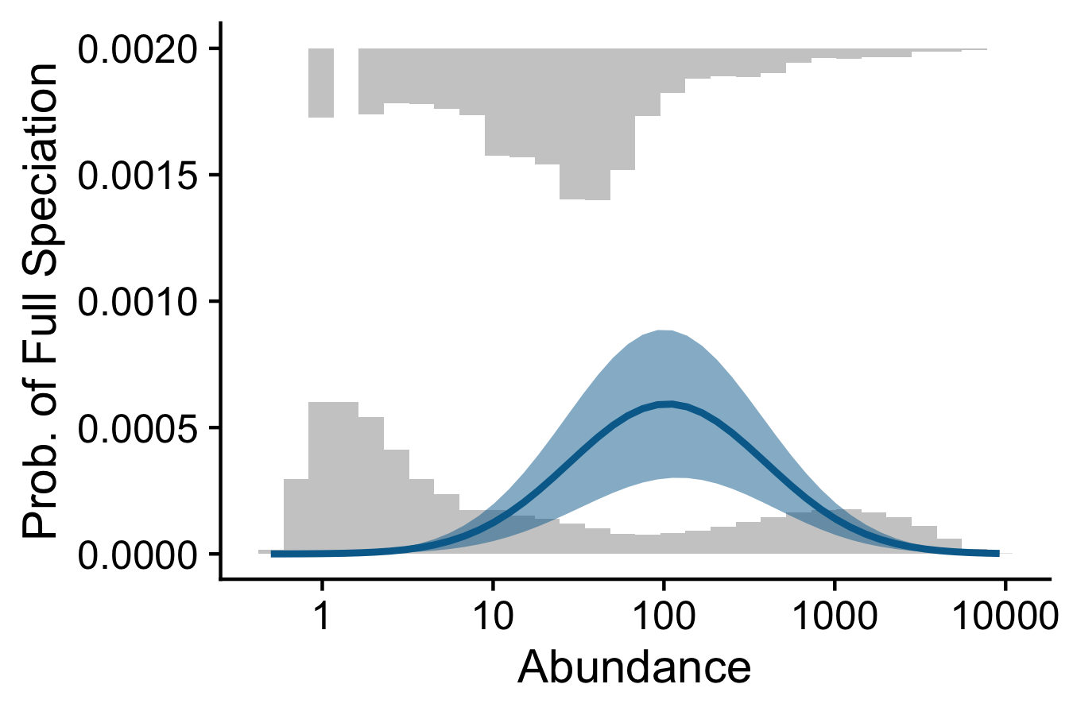
Figure 4: Relationship across simulation run windows between average abundance and speciation across. Histograms across bottom and top show the frequencies of windows without speciation (bottom) and with full-speciation (top) across different different incipient speciation rates. Curve is a binomial generalized linear model and shaded region shows 95% confidence envelope.

Effects of simulation model parameters on probability of speciation
Figure 5 shows the estimated effects on speciation probability from GLMMs that include simulation model parameters interacting with abundance. After accounting for the hump-shaped effects of abundance on probability of speciation, incipient speciation rate $ν$ and growth rate $λ-μ$ both have positive impacts on probability of speciation. Conversely, after accounting for abundance, $τ$ (the base wait time to speciation) and combined dispersal rate (local plus global) have no significant impact on probability of speciation. Across all GLMMs, the 95% CI of the quadratic term for abundance never crosses zero.
Figure 5 also shows how these GLMMs with simulation model covariates lead to different estimates of peak speciation probability. Relative to the GLMM with only a hump-shaped relationship with abundance, incipient speciation rate and growth rate both shift the location of peak speciation probability lower. Greater dispersal shifts the location of the peak higher while $τ$ has only a negligible effect.
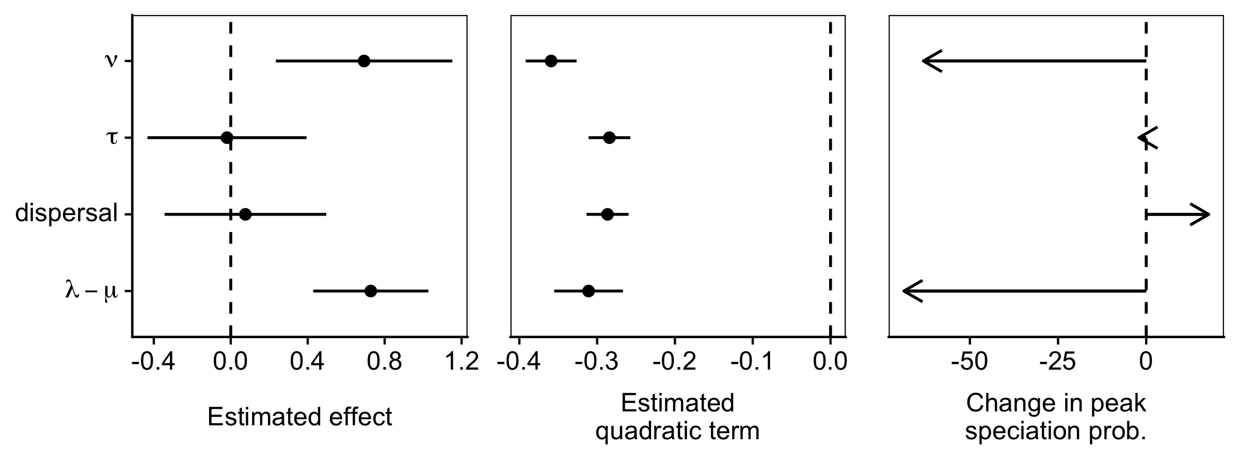
Figure 5: Summary of different GLMMs predicting speciation probability. Different models are shown across the y-axis, labeled by the simulation model parameter included as a covariate along with the hump-shaped relationship effect of abundance. Estimated effect sizes and 95% confidence intervals are shown in the left hand panel. The quadratic term for abundance from each model is shown in the middle panel. The right hand panel shows the shift in abundance value at which probability of speciation reaches its peak. This shift is shown relative to the model without simulation model parameters as covariates. The magnitudes each arrow represent how the location of peak speciation probability would shift with an increase in the simulation model covariate.

Relationship between genus abundance and species richness in Hawai`i arthropods
Arthropods in Hawai`i show a hump-shaped relationship between abundance and species richness (Figure 6). There is a clear outlier with higher genus species richness (above 300) than expected based on abundance. This outlier is Drosophila, which is not surprising given both the extensive systematics work on Hawaiian Drosophila and their unique speciation mechanisms (O’Grady and DeSalle 2018), both of which could inflate the group’s reported species richness.
The hump-shaped relationship is captured by a quadratic generalized beta-geometric model with sample size $n=118$ and coefficients intercept = 0.920 (95% CI: [0.207, 1.634]), linear term = -0.545 (95% CI: [-0.922, -0.168]), quadratic term = 0.100 (95% CI: [0.030, 0.170]). 95% CIs are Wald confidence intervals. Coefficient values are reported on the link scale (i.e. as in eq. ). The location of maximum predicted genus richness (and therefore $1-\hat{p}$) is 15.273 with 95% CI [8.641, 26.995].
A likelihood ratio test comparing quadratic and linear models of genus richness across average per-species abundance favors the quadratic model with a likelihood ratio of 7.012 and a P-value of 0.0081 from a $χ^{2}$ distribution with $d.f.$ = 1. Removing Drosophila has no meaningful impact on the relationship or the statistical significance of the quadratic term (see Supplementary Section S5).
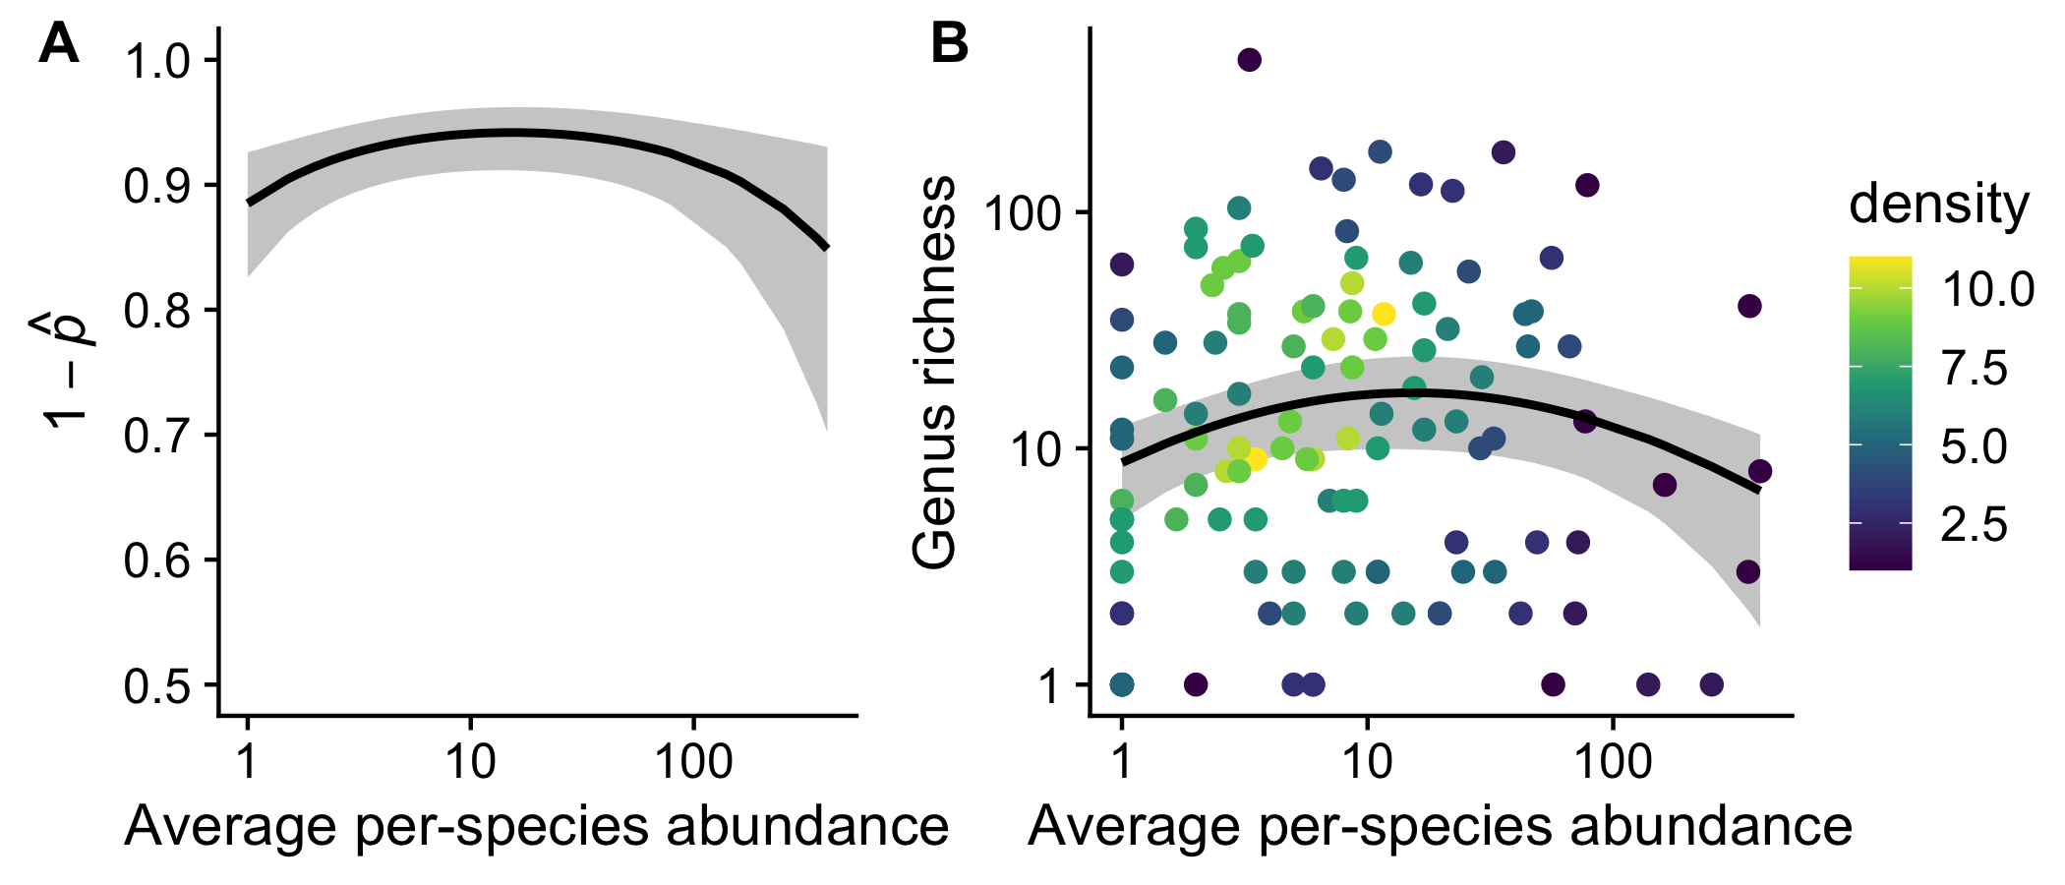
Figure 6: Relationship between genus abundance and species richness for arthropods endemic to Hawai`i. Panel A shows the fitted relationship between abundance and the observable diversification probability $1-\hat{p}$. Solid line is expected value and gray shaded region is 95% confidence envelope. Panel B shows the pattern in the raw data along with the relationship predicted by the quadratic model. The solid black line represents the expected value and gray shaded regions the 95% confidence envelope. Colors of points reflect the local density of data points such that a yellow point indicates a cluster of greater than 10 data points at that specific x-y location and dark a purple point indicates only a single data point. Points coded by density were used instead of hexagons coded by count (as in Figures 2 and 3) because of the sparsity of these real data compared to the abundance of simulated data. The outlier with genus richness above 300 is Drosophila discussed further in the main text and Supplementary Section S5.

Discussion
Taken all together these results indicate support, from both theoretical and empirical perspectives, for the idea that intermediate abundances promote speciation. Using a theoretical simulation-based model we show that the chance of speciation peaks at intermediate abundances and that this peak is robust even when considering the interactive effects other model parameters might have on speciation. This result is consistent with the idea that these intermediate abundances represent a balance between dispersal, which slows speciation, and population persistence plus per capita incipient speciation, which are necessary for speciation. The balance would arise because total dispersal is lowest at low abundance (meaning the rate of transition from incipient to full speciation is greatest at low abundance) while persistence and incipient speciation are highest at high abundance. Our work suggests an intriguing possibility that if properties like abundance and dispersal are emergent species-level traits that modulate speciation, they could be acted upon by macroevolutionary selection (Rabosky and McCune 2010).
Our results are novel in that they go against the widespread assumption that more abundant lineages should be those that produce more new speciation—an assumption tracing back to Darwin (1859) and also integral to the unified neutral theory of biodiversity (Hubbell 2001). However, our theoretical results are also grounded in published hypotheses, specifically the role of total dispersal in modulating speciation (Price and Wagner 2004, Claramunt et al. 2012, Czekanski-Moir and Rundell 2019, Yamaguchi 2022).
We arrive at these results by building on established modeling frameworks (Hubbell 2001, Rosindell et al. 2010), but we explore how abundance drives total dispersal, in turn swamping regional differentiation (Price and Wagner 2004, Birand et al. 2012, Claramunt et al. 2012, Czekanski-Moir and Rundell 2019, Ashby et al. 2020, Ciccheto et al. 2024). The model produces realistic patterns of abundance as responding to growth rate and, when growth rate is low, responding to dispersal via a rescue-effect like mechanism (Brown and Kodric-Brown 1977). The scaling of abundance and total dispersal is driven in large part by abundance (because abundances can reach large sizes) such that after accounting for abundance there is no residual effect on speciation probability of per capita dispersal, or of the base-level waiting time to full speciation in the absence of immigration. However, the GLMM including per capita dispersal, despite a seemingly non-significant dispersal term, does shift location of the peak probability of speciation. The shift is toward larger abundance. This would make sense if greater per capita dispersal slows (but does not prevent) eventual full speciation and the longer wait time to full speciation allows populations to reach a higher abundance.
The fact that greater incipient speciation rate increases the chance of full speciation is not surprising (more incipient events yield more random trials for possible full speciation). Similarly, the shift in peak speciation toward lower abundance with greater incipient speciation rate is likely due to a shorter total wait time to full speciation because incipient speciation happens more quickly. It might seem counter-intuitive that greater growth rate would decrease the abundance at which speciation peaks, but when growth rates are greater, then abundance is gained locally (increasing regional differentiation) without the need for immigration to buoy it; thus if full speciation is reached, it will be at lower abundances.
Our empirical results are qualitatively consistent with the theoretical finding that speciation peaks at intermediate abundances. The empirical results are made possible by the unique evolutionary setting of the Hawaiian Archipelago, where extreme isolation aids in the direct observation of diversification (Wagner and Funk 1995, Price and Wagner 2004). However, inferring past diversification from modern-only data has been shown to have multiple technical pitfalls including artifacts of sampling (Gruner et al. 2008), model non-identifiability (Louca and Pennell 2020), and difficulty in disambiguating effects of clade age and clade diversification rate (Yu and Wiens 2024). We test for sampling artifacts due to possibly under-sampling rare taxa (Supplementary Section S5.4) and due to choice of summary statistic (Supplementary Section S5.5) and find our results are robust to these checks.
The empirical and theoretical results are also distinct and cannot be interpreted as quantitatively equivalent. While both produce a hump-shaped relationship between abundance and measures of speciation or diversification, this does not mean that the simulation model parameters have a one-to-one mapping onto the parameters of a hypothetical diversification model that could have produced the empirical patterns. The parameters of the simulation model have to be interpreted separately from the empirical results because of key differences between the simulation set-up and the empirical analysis. Firstly, the “response variables” of each analysis are different—the simulation is able to directly observe speciation and thus we directly analyze speciation probability; conversely, we cannot directly observe speciation in the empirical system and so instead model $1-\hat{p}$, the “observable diversification probability.” The fact that we stop a simulation run once speciation is achieved also makes the simulated results different from the empirical system—in the real world, time does not stop if speciation occurs; instead, some clades continue to diversify and some go extinct. Our simulation model is thus one of the probability of first speciation and does not account for how the probability of speciation may itself change over the course of diversification (e.g., Rabosky 2009, Wagner et al. 2014, Calcagno et al. 2017, Foote 2023). The continued diversification of real world clades could also explain the flatter relationship of $1-\hat{p}$ across abundances. Additionally, while both the simulation model and empirical analysis are concerned with abundance, the way abundance is recorded in each is different. In the simulation we know the complete abundance of every local population and we scale rates such that local abundances are computationally tractable. Real world abundances (perhaps up to ${10}^{8}$) would not be computationally manageable. Also unlike the simulations, the real world data represent tiny subsamples of the whole populations.
Nonetheless, the simulation model provides a proof-of-concept and a mechanism for how speciation might depend on abundance in a more nuanced way than previously considered. Critically, our model does not depend on a neutrality assumption to arrive at this conclusion. Although our model is inspired by the agent-based modeling approaches of neutral theories (Hubbell 2001, Rosindell and Harmon 2013, Rosindell et al. 2015) we only model populations of a single species and thus make no assumption about how multiple species interact or whether different species have different eco-evolutionary rates. Thus our findings apply regardless of whether one assumes neutral- or niche-based dynamics. We also do not assume density dependence, as this is not our focus. However, one can postulate that positive density-dependent dispersal (Travis et al. 1999), which causes total dispersal rate to increase super-linearly with abundance, could further accentuate our findings. Conversely, negative density-dependent dispersal (Rodrigues and Johnstone 2014) could dampen the effects we find, but, so long as per-capita dispersal remains a non-zero probability, likely not eliminate them.
Because our model focuses on a single species and thus makes no assumptions about dynamics or interactions between species we highlight the unnecessary assumptions of previous approaches. Darwin (1859), for example, was also interested in the relationship between abundance and speciation. He assumed that more abundant species gave rise to more new species because those abundant species were biologically dominant to less abundant one, and that this dominance promoted both abundance and diversification (Darwin 1859, Maurer 1999). The language of Darwin (1859), including reference to “conquer[ing]” [p. 125] and “triumphant” [p. 126] clades, cannot be separated from discourse then and now that seeks to justify racism and colonial violence (Brantlinger 2003, Hesse 2007, Fuentes 2021, Diogo et al. 2023). Beyond the inherent amorality of such assumptions, our work shows they are unnecessary in explaining why abundance connects to speciation. We also show that these unnecessary assumptions lead to a prediction—a positive relationship between abundance and speciation—that may not universally hold.

References
Afonso Silva, A. C., Maliet, O., Aristide, L., Nogués-Bravo, D., Upham, N., Jetz, W. and Morlon, H. 2025. Negative global-scale association between genetic diversity and speciation rates in mammals. - Nature Communications 16: 1796.
Ashby, B., Shaw, A. K. and Kokko, H. 2020. An inordinate fondness for species with intermediate dispersal abilities. - Oikos 129: 311–319.
Avise, J. C. and Liu, J.-X. 2011. On the temporal inconsistencies of linnean taxonomic ranks. - Biological Journal of the Linnean Society 102: 707–714.
Birand, A., Vose, A. and Gavrilets, S. 2012. Patterns of species ranges, speciation, and extinction. - The American Naturalist 179: 1–21.
Brantlinger, P. 2003. Dark vanishings: Discourse on the extinction of primitive races, 1800–1930. - Cornell University Press.
Brown, J. H. 1995. Macroecology. - University of Chicago Press.
Brown, J. H. and Kodric-Brown, A. 1977. Turnover rates in insular biogeography: Effect of immigration on extinction. - Ecology 58: 445–449.
Calcagno, V., Jarne, P., Loreau, M., Mouquet, N. and David, P. 2017. Diversity spurs diversification in ecological communities. - Nature communications 8: 15810.
Chesson, P. 2000. Mechanisms of maintenance of species diversity. - Annual Review of Ecology and Systematics 31: 343–366.
Ciccheto, J. R. M., Carnaval, A. C. and Araujo, S. B. L. 2024. The influence of fragmented landscapes on speciation. - Journal of Evolutionary Biology 37: 1499–1509.
Claramunt, S., Derryberry, E. P., Remsen Jr, J. and Brumfield, R. T. 2012. High dispersal ability inhibits speciation in a continental radiation of passerine birds. - Proceedings of the Royal Society B: Biological Sciences 279: 1567–1574.
Claramunt, S., Sheard, C., Brown, J. W., Cortés-Ramı́rez, G., Cracraft, J., Su, M. M., Weeks, B. C. and Tobias, J. A. 2025. A new time tree of birds reveals the interplay between dispersal, geographic range size, and diversification. - Current Biology 35: 3883–3895.
Cowie, R. H. and Holland, B. S. 2008. Molecular biogeography and diversification of the endemic terrestrial fauna of the hawaiian islands. - Philosophical Transactions of the Royal Society B: Biological Sciences 363: 3363–3376.
Czekanski-Moir, J. E. and Rundell, R. J. 2019. The ecology of nonecological speciation and nonadaptive radiations. - Trends in Ecology & Evolution 34: 400–415.
Darwin, C. 1859. On the origin of species by means of natural selection, or the preservation of favoured races in the struggle for life. - John Murray.
Diogo, R., Adesomo, A., Farmer, K. S., Kim, R. J. and Jackson, F. 2023. Not just in the past: Racist and sexist biases still permeate biology, anthropology, medicine, and education. - Evolutionary Anthropology: Issues, News, and Reviews 32: 67–82.
Eddelbuettel, D., Francois, R., Allaire, J., Ushey, K., Kou, Q., Russell, N., Ucar, I., Bates, D. and Chambers, J. 2025a. Rcpp: Seamless r and c++ integration.
Eddelbuettel, D., Francois, R., Bates, D., Ni, B. and Sanderson, C. 2025b. RcppArmadillo: ’Rcpp’ integration for the ’Armadillo’ templated linear algebra library.
Etienne, R. S. and Haegeman, B. 2011. The neutral theory of biodiversity with random fission speciation. - Theoretical Ecology 4: 87–109.
Etienne, R. S., Apol, M. E. F., Olff, H. and Weissing, F. J. 2007. Modes of speciation and the neutral theory of biodiversity. - Oikos 116: 241–258.
Foote, M. 2023. Diversity-dependent diversification in the history of marine animals. - The American Naturalist 201: 680–693.
Fuentes, A. 2021. “The descent of man,” 150 years on. - Science 372: 769–769.
Gaston, K. J. 2003. The structure and dynamics of geographic ranges. - Oxford University Press.
Gaston, K. J., Blackburn, T. M. and Lawton, J. H. 1997. Interspecific abundance-range size relationships: An appraisal of mechanisms. - Journal of Animal Ecology: 579–601.
Gillespie, D. T. 1976. A general method for numerically simulating the stochastic time evolution of coupled chemical reactions. - Journal of computational physics 22: 403–434.
Gillespie, D. T. 1977. Exact stochastic simulation of coupled chemical reactions. - The journal of physical chemistry 81: 2340–2361.
Goldberg, E. E., Lancaster, L. T. and Ree, R. H. 2011. Phylogenetic inference of reciprocal effects between geographic range evolution and diversification. - Systematic Biology 60: 451–465.
Greenberg, D. A. and Mooers, A. Ø. 2017. Linking speciation to extinction: Diversification raises contemporary extinction risk in amphibians. - Evolution Letters 1: 40–48.
Gruner, D. S. 2007. Geological age, ecosystem development, and local resource constraints on arthropod community structure in the hawaiian islands. - Biological Journal of the Linnean Society 90: 551–570.
Gruner, D. S., Gotelli, N. J., Price, J. P. and Cowie, R. H. 2008. Does species richness drive speciation? A reassessment with the hawaiian biota. - Ecography 31: 279–285.
Hanski, I. 1998. Metapopulation dynamics. - Nature 396: 41–49.
Hay, E. M., McGee, M. D. and Chown, S. L. 2022. Geographic range size and speciation in honeyeaters. - BMC Ecology and Evolution 22: 86.
Hedges, S. B., Marin, J., Suleski, M., Paymer, M. and Kumar, S. 2015. Tree of life reveals clock-like speciation and diversification. - Molecular Biology and Evolution 32: 835–845.
Hesse, B. 2007. Racialized modernity: An analytics of white mythologies. - Ethnic and Racial Studies 30: 643–663.
HilleRisLambers, J., Adler, P. B., Harpole, W. S., Levine, J. M. and Mayfield, M. M. 2012. Rethinking community assembly through the lens of coexistence theory. - Annual review of ecology, evolution, and systematics 43: 227–248.
Holt, R., Lawton, J., Gaston, K. and Blackburn, T. 1997. On the relationship between range size and local abundance: Back to basics. - Oikos: 183–190.
Hubbell, S. P. 2001. The unified neutral theory of biodiversity and biogeography. - Princeton University Press.
Irwin, J. O. 1975. The generalized waring distribution. Part i. - Journal of the Royal Statistical Society: Series A (General) 138: 18–31.
Jablonski, D. and Roy, K. 2003. Geographical range and speciation in fossil and living molluscs. - Proceedings of the Royal Society of London. Series B: Biological Sciences 270: 401–406.
Kendall, D. G. 1948. On the generalized “birth-and-death” process. - The Annals of Mathematical Statistics: 1–15.
Krug, A. Z., Jablonski, D. and Valentine, J. W. 2008. Species–genus ratios reflect a global history of diversification and range expansion in marine bivalves. - Proceedings of the Royal Society B: Biological Sciences 275: 1117–1123.
Letten, A. D., Ke, P.-J. and Fukami, T. 2017. Linking modern coexistence theory and contemporary niche theory. - Ecological Monographs 87: 161–177.
Louca, S. and Pennell, M. W. 2020. Extant timetrees are consistent with a myriad of diversification histories. - Nature 580: 502–505.
Makarieva, A. M. and Gorshkov, V. G. 2004. On the dependence of speciation rates on species abundance and characteristic population size. - Journal of Biosciences 29: 119–128.
Matzke, N. J. 2014. Model selection in historical biogeography reveals that founder-event speciation is a crucial process in island clades. - Systematic Biology 63: 951–970.
Maurer, B. A. 1999. Untangling ecological complexity: The macroscopic perspective. - University of Chicago Press.
McGillycuddy, M., Warton, D. I., Popovic, G. and Bolker, B. M. 2025. Parsimoniously fitting large multivariate random effects in glmmTMB. - Journal of Statistical Software 112: 1–19.
McPeek, M. A. and Brown, J. M. 2007. Clade age and not diversification rate explains species richness among animal taxa. - The American Naturalist 169: E97–E106.
Mills, L. S. and Allendorf, F. W. 1996. The one-migrant-per-generation rule in conservation and management. - Conservation biology 10: 1509–1518.
Nishida, G. M. 2002. Hawaiian terrestrial arthropod checklist.
O’Grady, P. and DeSalle, R. 2018. Hawaiian drosophila as an evolutionary model clade: Days of future past. - BioEssays 40: 1700246.
Pennell, M. and MacPherson, A. 2025. Reading yule in light of the history and present of macroevolution. - Philosophical Transactions of the Royal Society B: Biological Sciences in press.
Price, J. P. and Wagner, W. L. 2004. Speciation in hawaiian angiosperm lineages: Cause, consequence, and mode. - Evolution 58: 2185–2200.
R Core Team 2025. R: A language and environment for statistical computing. - R Foundation for Statistical Computing.
Rabosky, D. L. 2009. Ecological limits and diversification rate: Alternative paradigms to explain the variation in species richness among clades and regions. - Ecology letters 12: 735–743.
Rabosky, D. L. and McCune, A. R. 2010. Reinventing species selection with molecular phylogenies. - Trends in Ecology & Evolution 25: 68–74.
Ricklefs, R. E. 2003. A comment on hubbell’s zero-sum ecological drift model. - Oikos 100: 185–192.
Rodrigues, A. M. and Johnstone, R. A. 2014. Evolution of positive and negative density-dependent dispersal. - Proceedings of the Royal Society B: Biological Sciences 281: 20141226.
Rosindell, J. and Harmon, L. J. 2013. A unified model of species immigration, extinction and abundance on islands. - Journal of Biogeography 40: 1107–1118.
Rosindell, J., Cornell, S. J., Hubbell, S. P. and Etienne, R. S. 2010. Protracted speciation revitalizes the neutral theory of biodiversity. - Ecology Letters 13: 716–727.
Rosindell, J., Hubbell, S. P., He, F., Harmon, L. J. and Etienne, R. S. 2012. The case for ecological neutral theory. - Trends in ecology & evolution 27: 203–208.
Rosindell, J., Harmon, L. J. and Etienne, R. S. 2015. Unifying ecology and macroevolution with individual-based theory. - Ecology Letters 18: 472–482.
Scholl, J. P. and Wiens, J. J. 2016. Diversification rates and species richness across the tree of life. - Proceedings of the Royal Society B: Biological Sciences 283: 20161334.
Smyčka, J., Toszogyova, A. and Storch, D. 2023. The relationship between geographic range size and rates of species diversification. - Nature Communications 14: 5559.
Stanley, S. M. 1986. Population size, extinction, and speciation: The fission effect in neogene bivalvia. - Paleobiology 12: 89–110.
Tao, R., Sack, L. and Rosindell, J. 2021. Biogeographic drivers of evolutionary radiations. - Frontiers in Ecology and Evolution 9: 644328.
Tilman, D. 1982. Resource competition and community structure. - Princeton university press.
Travis, J. M., Murrell, D. J. and Dytham, C. 1999. The evolution of density–dependent dispersal. - Proceedings of the Royal Society of London. Series B: Biological Sciences 266: 1837–1842.
Vitousek, P. M., Turner, D. R. and Kitayama, K. 1995. Foliar nutrients during long-term soil development in hawaiian montane rain forest. - Ecology 76: 712–720.
Wagner, W. L. and Funk, V. A. 1995. Hawaiian biogeography: Evolution on a hot spot archipelago.
Wagner, C. E., Harmon, L. J. and Seehausen, O. 2014. Cichlid species-area relationships are shaped by adaptive radiations that scale with area. - Ecology letters 17: 583–592.
Wright, S. 1931. Evolution in mendelian populations. - Genetics 16: 97.
Yamaguchi, R. 2022. Intermediate dispersal hypothesis of species diversity: New insights. - Ecological Research 37: 301–315.
Yee, T. W. 2025. VGAM: Vector generalized linear and additive models.
Yu, D. and Wiens, J. J. 2024. The causes of species richness patterns among clades. - Proceedings of the Royal Society B: Biological Sciences 291: 20232436.
Yule, G. U. 1925. A mathematical theory of evolution, based on the conclusions of dr. J. C. Willis, f.r.s. - Philosophical Transactions of the Royal Society of London. Series B, Containing Papers of a Biological Character 213: 21–87.

