# Appendix S1 Figure S1.

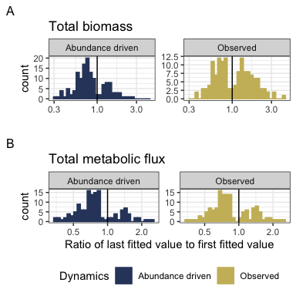

#### Appendix S1 Figure S1. Long-term trends in total biomass and energy use.

Histograms showing the direction and magnitude of long-term trends for the abundance-driven (null-model; left) and observed (right) changes in biomass (A) and energy use (B), for communities with a significant slope and/or interaction term (for biomass, 141/199 routes; for energy use, 137/199 routes; Table 1). Change is summarized as the ratio of the fitted value for the last year in the time series to the fitted value for the first year in the timeseries from the best-fitting model for that community. Values greater than 1 (vertical black line) indicate increases in total energy or biomass over time, and less than 1 indicate decreases. The abundance-driven dynamics (left) reflect the trends fit for the null model, while the observed dynamics (right) reflect trends incorporating both change in total abundance and change in the size structure over time. For communities best-described by syndromes of “coupled trends” or “no directional change”, the “abundance-driven” and “observed” ratios will be the same; for communities with “decoupled trends”, there will be different ratios for or “abundance-driven” and “observed” dynamics.

Among routes with temporal trends (“coupled trends” or “decoupled trends”), there are qualitatively different continental-wide patterns in abundance-driven and observed dynamics for total biomass and total energy use. 76% of trends in abundance-driven (null model) dynamics for energy use are decreasing, and 72% for biomass (Table 2). For biomass, observed dynamics are balanced evenly between increases (50% of routes) and decreases (50%) - indicating that changes in the size structure produce qualitatively different long-term trends for biomass than would be expected given abundance changes alone. However, trends for energy use (which scales nonlinearly with biomass) are dominated by decreases (69% of routes), more closely mirroring the trends expected given changes in individual abundance alone.

# Tables

### Appendix S1 Table S1.

|  |  |  |  |
| --- | --- | --- | --- |
| Currency | Selected model | Number of routes | Proportion of routes |
| Total biomass | Intercept-only | 58 | 0.29 |
| Total biomass | Trend, not decoupled | 86 | 0.43 |
| Total biomass | Decoupled trend | 55 | 0.28 |
| Total metabolic flux | Intercept-only | 62 | 0.31 |
| Total metabolic flux | Trend, not decoupled | 115 | 0.58 |
| Total metabolic flux | Decoupled trend | 22 | 0.11 |

#### Table 1. Selected models.

Table of the number and proportion of routes whose dynamics for total biomass and total energy use are best-fit by: a model with no temporal trend (intercept-only model, response ~ 1); a model with a temporal trend, but no difference in trend between observed and abundance-driven dynamics (response ~ timeperiod); or a model with decoupled temporal trends for observed and abundance-driven dynamics (response ~ timeperiod * dynamics, where dynamics is either observed or abundance-driven/null model).

For 31-32% of routes, models with trends do not outperform simple intercept-only models. For the remaining routes, in most instances, the dynamics of biomass and energy use exhibit a temporal trend, but with no detectable difference in the temporal trends for abundance-driven and observed dynamics. However, for a substantial minority of routes (28% overall for biomass; 11% overall for energy use), there is a detectable deviation between the trends expected due only to changes in abundance and the observed dynamics.

### Table 2.

|  |  |  |  |
| --- | --- | --- | --- |
| Currency | Proportion of increasing abundance-driven trends | Proportion of increasing observed trends | Number of routes with temporal trends |
| Total biomass | 0.28 | 0.50 | 141 |
| Total metabolic flux | 0.24 | 0.31 | 137 |

#### Table 2. Direction of temporal trends in abundance-driven and observed dynamics.

Restricted to the routes exhibiting temporal trends in total biomass and total metabolic flux, the proportion of trends that are increasing (specifically, the ratio of the last fitted value to the first fitted value > 1) for abundance-driven and observed dynamics. Trends that are not increasing are decreasing.

Trends in abundance-driven dynamics are dominated by *declines* (72% of routes for total biomass, and 76% of routes for total energy). Observed dynamics for biomass differ qualitatively from the abundance-driven dynamics; observed trends in biomass are evenly divided between increases and decreases (50% increasing). Observed trends in energy use more closely mirror abundance-driven trends (69% declines).

# Appendix S1 Figure S2

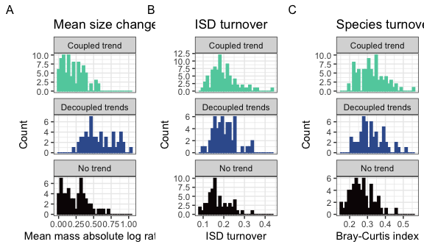

#### Figure 4. Histograms of change in community structure for routes showing no trends, coupled, and decoupled trends in abundance-driven and observed dynamics.

Histograms of (A) change in mean body size from the first to the last five years of monitoring, (B) overall change in the size structure, and (C) change in species composition for routes whose dynamics for total biomass were best-described using no temporal trend (bottom row; intercept-only model), separate trends for observed and abundance-driven dynamics (middle row), or the same trend for observed and abundance-driven dynamics (top row). Change in mean body size (A) is calculated as the ratio of the mean body size of all individuals observed in the last 5 years of the timeseries relative to the mean body size of all individuals observed in the first 5 years. Overall change in the ISD (B) is calculated as the degree of turnover between the ISDs for the first and last five years of the timeseries (see text). Change in species composition (C) is Bray-Curtis dissimilarity comparing species composition in the first five years to the last five years.

Routes that exhibit decoupling between observed and abundance-driven changes in total biomass exhibit a high prevalence of increases and decreases in mean body size (middle row, panel A) compared to the changes seen in routes that show either no trend or non-decoupled trends. However, routes with all three signatures of dynamics (coupling, decoupling, or no trend) are not detectably different in the degree of overall change in the ISD or in species composition over time (panels B and C).

# Statistical comparisons of distributions in Figure S2

### Mean mass

#### Appendix S1 Table S3.

|  |  |  |  |  |  |
| --- | --- | --- | --- | --- | --- |
| Res.Df | RSS | Df | Sum of Sq | F | Pr(>F) |
| 196 | 5.993024 | NA | NA | NA | NA |
| 198 | 11.105203 | -2 | -5.11218 | 83.59613 | 0 |

ANOVA comparing the models abs_log_ratio_mean_mass ~ best fitting model type and abs_log_ratio_mean_mass ~ 1. The fit incorporating model type is superior to the intercept-only model (p < 0.0001).

#### Table 4. Model estimates for absolute log ratio of mean mass for routes best-described by different dynamics.

|  |  |  |  |  |  |
| --- | --- | --- | --- | --- | --- |
| categorical_fit | emmean | SE | df | lower.CL | upper.CL |
| Coupled trend | 0.2084997 | 0.0188558 | 196 | 0.1713133 | 0.2456861 |
| Decoupled trends | 0.5779023 | 0.0235784 | 196 | 0.5314024 | 0.6244021 |
| No trend | 0.2385438 | 0.0229605 | 196 | 0.1932625 | 0.2838251 |

Estimates (calculated using emmeans (Lenth 2021)) for the mean absolute log ratio of mean mass for routes whose dynamics for biomass best-described by different model types. Routes with decoupled long-term trends between biomass and abundance-driven dynamics have higher absolute log ratios (mean .56, 95% credible interval .53-.58) than routes with covarying trends in biomass and abundance (mean of .2; 95% interval .18-.22) or no detectable temporal trend (mean of .22; .2-.24).

#### Table 5. Contrasts for absolute log ratio of mean mass.

|  |  |  |  |  |  |
| --- | --- | --- | --- | --- | --- |
| contrast | estimate | SE | df | t.ratio | p.value |
| Coupled trend - Decoupled trends | -0.3694026 | 0.0301908 | 196 | -12.235620 | 0.0000000 |
| Coupled trend - No trend | -0.0300441 | 0.0297107 | 196 | -1.011221 | 0.5706639 |
| Decoupled trends - No trend | 0.3393585 | 0.0329108 | 196 | 10.311453 | 0.0000000 |

Contrasts for the above comparisons. There is a significant contrast between routes with decoupled trends and the other two types of dynamics (both contrasts, p < 0.001), but not between “no trend” and “coupled trend” routes (contrast p = .31).

### ISD turnover

#### Table 6. ANOVA for turnover in the ISD

|  |  |  |  |  |
| --- | --- | --- | --- | --- |
| Resid. Df | Resid. Dev | Df | Deviance | Pr(>Chi) |
| 196 | 4.053082 | NA | NA | NA |
| 198 | 4.253015 | -2 | -0.1999328 | 0.9048678 |

### Species compositional turnover

#### Table 7. ANOVA for Bray-Curtis dissimilarity

|  |  |  |  |  |
| --- | --- | --- | --- | --- |
| Resid. Df | Resid. Dev | Df | Deviance | Pr(>Chi) |
| 196 | 4.455349 | NA | NA | NA |
| 198 | 5.044039 | -2 | -0.5886892 | 0.7450197 |

ANOVA comparing a binomial GLM of the form bray curtis dissimilarity ~ best fitting model type to an intercept-only model. The best fitting model type model is not superior to the intercept only model (p = .37).

# References

Lenth, R. V. 2021. Emmeans: Estimated Marginal Means, aka Least-Squares Means.