
February 23, 2018
National Science Foundation

To: NSF Dimensions of Biodiversity Program
From: Prof. Luke Harmon
If the proposal submitted by Dr. Andrew Rominger entitled Integrating Across Dimensions of Biodiversity: Developing Novel Theory and Informatics is selected for funding by NSF, it is my intent to collaborate and/or commit resources as detailed in the Project Description or the Facilities, Equipment and Other Resources section of the proposal.

Signed: _________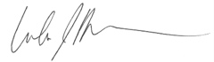______________
Organization: Department of Biological Sciences, University of Idaho
Date: 23 Feb. 2018

