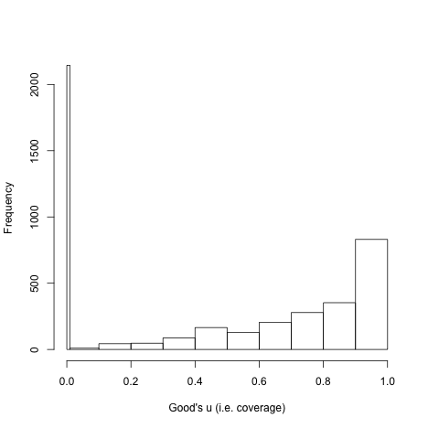

Histogram of coverage statistic for each order in each time period.

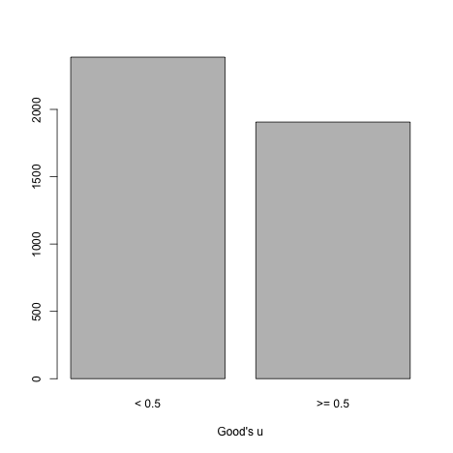

Proportion of coverage statistics below and above 0.5.

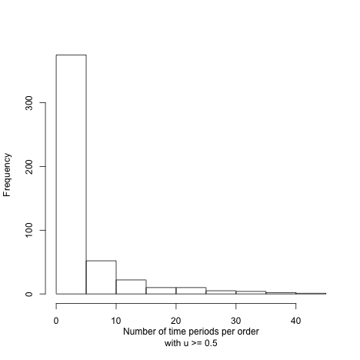

Histogram of length of durations with decent coverage (i.e. u >= 0.5).

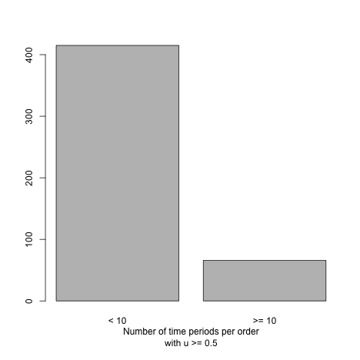

Proportion of durations with less than or greater than 10 time units.