**Title:** Metabolic Partitioning Across Individuals in Ecological Communities

**Authors:** John Harte 1,2*, Erica A. Newman 3,4, Andrew J. Rominger 2

1 Energy and Resources Group, University of California at Berkeley, 310 Barrows Hall, Berkeley, CA 94720, USA

2 Department of Environmental Science, Policy, and Management, University of California at Berkeley, 130 Mulford Hall, Berkeley, CA 94720, USA

3 School of Natural Resources and the Environment, University of Arizona, Tucson, AZ 85719, USA

4 Pacific Wildland Fire Sciences Laboratory, USDA Forest Service, Seattle, WA 98103, USA

*Corresponding author email: jharte@berkeley.edu

**Keywords:** macroecology, metabolism,metabolic rate distribution,community structure, body-size distribution

**Running head:** Metabolic Partitioning in Ecological Communities

**Corresponding author:** John Harte

**Number of words in the Abstract:** 244

**Number of words in main text:** 2153

**Number of references:** 32

**ABSTRACT**

**Issue**

The mechanistic origin and shape of body-size distributions within communities are of considerable interest in ecology. A recently proposed light-limitation model by Farrior *et al*. (2016) provides a good fit to the distribution of tree sizes in a tropical forest plot. The Maximum Entropy Theory of Ecology (METE) also predicts size distributions, but without explicit mechanistic assumptions, and thus its predictions should hold in ecosystems generally, regardless of whether they are light-limited. A comparison of the form and success of the predictions of the model and the theory can provide insight into the role that mechanisms play in shaping patterns in macroecology.

**Evidence**

METE’s prediction of the size distribution of organisms is remarkably similar in form to the model prediction of Farrior *et al.* (2016), predicting power-law behavior in the size range where the light-limitation model predicts a power law, and exponential behavior in the size range where the model predicts an exponential tail. The METE prediction matches data widely, including in ecosystems where light is not limiting. We show examples for three disparate communities: trees in a tropical forest plot, herbaceous plants in a treeless subalpine meadow, and island arthropods.

**Conclusion**

The success of METE’s predicted form across systems, including those that are clearly not light limited, enriches our capacity to predict patterns in macroecology without making explicit mechanistic assumptions, and provides a unified framework that can capture ubiquitous features of those patterns across diverse ecosystems governed by a variety of mechanisms.

**INTRODUCTION**

Among the many patterns in nature that macroecologists seek to predict are the shape and spatial-scale-dependence of the distribution of body sizes or metabolic rates across individuals within a broad taxonomic group (Brown & Maurer, 1986; Gaston & Blackburn, 2000). Models that propose to explain the greater abundance of small-bodied organisms than large-bodied organisms in a given ecosystem have invoked resource allocation (Hutchinson & MacArthur, 1959; Ritchie, 2010), macroevolution (Maurer, 1988; Clauset & Erwin, 2008; Clauset & Redner, 2009), and birth-death processes (Maurer *et al*., 1992). Although nearly all such efforts reproduce the pattern of small individuals outnumbering large individuals, there is no consensus as to the underlying mechanisms that shape body size distributions (McGill & Nekola, 2010), nor if any common distribution function, such as a power law or a lognormal, provides the best description (Gaston & Blackburn, 2000).

Recently, Farrior *et al*. (2016) have proposed a light-competition model to describe the distribution of tree sizes in the Barro Colorado Island (BCI) forest plot in Panama (Hubbell *et al*., 2005). With suitably chosen parameters, it describes adequately the distribution of stem diameters in that 50-hectare plot. In particular, the model predicts power-law behavior for the size distribution of the smaller trees and exponential behavior for the size distribution of the larger trees. We note that within the framework of metabolic scaling theory, Enquist and Niklas (2001) also find support for approximate power-law behavior for stem diameters of trees.

We show here that the Maximum Entropy Theory of Ecology (METE; Harte *et al*., 2008; Harte and Newman, 2014) predicts very similar behavior to that of Farrior *et al*. (2016) for the body size distribution, but without reliance on an explicit light-limitation mechanism. In practice, METE’s predicted size distribution describes communities regardless of whether they are light limited or otherwise resource-constrained. METE’s predictions derive from the maximum entropy inference procedure (Jaynes, 1957; 1982; Harte, 2011; Harte & Newman, 2014) and require no explicit assumptions about governing mechanisms. Instead, predictions are derived by maximizing residual information that remains unknown after empirical constraints are imposed. The constraints are ratios of measured state variables, *S*0, *N*0, and *E*0, which correspond, respectively, to the total number of species in the plot, the total number of individuals in the plot, and their total combined metabolic rate. Aside from these empirical constraints, METE, in contrast with models that contain base parameters that are free to vary (O’Dwyer *et al.*, 2017), contains no fitted parameters. Additionally, METE successfully predicts many other macroecological metrics, such as the species-abundance distribution and the species-area relationship (Harte *et al*., 2008; 2009; 2015; Harte 2011), as well as the distribution of metabolic rates across individuals (Harte 2011, Newman *et al.*, 2014, Xiao *et al.*, 2015).

**METABOLIC RATE DISTRIBUTIONS CAN BE PREDICTED WITHOUT INVOKING EXPLICIT MECHANISMS**

METE predicts the distribution of metabolic rates, rather than of sizes or masses, across individuals in the community. To extend the prediction from metabolic rate to tree basal area, we use results from tree allometry and metabolic scaling theory and thus assume metabolic rate scales as the square of stem diameter (Enquist & Niklas, 2001; Xiao *et al*., 2015). We recognize that this substitution of basal area for metabolic rate introduces some amount of error because there is evidence for size dependent deviations from the ¾-power metabolic scaling rule and the tree allometry that link basal area to metabolism (Muller-Landau *et al*., 2006, Mori *et al*., 2010). However, using an alternate estimate of metabolic scaling for plants (Mori *et al*. 2010) does not substantially change the fit of METE to BCI trees across size classes.

The METE prediction for the distribution of metabolic rates *ε*, across all individual organisms of a focal group in a well-defined area is (Harte *et al*., 2008):

 (1)

Here, *β* = *λ*1 + *λ*2, *γ*(*ε*)= *λ*1 + *λ*2*ε*,and *λ*1 and *λ*2 are Lagrange multipliers that are uniquely determined from the measured values of the state variables. For details of the calculations, see Harte (2011, pp.143-148) and Appendix S1 in Supporting Information. Analyses were carried out using the meteR package (Rominger & Merow, 2016) in R (R Core Team, 2015). Analysis code is available in Appendix S2.

The derived shape of the metabolic rate distribution in equation (1) is not a commonly encountered function in ecology and a convincing intuitive explanation for its shape may not be immediately apparent. When a distribution is constrained only by its mean value, an exponential distribution results from information entropy maximization in the Shannon entropy formulation. The constraints in METE are more complex; not only is metabolism allocated to individuals under the constraint of a specified average metabolic rate per individual, but individuals are also allocated to species under the constraint of a specified average abundance per species. As shown in Appendix S1, the combination of these two constraints yields the more complex function in equation (1). The mathematical relationship produced is neither a power law nor an exponential, but as we explain next, it approximates those two functional forms over two separate domains of the metabolic rate, *ε*.

The shape of the distribution in equation (1) is determined by the values of the Lagrange multipliers. The value of *λ*1 is on the order of (*S*0/*N*0)/ln(*N*0/*S*0) << 1 and the value of *λ*2 is on the order of *S*0/*E*0 << *λ*1. For relatively small values of *ε*, such that *λ*2*ε* << 1, the term  in the numerator in equation (1) is ≈ 1, and the denominator is (to leading order) ≈ *γ*2(*ε*). If *ε* is sufficiently small, this expression in the denominator is ≈ (*λ*1)2, while for values of *ε* such that 1 >> *λ*2*ε* > *λ*1,it is ≈ (*λ*2*ε*)2. Thus for very small values of *ε, Ψ*(*ε*) is predicted to be constant and for intermediate values of *ε* it is approximately power-law. For still larger values of *ε*, such that *λ*2*ε* > 1, the exponential term in the numerator becomes influential and the denominator is ≈ 1, resulting in:

 (2)

We emphasize that the power-law behavior predicted for intermediate values of *ε*, and the exponential behavior predicted at large *ε*,are only approximate. MaxEnt predicts exact power law behavior when the distribution is constrained just by the mean value of the logarithm of the independent variable, and exact exponential behavior when just the mean, itself, is constrained. Neither is the case in METE.

Fig. 1 shows METE’s predicted distribution of metabolic rates (equation (1)) using the numerical values of the state variables for the BCI plot (1995 census; Hubbell *et al*., 2005). The domain in *ε* over which approximate power-law behavior is predicted is 10 < *ε* < 10000, in normalized units such that the smallest individual in the dataset is defined as having *ε* = 1. For BCI data, the smallest individual corresponds to a stem diameter of 1 cm. The range of metabolic rates over which power-law behavior is predicted corresponds to stem diameters between approximately 30 and 1000 mm. This range of diameters corresponds well with the range over which Farrior *et al*. (2016) predict power-law behavior. The exponential term in the numerator should begin to exert influence over the shape of the metabolic rate distribution for values of *ε* > 10000, corresponding to stem diameters > 1000 mm, which matches well the transition threshold between exponential and the power-law dominance in Farrior *et al*. (2016). Because there are no adjustable parameters once the values of the Lagrange multipliers are fixed by empirical data, the domain in which power-law behavior and exponential behavior separately hold, as well as the power law exponent and the coefficient in the exponential term, are all uniquely predicted from the form of equation (1) and the measured values of the state variables *S*0, *N*0, and *E*0. We note that the shape of the distribution is independent of the units in which we measure metabolic rate. For example, if we chose units in which the minimum metabolic rate had a value  instead of , then the value of the state variable *E*0 would double, but the rank order of the stem diameter at which a break point occurs would not be altered.

A comparison of the prediction in equation (1) with metabolic rates estimated from basal area at BCI is shown in Fig. 2a. We use rank plots to display the data and the prediction in order to avoid the arbitrary choices involved in binning data into size classes, which also results in a loss of information (White *et al*., 2008; Virkar & Clauset, 2014). Relatively small but systematic differences between the METE prediction and observation are revealed in Fig. 2a, just as was the case for the model in Farrior *et al*. (2016). We do not know how much of the discrepancy is simply due to inaccuracies in the tree allometry and the metabolic scaling rule that were used here to replace metabolic rate with basal area, particularly for the ~30 largest individual trees in the plot (out of ~230,000) for which the deviation between theory and observation is greatest.

Xiao *et al*. (2015) showed that the METE prediction (equation (1)) accurately describes the distribution of tree metabolic rates in the 60 globally distributed forests they analyzed. Their data sets included a total of ≈ 2000 species and ≈ 300,000 individuals. Newman *et al.* (2014) showed it equally well describes meadow vegetation (Fig. 2b). Rominger *et al.* (2016) and Harte (2011) showed it applies to arthropods (Fig. 2c). It is noteworthy that the open-canopy meadow vegetation and the arthropod communities in Figs 2b-c would not be considered light-limited.

**DISCUSSION**

We are not claiming that the METE prediction is, statistically, better than the model prediction in Farrior *et al*. (2016). Comparing the merits of METE and a light-limitation model at this stage is not straightforward because METE predicts many other macroecological metrics besides the metabolic rate distribution, such as species-area relationships, abundance distributions, size-abundance relationships, and distributions of species richness over higher taxonomic classifications (Harte *et al*., 2008; 2009, 2015; Harte, 2011; Harte & Newman, 2014). Given inherent uncertainties in both tropical tree allometry and metabolic scaling, which are needed to make the connection between predictions and measured data, we see no merit in making fine comparative distinctions in goodness of fit for the model and the theory.

Nor do we claim that light limitation is not a factor influencing the size distribution of trees at BCI. Instead, we are pointing out that a statistical theory (Harte, 2011; Harte & Newman 2014), which makes no explicit assumptions about light limitation, and a light-limitation model yield functionally similar and comparably accurate predictions for the distribution of metabolic rates of trees at the BCI forest plot.

Because the theory predicts the metabolic rate distribution equally well for taxa and habitats that are clearly not light limited, we can conclude that the general properties of the METE prediction for the metabolic rate distribution (constant at very small metabolic rates, power-law at intermediate rates, and exponential at large rates) provide a robust description of size or metabolic rate distributions when light limitation is not a factor.

METE is a statistical theory of allocation of metabolism to individuals and individuals to species that builds in a limitation or constraint; namely that the sum of all the individual metabolic rates is a fixed constant. Thus it is possible that the Farrior *et al.* (2016) model provides a specific realization of the more general feature of constraint or limitation, and that a different mechanistic model with a constraint could describe the metabolic rate distributions in the arthropod and the meadow vegetation community. In such a case, it is not unreasonable that the two approaches, a mechanistic model with adjustable fitting parameters, and a statistical theory in which measured state variables determine the explicit shape of the distribution, could both make very similar predictions.

If the above is correct, further insight might come from auxiliary predictions (McGill, 2003; McGill *et al*., 2007) of the light limitation model for macroecological metrics such as the species abundance distribution and the species area relationship to determine if they are also as accurate as the METE predictions for those metrics. On the other hand, it is possible that a statistical theory such as METE is successful precisely because a multiplicity of mechanisms operate at every site, including the BCI forest, to structure size distributions, and that light limitation is only one of many possible such mechanisms at BCI. The success of METE’s predicted form across systems, including those that are clearly not light limited, enriches our capacity to predict patterns in macroecology without making explicit mechanistic assumptions, and reinforces the hope that a unified theoretical framework based on a statistical foundation can capture ubiquitous features of patterns in ecology across a wide variety of ecosystems that are each governed by a wide variety of mechanisms.

We conclude that the accumulation of data describing empirical patterns and distributions in macroecology, in combination with predictive models and theories, promotes progress toward a comprehensive and unified understanding of the structure of ecological communities.

**ACKNOWLEDGEMENTS**

Funding for this project was provided by the Gordon and Betty Moore Foundation and by grant DEB 1137685 from the US National Science Foundation. Postdoctoral funding for EAN was provided by the University of Arizona and the USDA Forest Service; and for AJR by the Berkeley Initiative in Global Change Biology.

**DATA ACCESSIBILITY**

All data used in this study has been previously published as cited in the main text and are available in Supporting Information. Analyses were carried out in the R package “meteR” (Rominger and Merow 2016).

**BIOSKETCH**

**John Harte** is a professor in the Energy and Resources Group and the Department of Environmental Science, Policy and Management at the University of California, Berkeley. His research broadly spans topics of biodiversity, climate-ecosystem feedbacks, and applications of the Maximum Entropy Principle to ecology.

**Erica A. Newman** is postdoctoral researcher focusing on connections between disturbance ecology and biodiversity patterns, including applied topics in fire management and disease ecology.

**Andrew J. Rominger** is a postdoctoral fellow studying island biogeography, and connections between ecological and evolutionary processes.

**REFERENCES**

Brown, J. & Maurer, B. (1986) Body size, ecological dominance and Cope’s Rule. *Nature*, **324**, 248-250.

Clauset, A. & Erwin, D. (2008) The evolution and distribution of species body size. *Science*, **321**, 399-401.

Clauset, A. & Redner, S. (2009) Evolutionary model of species body mass diversification. *Physical Review Letters*, **102**, 038103.

Enquist, B.J. & Niklas, K.J. (2001) Invariant scaling relations across tree-dominated communities. *Nature*, **410**, 655-660.

Farrior, C., Bohlman, S., Hubbell, S. & Pacala, S. (2016) Dominance of the suppressed: Power-law size structure in tropical forests. *Science*,**351**, 155-157.

Gaston, K. & Blackburn, T. (2000) *Pattern and Process in Macroecology*. Blackwell Scientific, Oxford, UK.

Gruner, D.S. (2007) Geological age, ecosystem development, and local resource constraints on arthropod community structure in the Hawaiian Islands. *Biological Journal of the Linnean Society*, **90**, 551-570.

Harte, J., Zillio, T., Conlisk, E. & Smith, A.B. (2008) Maximum entropy and the state variable approach to macroecology. *Ecology*, **89**, 2700–2711.

Harte, J., Smith, A. & Storch, D. (2009) Biodiversity scales from plots to biomes with a universal species-area curve. *Ecology Letters*, **12**, 789–797.

Harte J. (2011) *Maximum Entropy and Ecology: A Theory of Abundance, Distribution, and Energetics*. Oxford Univ. Press, Oxford, UK.

Harte, J. & Newman, E.A. (2014) Maximum entropy as a foundation for ecological theory. *Trends in Ecology and Evolution*, **29**, 384-389.

Harte, J. Rominger, A. & Zhang, Y. (2015) Extending the maximum entropy theory of ecology to higher taxonomic levels. *Ecology Letters*, **18**, 1068-1077.

Hubbell, S., Condit, R. & Foster, R. (2005) Forest census plot on Barro Colorado Island. http://ctfs.arnarb.Harvard.edu/webatlas/datasets/bci

Hutchinson, G. E. & MacArthur, R. (1959) A theoretical ecological model of size distributions among species of animals. *American Naturalist*, **93**, 117-125.

Jaynes, E. (1957) Information theory and statistical mechanics. *Physical Review*, **106**, 620-

630.

Jaynes, E.T. (1982) On the rationale of maximum entropy methods. *Proceedings of the Institute of Electrical and Electronic Engineering*, **70**, 939-952.

Maurer, B. (1988) The evolution of body size in birds. I. Evidence for non-random diversification. *Evolutionary Ecology*, **12**, 925-934.

Maurer, B., Brown, J. & Rusler, R. (1992) The micro and macro in body size evolution. *Evolution* **46**, 939-953.

McGill, B. (2003). Strong and weak tests of macroecological theory. *Oikos*, **102**, 679-685.

McGill, B.J., Etienne, R.S., Gray, J.S., Alonso, D., Anderson, M.J., Benecha, H.K., Dornelas, M., Enquist, B.J., Green, J.L., He, F. & Hurlbert, A.H. (2007). Species abundance distributions: moving beyond single prediction theories to integration within an ecological framework. *Ecology Letters*, **10**, 995-1015.

McGill, B.J. & Nekola, J.C. (2010) Mechanisms in macroecology: AWOL or purloined letter? Towards a pragmatic view of mechanism. *Oikos*, **119**, 591-603.

Mori, S., Yamaji, K., Ishida, A., Prokushkin, S.G., Masyagina, O.V., Hagihara, A., Hoque, A.R., Suwa, R., Osawa, A., Nishizono, T. & Ueda, T. (2010). Mixed-power scaling of whole-plant respiration from seedlings to giant trees. *Proceedings of the National Academy of Sciences*, **107**, 1447-1451.

Muller-Landau, H.C., Condit, R.S., Harms, K.E., Marks, C.O., Thomas, S.C., Bunyavejchewin, S., Chuyong, G., Co, L., Davies, S., Foster, R. & Gunatilleke, S. (2006). Comparing tropical forest tree size distributions with the predictions of metabolic ecology and equilibrium models. *Ecology Letters*, **9**, 589-602.

Newman, E.A., Harte, M.E., Lowell, N., Wilber, M. & Harte, J. (2014) Empirical tests of within- and across-species energetics in a diverse plant community. *Ecology*, **95**, 2815-2825.

O'Dwyer, J.P., Rominger, A. & Xiao, X. (2017) Who Constrains the Constraints? Using Maximum Entropy to test the value of Mechanistic Models. *arXiv preprint*, arXiv:1702.08543.

R Core Team (2015). R: A language and environment for statistical computing. R Foundation for Statistical Computing, Vienna, Austria. URL http://www.R-project.org/.

Ritchie, M. (2010) *Scale, Heterogeneity, and the Structure and Diversity of Ecological Communities.* Princeton U. Press, Princeton, NJ.

Rominger, A.J. and Merow, C. (2016) meteR: an R package for testing the maximum entropy theory of ecology. *Methods in Ecology and Evolution*, **8**, 241-247.

Rominger, A.J., Goodman, K.R., Lim, J.Y., Armstrong, E.E., Becking, L.E., Bennett, G.M., Brewer, M.S., Cotoras, D.D., Ewing, C.P., Harte, J. & Martinez, N.D. (2016). Community assembly on isolated islands: macroecology meets evolution. *Global Ecology and Biogeography*, **25**, 769-780.

Virkar, Y. & Clauset, A. (2014) Power-law distributions in binned empirical data. *The Annals of Applied Statistics*, 8, 89-119.

White, E.P., Enquist, B.J. & Green, J.L. (2008) On estimating the exponent of power‐law frequency distributions*. Ecology*, **89**, 905-912.

Xiao, X., McGlinn, D. & White, E. (2015) A strong test of the Maximum Entropy Theory of Ecology. *American Naturalist*, **185**, E70-E80.

**FIGURES**

Figure 1. Probability density function predicted by METE parameterized for Barro Colorado Island 1995 census. The white region encompasses very small values of metabolic rates of individuals, and the predicted form of the metabolic rate distribution is relatively constant in this region. The dark gray region corresponds to power law behavior, while the light gray region represents dominance of exponential behavior.

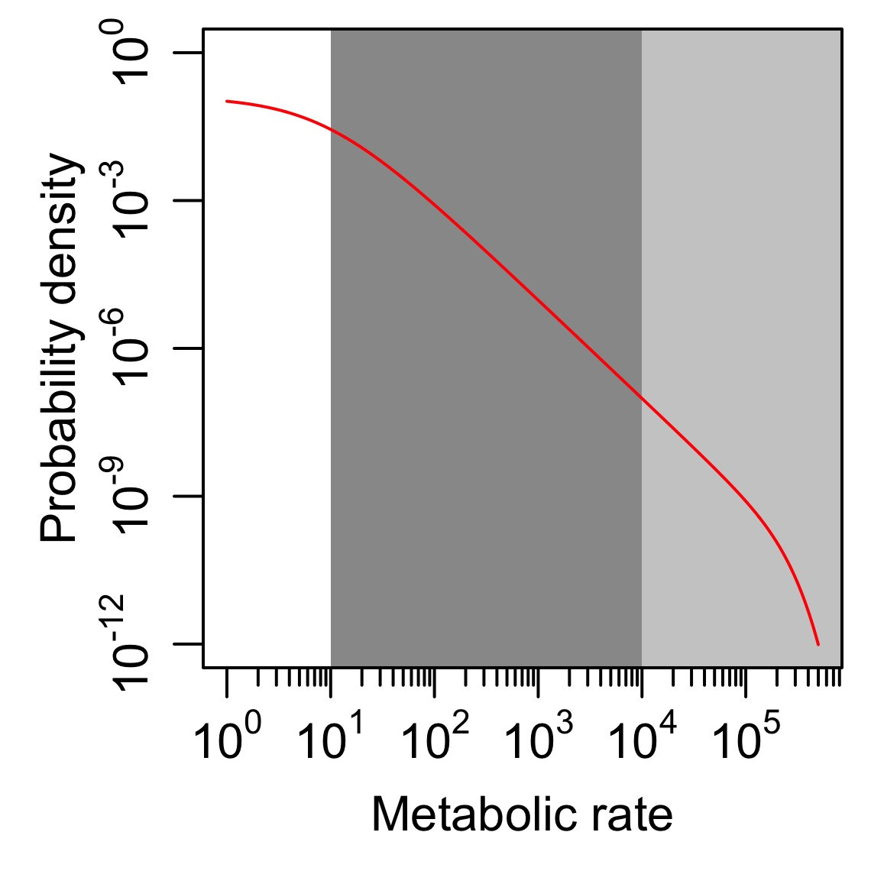

Figure 2. Comparison of the METE prediction for the distribution of metabolic rates with observed values for (A) individual trees at Barro Colorado Island (1995 census; Hubbell et al. 2005), where basal area is assumed to be a surrogate for metabolic rate, and (B) subalpine meadow plants from Rocky Mountain Biological Laboratory, Colorado, USA (Newman et al. 2014); and (C) a community of predaceous arthropods in Hawaii (data from Gruner 2007). Data and theory are presented as rank curves with log metabolic rate for each individual on the y-axis and individual rank (from largest to smallest) on the x-axis.

